**LAB 0: Ubuntu, ROS and Sparkiduino**

**CSCI 3302: Introduction to Robotics**

By: Nebiyu Tadesse

1. Outcome of Tutorial 13

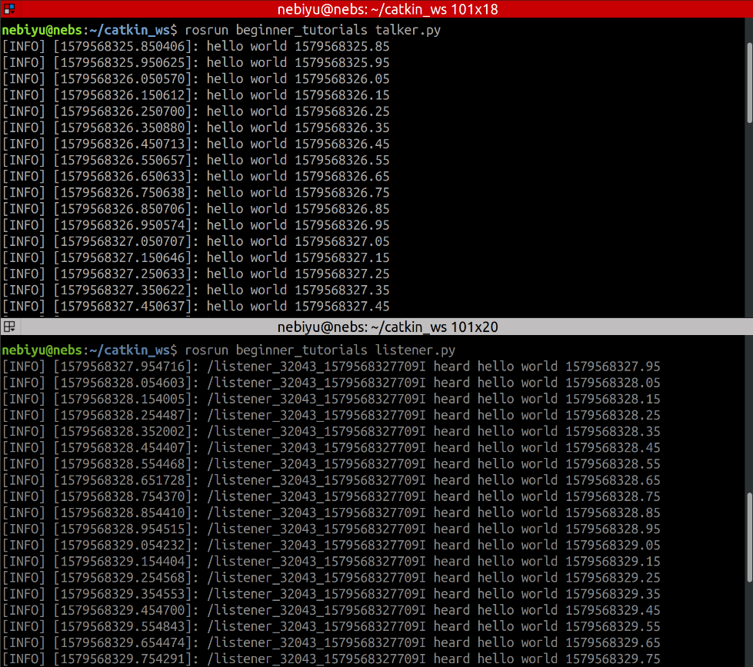

1. Outcome of Tutorial 16

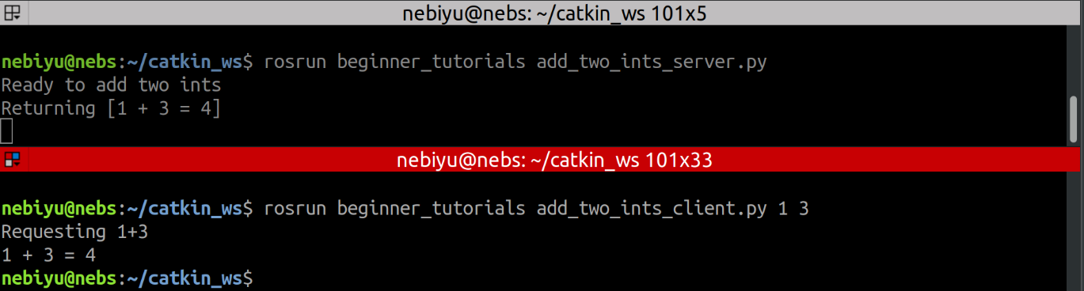

1. Screenshot of the rqt_graph

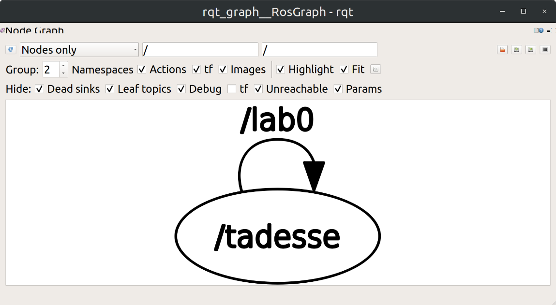

1. Screenshot of terminal’s output from command “rostopic info /lab0”

