

Sabratha University

Faculty of Engineering Sabratha

Electrical and Electronic Engineering

Control Engineering Lab

Experiment 1: Open Loop Control System

Name: Nedal Abdullah Eisa.

ID: 1611100336

* Introduction

An open loop control system is a type of control system where the output is not fed back to the input for correction or adjustment. In other words, the system does not have any means of measuring the output and comparing it to the desired value. Instead, it relies on a pre-determined input or command to generate the required output.

Open loop control systems are commonly used in situations where the system dynamics are well understood, and the variations in the input and external disturbances are minimal or predictable. They are relatively simple and cost-effective to implement, as they do not require feedback sensors or complex control algorithms.

Overall, open loop control systems are suitable for applications where precise control for variations and disturbances is not critical. They are commonly used in simple processes, where the output does not need to be closely regulated or where the feedback information is not available or necessary.

* Objectives

In this Experiment we will study the behavior of open loop control system by controlling the Speed (RPM) of a DC motor by applying different voltages as input and see the output of the open loop system as change in speed of the DC motor.

And the goals of this experiment can be described in the next points:

1. Study the Behavior of Open loop system.
2. Study the Behavior of Open loop system with different loads.
3. Find / Draw the relationship between the input and output.

* Equipment

All the equipment used in this experiment are listed in the Table 1.

|  |  |
| --- | --- |
| Name | Count |
| DC Motor Experiment Board | 1 |
| Voltmeter | 1 |
| Potentiometer | 1 |
| Power Supply  (12, 5, 0, -5, -12) V | 1 |
| Connection Wires | - |

Table 1

* Block Diagram

The Figure 1 shows the Block diagram for this experiment.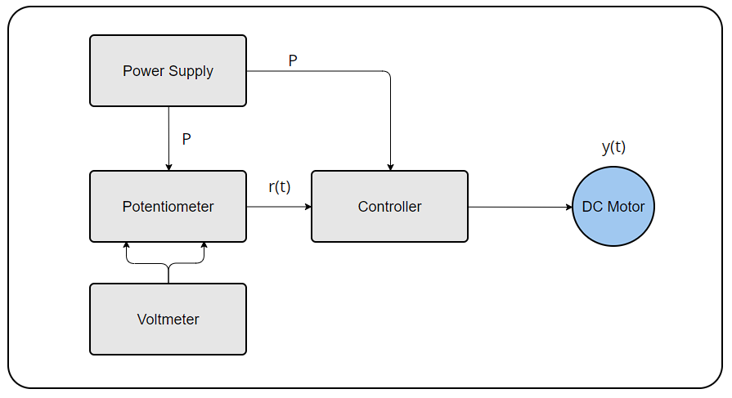

Figure 1

Figure 2

* Circuit Connection

The Figure 2 shows the Circuit Connection For this experiment.

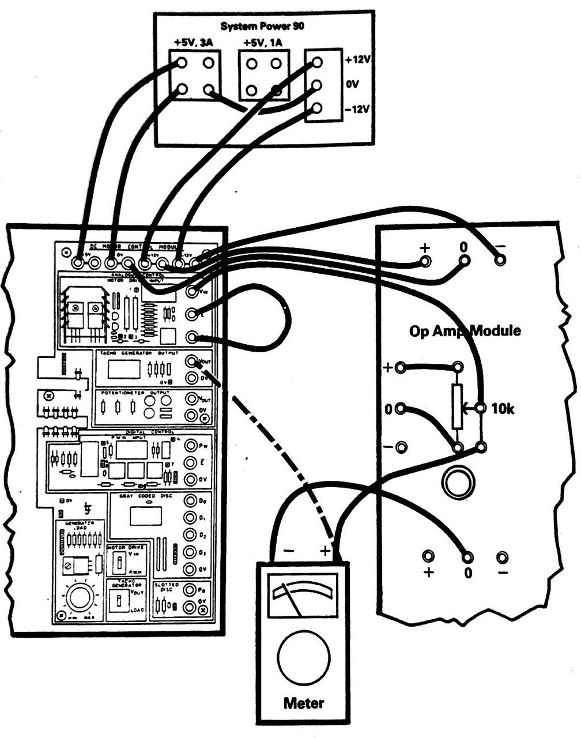

Figure 2

* Theory

In control theory, an open-loop controller, also called a non-feedback controller, is a control loop part of a control system in which the control action ("input" to the system) is independent of the "process output", which is the process variable that is being controlled.

It does not use feedback to determine if its output has achieved the desired goal of the input command or process setpoint, There are many open-loop controls, such as on/off switching of valves, machinery, lights, motors or heaters, where the control result is known to be approximately sufficient under normal conditions without the need for feedback. The advantage of using open-loop control in these cases is the reduction in component count and complexity. However, an open-loop system cannot correct any errors that it makes or correct for outside disturbances, and cannot engage in machine learning, unlike a closed-loop control system.

In open-loop control, the control action from the controller is independent of the "process output" (or "controlled process variable"). A good example of this is a central heating boiler controlled only by a timer, so that heat is applied for a constant time, regardless of the temperature of the building. The control action is the switching on/off of the boiler, but the controlled variable should be the building temperature, but is not because this is open-loop control of the boiler, which does not give closed-loop control of the temperature.

The output of the open loop control system is not compared with the input of the system for checking errors in the output. The output of non-feedback signal “faithfully” depends upon its input and doesn’t depend on any other circumstances or parameters external to the system.

These systems may be affected by large deviation in output, when the preset value of the system drifts away. As the open loop system doesn’t have any knowledge of the output, it cannot correct errors itself. This is a major disadvantage of the open loop control system.

Another disadvantage is that these systems cannot handle the external disturbances and have very poor ability to oppose the adoption of changes to external system parameters.

The Figure 3 shows the Block diagram of basic Open-Loop control system.

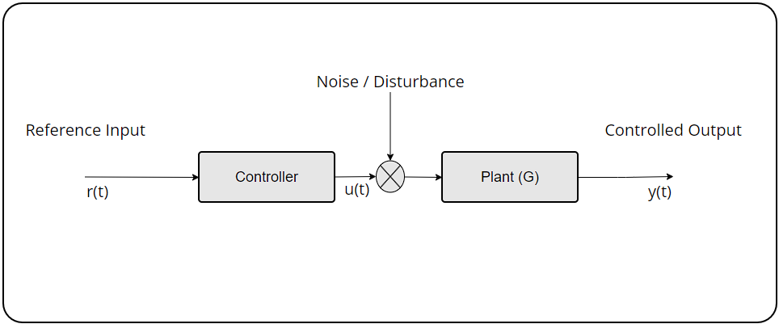

Figure 3

From the Figure 3 we can write the Output Formula as shown in next Formula:

$$y\left(t\right)=\left(Disturbance+u\left(t\right)\right)*G$$

In the Idle case where the [Disturbance = 0] then the Output Formula will become as next:

$$y\left(t\right)=u\left(t\right)*G$$

* Steps

1. Connect the Circuit to Power-Supply as shown in Figure 2 in [Circuit Connection].
2. Connect the Potentiometer to the Circuit Input as reference input as shown in Figure 2 in [Circuit Connection].
3. Connect the Voltmeter to the Potentiometer in parallel as shown in Figure 2 in [Circuit Connection].
4. Make sure that Everything is wire-up correctly.
5. Turn on the power supply.
6. Start taking the Speed readings of the DC Motor from the experiment board and record them.
7. Start changing the value of the potentiometer to change the reference voltage and record the new speed readings.
8. Repeat steps 6 to 7 until no change in speed occurs
9. Repeat steps 6 to 8 with difference disturbance that are exist on the experiment board.
10. Turn off power supply.

* Observation Data

The Table 2 shows all the readings we got from this experiment with different [loads / disturbance] where [d] is the disturbance.

|  |  |  |  |
| --- | --- | --- | --- |
| Input Voltage (V) | Output Speed (RPM) d=0 | Output Speed (RPM) d=1 | Output Speed (RPM) d=2 |
| 0.5 | 16 | 14 | 10 |
| 0.7 | 28 | 25 | 19 |
| 0.8 | 34 | 30 | 24 |
| 1.0 | 48 | 40 | 32 |
| 1.5 | 79 | 62 | 53 |
| 2.0 | 113 | 94 | 75 |
| 2.5 | 145 | 123 | 96 |
| 3.0 | 176 | 150 | 116 |
| 3.5 | 208 | 177 | 137 |
| 4.0 | 240 | 203 | 160 |
| 4.5 | 273 | 230 | 180 |
| 5.0 | 304 | 255 | 202 |
| 5.5 | 308 | 257 | 202 |
| 6.0 | 308 | 254 | 200 |

Table 2

The Table 3 shows the saturation and dead-zone values that we got in this experiment for the different [loads / disturbance].

|  |  |  |
| --- | --- | --- |
| Load Value | Saturation | Dead-Zone |
| 0 | 5.2 | 0.29 |
| 1 | 5.2 | 0.31 |
| 2 | 5.2 | 0.31 |

Table 3

* Graph

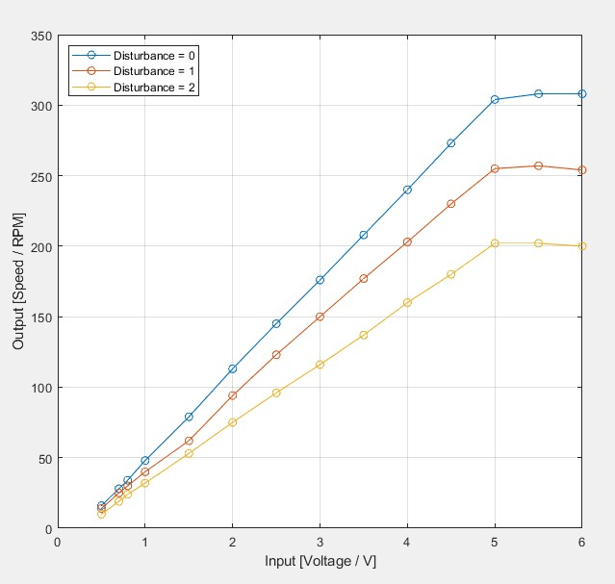The Figure 4 shows input output relationship with different loads.

Figure 4

The Figure 5 Shows the Averaged input output relationship for the different loads.

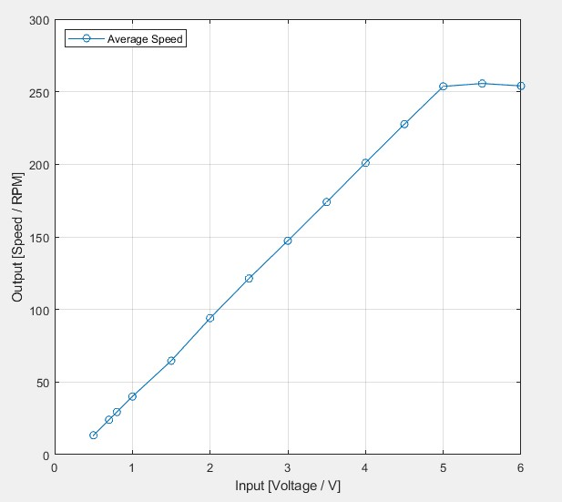

Figure 5

The Figure 6 Shows the Saturation and Dead Zones for the different loads.

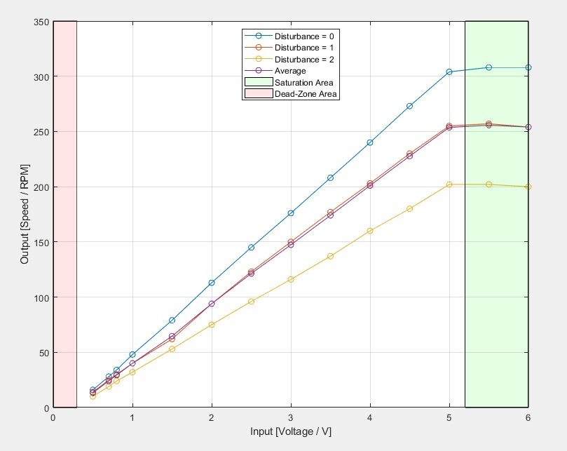

Figure 6

The Figure 7 Shows the Saturation and Dead Zones for the Averaged different loads.

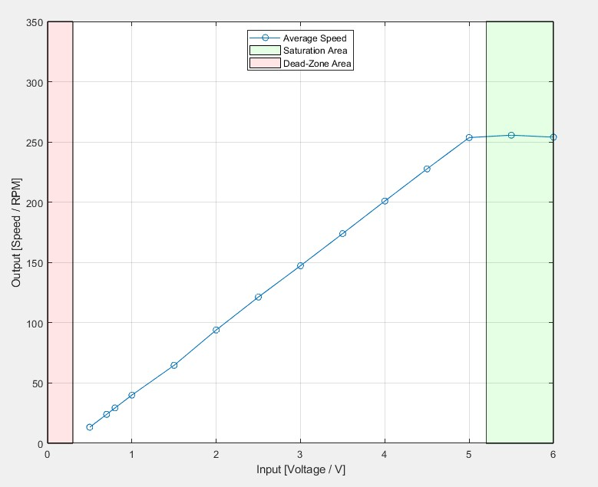

Figure 7

The Figure 8 Shows the Response of the Open loop system to the Disturbance.

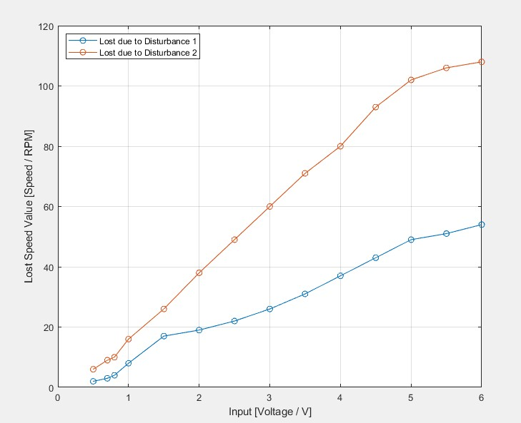

Figure 8

* Conclusion

From the Graphs the we got from this experiment we can notice that we got two important points:

Starting Point: and it’s the point where the motor start moving and its value [0.30 V].

Saturation Point: and It’s the point where the motor speed stop increasing.

* Resources

To get the pdf Format of this report or if you want to get all the resources for this experiment including pictures, matlab code that used to draw the graphs and …etc, just scan the below QR-CODE.

