

Sabratha University

Faculty of Engineering Sabratha

Electrical and Electronic Engineering

Control Engineering Lab

Experiment 2: Velocity Sensor

Name: Nedal Abdullah Eisa.

ID: 1611100336

* Introduction

The velocity sensor, a pivotal component in modern technology, captures the essence of motion with precision. From automotive to aerospace, robotics to virtual reality, this device measures an object's rate of position change over time. Employing various methodologies, such as light-based tracking or accelerometers, velocity sensors enable safety, performance, and efficiency in industries worldwide. They enhance automotive control systems, aid aerospace monitoring, empower agile robotics, and facilitate immersive virtual reality experiences. The velocity sensor's ability to transform motion into actionable data propels progress and unlocks new frontiers of achievement.

* Objectives

In this Experiment we will study the behavior of velocity sensor by controlling the Speed (RPM) of a DC motor by applying different voltages as input and see the output of the velocity sensor as change in voltage on the Voltmeter.

And the goals of this experiment can be described in the next points:

1. Study the Behavior of Velocity sensor.
2. Study the Behavior of Velocity sensor with different Speeds.
3. Find / Draw the relationship between the input and output.

* Equipment

All the equipment used in this experiment are listed in the Table 1.

|  |  |
| --- | --- |
| Name | Count |
| DC Motor Experiment Board | 1 |
| Voltmeter | 1 |
| Potentiometer | 1 |
| Power Supply  (12, 5, 0, -5, -12) V | 1 |
| Connection Wires | - |

Table 1

* Block Diagram

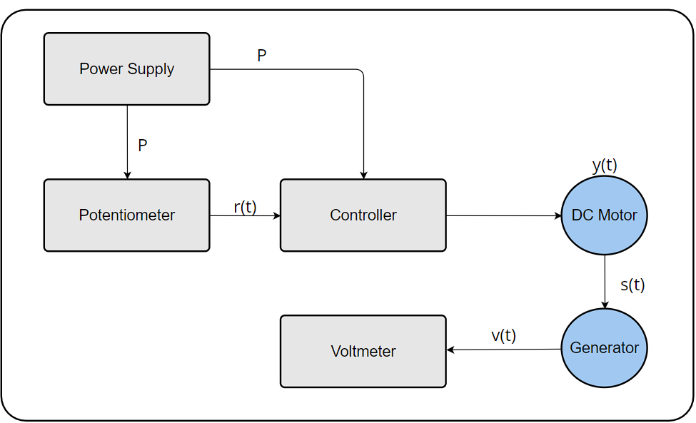The Figure 1 shows the Block diagram for this experiment.

Figure 1

Figure 2

* Circuit Connection

The Figure 2 shows the Circuit Connection For this experiment.

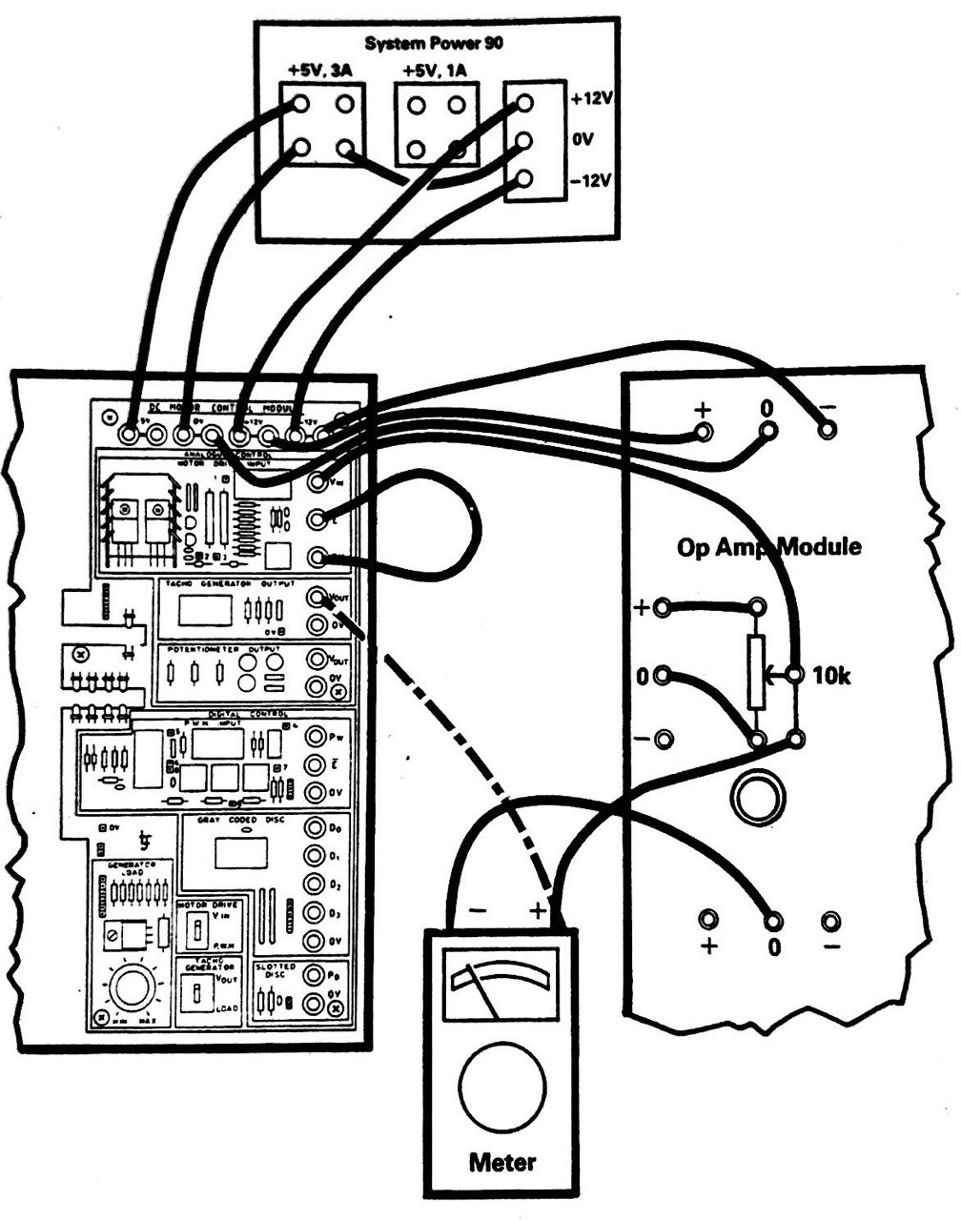

Figure 2

* Theory

When a DC motor is supplied with electrical power, it converts the electrical energy into mechanical energy, causing the motor shaft to rotate. However, an interesting phenomenon occurs when the motor shaft is rotated externally, such as by an external force or by another mechanical device. In this scenario, the DC motor can function as a generator, converting mechanical energy into electrical energy.

The underlying principle behind this operation lies in Faraday's law of electromagnetic induction. According to this law, when a conductor (such as the armature winding of a DC motor) cuts through magnetic lines of force, an electromotive force (EMF) is induced across the conductor. This induced EMF generates an electrical current if the circuit is closed, allowing the conversion of mechanical energy into electrical energy.

When the DC motor is used as a generator, the external mechanical force applied to rotate the motor shaft drives the armature winding to cut through the magnetic field produced by the motor's permanent magnets or electromagnets. This cutting action induces an EMF in the armature winding, which can then be harnessed as electrical power.

To extract electrical power from the generated EMF, it is necessary to connect load devices, such as resistors or electrical circuits, to the terminals of the DC motor acting as a generator. The load devices provide a closed circuit for the generated current to flow through, allowing the electrical energy to be utilized.

It is worth noting that the voltage and current output of a DC motor used as a generator are influenced by various factors, including the speed of rotation, the strength of the magnetic field, and the characteristics of the load connected to the terminals. Additionally, the efficiency of the conversion process is affected by losses within the motor, such as mechanical friction and electrical resistance.

In practical applications, the concept of using a DC motor as a generator finds utility in areas such as regenerative braking systems, wind power generation, and small-scale energy harvesting projects. By harnessing the mechanical energy in the form of rotation, the DC motor can be repurposed as a generator, exemplifying the versatility and adaptability of this electromechanical device.

The DC motor can also be utilized as a velocity sensor, thanks to its ability to generate an electrical output proportional to its rotational speed.

The magnitude of the back EMF is directly proportional to the speed of the motor shaft. At higher speeds, the back EMF increases, while at lower speeds, it decreases. By measuring the back EMF, it is possible to determine the rotational speed of the motor shaft.

To use a DC motor as a velocity sensor, the motor is connected in a configuration where it acts as a generator. The motor's terminals are connected to a load resistor or an appropriate circuit that provides a closed path for the generated current. As the motor shaft rotates, the back EMF is produced, resulting in a voltage across the terminals.

By measuring this voltage, it is possible to deduce the rotational speed of the motor shaft. This can be achieved by using an analog-to-digital converter (ADC) to convert the voltage into a digital signal, which can then be processed and interpreted by a microcontroller or computer system.

The use of DC motors as velocity sensors offers several advantages. They are relatively inexpensive, readily available, and can provide real-time velocity feedback without the need for additional sensors. Furthermore, they can be integrated into systems where precise speed control and monitoring are required, such as robotics, motion control applications, and industrial automation.

* Steps

1. Connect the Circuit to Power-Supply as shown in Figure 2 in [Circuit Connection].
2. Connect the Potentiometer to the Circuit Input as reference input as shown in Figure 2 in [Circuit Connection].
3. Connect the Voltmeter to the Generator Output in parallel as shown in Figure 2 in [Circuit Connection].
4. Make sure that Everything is wire-up correctly.
5. Turn on the power supply.
6. Start taking the Voltage readings of the Generator from the experiment board and record them.
7. Start changing the value of the potentiometer to change the Speed of the DC Motor and record the new Voltage readings.
8. Repeat steps 6 to 7 until no change in Voltage occurs
9. Turn off power supply.

* Observation Data

The Table 2 shows all the readings we got from this experiment with different [loads / disturbance] where [d] is the disturbance.

|  |  |
| --- | --- |
| Speed (RPM) | Output Voltage (V) |
| 0 | 0 |
| 25 | 0.40 |
| 50 | 0.81 |
| 75 | 1.23 |
| 100 | 1.66 |
| 125 | 2.08 |
| 150 | 2.51 |
| 175 | 2.96 |
| 200 | 3.33 |
| 225 | 3.73 |
| 250 | 4.19 |
| 275 | 4.60 |
| 300 | 4.88 |
| 325 | 4.88 |

Table 2

The Table 3 shows the saturation values that we got in this experiment for the [Speed / Voltage].

|  |  |
| --- | --- |
| Type | Saturation |
| Speed | 294 |
| Voltage | 4.88 |

Table 3

* Graph

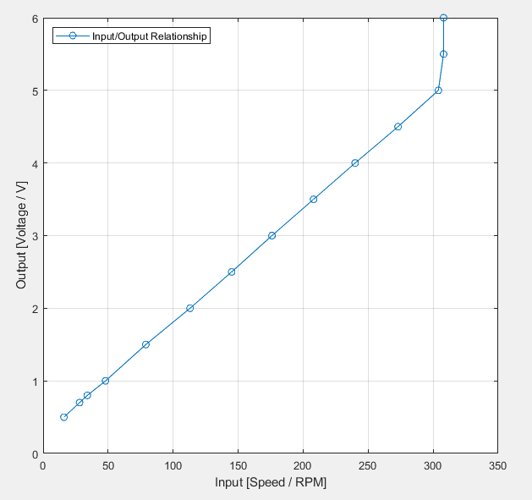The Figure 4 shows input output relationship for different speeds.

Figure 3

* Conclusion

From the Readings and Graphs the we got from this experiment we can notice that we can use the DC Motor as generator to measure the Velocity.

* Resources

To get the pdf Format of this report or if you want to get all the resources for this experiment including pictures, matlab code that used to draw the graphs and …etc, just scan the below QR-CODE.

