

Sabratha University

Faculty of Engineering Sabratha

Electrical and Electronic Engineering

Control Engineering Lab

Experiment 3: Potentiometer Calibration

Name: Nedal Abdullah Eisa.

ID: 1611100336

* Introduction

The potentiometer, often referred to as a "pot," is a fundamental electrical component that enables precise control and measurement of electrical resistance. This versatile device consists of a resistive element and a movable contact that slides along its surface, allowing for variable resistance values to be obtained.

The potentiometer finds widespread use in a plethora of applications. It serves as a fundamental tool in electronics and electrical engineering, enabling precise control of parameters such as volume, brightness, speed, and position. Potentiometers are commonly found in audio equipment, where they adjust sound levels, tone, and balance. They are also utilized in industrial control systems, robotics, and instrumentation, providing a means to fine-tune and calibrate variables in real-time.

Moreover, the potentiometer serves as a valuable sensing tool. By utilizing the variable resistance, it can be employed as a position or angle sensor. This makes it useful in applications such as joystick controls, robotic arms, and linear actuators, where the position or displacement needs to be precisely monitored and controlled.

Potentiometers come in various forms, including rotary and linear types. Rotary potentiometers have a circular form factor and are commonly used for adjusting parameters by rotating a knob. Linear potentiometers, on the other hand, have a linear slider or track and are suitable for applications that require linear position sensing or adjustment.

* Objectives

In this Experiment we will study the behavior of potentiometer by reading the voltage values for different [angles / positions] as input.

And the goals of this experiment can be described in the next points:

1. Study the Behavior of Potentiometer.
2. Study the Behavior of Potentiometer with different [angles / positions].
3. Find / Draw the relationship between the input and output.

* Equipment

All the equipment used in this experiment are listed in the Table 1.

|  |  |
| --- | --- |
| Name | Count |
| DC Motor Experiment Board | 1 |
| Voltmeter | 1 |
| Potentiometer | 1 |
| Power Supply  (12, 5, 0, -5, -12) V | 1 |
| Connection Wires | - |

Table 1

* Block Diagram

The Figure 1 shows the Block diagram for this experiment.

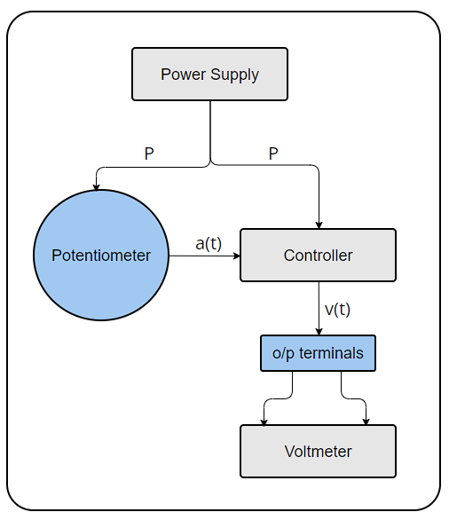

Figure 1

Figure 2

* Circuit Connection

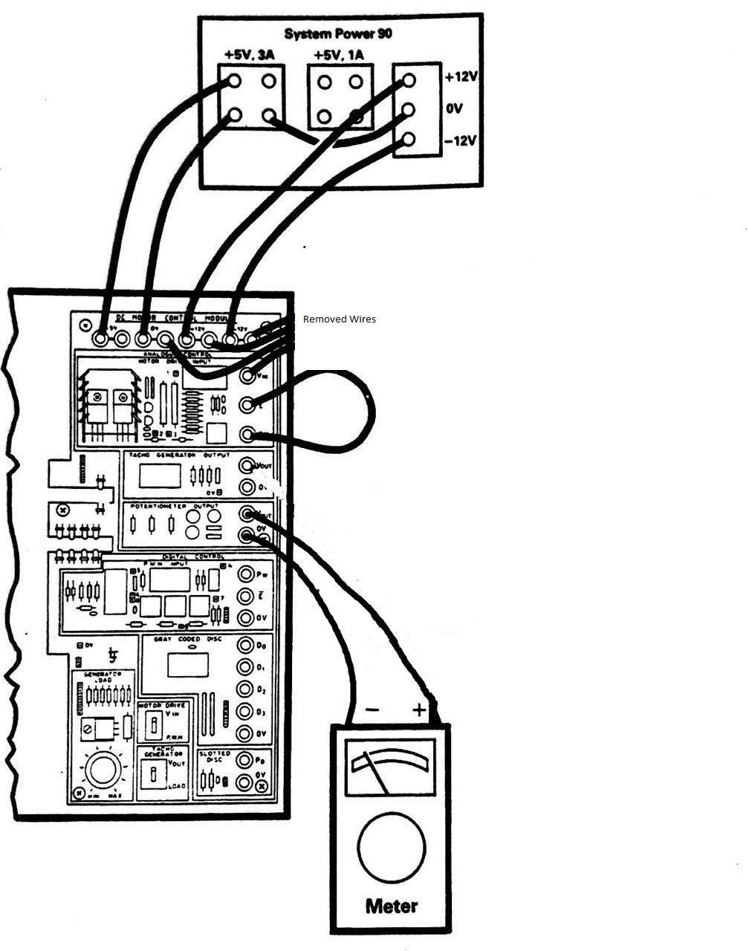The Figure 2 shows the Circuit Connection For this experiment.

Figure 2

* Theory

Potentiometers are essential components in electrical circuits that enable precise control and measurement of electrical resistance. They operate on the principle of voltage division, where a resistive element and a movable contact combine to create a variable resistance.

The resistive element in a potentiometer is typically a coil or strip of resistive material. It has two fixed terminal points, with the resistance value evenly distributed along its length. The movable contact, controlled by an external mechanism or user input, taps into the resistive element at a specific point, creating a voltage output.

The voltage output of a potentiometer is determined by the position of the movable contact along the resistive element. As the contact moves, it changes the length of the resistive path through which the current flows. This variation in the resistive path alters the voltage division, resulting in a voltage output that is directly proportional to the position of the contact.

Potentiometers find wide applications in electronics and electrical engineering. They are commonly used for controlling parameters such as volume, brightness, speed, and position. In audio equipment, potentiometers adjust sound levels, tone, and balance. They are also employed in industrial control systems, robotics, and instrumentation to fine-tune variables in real-time.

Potentiometers can also be utilized as position or angle sensors. By exploiting the variable resistance, they can accurately measure and monitor the position or displacement of mechanical systems. This makes them useful in applications such as joysticks, robotic arms, and linear actuators, where precise position sensing is required.

Potentiometers come in different forms, including rotary and linear types. Rotary potentiometers have a circular form factor and are commonly used with knobs for adjusting parameters by rotating them. Linear potentiometers have a linear slider or track and are suitable for applications that require linear position sensing or adjustment.

The Figure 3 shows the diagram for circular potentiometer.

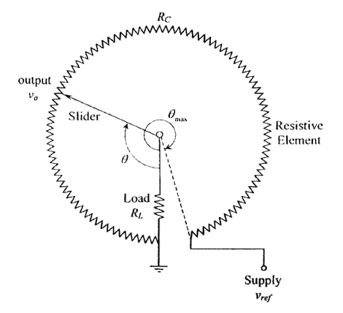

Figure 3

From the Figure 3 we can write the Output Formula as shown in next Formula:

$$Vo=Vref*\frac{Rl}{(Rl +Rc)}$$

* Steps

1. Connect the Circuit to Power-Supply as shown in Figure 2 in [Circuit Connection].
2. Connect the Voltmeter to the Potentiometer Output in parallel as shown in Figure 2 in [Circuit Connection].
3. Make sure that Everything is wire-up correctly.
4. Turn on the power supply.
5. Start taking the Voltage readings of the Voltmeter and record them.
6. Start changing the value of the potentiometer to change the [angle / position] and record the new voltage readings.
7. Repeat steps 6 to 7 until we reach angle 360.
8. Turn off power supply.

* Observation Data

The Table 2 shows all the readings we got from this experiment with different [angles / positions].

|  |  |
| --- | --- |
| Angle / Position [input] | Voltage [output] |
| 0 | -4.98 |
| 30 | -4.35 |
| 60 | -3.77 |
| 90 | -2.93 |
| 120 | -2.05 |
| 150 | -1.17 |
| 180 | -0.28 |
| 210 | +0.58 |
| 240 | +1.50 |
| 270 | +2.42 |
| 300 | +3.31 |
| 330 | +4.25 |
| 360 | +5.15 |

Table 2

* Graph

The Figure 4 shows input output relationship with different angles.

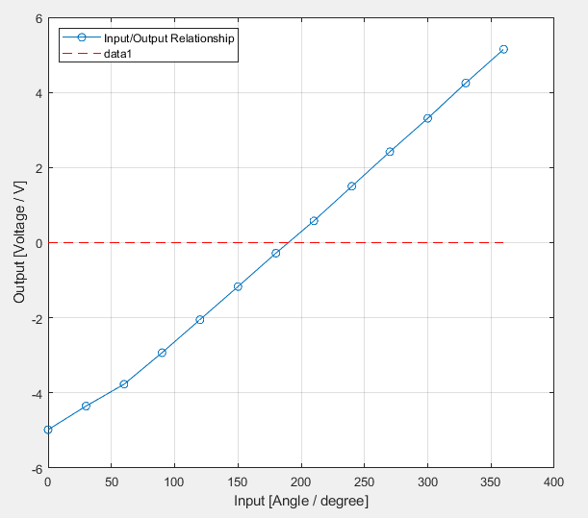

Figure 4

* Conclusion

From the Graph the we got from this experiment we can notice that we can convert the position into voltage difference and we notice that there is a change in polarity after (180) degree, and from the table we notice that we got range from (-5V) to (+5V)

* Resources

To get the pdf Format of this report or if you want to get all the resources for this experiment including pictures, matlab code that used to draw the graphs and …etc, just scan the below QR-CODE.

