
Sabratha University
Engineering Faculty Sabratha
EEE-Departmant

Inverting Operational Amplifier

Author: Nedal Abdullah
ID: 1611100336

- Objectives
The objective of this experiment is to study and simulating inverting configuration of 741 operational-amplifier using multisim simulating kit.

- Equipment
  - Oscilloscope
  - AC Voltage Source
  - Vcc (+12v)
  - Vdd (-12v)
  - IC-741
  - Resistors(1kΩ, 2kΩ, 3kΩ, 4kΩ)

- Circuit Diagram
Figure 1 shows the circuit diagram for inverting configuration.
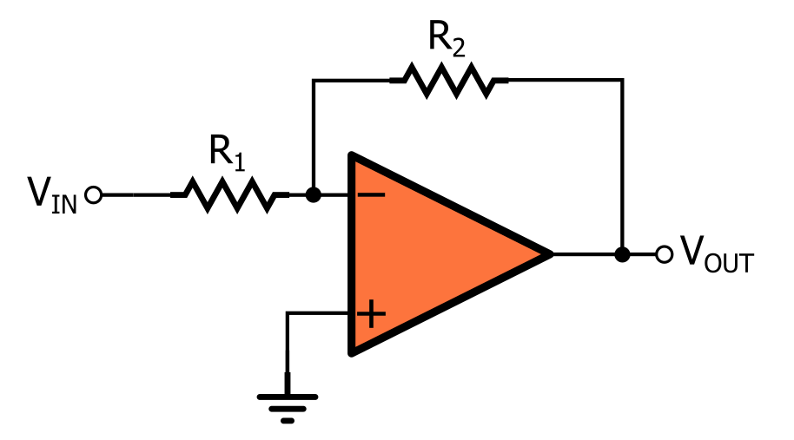Figure 1

Figure 2 shows the circuit connection for inverting configuration on multisim simulating application.

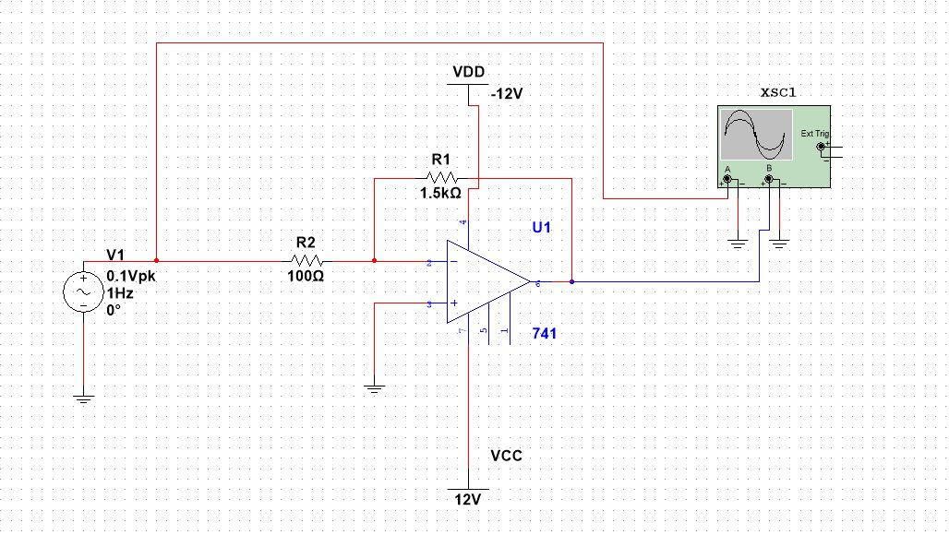Figure 2

- Theory
A modern op-amp has hundreds of transistors integrated on a single chip, It is not necessary to understand how the internal circuitry works in order to use the op-amp; it can be treated as a “black-box” device.
The symbol for an 741 op-amp is shown in figure 1, This is the most basic op-amp symbol with five terminals comprised of positive (non-inverting) and negative (inverting) inputs; V+ and V- supply terminals; and one output.
All equations that describe the behavior of op-amp circuits rely on certain assumptions about the op-amp. These assumptions about an ideal op-amp are summarized in table 1 and compared to the real op-amp used in this lab, the 741.
A modern op-amp approaches an ideal op-amp when used within its bandwidth and output limitations. For non-critical applications the ideal op-amp assumptions are valid.
In the case of the 741 as long as the device is operated at low frequencies and does not exceed its rated output voltage and current limits the ideal assumptions are valid.

Parameter | Ideal Op-Amp | 741
R_{in} | Infinite | 2MΩ
Open loop Gain | Infinite | 200,000
Bandwidth | Infinite | 1MHz
Voltage Output | Infinite | +/- 15.0V
Current Output | Infinite | 25mA
R_{O} | Zero | 75Ω
Input Offset Voltage | Zero | 1mV
Input Bias Current | Zero | 0.2nA
Table 1

The behavior of an op-amp can be described by two rules:
- An op-amp will attempt to make the voltage at both its inputs equal through the use of a feedback path.
- No current can flow through inputs terminals.

Now by connected the 741 as shown in figure 1, we will get the inverting operation amplifier configuration and this configuration has a negative gain and negative feedback loop and for this configuration the input/output relationship is
given by:

Formula 1

and Transfer function is given by:
Formula 2

- Observation Data

- Simulation Readings
table 2 shows all the readings that we got from the simulation using different values of R₁ and R₂ and different input voltages.
R₁(kΩ) | R₂(kΩ) | F(Hz) | V_{i1}(v) | V_{o1}(v) | V_{i2}(v) | V_{o2}(v) | V_{i3}(v) | V_{o3}(v)
1 | 1 | 1 | 1 | -0.994 | 2 | -1.993 | 3 | -2.989
2 | 1 | 1 | 1 | -1.987 | 2 | -3.983 | 3 | -5.976
3 | 1 | 1 | 1 | -2.987 | 2 | -5.984 | 3 | -8.958
4 | 1 | 1 | 1 | -3.981 | 2 | -7.981 | 3 | -11.115
1 | 2 | 1 | 1 | -0.496 | 2 | -0.994 | 3 | -1.496
2 | 2 | 1 | 1 | -0.995 | 2 | -1.997 | 3 | -2.994
3 | 2 | 1 | 1 | -1.492 | 2 | -2.991 | 3 | -4.489
4 | 2 | 1 | 1 | -1.986 | 2 | -3.983 | 3 | -5.981
Table 2

Table 3 shows both the theoretical Gain calculated using the Formula 1 and the Actual gain for the Table 2 and Averaged Gain error.

Theoretical Gain | Actual Gain | Error (%)
-1 | -0.995 | 0.5
-2 | -1.990 | 0.5
-3 | -2.988 | 0.4
-4 | -3.892 | 2.7
-0.5 | -0.497 | 0.6
-1 | -0.997 | 0.3
-1.5 | -1.494 | 0.4
-2 | -1.990 | 0.5
Table 3

Table 4 shows the Frequency Response for the 741 operational amplifier.

R1(Ω) | R2(Ω) | F(Hz) | V_{in} (V) | V_{out} (V)
1.5k | 100 | 1 | 0.1 | -1.480
1.5k | 100 | 100 | 0.1 | -1.478
1.5k | 100 | 500 | 0.1 | -1.477
1.5k | 100 | 1k | 0.1 | -1.480
1.5k | 100 | 100k | 0.1 | -0.275
1.5k | 100 | 500k | 0.1 | -0.104
1.5k | 100 | 1M | 0.1 | 0.016
Table 4

- Oscilloscope output
The Figure 3 shows the input signal and the amplified output signal on
the Oscilloscope.

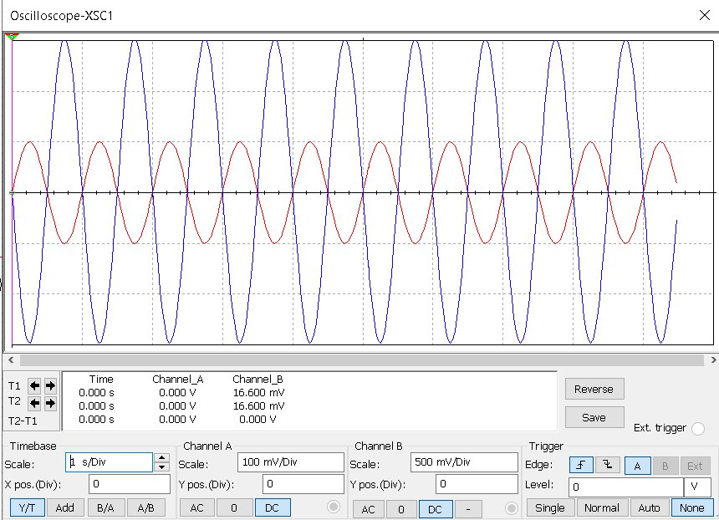Figure 3: input and output signals

The Figure 4 shows the input signal and Saturated Output signal.

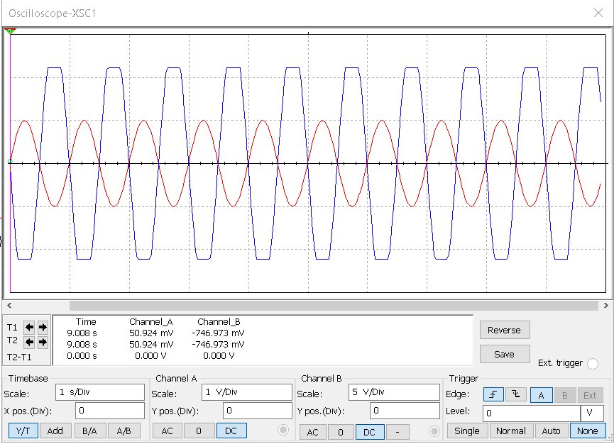Figure 4: Saturated output Signal

The Figure 5 shows the output signal when the R1 and R2 are equal this
is called Unity Gain.
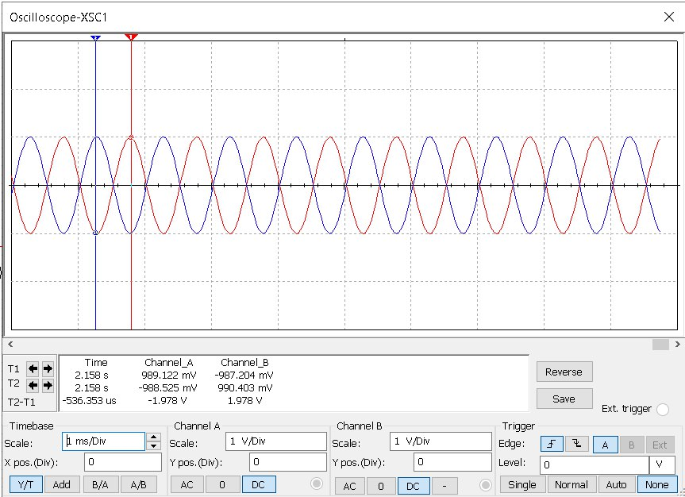Figure 5: Unity Gain

The Figures 6, 7, 8 shows the output signal at different frequencies.
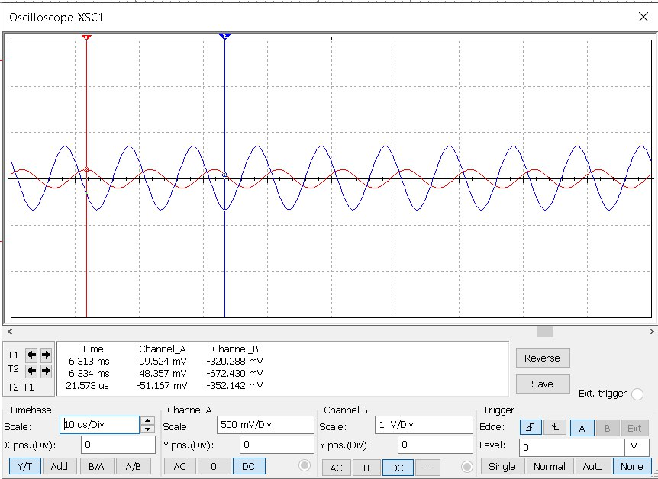Figure 6: output at Frequency of 100Khz

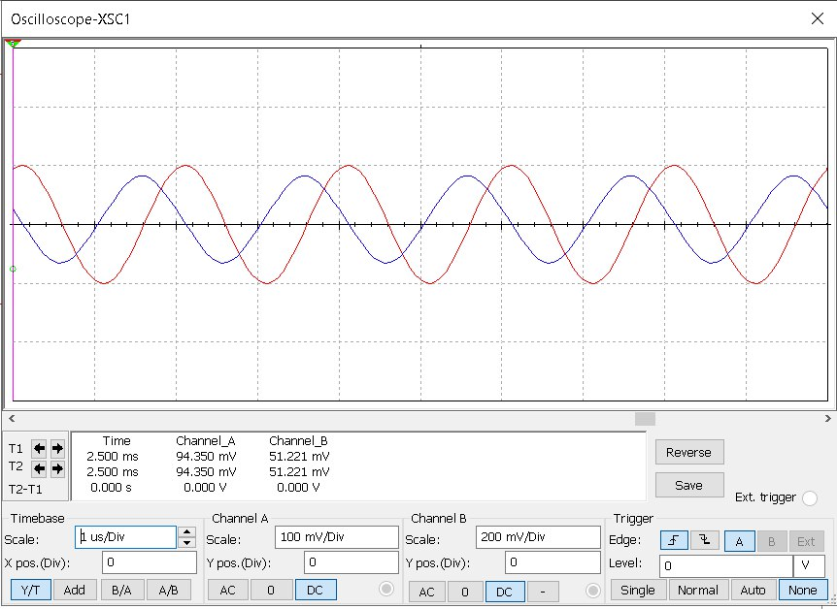Figure 7: output at Frequency of 500KHz

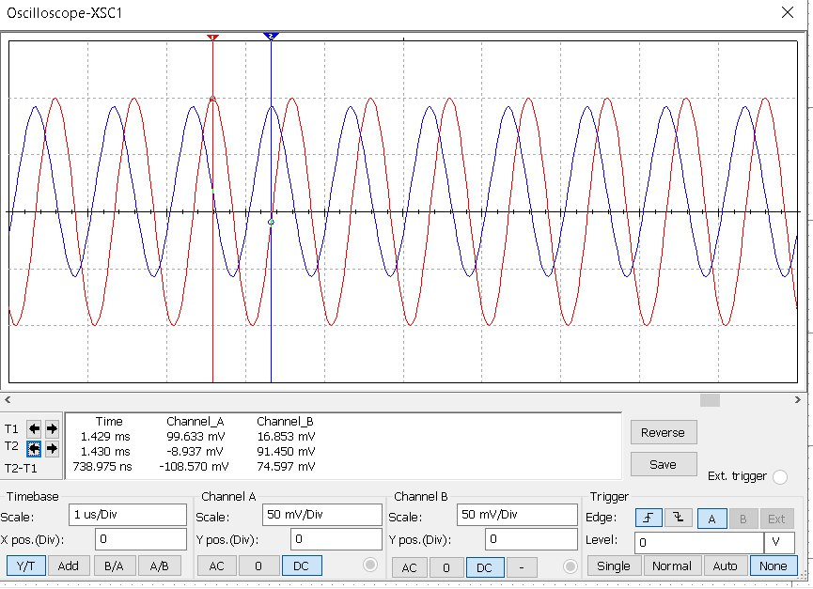Figure 8: output signal at 1MHz

- Graphs
The Figure 9 shows the graph between Theoretical Gain and Actual Gain.

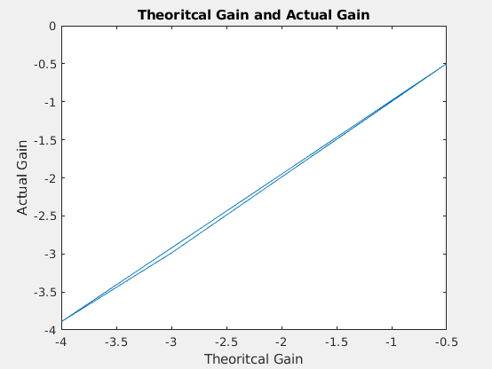Figure 9: Theoretical Gain and Actual Gain Graph

The Figure 10 shows the input and output for different values of Gain.

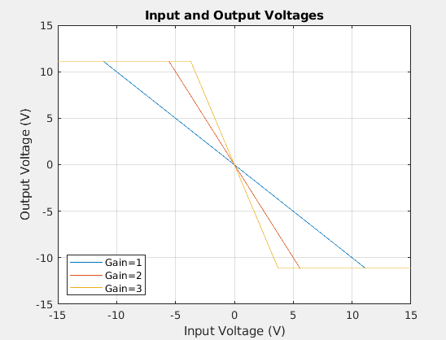Figure 10: Input and Output Voltages

The Figure 11 shows the Frequency Response for 741 op-amp in inverting configuration
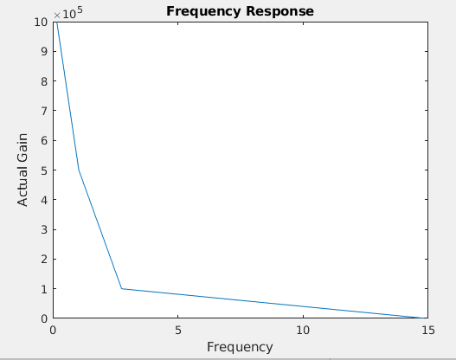Figure 11: Frequency Response

- Analysis
From the readings that we got from simulating and showed in Table 2 we can see that the output depend on input and we can change the Gain by changing the Values of the R₁ and R₂ and we can see that we can’t get the Theoretical output voltage because there is an Output Resistance For operational amplifier and its value shown in Table 1.
If we see the Figure 4 we can notice that we got a cutting on output signal and that happened because the Amplified signal is Limited to the supply inputs voltages (+Vcc / -Vdd) and we can avoid that by increasing the input voltages but notice that we got a maximum value of input voltages for IC-741 as shown in Table 1, and from the Figure 3 we can see that output signal is amplified and its out-phase (negative-gain).
And from the Table 4 we can see that the open-loop gain of operational amplifier is varies with Frequency so it can be high at low frequencies as we can see from the Table 4, but decreases rapidly above some frequencies which is characteristic of the 741 op-amp or you can say the limits of 741 op-amp.

- Conclusion
From this experiment we can see that the inverting configuration provides a simple way to amplify a voltage signal with negative fixed gain that can choose its value by changing the R₁ and R₂ Resistors.
And also we see one of the limitation of the inverting and its Limited input voltage range, and the Frequency limit and slewing-rate limit.

- Resources
All the Resources for this experiment including the pdf file and the simulation file and MATLAB scripts and pictures and etc…, are available on Github Repository just scan the next QR Code to get the link for that Repository.



Scan Here

