
Sabratha University
Engineering Faculty Sabratha
EEE-Departmant

Subtractor Operational Amplifier

Author: Nedal Abdullah
ID: 1611100336

- Objectives
The objective of this experiment is to study and simulating subtractor configuration of 741 operational-amplifier using multisim simulating kit.

- Equipment
  - Oscilloscope
  - Multimeter
  - AC Source
  - DC Source
  - Vcc (+15v)
  - Vdd (-15v)
  - IC-741
  - Resistors(1kΩ, 2kΩ, 3kΩ, 4kΩ)

- Circuit Diagram
Figure 1 shows the circuit diagram for two input subtractor configuration.
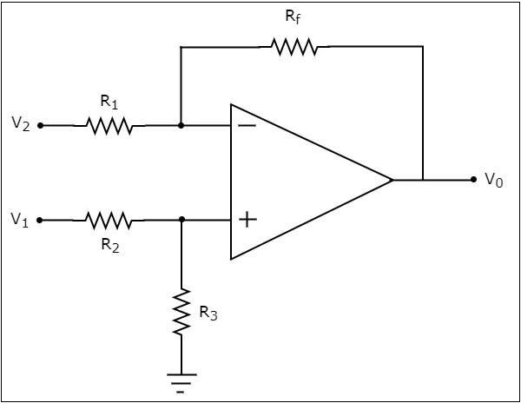Figure 1

Figure 2 shows the circuit connection for two input subtractor configuration for DC input and Figure 3 shows the configuration for AC input on multisim simulating application.

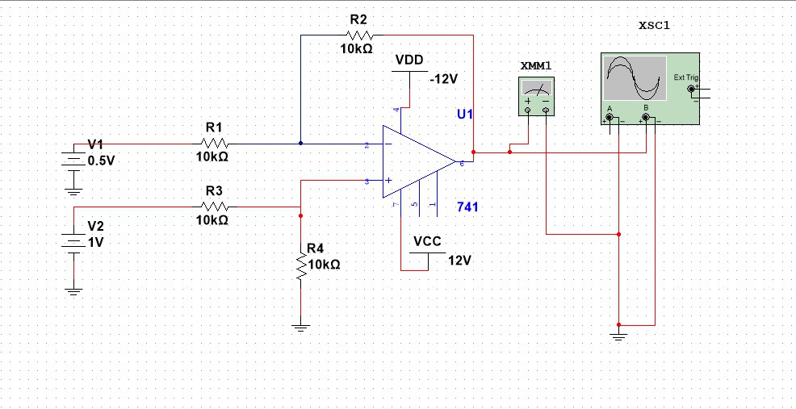Figure 2

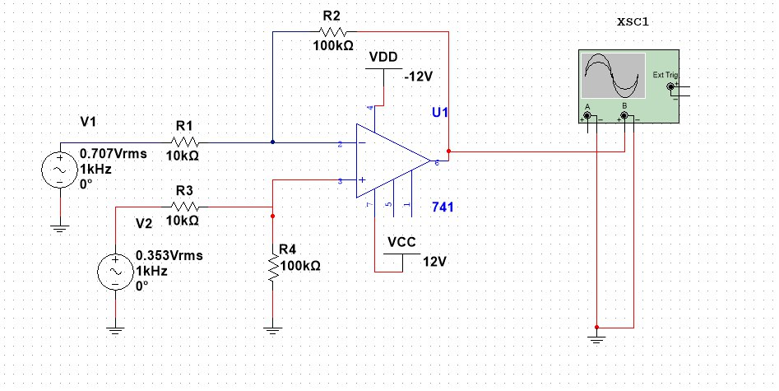Figure 3

- Theory
A modern op-amp has hundreds of transistors integrated on a single chip, It is not necessary to understand how the internal circuitry works in order to use the op-amp; it can be treated as a “black-box” device.
The symbol for an 741 op-amp is shown in figure 1, This is the most basic op-amp symbol with five terminals comprised of positive (non-inverting) and negative (inverting) inputs; V+ and V- supply terminals; and one output.
All equations that describe the behavior of op-amp circuits rely on certain assumptions about the op-amp. These assumptions about an ideal op-amp are summarized in table 1 and compared to the real op-amp used in this lab, the 741.
A modern op-amp approaches an ideal op-amp when used within its bandwidth and output limitations. For non-critical applications the ideal op-amp assumptions are valid.
In the case of the 741 as long as the device is operated at low frequencies and does not exceed its rated output voltage and current limits the ideal assumptions are valid.
Parameter | Ideal Op-Amp | 741
R_{in} | Infinite | 2MΩ
Open loop Gain | Infinite | 200,000
Bandwidth | Infinite | 1MHz
Voltage Output | Infinite | +/- 15.0V
Current Output | Infinite | 25mA
R_{O} | Zero | 75Ω
Input Offset Voltage | Zero | 1mV
Input Bias Current | Zero | 0.2nA
Table 1

The behavior of an op-amp can be described by two rules:
- An op-amp will attempt to make the voltage at both its inputs equal through the use of a feedback path.
- No current can flow through inputs terminals.

Now by connected the 741 as shown in figure 1, we will get the subtractor operation amplifier configuration and this configuration has a negative gain and negative feedback loop and this configuration can subtract two input voltage together and for this configuration the input/output relationship is
given by:

Formula 1

in case of R₁ equal R₂ and R₃ equal R₄ the output will given by the Formula 2:

Formula 2

- Observation Data

- Simulation Readings
Table 2 shows all the readings that we got from the simulation using different values of R₂ and different input voltages.
V₁(v) | V₂(V) | R₁(kΩ) | R₃(kΩ) | R₂(kΩ) | V_{o-real}(v) | V_{o-sim}(v) | F(Hz) | Error(%)
0.1 | 0.1 | 10 | 10 | 10 | -0.2 | -0.1999 | 1000 | 0.005
0.5 | 0.5 | 10 | 10 | 10 | -1 | -0.9999 | 1000 | 0.003
1 | 1 | 10 | 10 | 10 | -2 | -2 | 1000 | 0
2 | 2 | 10 | 10 | 10 | -4 | -4 | 1000 | 0
5 | 5 | 10 | 10 | 10 | -10 | -9.9999 | 1000 | 0.010
10 | 10 | 10 | 10 | 10 | -20(cut) | -12.493 | 1000 | 37.535
0.1 | 0.1 | 10 | 10 | 100 | -2 | -1.999 | 1000 | 0.005
0.5 | 0.5 | 10 | 10 | 100 | -10 | -9.9960 | 1000 | 0.040
Table 2

Table 3 shows the Frequency Response for the 741 operational amplifier.

V₁(v) | V₂(V) | R₁(kΩ) | R₃(kΩ) | R₂(kΩ) | F(Hz) | V_{o-real}(v)
0.5 | 0.5 | 10 | 10 | 10 | 10 | 1.0010
0.5 | 0.5 | 10 | 10 | 10 | 100 | 0.9999
0.5 | 0.5 | 10 | 10 | 10 | 100 | 0.9999
0.5 | 0.5 | 10 | 10 | 10 | 100k | 0.6957
0.5 | 0.5 | 10 | 10 | 10 | 1M | 0.0710
0.5 | 0.5 | 10 | 10 | 10 | 10M | 0.0077
Table 3

- Oscilloscope output
The Figure 3 shows the input signal and the summing output signal on
the Oscilloscope.

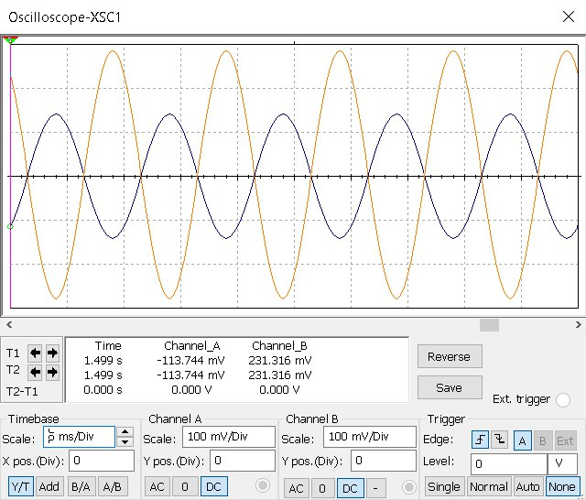Figure 4: input and output signals

The Figure 4 shows the input signal and Saturated Output signal.

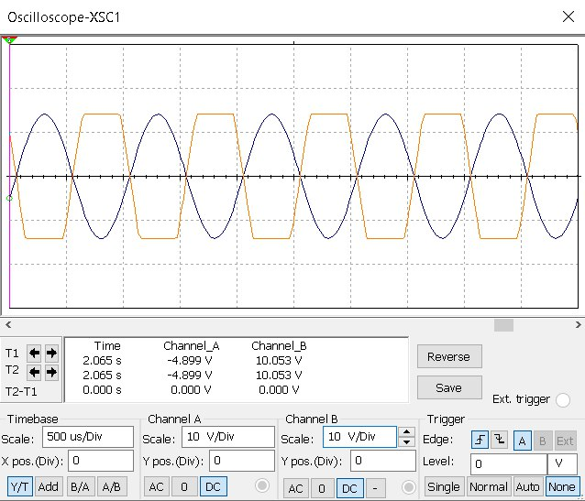Figure 5: Saturated output Signal

The Figure 5 shows the input signal and zero Output signal when both switches are open

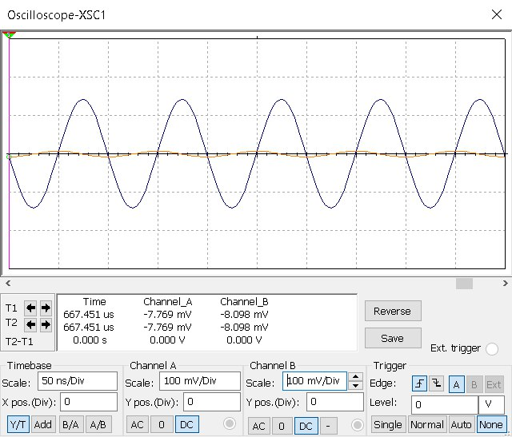Figure 6: Both Switches are Opened

- Multimeter output

The Figure 6 shows the Output signal Voltage value.

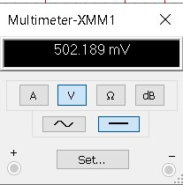Figure 7: Both Switches are Closed

The Figure 6 shows the Output signal Voltage value when the input voltages are equal.

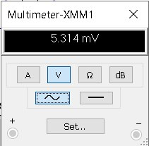Figure 8: Both Switches are Opened

- Graphs
The Figure 5 shows the graph between Theoretical Output and Actual Output.

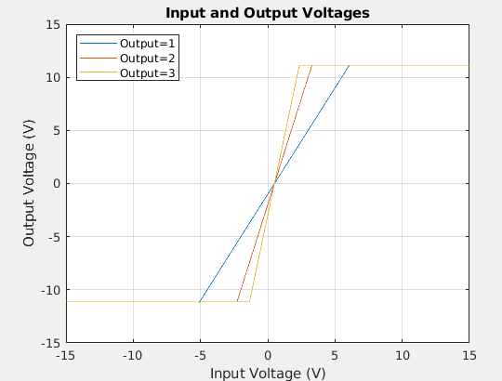Figure 9: Theoretical Output and Actual Output

The Figure 10 shows the output for different values of inputs.

Figure 10

The Figure 11 shows the Frequency Response for 741 op-amp in summing
configuration
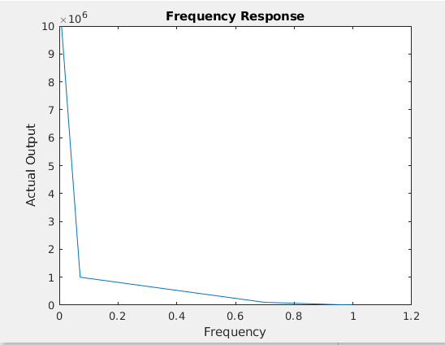Figure 11: Frequency Response

- Analysis
From the readings that we got from simulating and showed in Table 2 we can see that the output depend on input and we can change the Gain by changing the Value R₃ and R₁ and we can see that we can’t get the Theoretical output voltage because there is an Output Resistance For operational amplifier and its value shown in Table 1.
If we see the Figure 4 we can notice that we got a cutting on output signal and that happened because the Amplified signal is Limited to the supply inputs voltages (+Vcc / -Vdd) and we can avoid that by increasing the input voltages but notice that we got a maximum value of input voltages for IC-741 as shown in Table 1, and from the Figure 3 we can see that output signal is the difference between the two input signals and the output is out-phase (negative-gain).

- Conclusion
From this experiment we can see that the subtractor configuration provides a simple way to subtract two input voltage signals with negative fixed gain that can choose its value by changing R₂ and R₃ Resistors.
And also we see one of the limitation of the summing and its Limited input voltage range, and the Frequency limit and slewing-rate limit.

- Resources
All the Resources for this experiment including the pdf file and the simulation file and MATLAB scripts and pictures and etc…, are available on Github Repository just scan the next QR Code to get the link for that Repository.


Scan Here

