
Sabratha University
Engineering Faculty Sabratha
EEE-Departmant

Differentiator Operational Amplifier

Author: Nedal Abdullah
ID: 1611100336

- Objectives
The objective of this experiment is to study and simulating differentiator configuration of 741 operational-amplifier using multisim simulating kit.

- Equipment
  - Oscilloscope
  - Capacitors
  - AC Source
  - Vcc (+15v)
  - Vdd (-15v)
  - IC-741
  - Resistors(1kΩ, 2kΩ, 3kΩ, 4kΩ)

- Circuit Diagram
Figure 1 shows the circuit diagram for two input differentiator configuration.
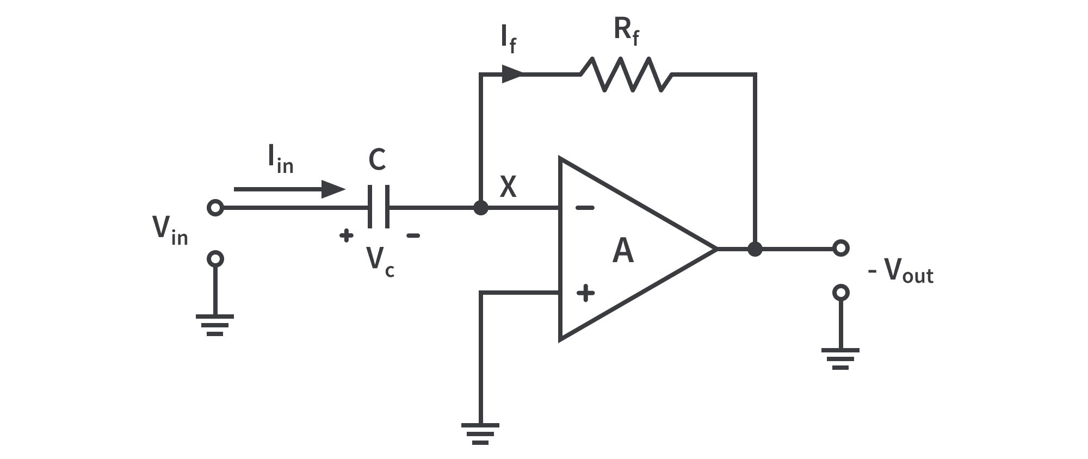Figure 1

Figure 2 shows the circuit connection for differentiator configuration.

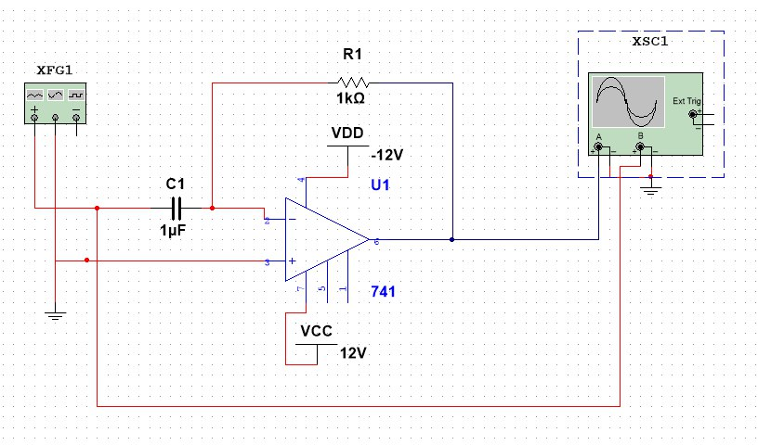Figure 2

- Theory
A modern op-amp has hundreds of transistors integrated on a single chip, It is not necessary to understand how the internal circuitry works in order to use the op-amp; it can be treated as a “black-box” device.
The symbol for an 741 op-amp is shown in figure 1, This is the most basic op-amp symbol with five terminals comprised of positive (non-inverting) and negative (inverting) inputs; V+ and V- supply terminals; and one output.
All equations that describe the behavior of op-amp circuits rely on certain assumptions about the op-amp. These assumptions about an ideal op-amp are summarized in table 1 and compared to the real op-amp used in this lab, the 741.
A modern op-amp approaches an ideal op-amp when used within its bandwidth and output limitations. For non-critical applications the ideal op-amp assumptions are valid.
In the case of the 741 as long as the device is operated at low frequencies and does not exceed its rated output voltage and current limits the ideal assumptions are valid.
Parameter | Ideal Op-Amp | 741
R_{in} | Infinite | 2MΩ
Open loop Gain | Infinite | 200,000
Bandwidth | Infinite | 1MHz
Voltage Output | Infinite | +/- 15.0V
Current Output | Infinite | 25mA
R_{O} | Zero | 75Ω
Input Offset Voltage | Zero | 1mV
Input Bias Current | Zero | 0.2nA
Table 1

The behavior of an op-amp can be described by two rules:
- An op-amp will attempt to make the voltage at both its inputs equal through the use of a feedback path.
- No current can flow through inputs terminals.

Now by connected the 741 as shown in figure 1, we will get the differentiator operation amplifier configuration and this configuration has a negative gain and negative feedback loop and this configuration can differential input voltage and for this configuration the input/output relationship is
given by:

Formula 1

- Oscilloscope output
The Figure 3 shows the output where the input is Sine wave, where the input is the red and output is blue.

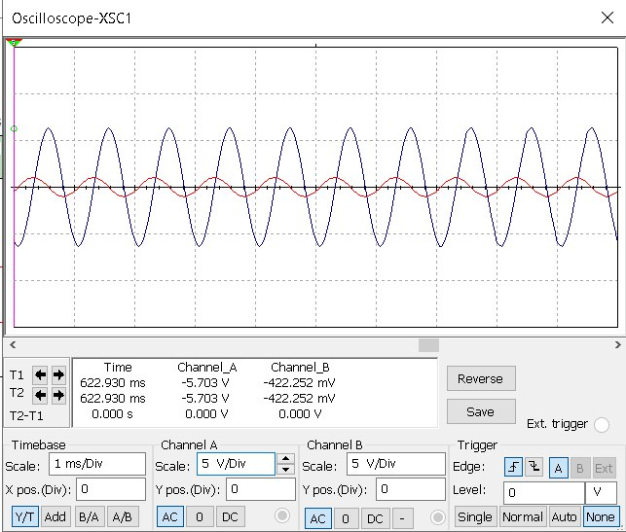Figure 3: sine input

The Figure 4 shows the output where the input is Square wave, where the input the red and output is blue.
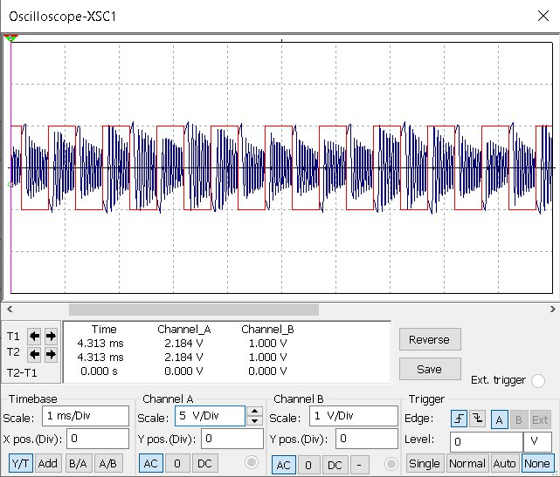Figure 4: Square input

The Figure 5 shows the output where the input is Triangular wave, where the input the red and output is blue.

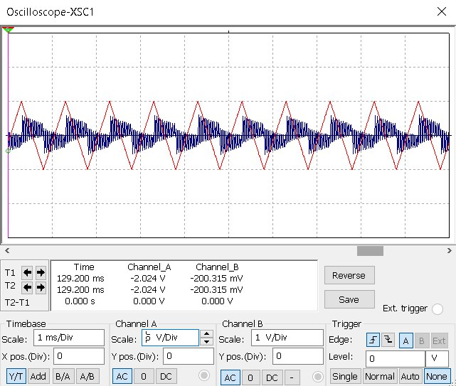Figure 5: Triangular input

- Analysis
From the output that we got from simulating and showed in Figures we can see that the output depend on input and we can change the Gain by changing the Value R and C and we can see that we can’t get the Theoretical output voltage because there is an Output Resistance For operational amplifier and its value shown in Table 1.
From the Figures we can see that output signal is the differential of the input Signal and the output is out-phase (negative-gain).

- Conclusion
From this experiment we can see that the differentiator configuration provides a simple way to differential input voltage signals with negative fixed gain that can choose its value by changing R and C.
And also we see one of the limitation of the summing and its Limited input voltage range, and the Frequency limit and slewing-rate limit.

