

**Sabratha University**

**Engineering Faculty Sabratha**

**EEE-Departmant**

**Non-Inverting Operational Amplifier**

Author: Nedal Abdullah

ID: 1611100336

1. **Objectives**

The objective of this experiment is to study and simulating non-inverting configuration of 741 operational-amplifier using multisim simulating kit.

1. **Equipment**
   1. Oscilloscope
   2. Function-generator
   3. Vcc (+12v)
   4. Vdd (-12v)
   5. IC-741
   6. Resistors(1kΩ, 2kΩ, 3kΩ, 4kΩ)
2. **Circuit Diagram**

Figure 1 shows the circuit diagram for non-inverting configuration.

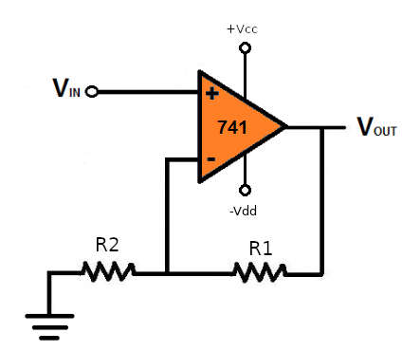Figure 1

Figure 2 shows the circuit connection for non-inverting configuration on multisim simulating application.

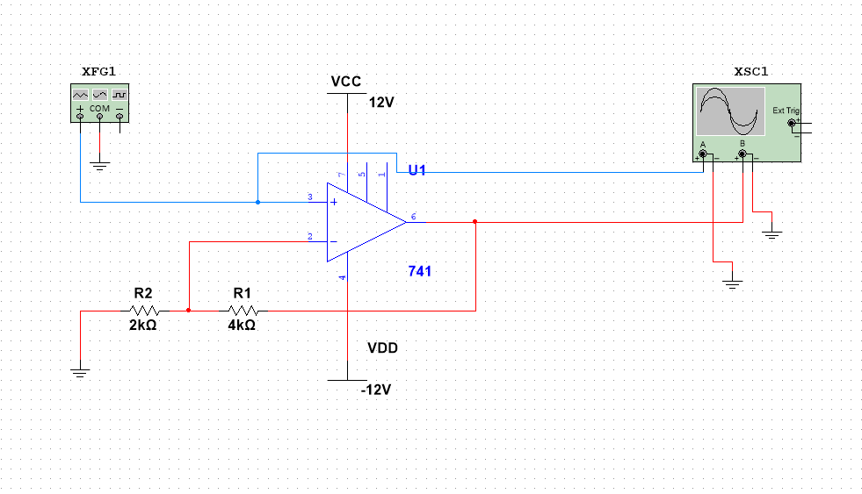Figure 2

1. **Theory**

A modern op-amp has hundreds of transistors integrated on a single chip, It is not necessary to understand how the internal circuitry works in order to use the op-amp; it can be treated as a “black-box” device.

The symbol for an 741 op-amp is shown in figure 1, This is the most basic op-amp symbol with five terminals comprised of positive (non-inverting) and negative (inverting) inputs; V+ and V- supply terminals; and one output.

All equations that describe the behavior of op-amp circuits rely on certain assumptions about the op-amp. These assumptions about an ideal op-amp are summarized in table 1 and compared to the real op-amp used in this lab, the 741.

A modern op-amp approaches an ideal op-amp when used within its bandwidth and output limitations. For non-critical applications the ideal op-amp assumptions are valid.

In the case of the 741 as long as the device is operated at low frequencies and does not exceed its rated output voltage and current limits the ideal assumptions are valid.

|  |  |  |
| --- | --- | --- |
| Parameter | Ideal Op-Amp | 741 |
| Rin | Infinite | 2MΩ |
| Open loop Gain | Infinite | 200,000 |
| Bandwidth | Infinite | 1MHz |
| Voltage Output | Infinite | +/- 15.0V |
| Current Output | Infinite | 25mA |
| RO | Zero | 75Ω |
| Input Offset Voltage | Zero | 1mV |
| Input Bias Current | Zero | 0.2nA |

Table 1

The behavior of an op-amp can be described by two rules:

1. An op-amp will attempt to make the voltage at both its inputs equal through the use of a feedback path.
2. No current can flow through inputs terminals.

Now by connected the 741 as shown in figure 1, we will get the non-inverting operation amplifier configuration and this configuration has a positive gain and negative feedback loop and for this configuration the input/output relationship is

given by:

$Vo=(1+\frac{R1}{R2})Vi$ Formula 1

and Transfer function is given by:

$G=1+\frac{R1}{R2}$ Formula 2

1. **Observation Data**

* **Simulation Readings**

table 2 shows all the readings that we got from the simulation using different values of R1 and R2 and different input voltages.

|  |  |  |  |  |  |  |  |  |
| --- | --- | --- | --- | --- | --- | --- | --- | --- |
| R1(kΩ) | R2(kΩ) | F(Hz) | Vi1(v) | Vo1(v) | Vi2(v) | Vo2(v) | Vi3(v) | Vo3(v) |
| 1 | 1 | 1 | 1 | 1.994 | 2 | 3.986 | 3 | 5.983 |
| 2 | 1 | 1 | 1 | 2.992 | 2 | 5.974 | 3 | 8.972 |
| 3 | 1 | 1 | 1 | 3.992 | 2 | 7.966 | 3 | 11.115 |
| 4 | 1 | 1 | 1 | 4.990 | 2 | 9.920 | 3 | 11.115 |
| 1 | 2 | 1 | 1 | 1.496 | 2 | 2.993 | 3 | 4.500 |
| 2 | 2 | 1 | 1 | 1.997 | 2 | 3.987 | 3 | 5.973 |
| 3 | 2 | 1 | 1 | 2.497 | 2 | 4.991 | 3 | 7.475 |
| 4 | 2 | 1 | 1 | 2.994 | 2 | 6.001 | 3 | 8.972 |

Table 2

Table 3 shows both the theoretical Gain calculated using the Formula 1 and the Actual gain for the Table 2 and Averaged Gain error.

|  |  |  |
| --- | --- | --- |
| Theoretical Gain | Actual Gain | Error (%) |
| 2 | 1.993 | 0.35 |
| 3 | 2.989 | 0.36 |
| 4 | 3.898 | 2.55 |
| 5 | 4.551 | 8.98 |
| 1.5 | 1.497 | 0.20 |
| 2 | 1.993 | 0.35 |
| 2.5 | 2.494 | 0.24 |
| 3 | 2.995 | 0.16 |

Table 3

* **Oscilloscope output**

The Figure 3 shows the input signal and the amplified output signal on

the Oscilloscope.

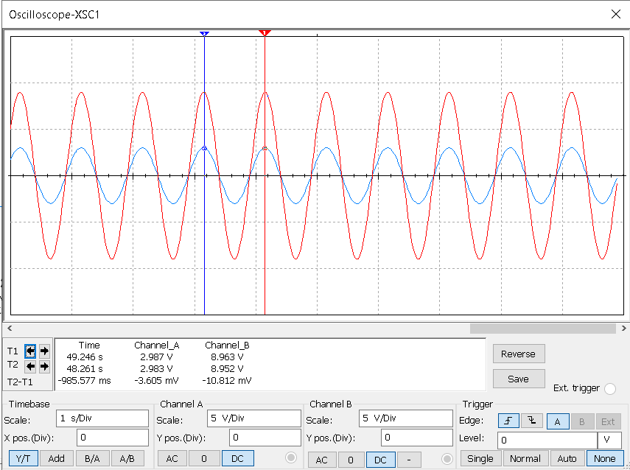Figure 3: input and output signals

The Figure 4 shows the input signal and Saturated Output signal.

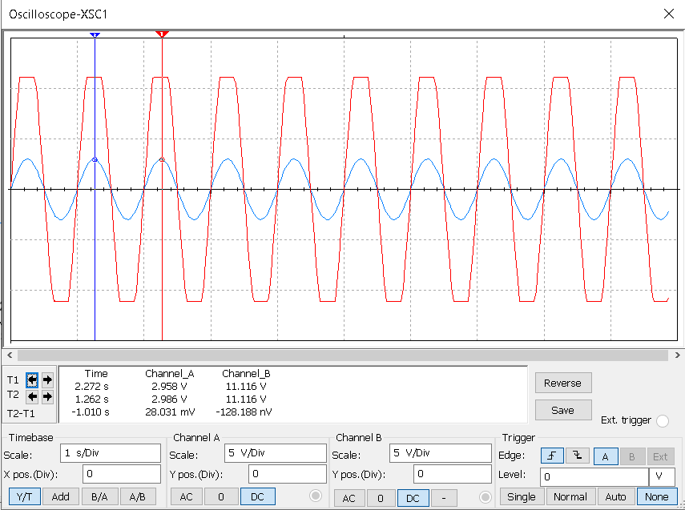Figure 4: Saturated output Signal

1. **Graphs**

The Figure 5 shows the graph between Theoretical Gain and Actual Gain.

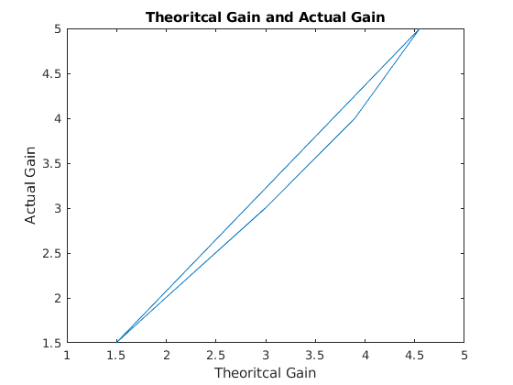Figure 5: Theoretical Gain and Actual Gain Graph

The Figure 6 shows the input and output for different values of Gain.

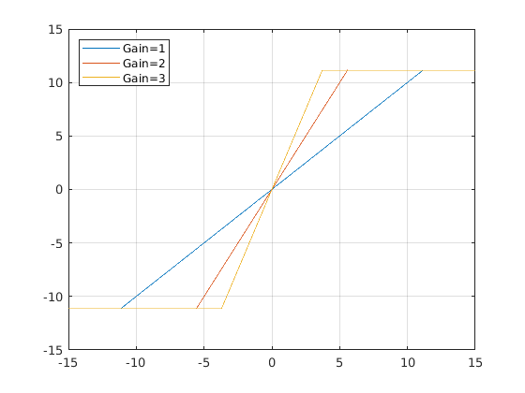Figure 6: Input and Output Voltages

1. **Analysis**

From the readings that we got from simulating and showed in Table 2 we can see that the output depend on input and we can change the Gain by changing the Values of the R1 and R2  and we can see that we can’t get the Theoretical output voltage because there is an Output Resistance For operational amplifier and its value shown in Table 1.

If we see the Figure 4 we can notice that we got a cutting on output signal and that happened because the Amplified signal is Limited to the supply inputs voltages (+Vcc / -Vdd) and we can avoid that by increasing the input voltages but notice that we got a maximum value of input voltages for IC-741 as shown in Table 1, and from the Figure 3 we can see that output signal is amplified and its in-phase (positive-gain).

1. **Conclusion**

From this experiment we can see that the non-inverting configuration provides a simple way to amplify a voltage signal with positive fixed gain that can choose its value by changing the R1 and R2 Resistors.

And also we see one of the limitation of the non-inverting and its Limited input voltage range.

1. **Resources**

All the Resources for this experiment including the pdf file and the simulation file and MATLAB scripts and pictures and etc…, are available on Github Repository just scan the next QR Code to get the link for that Repository.

