
Sabratha University
Engineering Faculty Sabratha
EEE-Departmant

Resistors in Parallel (Current-Divider)

Author: Nedal Abdullah
ID: 1611100336

- Objectives
The objectives of this experiment is to calculate the current on the resistors that connected in parallel using DMM and compared with the theoretical calculated values.
- Equipment
- power supply
- Resistors (220Ω, 47Ω)
- Wires
- DMM
- Connection Board

- Circuit Diagram
The Figure 1 shows the circuit diagram for this experiment.

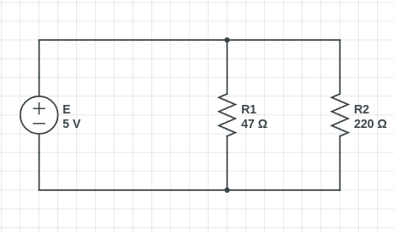Figure 1

- Theory
Resistors are said to be connected in "Parallel", when both of their terminals are respectively connected to each terminal of the other resistor or resistors.
Since all the the voltage drop across all the resistors in parallel is the same Then, resistors in parallel have a common Voltage drop on them so the voltage in all resistors is equal.

But the current across each resistor is different for the case of resistors in parallel
And the values of the current for each resistor is given by the Current Divider rule
and this rule is shown in the Formula 1 for I₁ and Formula 2 for I₂ .

Formula 1
Formula 2

- Procedures
- connect the circuit on the connection board as shown in the Figure 1.
- power-off the power supply.
- set the DMM in Ameter mode by moving the DMM rotary to “A” and make sure it is on “200mA” mode.
- Connect the DMM with series wit the resistors as shown in Figure 2 where the positive side goes to the “A” in the DMM and the negative side goes to the “COM” in the DMM.
- close the circuit with the wires.
- power-on the power supply.
- write down the readings from the DMM.
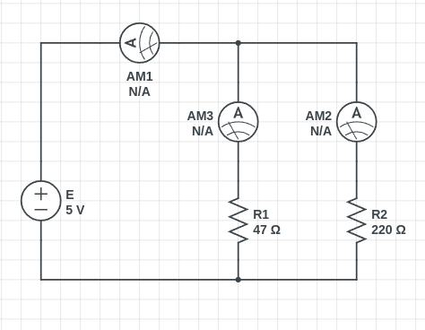Figure 2

- Observation Table
The Table 1 contain the measured readings and the theoretical values and the error percentage for readings for I.

Measured-Reading(mA) | Theoretical-Values(mA) | Error(%)
124.2 | 129.1 | 3.80
Table 1

The Table 2 contain the measured readings and the theoretical values that been calculated using the Formula 1 and the error percentage for readings for I₁ .

Measured-Reading(mA) | Theoretical-Values(mA) | Error(%)
102.8 | 106.4 | 3.40
Table 2

The Table 3 contain the measured readings and the theoretical values that been calculated using the Formula 2 and the error percentage for readings for I₂ .

Measured-Reading(mA) | Theoretical-Values(mA) | Error(%)
22.6 | 22.7 | 0.44
Table 3

- Conclusion
we can conclude from our results that if we connect the resistors in parallel the current on those resistors will be divided where the greater resistor will got the lowest current value while the smaller resistor will got the higher current value and we got a good error percentage values for this experiment around (0.44% ~ 3.80%).

- Resources
All the Resources for this experiment including the pdf file and the pictures and etc…, are available on Github Repository just scan the next QR Code to get the link for that Repository.



Scan Here

