
Sabratha University
Engineering Faculty Sabratha
EEE-Departmant

Ohm’s Law

Author: Nedal Abdullah
ID: 1611100336

- Objectives
The objectives of this experiment is to calculate the voltage and current on the resistor that connected using DMM and compared with the theoretical calculated values, and verify that the voltage and current are directly proportional to each other.
- Equipment
- Variable DC Power supply
- Resistor (220Ω)
- Wires
- DMM
- Connection Board

- Circuit Diagram
The Figure 1 shows the circuit diagram for this experiment.

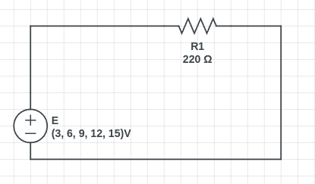Figure 1

- Theory
Ohm’s law is the fundamental law of Electrical Engineering. It relates the current flowing through any resistor to the voltage applied to its ends. According to the statement: The current flowing through a constant resistor is directly proportional to the voltage applied to its ends.
And the ohm’s law can be described mathematically as shown in Formula 1:

Formula 1

- Procedures
- connect the circuit on the connection board as shown in the Figure 1.
- power-off the power supply.
- set the DMM in Ammeter mode by moving the DMM rotary to “A” and make sure it is on “200 mA” mode.
- Connect the DMM with series with the resistor as shown in Figure 2 where the positive side goes to the “A” in the DMM and the negative side goes to the “COM” in the DMM.
- close the circuit with the wires.
- power-on the power supply.
- write down the readings from the DMM and the power supply voltage.
- Change the power supply voltage to the next value.
- Repeat from 7 and 8 until you test all the require voltages.

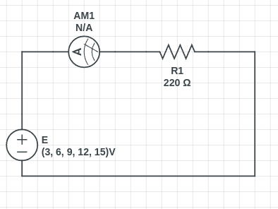Figure 2

- Observation Table
The Table 1 contain the measured readings and the theoretical values that been calculated using the Formula 1 and the error percentage for the current.
Measured-Reading(V) | Measured Reading(I mA) | Theoretical-Values(V) | Theoretical-Values(I mA) | Error(%)
3 | 14.1 | 3 | 13.6 | 3.67
6 | 27.5 | 6 | 27.2 | 1.10
9 | 40.8 | 9 | 40.9 | 0.24
12 | 54.3 | 12 | 54.5 | 0.36
15 | 67.8 | 15 | 68.1 | 0.44
Table 1

- Graph
The Figure 3 shows the Relationship between the current and voltage on ohm’s law.

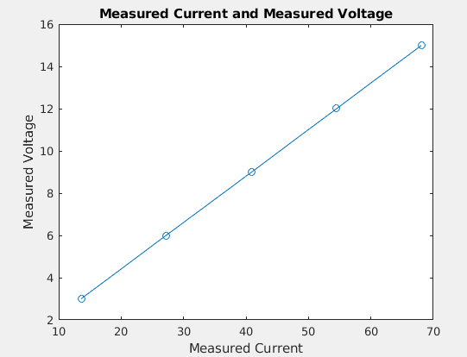Figure 3

- Conclusion
We conclude that current and voltage hold a direct relationship for resistive components. (They are linearly proportional).
And in this experiment we got a good error percentage values for this experiment around (0.24% ~ 3.67%).

- Resources
All the Resources for this experiment including the pdf file and the pictures and etc…, are available on Github Repository just scan the next QR Code to get the link for that Repository.



Scan Here

