
Sabratha University
Engineering Faculty Sabratha
EEE-Departmant

Resistors in Series (Voltage-Divider)

Author: Nedal Abdullah
ID: 1611100336

- Objectives
The objectives of this experiment is to calculate the voltage on the resistors that connected in series using DMM and compared with the theoretical calculated values.
- Equipment
- power supply
- Resistors (220Ω, 150Ω)
- Wires
- DMM
- Connection Board

- Circuit Diagram
The Figure 1 shows the circuit diagram for this experiment.

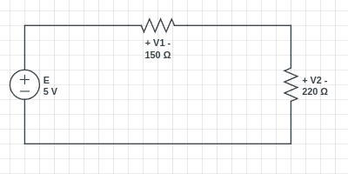Figure 1

- Theory
Resistors are said to be connected in "Series", when they are daisy chained together in a single line.
Since all the current flowing through the first resistor has no other way to go it must also pass through the second resistor and the third and so on. Then, resistors in series have a Common Current flowing through them so the current in all resistors is equal.
As the resistors are connected in series the same current passes through each resistor in the chain and the total resistance, RT of the circuit must be equal to the sum of all the individual resistors added together.
But the voltage across each resistor is different for the case of resistors in series
And the values of the voltage for each resistor is given by the Voltage Divider rule
and this rule is shown in the Formula 1 for V₁ and Formula 2 for V₂ .

Formula 1
Formula 2

- Procedures
- connect the circuit on the connection board as shown in the Figure 1.
- power-off the power supply.
- set the DMM in voltmeter mode by moving the DMM rotary to “V” and make sure it is on “20 V” mode.
- Connect the DMM with parallel wit the resistors as shown in Figure 2 where the positive side goes to the “V” in the DMM and the negative side goes to the “COM” in the DMM.
- close the circuit with the wires.
- power-on the power supply.
- write down the readings from the DMM.
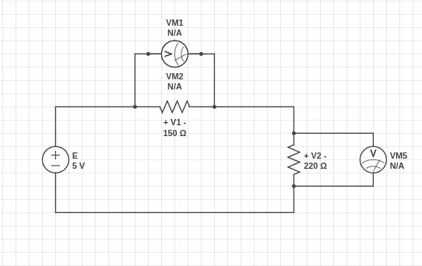Figure 2

- Observation Table
The Table 1 contain the measured readings and the theoretical values that been calculated using the Formula 1 and the error percentage for V₁.

Measured-Reading(V) | Theoretical-Values(V) | Error(%)
2.020 | 2.027 | 0.35
Table 1

The Table 2 contain the measured readings and the theoretical values that been calculated using the Formula 1 and the error percentage for V₂.

Measured-Reading(V) | Theoretical-Values(V) | Error(%)
2.940 | 2.973 | 1.11
Table 2

- Conclusion
we can conclude from our results that if we connect the resistors in series the voltage on those resistors will be divided where the greater resistor will got the higher voltage value while the smaller resistor will got the lowest voltage value and we got a good error percentage values for this experiment around (0.35% ~ 1.11%).

- Resources
All the Resources for this experiment including the pdf file and the pictures and etc…, are available on Github Repository just scan the next QR Code to get the link for that Repository.



Scan Here

