How the code of AP (TCP host) and Sta (TCP client) is transmitting/receiving data :
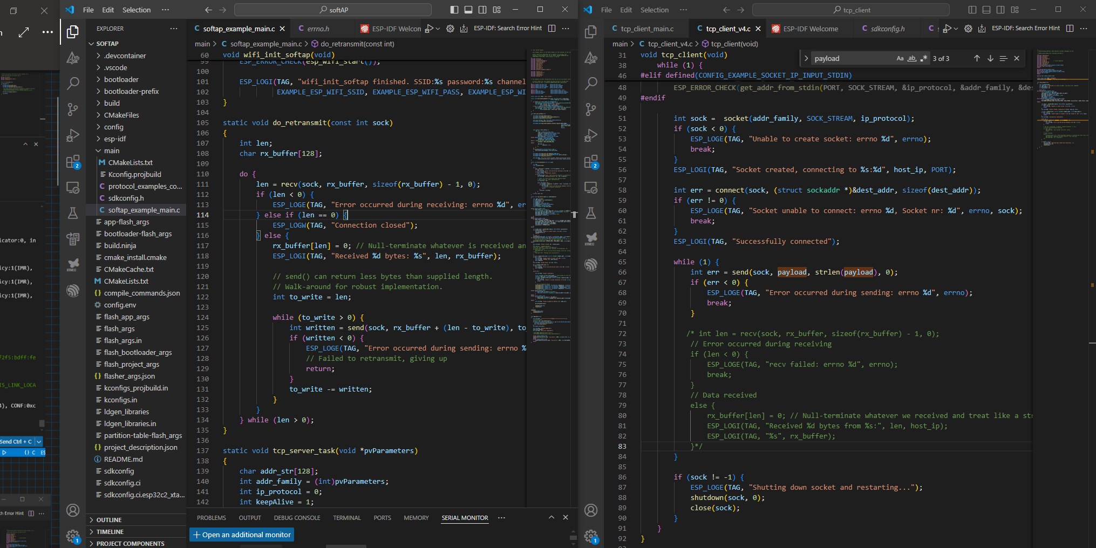
- STA (right) sends payload with send() and awaits retransmission with recv()
- AP (left) receives payload, transmits it back to STA (right)

Different scenarios when I disable certain functions :
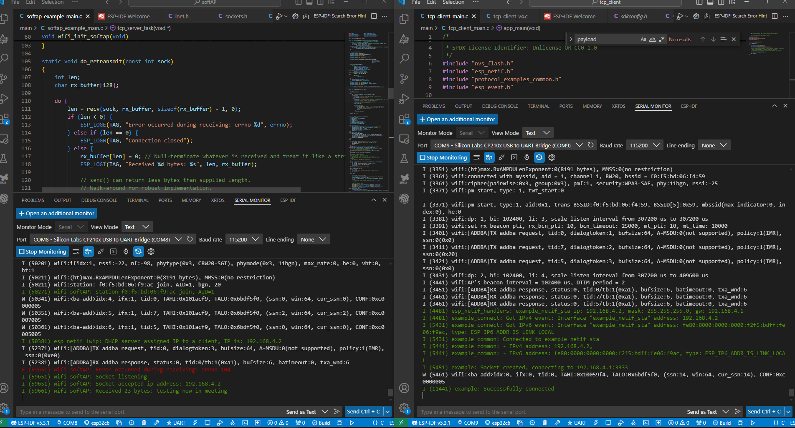
- send() of AP is disabled; we receive the payload at AP only once (I assume TCP-client on the left is waiting for a transmission that never comes)

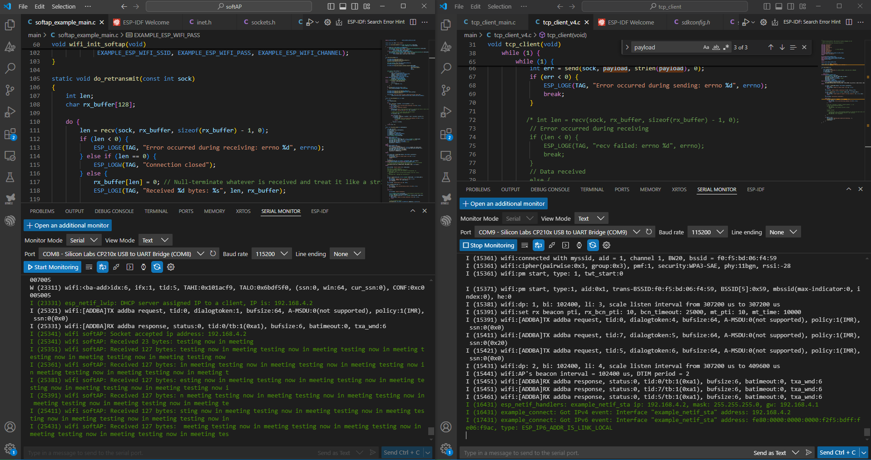
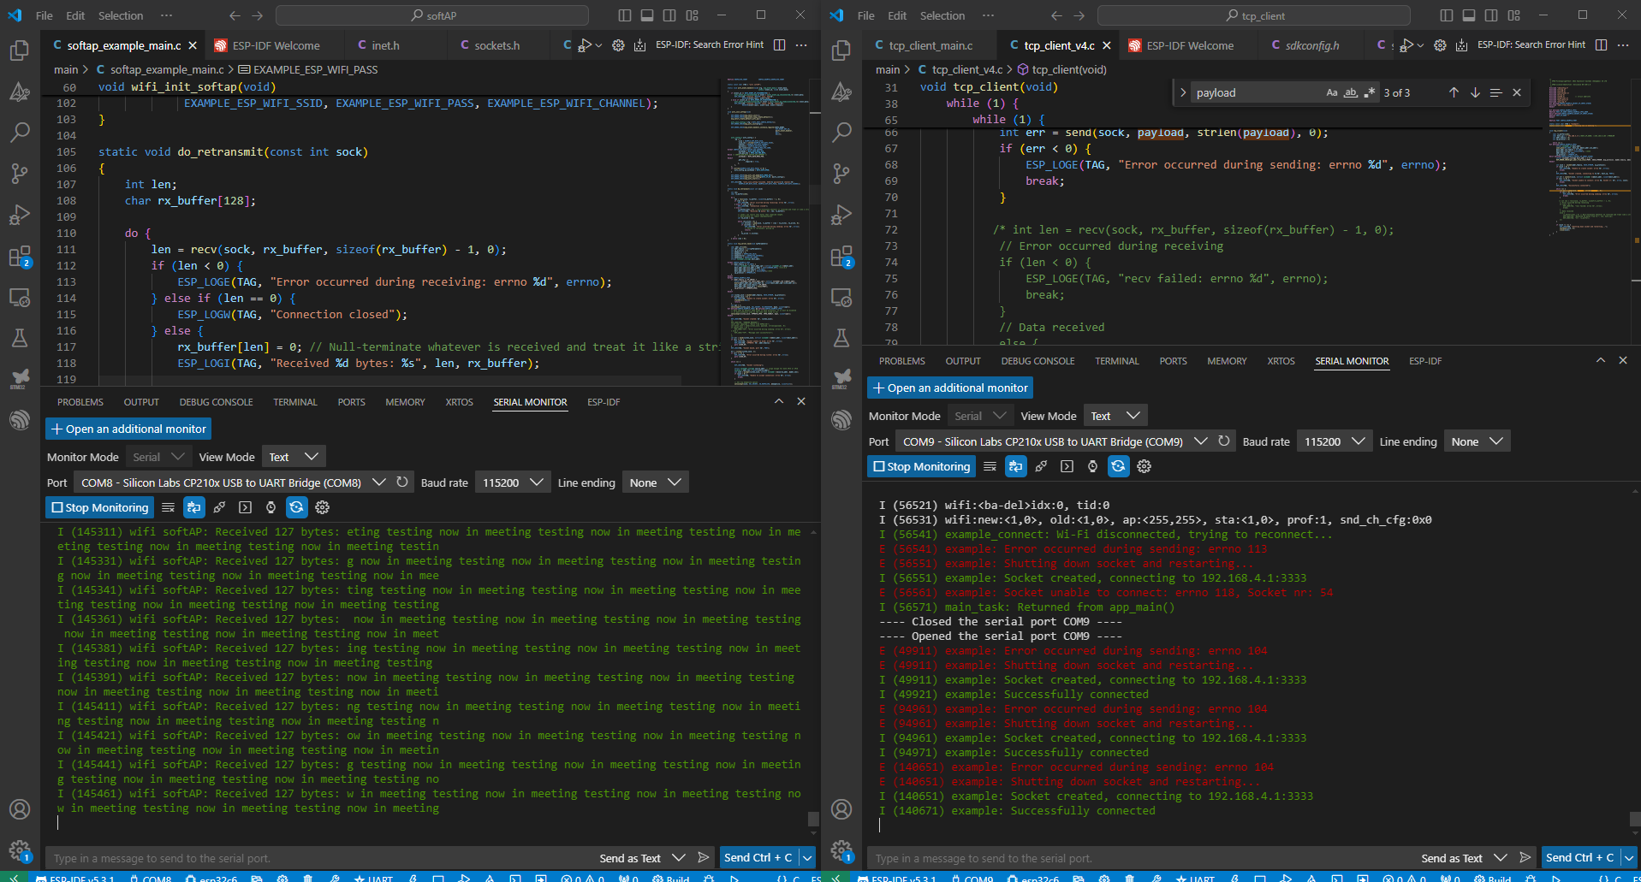
- recv() of STA is disabled ; AP receives the payload now continuously ; but in 127 byte packets, so messages are ‘cramped’ together and not separated in 23 byte transmissions
- transmission stops after a while (similar issue to iPerf throughput test)

In the serial monitors I find those errors
Apside : errno 104, 113
STA side : errno 104, 113, 118

When I leave the code with all four (recv, send) functions active it works.
Further down is a table what those numbers mean :
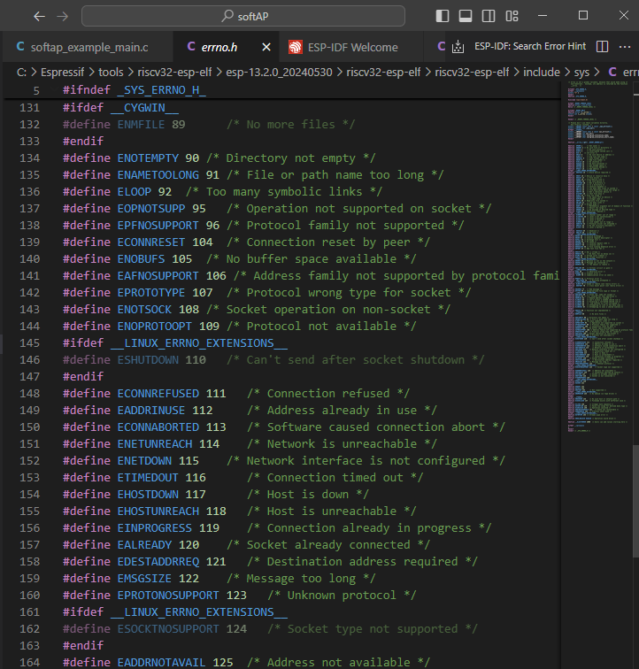
Defined errors

I also ran iPerf again and found that about 345'358 bytes get transmitted before the error occurs

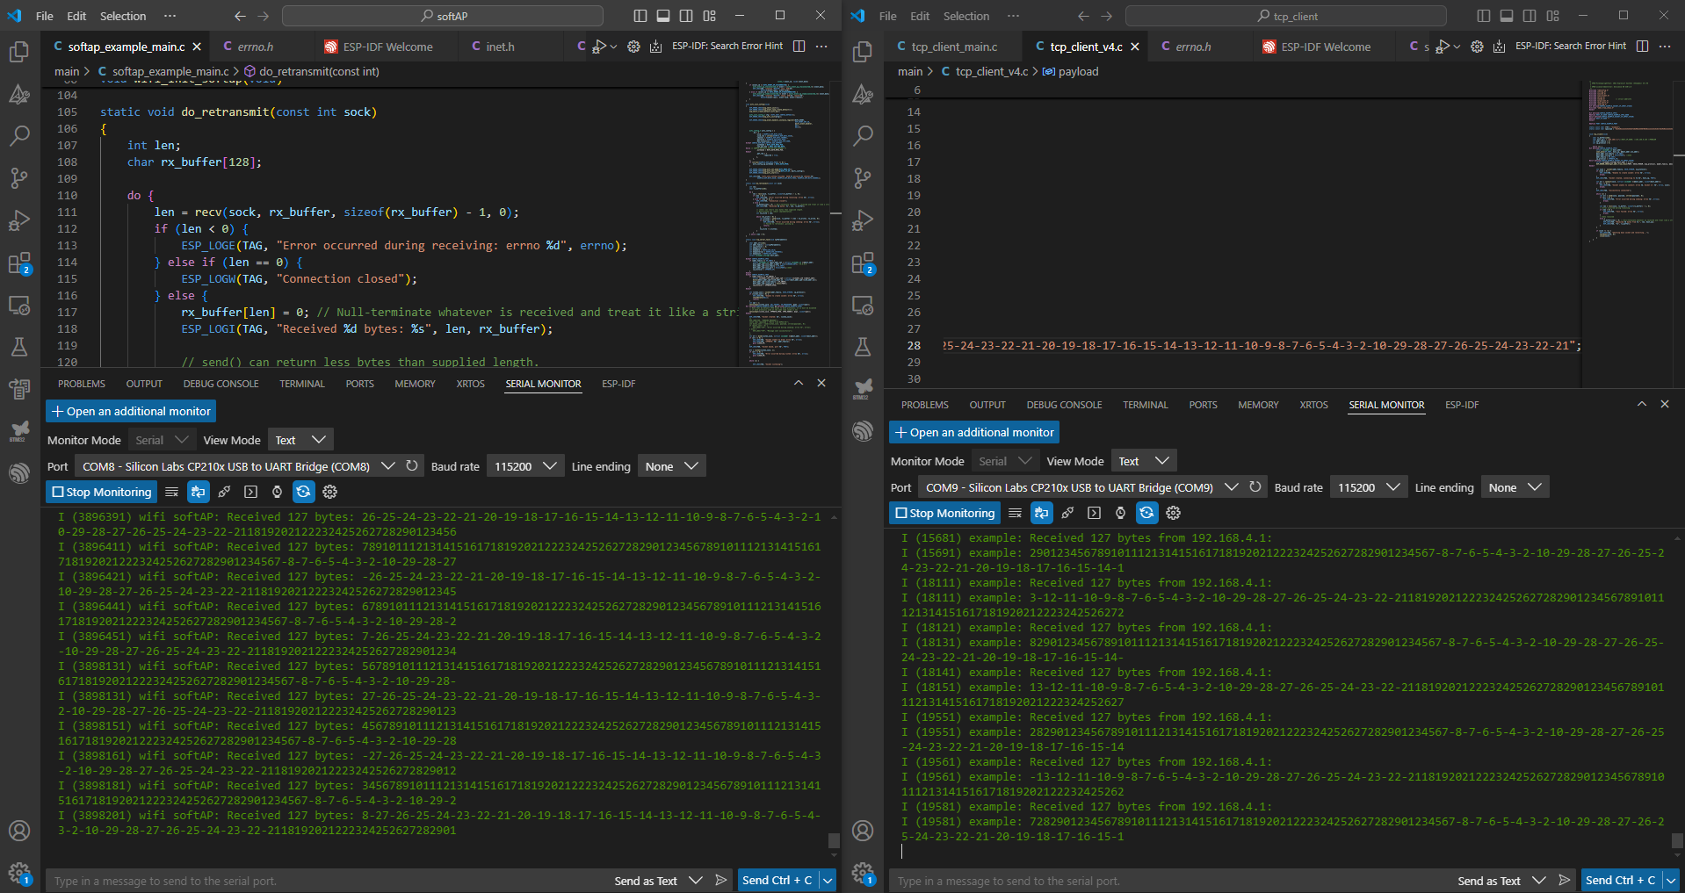
I’ve increased the payload’s size to 127 bytes (just like in iPerf). Here it also stops at some point. The state you see in the pic has been now for a while (with the previous smaller payload it never stalled)
So payload size could also be an issue

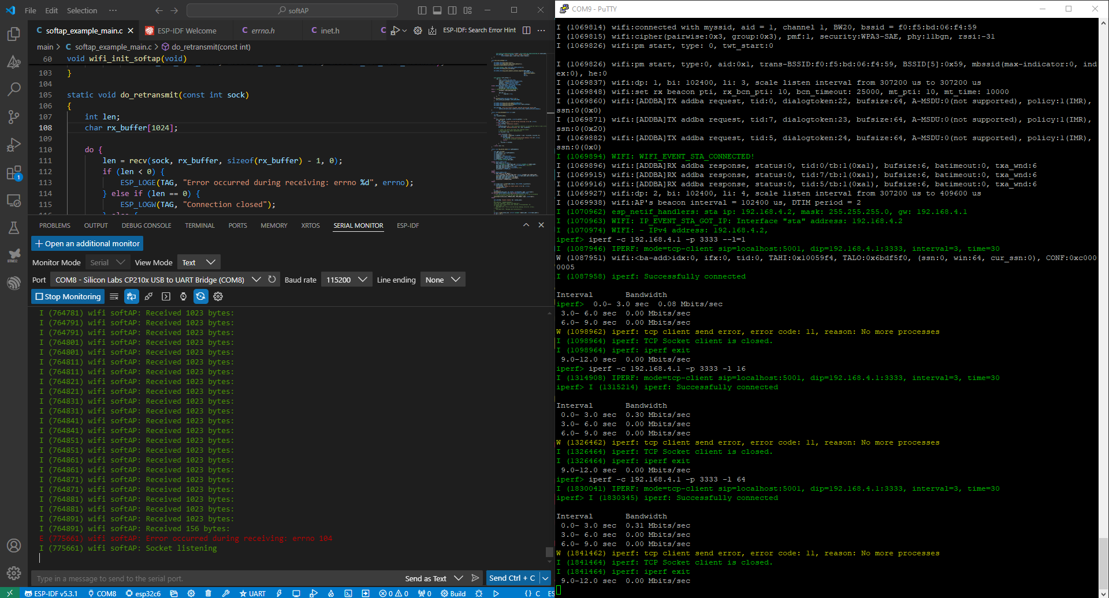
- I increased the rx_buffer’s size to 1024 (bytes) ; issue is the same
- On iPerf I tuned this parameter : (-l, --len=<length> length of buffer in bytes to write(Defaults: TCP=16384, IPv4 UDP=1470, IPv6 UDP=1450))

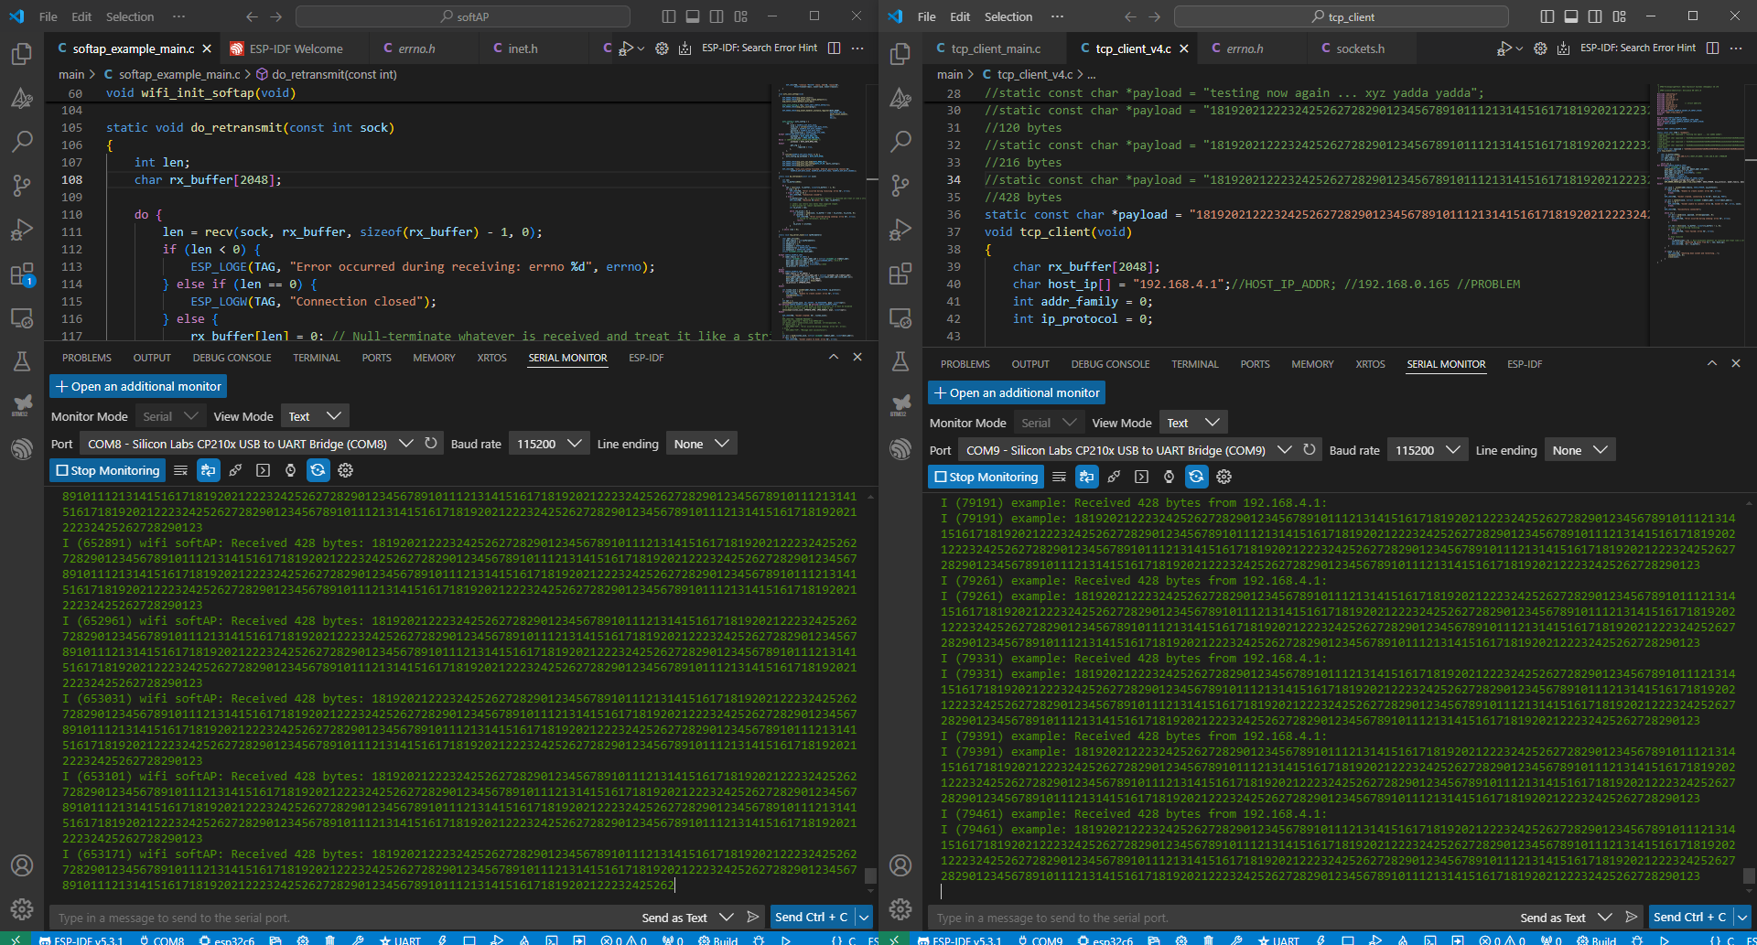
- I tested the transmission again, but now increased the rx_buffer’s sizes to 2048 (on AP/Host and STA/Client sides ; I can’t go higher, otherwise the code wouldn’t work at all ; probably the microprocessor can’t handle more)
- Sending 428 bytes continuously is no issue (steady transmission for 1 minute or so)
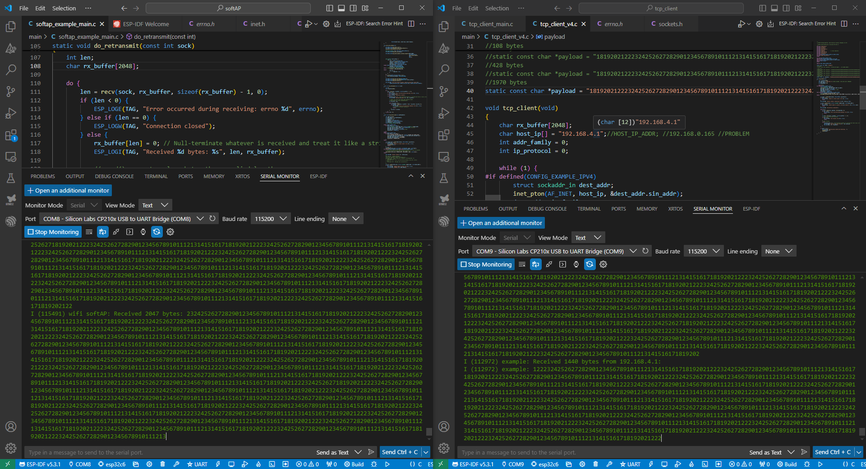
- I wanted to push it to the limit so I created a string of size 1970 bytes
- Transmission does work, continuously even (in the image it gets fragmented which wasn’t the case the first time I tried)
- There are errors though (stack overflow; see pics below); but transmissions get picked up again; therefore short breaks but communication still flows afterwards
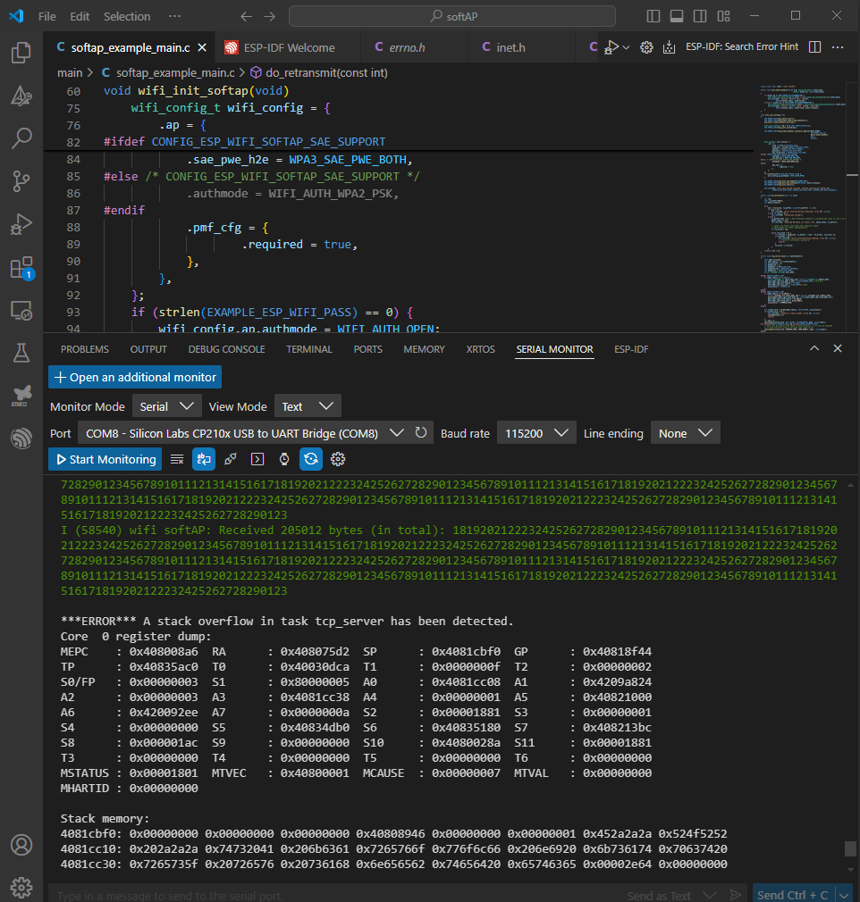
- On AP/Host side

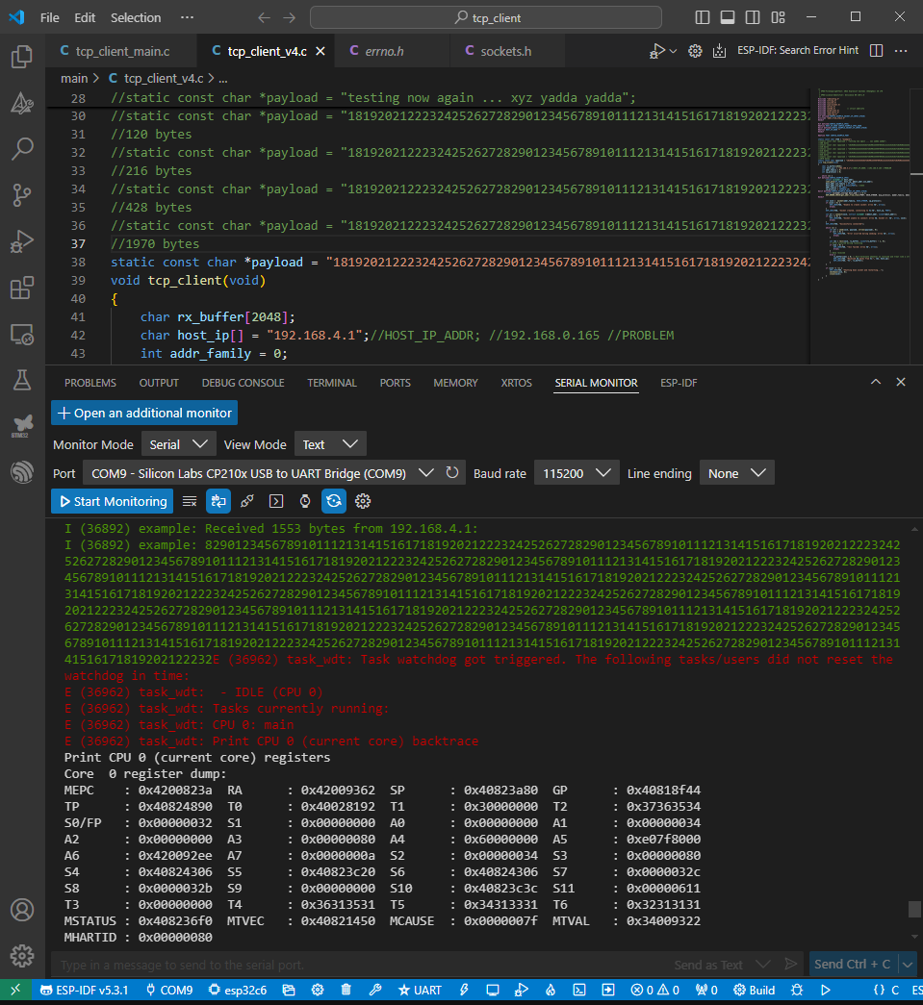
- On STA/client side

I’ve found starting/stopping serial monitoring on either side can break the transmission (error occurs and transmission stops); maybe it causes too much overhead for the microprocessor

I also tried measuring the throughput ‘by hand’ by letting the AP count the received bytes in total and measuring the time with my phone. Highest average throughput was about 10KB/s. I’m not sure if it’s representative, since the serial monitoring could slow the process down if the chip has to display each transmitted payload (display time is prob quite long).

