Detecting Fraud Signals
Case Study Team 2

Background

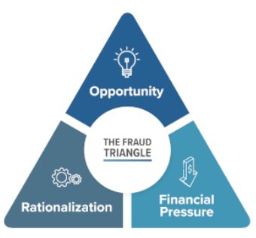
Our project “Detecting Fraud Signals in Centers for Medicaid and Medicare Services (CMS) Data using Machine Learning on Class Imbalanced Big Data” focuses on the healthcare fraud, waste and abuse that drains billions of taxpayer dollars each year and undermine the integrity of federally funded programs. Bad actors are motivated by opportunity, rationalization, and financial pressure to use healthcare as a means for fraudulent activity.
One particularly vulnerable area involves Durable Medical Equipment, Prosthetics, Orthotics, and Supplies (DMEPOS) which includes items such as wheelchairs, prosthetics, and medical supplies. DMEPOS is a frequent target of fraud and has a high improper payment rate. In Fiscal Year (FY) 2024, CMS identified $1.9 billion (21.4%) in improper payments related to DMEPOS. CMS is taking significant actions to crush fraud conducted by DMEPOS suppliers. The traditional fraud detection system takes time and relies heavily on manual audits and retrospective reviews, which are often slow, resource-intensive, and reactive rather preventive.
To assist with this problem, our approach…
…uses an analytical framework that integrates CMS DMEPOS claims, NPPES, Open Payments, the OIG Exclusion List, and U.S. Census indicators into a standardized provider–year dataset. We apply an explainable unsupervised ensemble to model baseline “normal” behavior within each specialty, then flag providers who are statistically atypical without relying on large numbers of confirmed fraud labels. Key signals include year-over-year changes, z-scored billing and payment spikes, and utilization mix patterns derived from HCPCS codes and product categories. Each provider receives a risk score by scaling and aggregating anomaly outputs across models (K-Means, LOF, Isolation Forest), producing a ranked list for triage. For transparency, the score is paired with top contributing anomaly factors and an evidence summary that documents the specific behaviors driving the flag, enabling faster, more consistent investigative prioritization.
Fig 1. Fraud triangle. Source: Fraud Conference News.

FRAUD in america
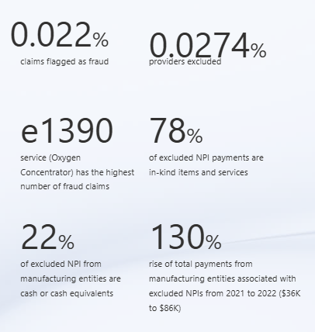
Some key findings from our data (2021-2023) are shown here.
While the statistics show that only a tiny portion of claims and providers are affected by fraud, it allows us to measure the scale and even assess the risk of the problem, highlighting the services, providers, or payment types that are most vulnerable, enabling targeted oversight.
Without these figures, it would be quite easy to underestimate the financial and patient-care impact of fraud, even if it is statistically rare, and miss patterns that could prevent and control loss.
Fig 2. Descriptive statistics on excluded providers.

Primary DMEPOS Items Targeted by EXCLUDED PROVIDERS
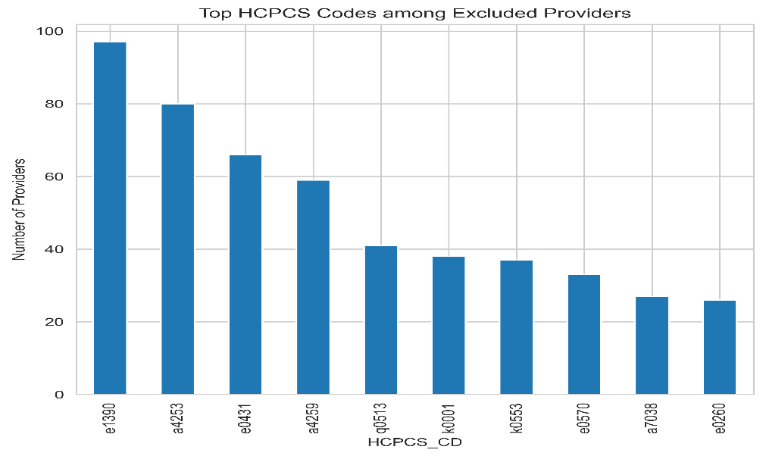
Fig 3. Descriptive statistics on excluded providers.
This visualization highlights the HCPCS codes most frequently associated with excluded referring providers. Most of these services are related to oxygen supply equipment, which is often billed monthly as rentals. This creates opportunities for fraud, either through upcoding or by failing to deliver the billed equipment.

Provider Specialties
An analysis of Medicare payment distributions shows that certain provider specialties such as interventional pain management, diagnostic radiology, and clinical cardiac electrophysiology exhibit higher median payment levels and wider variability compared to others. This elevated dispersion suggests that high-volume billing is more common in these specialties, reinforcing the need for specialty-specific peer benchmarking to distinguish legitimate high utilization from potentially abusive or anomalous billing behavior.

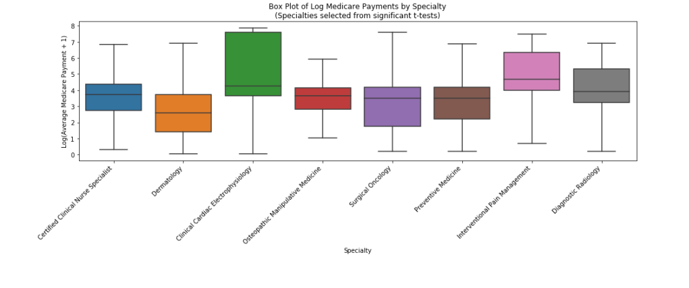
Fig 5. Boxplots by provider specialty.

following characteristics INDICATIVE OF EXCLUDED PROVIDERS
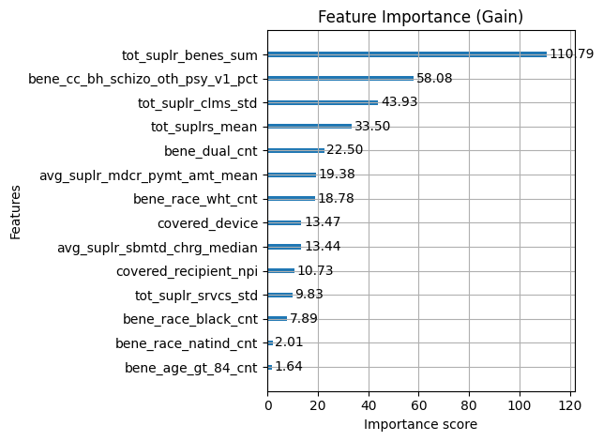
Using current machine learning methodology, we used XGBoost to rank characteristics that differentiate between OIG excluded providers and normal providers. By far, the most important feature by this metric is the sum of total supplier beneficiaries of a referring provider for a program year. Understanding why this feature contributes so significantly is a matter of future work
Fig 6. Feature importances of excluded provider classification.

Different RISK factors of fraud
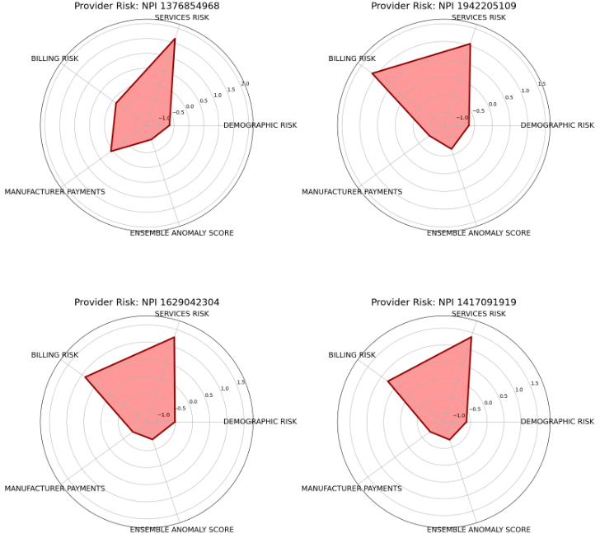
The provider risk score breaks providers into low, medium, and high risk, based on various factors. Including where they practice, what they bill for, and how they’ve behaved in the past. A supplier in a county with high poverty and a large senior population, offering a high share of “high-risk” services, money flowing in from manufacturers, history of high billing, lands farther to the outskirts of each circle in red.
Fig 4. Example NPI Radar Charts. The radar chart length is determined by the z score of the average values within each risk factor. The data used here is for example demonstrations only.

Risk Factor | Low Risk | Medium Risk | High Risk
Geographic & Demographic Risk | Provider in county with low poverty  Low senior population  Low veteran density | Provider in county with moderate poverty  Moderate senior population  Moderate veteran density | Provider in county with high poverty  High senior population  High veteran density
Services Risk | Primarily provides Low-risk services  High-risk service percentage < 10% of total services | Primarily provides low to moderate - risk services  High-risk service percentage around 10–30% of total services | Primarily provides moderate to high - risk services  High-risk service percentage >30% of total services
Billing Risk | Stable billing, no spikes | Moderate YOY changes, high amounts | Extreme billing spikes, unstable volume, payments drop off
Manufacturer Payments | Few or no payments | Recurrent small payments | Large/recurring payments, ownership
Ensemble Anomaly Score | Consistent with peers | Mixed anomaly signals | Strong anomalies across multiple models

PAYMENTS SPIKE SPOTLIGHT
These providers show distinct billing spikes, or quarters where payments from manufacturers are significantly higher than their own payment history based on a 4-quarter rolling z-score. In practice, these spikes may reflect true changes in activity (e.g., new product advertisements, seasonal programs, or one-off speaker events) or potential anomalies that warrant follow-up. Providers with multiple spike quarters are especially important to review, since outliers suggest a shift in billing behavior.
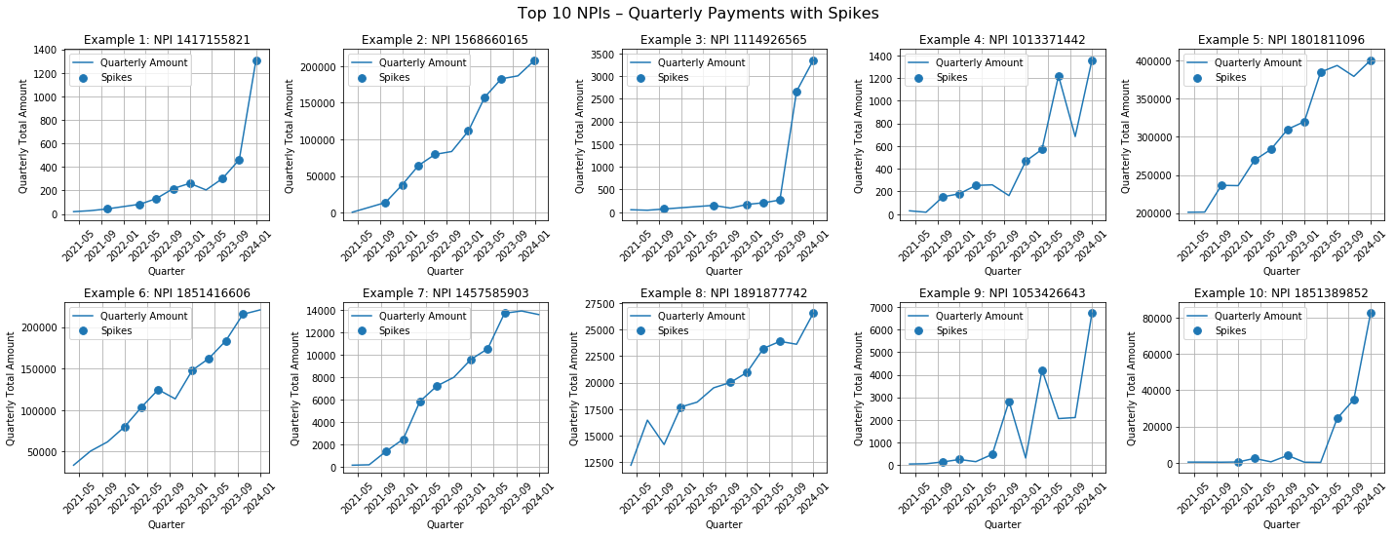
Fig 6. Top 10 NPIs with manufacturing payment spikes.

Conclusion
By combining descriptive analytics, feature ranking, and anomaly detection methods, we developed a framework that enhances the ability of oversight teams to identify suspicious behavior and prioritize cases for review. While this system does not predict fraud, it reveals the structural, financial, and behavioral markers that consistently align with confirmed cases. These insights help lay the groundwork for more efficient, proactive, and data-informed antifraud efforts.
Preventing Healthcare Fraud
If you suspect DMEPOS fraud, contact your provider or supplier or report it at cms.gov/fraud or by calling 1-800-MEDICARE.

