**Name:** Hafiz Naqash Abbasi.

**Reg-No:** Bse181057.

**Assignment-No:** 04.

**Submitted-To:** Sir Muhammad Hammad.

**Register_Form:**

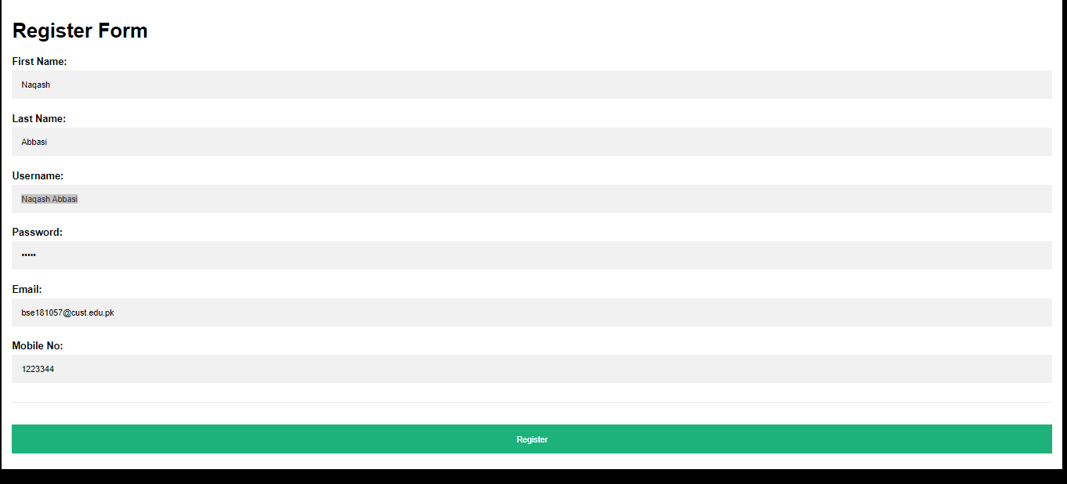

**Successfully Registered:**

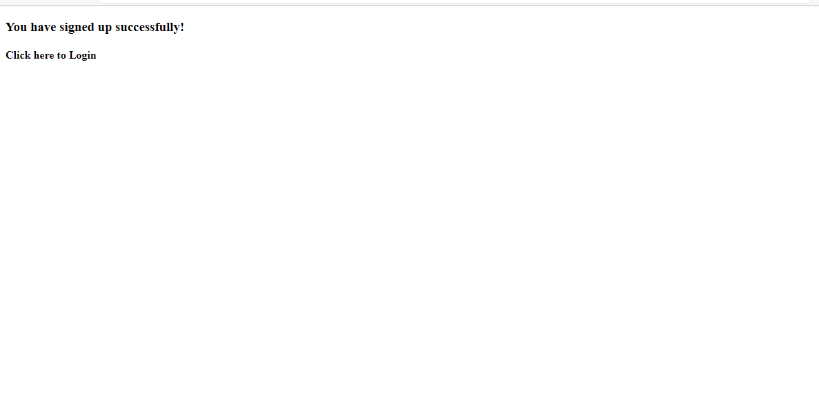

**Login_Form:**

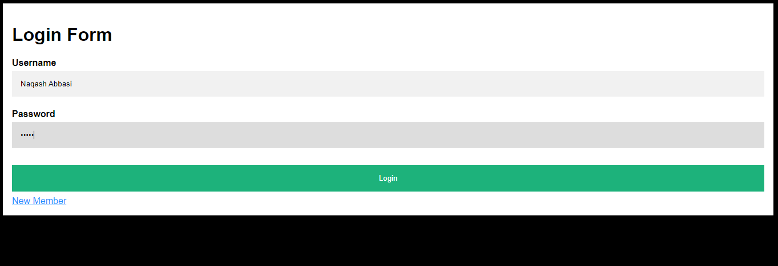

**Database:**

