Agile and Scrum

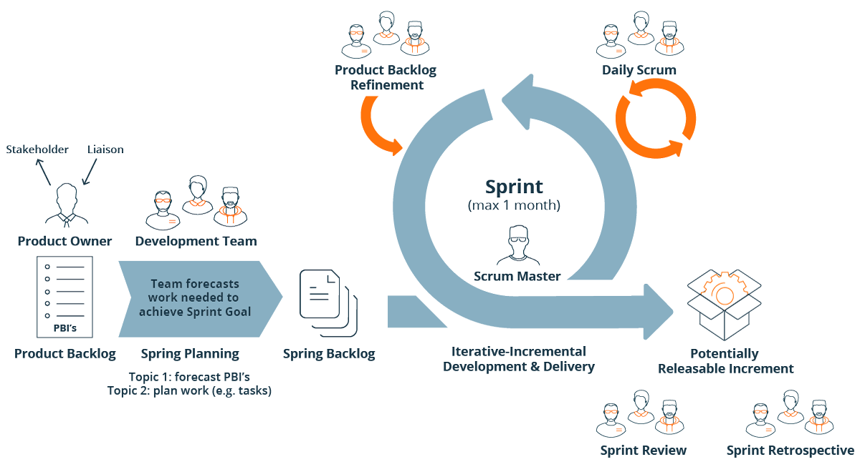

1. Explain the agile methodology of working and its purposes

|  |
| --- |
| 1. **Agile**    * + **Explanation:** Agile project management is a process for managing a project that involves constant collaboration and working in iterations. It works off the basis that a project can be continuously improved upon throughout its lifecycle and adapt to changes quickly.        - **Its purpose** 2. Customer satisfaction through early and continuous software delivery. 3. Frequent delivery of working software. 4. Embrace changing requirements, even in later stages. 5. The main measure of progress is working software. 6. The team reflects on how to become more effective at regular intervals, adjusting behavior accordingly. 7. Faster Time to Market. |

1. Compare agile and waterfall models: advantages, disadvantages, when to use it, best practice of both

|  |
| --- |
| 1. **Agile**  * **Advantages** * **Flexibility:** Agile allows teams to adapt to changing requirements and priorities, ensuring the final product meets the evolving needs of stakeholders. * **Faster Delivery:** By breaking down the project into smaller increments, Agile enables faster delivery of working software, leading to quicker feedback and validation. * **Value of teamwork:** The team members work closely together and have a clear vision of their responsibilities. * **Continuous Improvement:** The iterative nature of Agile encourages continuous improvement, as teams regularly assess their progress and make necessary adjustments based on feedback. * **Disadvantages** * **Predictability:** Agile allows teams to adapt to changing requirements and priorities, ensuring the final product meets the evolving needs of stakeholders. * **Stakeholder Involvement:** By breaking down the project into smaller increments, Agile enables faster delivery of working software, leading to quicker feedback and validation. * **Scope Management:** Agile fosters collaboration among team members, promoting better communication and transparency throughout the development cycle. * **When to use** * Ideal for dynamic environments or projects with evolving requirements. * Suitable for startups, innovative products, and continuous improvement initiatives. * Requires active stakeholder involvement and dedicated resources. * **Best practice** * Use short development cycles (Sprints). * Maintain close customer collaboration. * Hold regular retrospectives to improve processes  1. **Waterfall**  * **Advantages** * **Clear Plan:** Waterfall follows a step-by-step process, making it easy to plan resources and timelines in advance. * **Easy to Understand:** The Classical Waterfall Model is very simple and easy to understand. * **Stable Approach:** Best for projects with fixed requirements, ensuring detailed documentation and a structured workflow. * **Predictable Outcomes:** Since requirements are set early, projects stay on schedule and within budget with minimal changes. * **Properly Documented:** Processes, actions, and results are very well documented. * **Disadvantages** * **Long Development Time:** The final product is delivered at the end, with no early feedback. * **Rigidity:** Waterfall is not flexible, making it hard to adjust when requirements change later in the project. * **Limited Feedback:** Feedback comes late in the process, which can lead to a final product that may not fully meet stakeholder needs. * **When to use** * All the requirements are known, clear, and fixed. * There are no ambiguous requirements. * The project is short and simple * The development environment is stable * **Best practice** * Ensure comprehensive upfront planning. * Rigorously document all requirements. * Allocate clear milestones to track progress. |

**Reference**

<https://www.agilealliance.org/agile101/>

<https://www.wrike.com/project-management-guide/faq/what-is-agile-methodology-in-project-management/>

<https://www.forecast.app/blog/difference-between-agile-waterfall#:~:text=Agile%20is%20ideal%20for%20dynamic,late%20in%20the%20development%20cycle>.

<https://www.altexsoft.com/whitepapers/agile-project-management-best-practices-and-methodologies/>

<https://www.geeksforgeeks.org/waterfall-model/#advantages-of-the-sdlc-waterfall-model>

<https://www.actitime.com/project-management/what-is-waterfall-model>