Software Development Life cycle (SDLC)

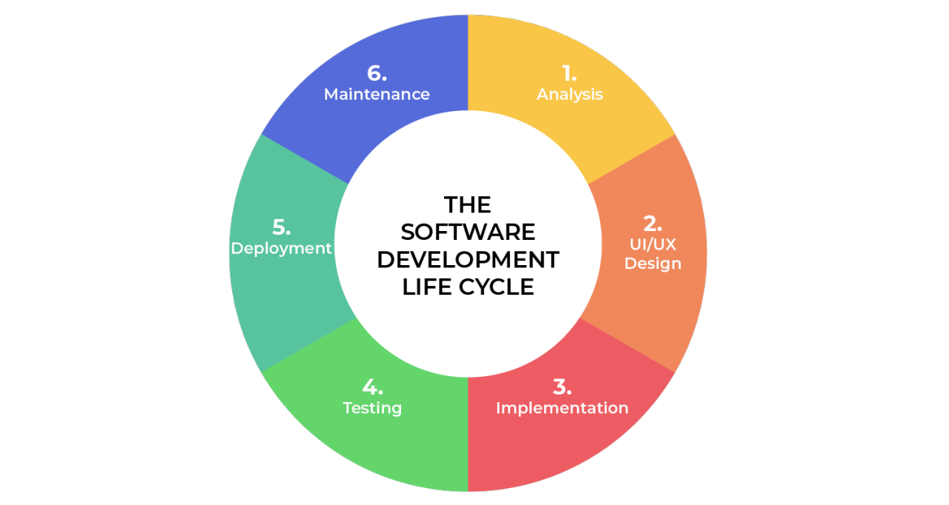

1. State all the SDLC phases: explain each phase, its role in software development and its input & output

|  |
| --- |
| 1. **Analysis**    * + **Role:** Gathering requirements and information about the software from the client.        - **Input:** Client needs, interviews        - **Output**: Software Requirement Specification (SRS) 2. **Design**    * + **Role:** The designer will design the software based on the client requirements/needs        - **Input:** Software Requirement Specification (SRS)        - **Output:** UI/UX, System architecture 3. **Development**    * + **Role:** based on UI/UX, System architect, the developer will develop the software        - **Input:** UI/UX, System architecture        - **Output:** Software 4. **Testing**    * + **Role:** Test the software for any error or issues based on acceptance criteria of user story        - **Input:** Software, acceptance criteria of user story, test cases        - **Output:** Test report, fix the errors 5. **Deployment**    * + **Role:** Deploy the software to the world        - **Input:** Software without any error        - **Output:** Live system 6. **Maintenance**    * + **Role:** Provides ongoing maintenance, updates, and bug fixes.        - **Input:** User feedback        - **Output:** Updated error fixed software versions |

1. state all the roles / titles that you know in the SDLC, their responsibilities and tools that they used if any

|  |
| --- |
| 1. **Analysis**    * + **Roles:** Product Owner, Project Manager, Business Analyst, CTO  * **Product Owner:** Defines product vision, sets priorities, and ensures the team builds what the stakeholders want * **Tools:** Jira * **Project Manager:** Plans project scope, timeline, resources, and risks * **Tools:** Jira, Trello, Microsoft Project * **Business Analyst:** Responsible for converting the requirements to the way which developer and designer understand, also make ToDo List * **Tools:** Lucid chart, ToDo List * **CTO:** Provides tools and software that should be used  1. **Design**    * + **Roles:** System Architect, UX/UI Designer  * **System Architect:** Designs the overall system architecture, including databases, servers, and software components * **Tools:** Lucid chart, star UML * **UX/UI Designer:** Designs the user experience (UX) and user interface (UI) of the software, ensuring it is intuitive and visually appealing * **Tools:** Figma, Adobe XD, Adobe Photoshop, Canva  1. **Development**    * + **Roles:** Front-end Developer, Back-end Developer  * **Front-end Developer:** Develops user interfaces * **Tools:** React.js, Angular, VS Code, Git * **Back-end Developer:** Develops server-side applications * **Tools:** Node.js, Python, Java, MySQL, Git, Docker  1. **Testing**    * + **Roles:** Solutions Architect, QA Engineer, Tester, DevOps  * **Solutions Architect:** Ensures system architecture matches business requirements * **QA Engineer:** Designs test cases and performs automated tests * **Tools:** Selenium * **Tester:** Executes manual and automated tests * **Tools:** Postman * **DevOps:** Automates testing in CI/CD pipeline * **Tools:** Jenkins  1. **Deployment**    * + **Roles:** Data Administrator, DevOps  * **Data Administrator:** Manages databases and backups * **Tools:** MySQL, Oracle * **DevOps:** Deploys applications, monitors servers * **Tools:** Azure, Docker  1. **Maintenance**    * + **Roles:** Users, Tester, Support Managers  * **Users:** Ensures system architecture matches business requirements * **Tester:** Designs test cases and performs automated tests * **Support Managers:** Executes manual and automated tests |

**Reference**

<https://www.pulsion.co.uk/blog/software-development-life-cycle-sdlc/>

<https://www.geeksforgeeks.org/system-development-life-cycle/#stage-6-implementation>

<https://theproductmanager.com/topics/software-development-life-cycle/>

<https://reliasoftware.com/blog/software-development-life-cycle-sdlc>

<https://djangostars.com/blog/roles-in-the-sdlc/>

<https://www.linkedin.com/pulse/essential-stages-sdlc-key-roles-drive-success-shruti-soni--xh5df/>

<https://www.browserstack.com/guide/sdlc-tools>

<https://hyperskill.org/learn/step/31958>