C#

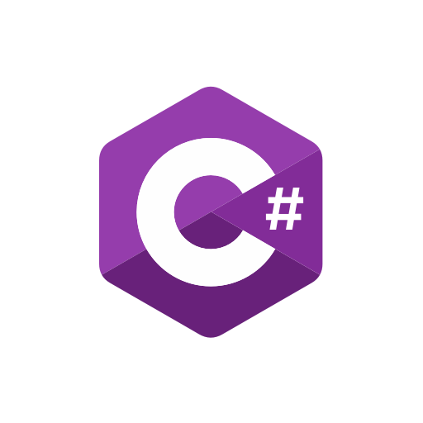

**Data Types & Variables**

*Variables store data, and each variable has a data type.*  
  
**1. Value Types:**

* *These store actual values in memory.*

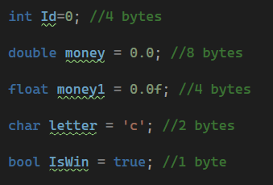

**2. Reference Types:**

* *These store memory addresses instead of actual values.*

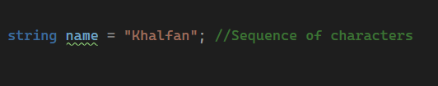

**Constants**

* *Constants cannot be changed after assignment.*

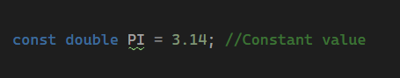

**Input & Output**

1. **Printing Output**

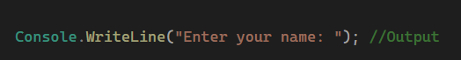

**2. Taking User Input**

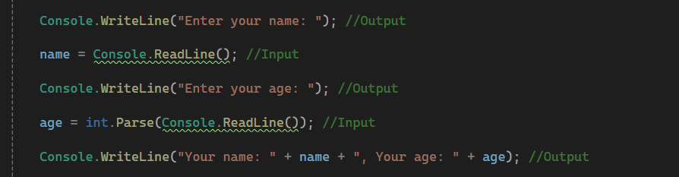

**Operators**

**A. Arithmetic Operators**

* Addition( + ) , Subtraction( - ) , Multiplication( * ) , Division ( / ) , Modulus( % )

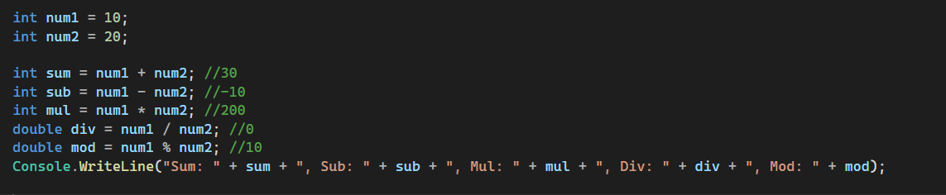

**B. Logical Operators**

* AND , NOT , OR

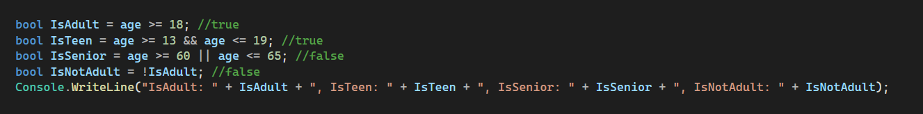

**Conditional statements (if else /** **switch case)**

**A. if else**

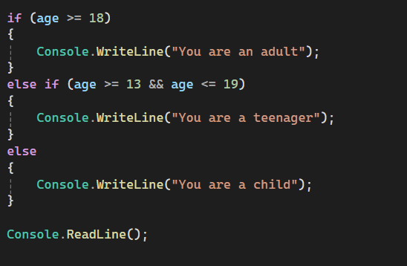

**B. Switch Case**

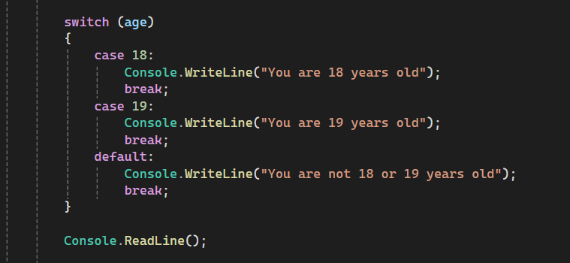

**Looping (for, while and do while)**

1. **For loop**

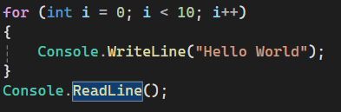

1. **While loop**

1. **Do-While loop**

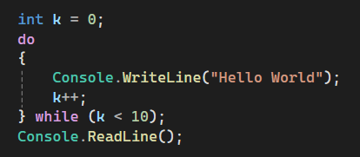

**Nested operations (nested conditions and nested looping)**

1. **Nested Conditions**

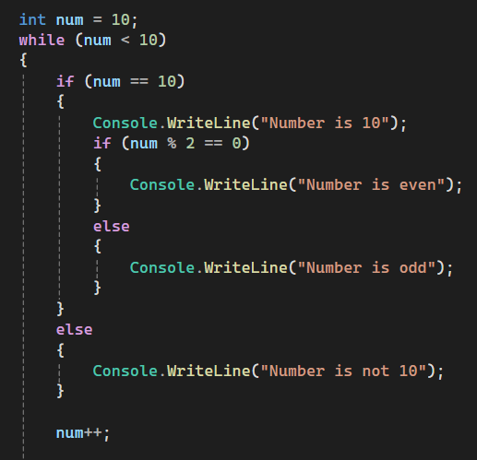

1. **Nested Looping**

**Array data structure**

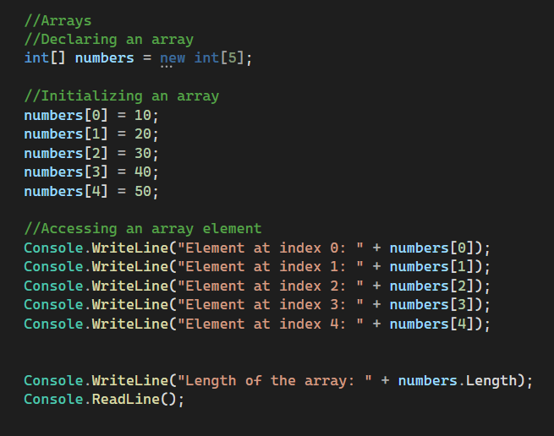

**Functions in CSharp ( built-in )**

1. **Math Functions**

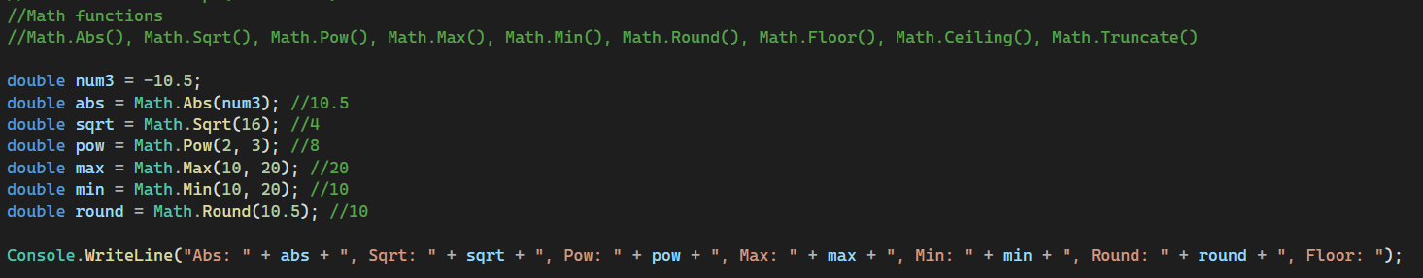

1. **String Functions**

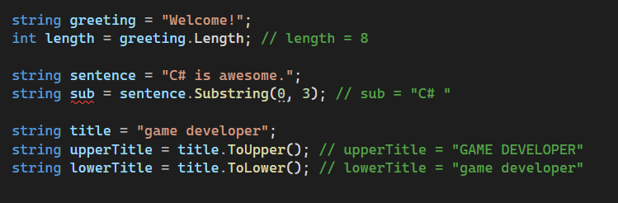

1. **Date and Time Functions**

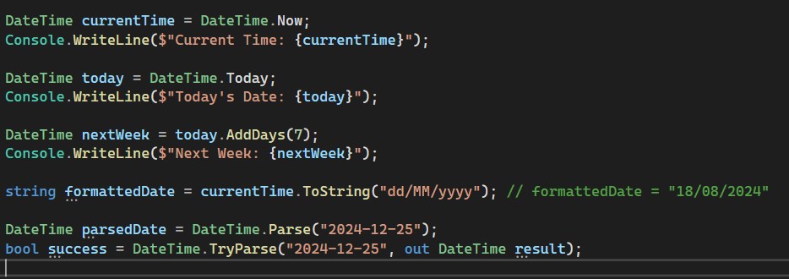

1. **Array Functions**

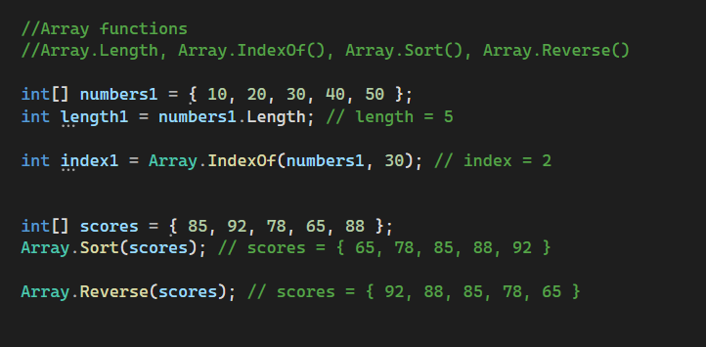

1. **Console Functions**

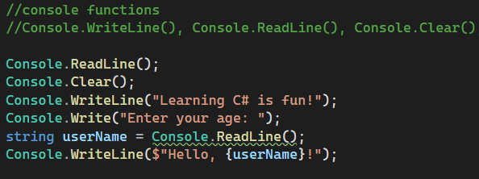

1. **Type Conversion Functions**



1. **Random Number Functions**

**Errors in programming**

1. **Syntax Errors**

* **Definition : Syntax errors occur when the code violates the grammatical rules of the programming language.**
* **Detection : These errors are detected by the compiler before the program runs.**
* 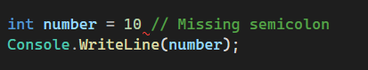**Example :**
* **Solution : Fix the syntax issue based on the compiler's error message**

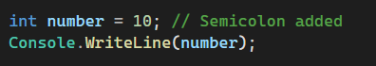

1. **Runtime Errors**

* **Definition : Runtime errors occur while the program is running, often due to invalid operations such as division by zero, accessing invalid memory locations, or null references.**
* **Detection : These errors are detected during program execution.**
* **Example:** A black background with white text

  AI-generated content may be incorrect.
* **Solution : Use exception handling or validation to prevent the error.**

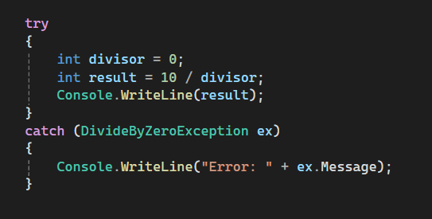

1. **Logical Errors**

* **Definition : Logical errors occur when the program compiles and runs but produces incorrect results due to flawed logic.**
* **Detection : These errors are difficult to detect because the program does not crash or show immediate signs of failure.**
* 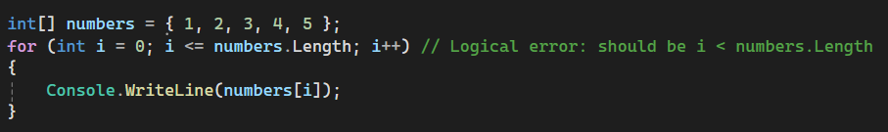**Example :**
* **Solution : Correct the loop condition to avoid out-of-bounds access.**

