Task 1

1. **Comparison Assignments**

**What is a Relational Database?**

A flat file, also known as a text database, stores data in plain text format and is organized as a single table with no relationships between tables.

**What is a Relational Database?**

A relational database is a type of database that stores and organizes data in a collection of tables. These tables are related to each other through the use of a common field known as a primary key. Relational databases are used to store, organize and retrieve data quickly and efficiently.

|  |  |  |
| --- | --- | --- |
| Difference Between Relational Database vs Flat File | | |
|  | Relational Database | Flat File |
| Structure | Data is organized into multiple related tables with rows and columns. | Data is stored in a single table or text file, usually line by line. |
| Data Redundancy | Low redundancy due to normalization and relationships. | High redundancy as data is repeated across records. |
| Relationships | Supports complex relationships using primary and foreign keys. | No inherent relationships between data records. |
| Example Usage | Commonly used in applications where data integrity and complex relationships are important, such as enterprise applications, e-commerce systems, and data analytics. | Ideal for small applications, simple data storage needs, or when data relationships are not complex. |
| Drawbacks | Requires a DBMS, more complex setup, and higher cost. | Not scalable, difficult to query and maintain with large datasets. |

1. DBMS Advantages Mind Map

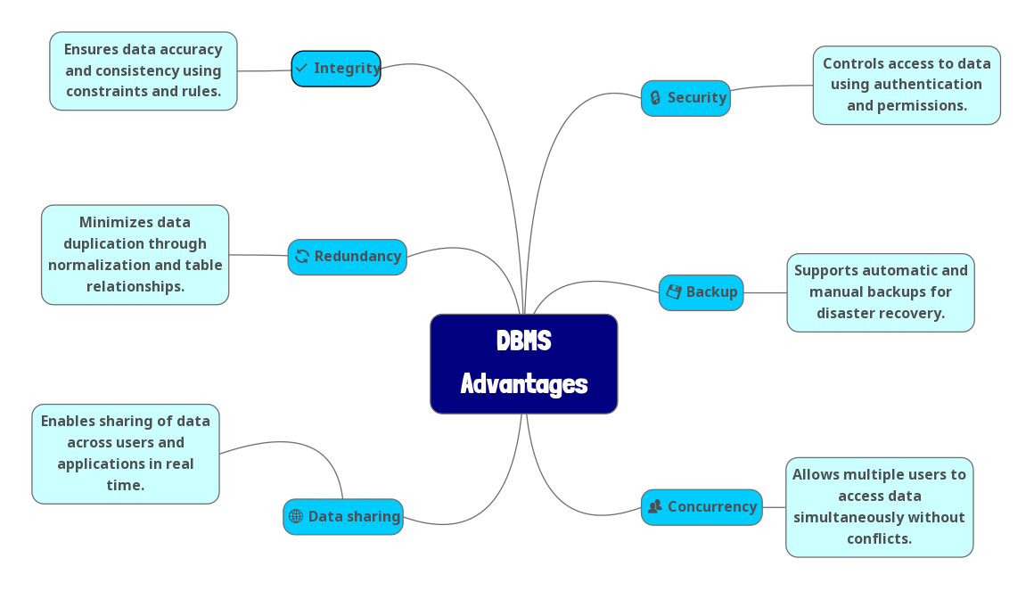

1. Roles in a Database System