**3. Querying Restaurants Collection Note: please use mongo shell for this task Have a look at a document from the collection to get familiar with the schema: db.restaurants.findOne()**

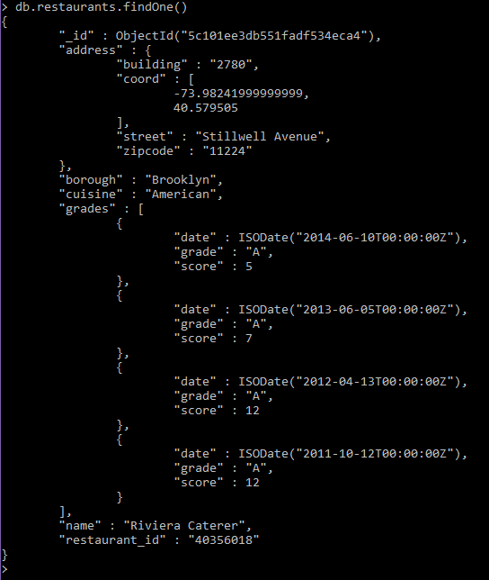

**Answer the following questions and include both query and the result (if applicable) into your report: 1. How many “Chinese” (cuisine) restaurants are in “Queens” (borough)?**



**2. What is the _id of the restaurant which has the grade with the highest ever score?**

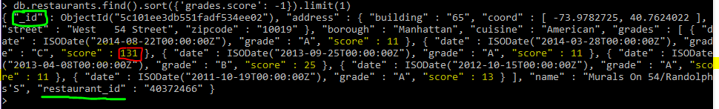

**3. Add a grade { grade: "A", score: 7, date: ISODate() } to every restaurant in “Manhattan” (borough).**



**4. What are the names of the restaurants which have a grade at index 8 with score less then 7? Use projection to include only names without _id.**

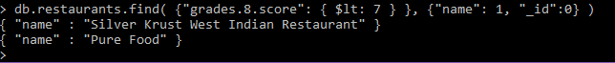

**5. What are _id and borough of “Seafood” (cuisine) restaurants which received at least one “B” grade in period from 2014-02-01 to 2014-03-01? Use projection to** include **only _id and borough.**

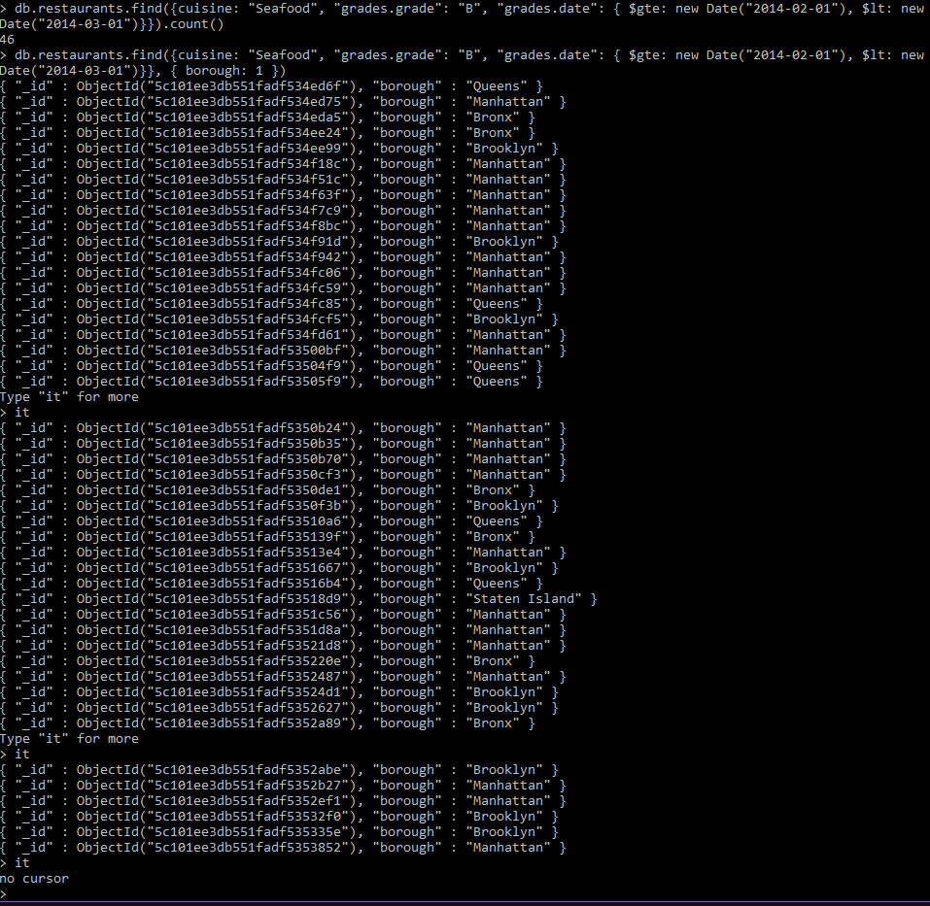

**_________________________________________________________________**

**4. Indexing Restaurants Collection**

Note: you may use MongoDB Compass for this task if you want to

Create the following indexes:

1. **Create an index which will be used by this query and provide proof (from explain() or Compass UI) that the index is indeed used by the winning plan:**

db.restaurants.find({ name: "Glorious Food" })

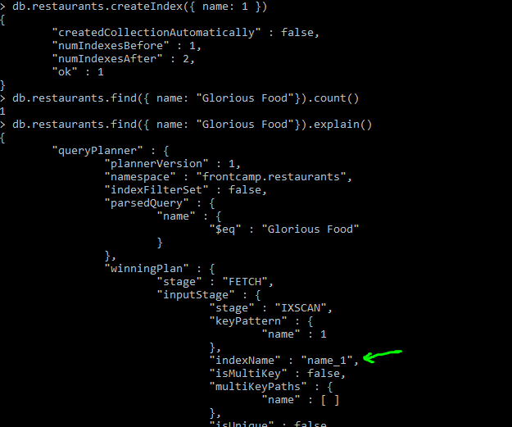

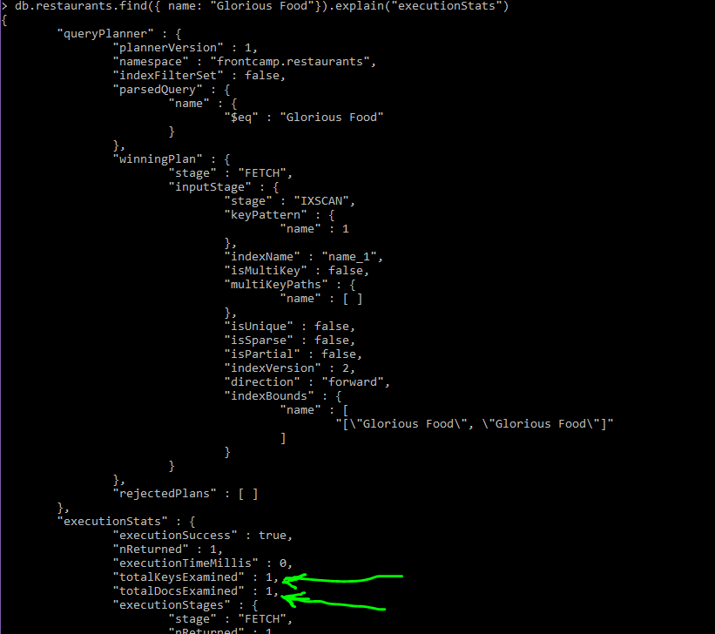

1. **Drop index from task 4.1**

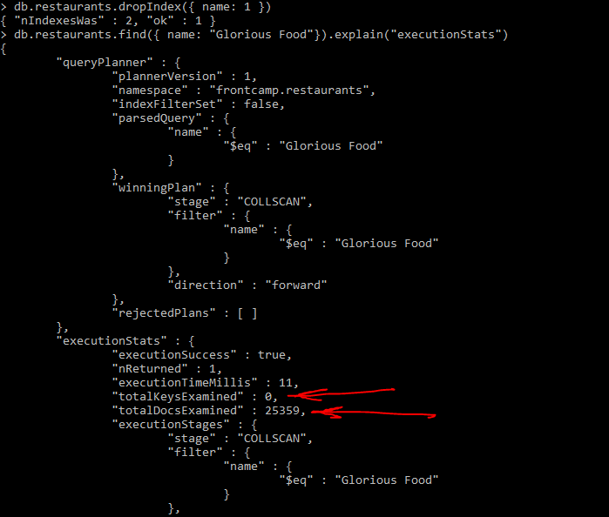

1. **Create an index to make this query covered and provide proof (from explain() or Compass UI) that it is indeed covered:**

db.restaurants.find({ restaurant_id: "41098650" }, { _id: 0, borough: 1 })

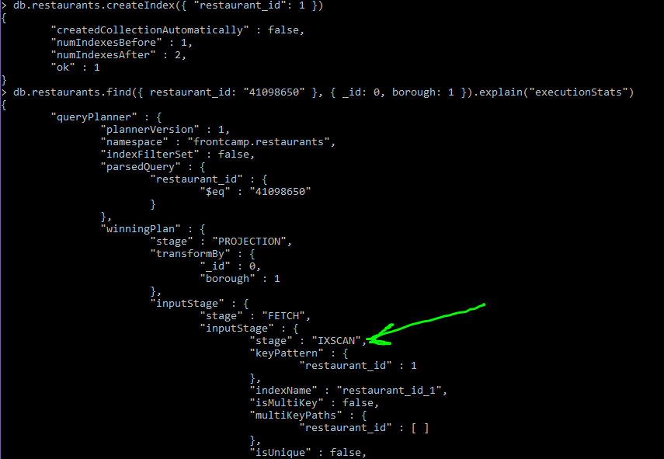

1. **Create a partial index on cuisine field which will be used only when filtering on borough equal to “Staten Island”:**

db.restaurants.find({ borough: "Staten Island", cuisine: "American" }) – uses index db.restaurants.find({ borough: "Staten Island", name: "Bagel Land" }) – does not use index db.restaurants.find({ borough: "Queens", cuisine: "Pizza" }) – does not use index

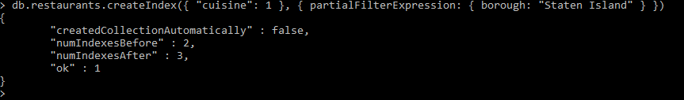

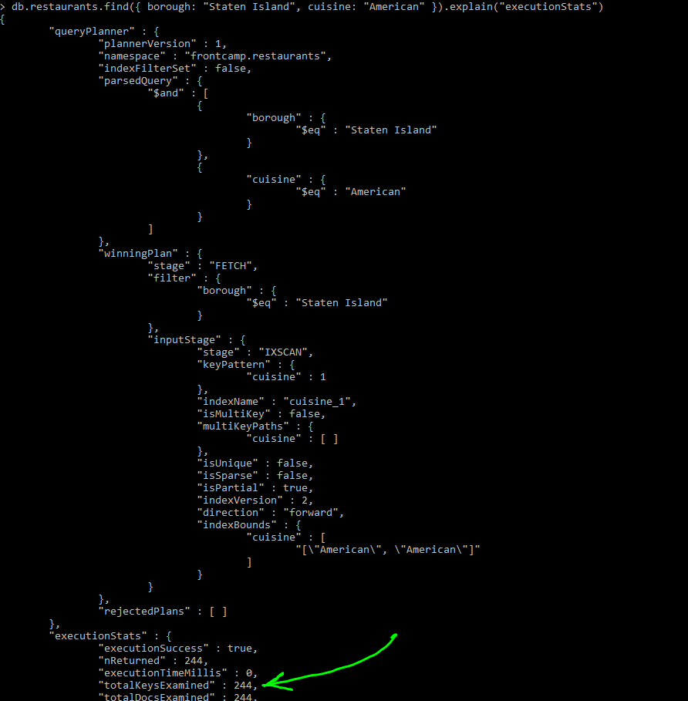

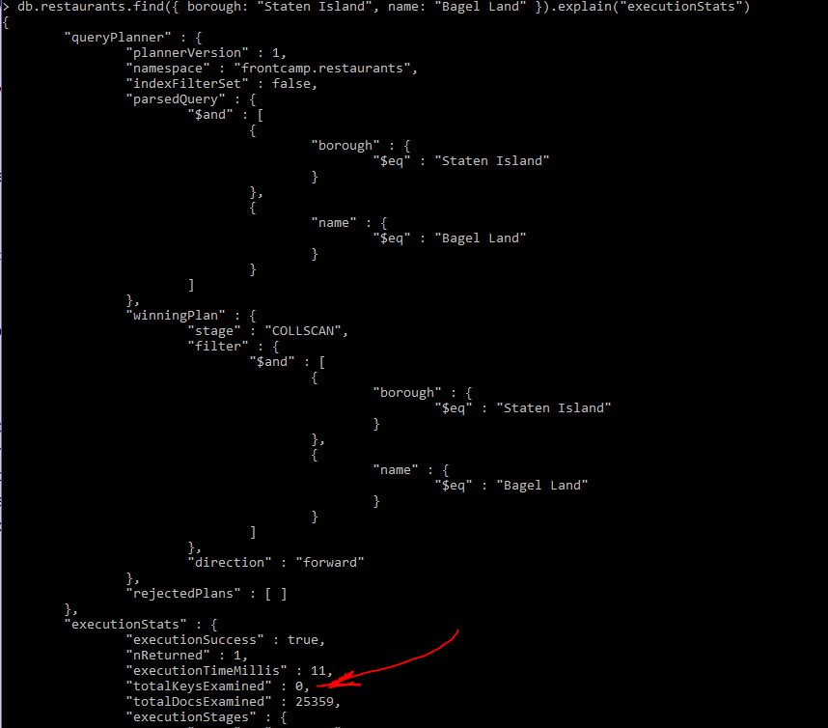

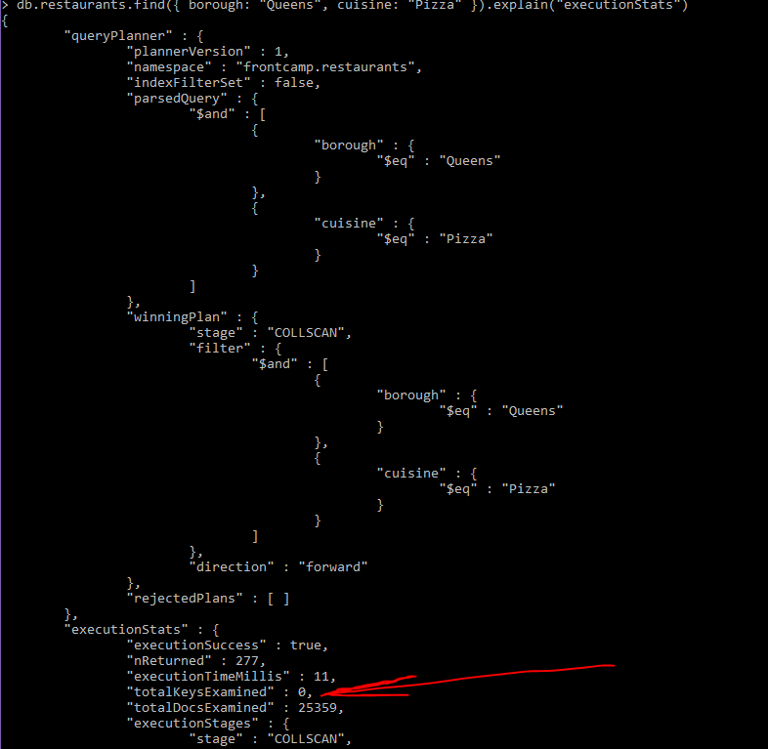

1. **Create an index to make query from task 3.4 covered and provide proof (from explain() or Compass UI) that it is indeed covered**