**Answer the following questions and include both query and the result into your report:**

1. **How many records does each airline class have? Use $project to show result as { class: "Z", total: 999 }**



1. **What are the top 3 destination cities outside of the United States (destCountry field, not included) with the highest average passengers count? Show result as { "avgPassengers" : 2312.380, "city" : "Minsk, Belarus" }**



1. **Which carriers provide flights to Latvia (destCountry)? Show result as one document { "_id" : "Latvia", "carriers" : [ "carrier1", " carrier2", …] }**



1. **What are the carriers which flue the most number of passengers from the United State to either Greece, Italy or Spain? Find top 10 carriers, but provide the last 7 carriers (do not include the first 3). Show result as { "_id" : "", "total" : 999}**

Top 10:

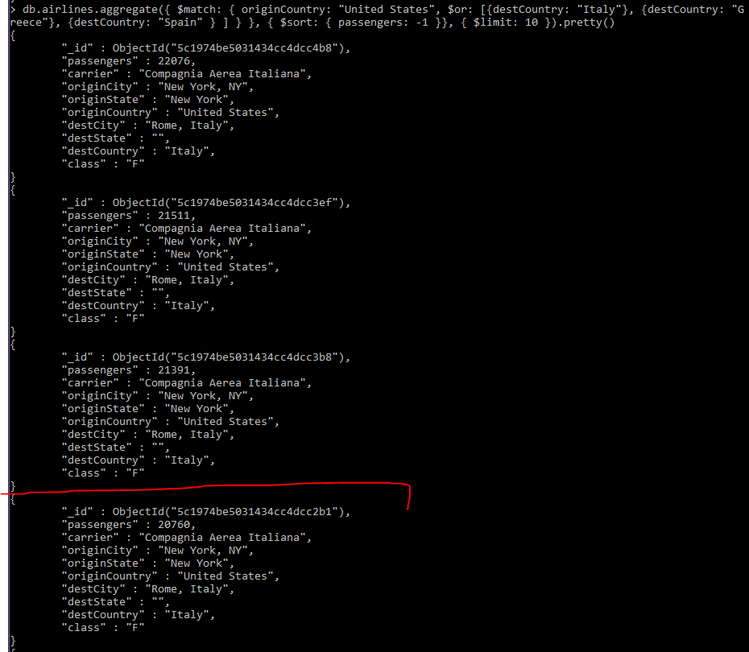

With first 3 skipped:



(PS. Все 7 не влезли на экран)

1. **Find the city (originCity) with the highest sum of passengers for each state (originState) of the United States (originCountry). Provide the city for the first 5 states ordered by state alphabetically (you should see the city for Alaska, Arizona and etc). Show result as { "totalPassengers" : 999, "location" : { "state" : "abc", "city" : "xyz" } }**

