VMWare Tools Installation

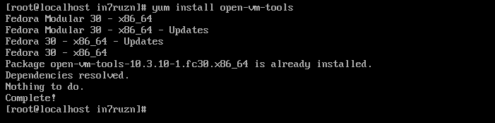

Figure Fedora VMware Tools

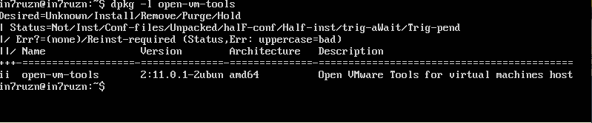

Figure Ubuntu VMware Tools