# Lab 02A

Perform the following activities on both of your virtual machines.  Record your commands and answer any questions in the lab activities.

Part 1) Ubuntu Server 18.04.1 Server

1. Create 2 users named **mary**and **max.**
   1. useradd --create-home mary --password password
   2. useradd --create-home max --password password



* 1. cat /etc/passwd



1. Create a group named **linux**. Add **mary**and **max** to the group named **linux**.
   1. groupadd linux
   2. usermod -G linux mary
   3. usermod -G linux max
   4. cat /etc/group | grep linux

1. Create a group named **employees** with a gid of 1600.
   1. groupadd --gid 1600 employees
   2. cat /etc/group | grep employees



1. Create a user named **jed** with a supplementary group of **employees**.
   1. useradd --create-home jed --password --groups employees



Add **max**to the **employees** group.

* 1. usermod --append --groups employees max



1. Create 2 system users named **adm1**and **adm2.**
   1. useradd --create-home --system adm1 --password password



* 1. useradd --create-home --system adm2 --password password



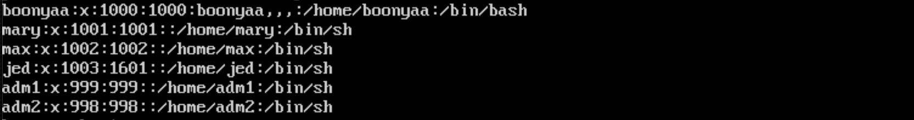

1. Create a group named **mgmt**with a gid of 800.
   1. groupadd --gid 800 mgmt



1. Create a user named **fred**with a supplementary group of **mgmt**.
   1. useradd --create-home fred --password password --groups mgmt.

8. Question: which of these accounts will have privileges above that of an ordinary user?

*Any users with GID between 0 (root) – 1000 and 65,534 will have higher privileges. Users beginning with 1001+ are normal users.*

Part 2) Fedora Server 28-1.1

1. Create 2 users named **mary**and **max.**
   1. useradd --create-home mary --password password
   2. useradd --create-home max --password password
   3. cat /etc/passwd



1. Create a group named **linux**. Add **mary**and **max** to the group named **linux**.
   1. groupadd linux
   2. usermod -G linux mary
   3. usermod -G linux max
   4. cat /etc/group | grep linux

1. Create a group named **employees** with a gid of 1600.
   1. groupadd --gid 1600 employees
   2. cat /etc/group | grep employees

1. Create a user named **jed** with a supplementary group of **employees**.

Add **max**to the **employees** group.

* 1. useradd --create-home jed --password --groups employees
  2. usermod --append --groups employees max



1. Create 2 system users named **adm1**and **adm2.**
   1. useradd --create-home --system adm1 --password password
   2. useradd --create-home --system adm2 --password password

* 1. cat /etc/passwd

1. Create a group named **mgmt**with a gid of 800.
   1. groupadd --gid 800 mgmt

1. Create a user named **fred**with a supplementary group of **mgmt**.
   1. useradd --create-home fred --password password --groups mgmt.

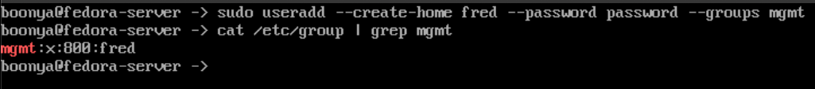

1. Question: which of these accounts will have privileges above that of an ordinary user?

*Any users with GID between 0 (root) – 1000 and 65,534 will have higher privileges. Users beginning with 1001+ are normal users.*

