# Lab 02D

Description: This lab will demonstrate the use of cron and at (see book Chapter 14).

Perform the following activities on both of your virtual machines.  Record your commands and answer any questions in the lab activities.

Part 1) Ubuntu Server 18.04.1 Server

PROCEDURE: Use the book and the appropriate man pages to form commands to complete the following tasks.  (Tip: You will need to work with **root** privileges to perform these commands.)

1. Create 3 ordinary users, **user1**,**user2** and **user3**

2. Configure the **cron** and **at** daemons to:

* Allow only **root** and **user1** to run the **cron** command
* Allow only **user3** and **root** to run the **at** command
* Restart each daemon

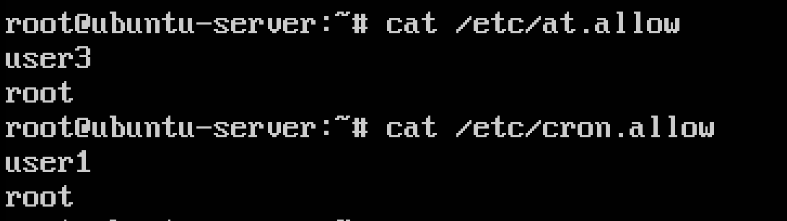

3. As **user1**, create a file named **cron1** to run the following job every 5 minutes of every hour of every day by placing the following line in the file:

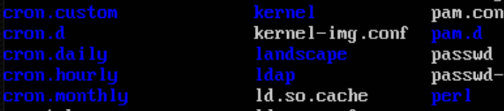

* I created a new directory – cron.custom to place my script

* I place this cron1 script inside my cron.custom directory. Replacing the line below

**5   *   *   *   * echo “This is cron job 1”**

4. As **user1**, submit the file **cron1** to run

And redirecting the contents of the script to /home/user1/cron.txt

5. As **user3**, create a file named **at1** that runs **ps –aux**

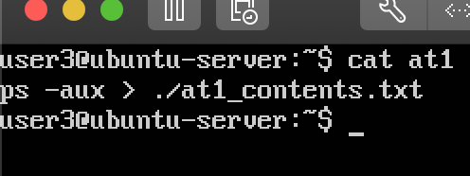

6. As **user3**, submit the file, **at1** to run in 2 minutes

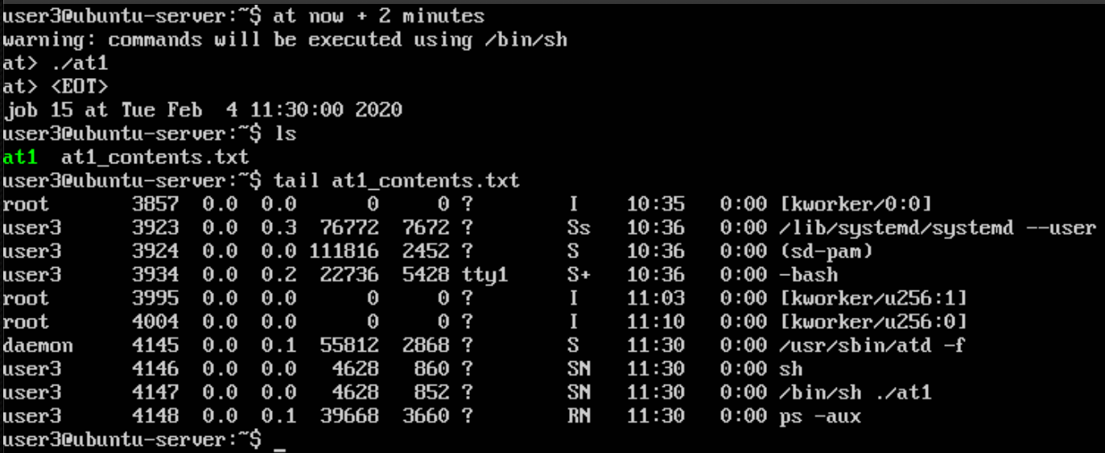

Confirm that the jobs have been submitted correctly by doing the following:

7. As **user1** type: **crontab –l**

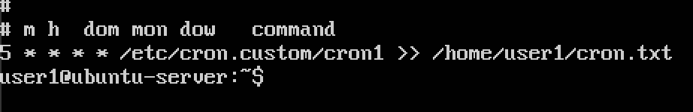

You should see the **cron1** file listed

8. As **user3** type: **atq**



You should see the **at** job listed by number

9. Confirm that **user2** cannot run cron or at jobs

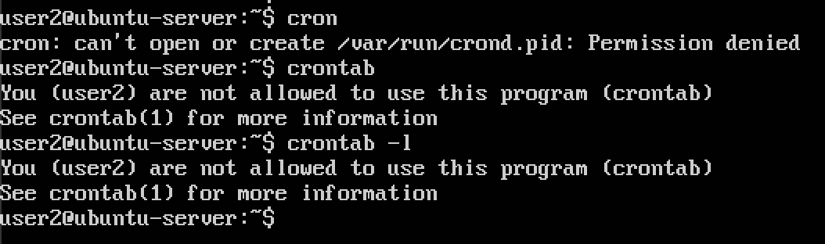

10. Remove the cron job when finished by typing: **crontab -r**

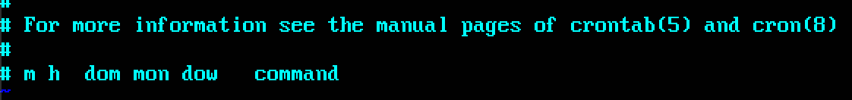

Part 2) Fedora Server 28-1.1

1. Create 3 ordinary users, **user1**,**user2** and **user3**

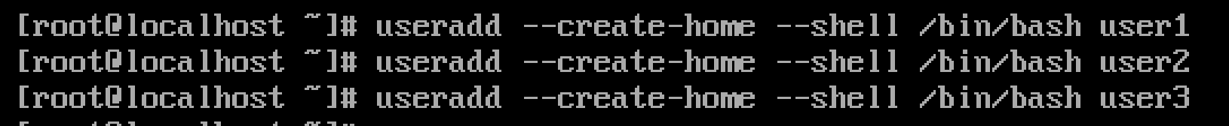

2. Configure the **cron** and **at** daemons to:

* Allow only **root** and **user1** to run the **cron** command

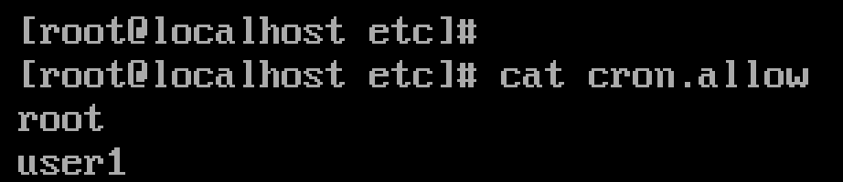

* Allow only **user3** and **root** to run the **at** command

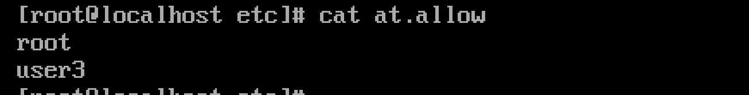

* Restart each daemon

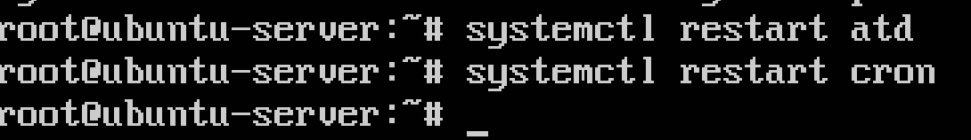

3. As **user1**, create a file named **cron1** to run the following job every 5 minutes of every hour of every day by placing the following line in the file:

**5   *   *   *   * echo “This is cron job 1”**

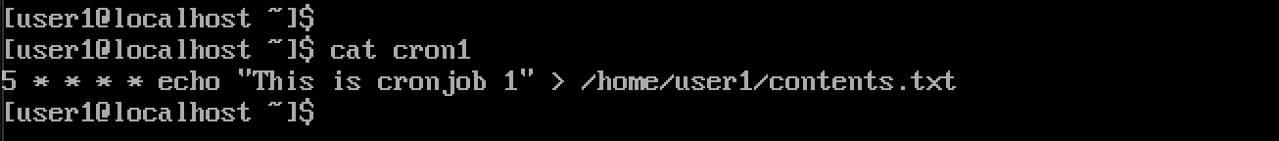

**\*contents of cron1**

4. As **user1**, submit the file **cron1** to run

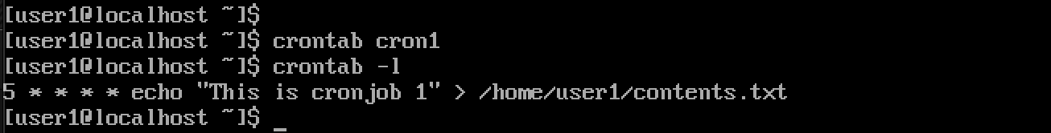

\***submit and then display jobs**

5. As **user3**, create a file named **at1** that runs **ps –aux**

6. As **user3**, submit the file, **at1** to run in 2 minutes

Confirm that the jobs have been submitted correctly by doing the following:

7. As **user1** type **crontab –l**

You should see the **cron1** file listed

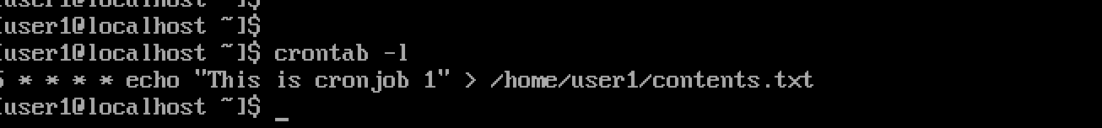

8. As **user3** type:**atq**

You should see the **at** job listed by number

9. Confirm that **user2** cannot run cron or at jobs

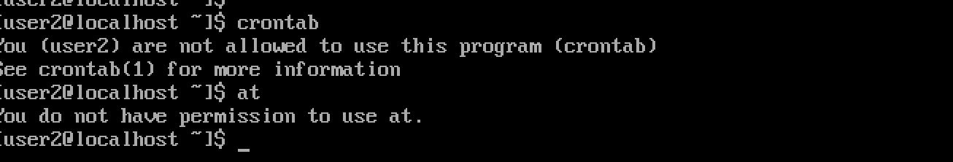

*since user2 is not in the cron.allow and at.allow, they cannot use those utilities

10. Remove the cron job when finished by typing: **crontab -r**

