**Description:** Installation and use of a private DNS server in Linux.

Perform the following activities on the specified virtual machines.  Record your commands and answer any questions in the lab activities.

**Part 1)** **Ubuntu 18.04.1 Server  
Part 2) Fedora 28-1.1 Server**

**PROCEDURE:** Use the book and the appropriate man pages to form commands to complete the following tasks.  (Tip: You will need to work with root privileges to perform these commands.)

**Part 1)**

**On Ubuntu Server 18.04.1:**

* Install and configure bind to automatically start at boot time
* Create a new zone named linux.cis

**It should include:**

* A global time to live of 1 day
* An SOA record
* An NS record
* An MX record
* At least 3 A records
* At least 1 CNAME record

**Step 1. Configure netplan**

**File:** /etc/netplan/01-netcfg.yaml

network:

version: 2

renderer: networkd

ethernets:

ens33:

dhcp4: no # Use Static IP

addresses: [192.168.166.160/24]

nameservers:

addresses: [192.168.166.160]

search: [linux.cis]

**Apply Configuration**:

sudo netplan apply

sudo systemd-resolve --status

**Step 2. Install BIND9**

**Run:**

sudo apt update && sudo apt upgrade

sudo apt install bind9 bind9utils

**Step 3. Configure /etc/default/bind9**

**File:** /etc/default/bind9

# run resolvconf?

RESOLVCONF=no

# startup options for the server

OPTIONS="-u bind"

OPTIONS="-u bind -4"

**Start BIND9:**

sudo systemctl restart bind9

sudo systemctl enable bind9

sudo systemctl status bind9

**Step 4: Configure Zones**

**File:** /etc/bind/named.conf.local

**# Forward**

zone "linux.cis" {

type master;

file "/var/lib/bind/db.linux.cis";

};

**# Reverse**

zone "166.168.192-in.addr.arpa" {

type master;

file "/var/lib/bind/db.192.168.166";

};

**Step 5: Configure Forward Lookup**

**File:** /var/lib/bind/db.linux.cis

**Copy default configurations:**

sudo cp /etc/bind/db.local /var/lib/bind/db.linux.cis

sudo vim /var/lib/bind/db.linux.cis

$TTL 1d

@ IN SOA ns.linux.cis. admin.ns.linux.cis. (

25 ; Serial

604800 ; Refresh

86400 ; Retry

2419200 ; Expire

604800 ) ; Negative Cache TTL

;

; NS

@ IN NS ns1.linux.cis. ; Name Server

@ IN MX 10 mailx.linux.cis. ; Mail Exchange

; A

ns1 IN A 192.168.166.160

ns1.linux.cis. IN A 192.168.166.160

linux.cis. IN A 192.168.166.160

mailx.linux.cis. IN A 192.168.166.160

clientx IN A 192.168.166.165

; CNAME

www IN CNAME linux.cis.

mail IN CNAME mailx.linux.cis.

client IN CNAME clientx

**Step 6. Configure Reverse Lookup**

**File:** /var/lib/bind/db.192.168.166

**Copy default configurations:**

sudo cp /etc/bind/db.127 /var/lib/bind/db.192.168.166

$TTL 1d

@ IN SOA ns.linux.cis. admin.ns.linux.cis. (

25 ; Serial

604800 ; Refresh

86400 ; Retry

2419200 ; Expire

604800 ) ; Negative Cache TTL

;

@ IN NS ns1.

160 IN PTR ns1.linux.cis.

; CLIENTS

165 IN PTR client.linux.cis.

**Restart BIND9:**

sudo systemctl restart bind9

sudo systemctl status bind9

**Step 7:** Check Configuration

**Run:**

sudo named-checkconf

sudo named-checkzone linux.cis /var/lib/bind/db.linux.cis

sudo named-checkzone 192.168.166-in.addr.arpa /var/lib/bind/db.192.168.166

**Step 8. Client Configuration**

**Edit Hosts File:**

sudo vim /etc/hosts

< --- >

127.0.0.1 localhost

127.0.1.1 hack.machine

192.168.166.160 www.linux.cis linux.cis

< --- >

**Show that you are able to query this zone from your VM**

**Forward Zone Configurations:**

**Reverse Lookup**

**MX Lookup**

**CNAME Lookup**

**Client Lookup**

**Ubuntu 18.04 RESOURCES:**

**Ubuntu 18.04 Domain Name Service (DNS**

<https://help.ubuntu.com/lts/serverguide/dns.html.en>

**How To Configure BIND as a Private Network DNS Server on Ubuntu 18.04**

<https://www.digitalocean.com/community/tutorials/how-to-configure-bind-as-a-private-network-dns-server-on-ubuntu-18-04>

**How to configure DNS using BIND9**

<https://www.youtube.com/watch?v=vUNLA-24MEQ>

**How to configure static IP addressing**

<https://linuxize.com/post/how-to-configure-static-ip-address-on-ubuntu-18-04/>

**BIND9 Server How to**

<https://help.ubuntu.com/community/BIND9ServerHowto>

**Ubuntu Server 18.04 - Bind9 DNS (Cache, Internal Zone, IPv6, Slave and Alias)**

<https://www.youtube.com/watch?v=JxiYqv4GFKU>

**How to set up Bind9 DNS in Ubuntu 17 or 18**

<https://www.youtube.com/watch?v=uHpoQLh7mi4>

**Installing DNS Server (Bind9) On Ubuntu 18.04**

<https://www.youtube.com/watch?v=-up_OfIivCM>

**Installing DNS SERVER (BIND9) on UBUNTU 18.04.02**

<https://www.youtube.com/watch?v=LsUThKtaJM4>

**Install DNS Server (Bind9) Ubuntu 18.04**

<https://www.youtube.com/watch?v=vUNLA-24MEQ>

**10 Linux DIG Command Examples for DNS Lookup**

https://www.thegeekstuff.com/2012/02/dig-command-examples/

**Sample zone file:**  [cis217.local.txtPreview the document](https://canvas.highline.edu/courses/1862999/files/129605784/download?wrap=1)

**Part 2)**

**On Fedora Server 28.1-1:**

* Install and configure bind to automatically start at boot time
* Create a new zone named cis217.local

**It should include:**

* A global time to live of 1 day
* An SOA record
* An NS record
* An MX record
* At least 3 A records
* At least 1 CNAME record

**Step 1:**

**Master DNS server:**

ns.fedora.local (**192.168.166.164**)

**Client:**

client.machine.local (**192.168.1.165**)

**Install packages:**

dnf update -y && dnf upgrade -y

sudo dnf install bind bind-utils -y

**Edit /etc/named.conf file**:

sudo vi /etc/named.conf

**Edit the following line:**

listen-on port 53 { 127.0.0.1; };

**Add Master DNS Server IP :**

listen-on port 53 { 127.0.0.1; **192.168.166.164;** };

**Edit the following line:**

allow-query { localhost; };

**And add a local network range:**

allow-query { localhost; **192.168.166.0/24;** };

**Specify a forward and reverse zone.**

zone "**ns.fedors.cis**" IN {

type master;

file "**forward.fedora.cis**";

allow-update { none; };

};

zone "**166.168.192.in-addr.arpa**" IN {

type master;

file "/**reverse.fedora.cis**";

allow-update { none; };

};

**Step 2: Create Zones**

**Create zones directory:**

sudo mkdir /var/named/

**Add config:**

**# FOWARD ZONE**

**File:** /var/named/forward.fedora.cis

sudo vi /var/named/forward.fedora.cis

**$TTL 1D**

@ IN SOA **ns.fedora.cis. root.fedora.cis.** (

10 ;Serial

3600 ;Refresh

1800 ;Retry

604800 ;Expire

86400 ;Minimum TTL

)

IN NS ns.fedora.cis.

ns.fedora.cis. IN A 192.168.166.164

fedora.cis. IN A 192.168.166.164

;

;

@ IN MX 10 mail

mail IN A 192.168.166.164

;

;

www IN CNAME fedora.cis.

mailx IN CNAME mail

**# REVERSE ZONE**

**File:** /var/named/zones/reverse.fedora.cis

sudo vi /var/named/zones/reverse.fedora.cis

**$TTL 1D**

@ IN SOA **ns.fedora.cis. root.fedora.cis.** (

10 ;Serial

3600 ;Refresh

1800 ;Retry

604800 ;Expire

86400 ;Minimum TTL

)

@ IN NS **ns.fedora.cis.**

@ IN PTR **fedora.cis.**

**ns** IN A **192.168.1.164**

**client** IN A **192.168.1.165**

**164**  IN PTR **ns.fedora.cis.**

**165** IN PTR **client.fedora.cis.**

**Change ownership of the configuration files:**

sudo chgrp named -R /var/named

sudo chown -v root:named /etc/named.conf

sudo restorecon -rv /var/named

sudo restorecon /etc/named.conf

**configure firewall:**

sudo firewall-cmd --add-service=dns --perm

sudo firewall-cmd --reload

**Step 3: Check Configuration for Syntax Errors:**

**Check the named.conf file for errors:**

sudo named-checkconf /etc/named.conf

**Check the forward and reverse zone files for errors:**

sudo named-checkzone forward.fedora.cis /var/named/forward.fedora.cis

sudo named-checkzone reverse.fedora.local /var/named/reverse.fedora.cis

**Step 4. Enable and start DNS Service**

sudo systemctl enable named

sudo systemctl start named

**Step 5. Configuring the resolv.conf file**

**Edit the /etc/resolv.conf file:**

sudo vi /etc/resolv.conf

**This needs to be changed:**

nameserver 192.168.166.x

**To the IP address of the Master DNS server:**

nameserver 192.168.166.164

**Prevent NetworkManager from overwriting the /etc/resolv.conf file:**

**Make /etc/resolv.conf immutable:**

sudo chattr +i /etc/resolv.conf

**Allow it to be overwritten again:**

sudo chattr -i /etc/resolv.conf

Save changes and exit**.**

**Prevent NetworkManager from overwriting the /etc/resolv.conf file:**

**Make /etc/resolv.conf immutable:**

sudo chattr +i /etc/resolv.conf

**Allow it to be overwritten again:**

sudo chattr -i /etc/resolv.conf

**Show that you are able to query this zone from your VM**

**Query ALL DNS records**

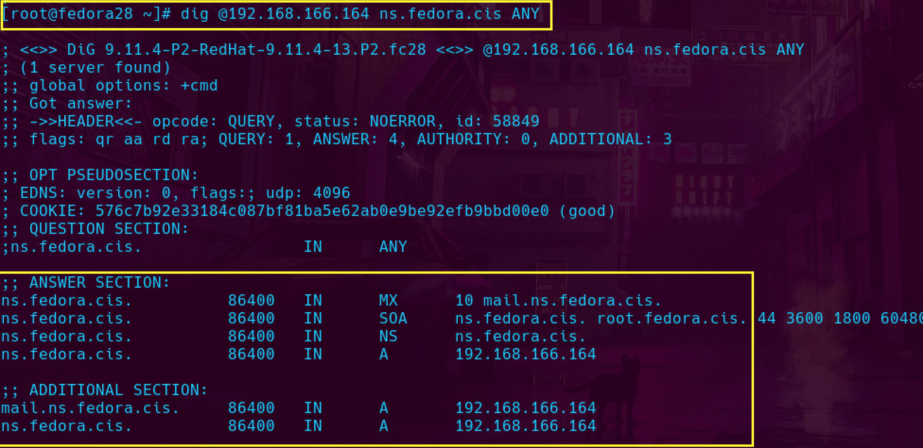

**Query CNAME records**

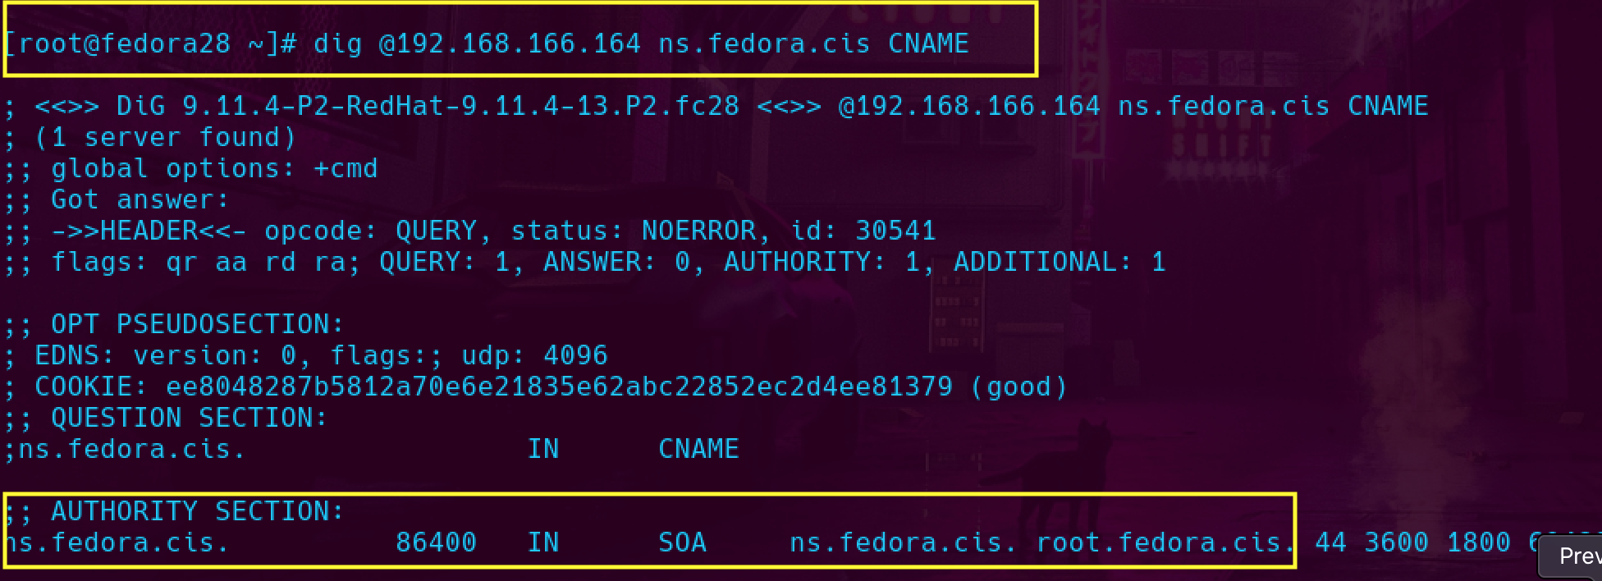

**RESOURCES:**

**Fedora 28: Install bind for DNS server**

<https://www.hiroom2.com/2018/05/17/fedora-28-bind-en/>

**How to Configure BIND as a Private Network DNS Server on CentOS 7(Fedora 28)**

<https://www.digitalocean.com/community/tutorials/how-to-configure-bind-as-a-private-network-dns-server-on-centos-7>

**BIND: Install / Configure**

<https://www.server-world.info/en/note?os=Fedora_28&p=dns&f=1>

**How to setup a DNS server with bind**

<https://fedoramagazine.org/how-to-setup-a-dns-server-with-bind/>

**Sample zone file:**  [cis217.local.txtPreview the document](https://canvas.highline.edu/courses/1862999/files/129605784/download?wrap=1)