Lab 05B

Description: This lab will demonstrate the installation and use of an email server in Linux.

Part 1) Ubuntu 18.04.1 Server  
Part 2) Fedora 28-1.1 Server

RESOURCES: [Email Server Resources](https://canvas.highline.edu/courses/1862999/pages/email-server-resources)

Part 1)

On Ubuntu Server 18.04.1:

Install postfix MTA:

**# sudo DEBIAN_PRIORITY=low apt install postfix**

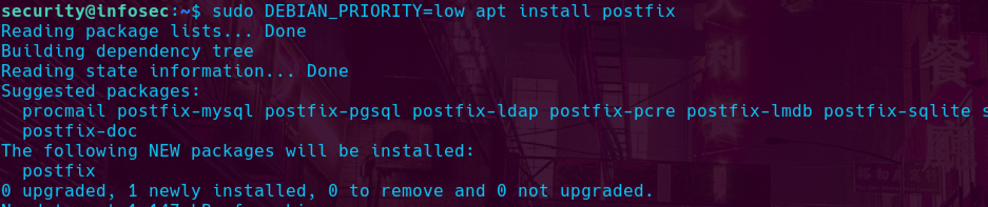

Configure postfix to use localhost.localdomain and ip address 127.0.0.1:

Install mutt or mail (mailutils) MUA:

**# apt-get install mutt (For Debian / Ubuntu based system)**

Show that you can send a test email from one user to another on the local machine:

**Using s-nail:**

Figure To Batman From Security

Figure To Security From Batman

**Using mutt:**

Figure To Batman From Security

Figure To Security From Batman

Part 2)

On Fedora Server 28.1-1:

Install postfix MTA:

**# dnf install -y postfix**

Configure postfix to use localhost.localdomain and ip address 127.0.0.1:

https://www.server-world.info/en/note?os=Fedora_28&p=mail&f=1

Install mutt or mail (mailx) MUA:

**# dnf install -y mutt**

Show that you can send a test email from one user to another on the local machine:

