Description: This lab will demonstrate the installation of the LAMP stack in Linux.

Perform the following activities on the specified virtual machines.  Record your commands and answer any questions in the lab activities.

Part 1) Ubuntu 18.04.1 Server

RESOURCES: [LAMP installation resources](https://canvas.highline.edu/courses/1862999/pages/lamp-installation-resources)

Part 1)

Install and configure apache2, mysql, php and phpmyadmin on Ubuntu Server 18.04.1:

sudo dnf update  
sudo dnf install httpd

sudo apt install php  
sudo apt install mysql-server  
sudo apt install phpmyadmin

6. Create and save a file named info.php in the /var/www/html directory containing the following text:

<?php  
phpinfo();  
?>

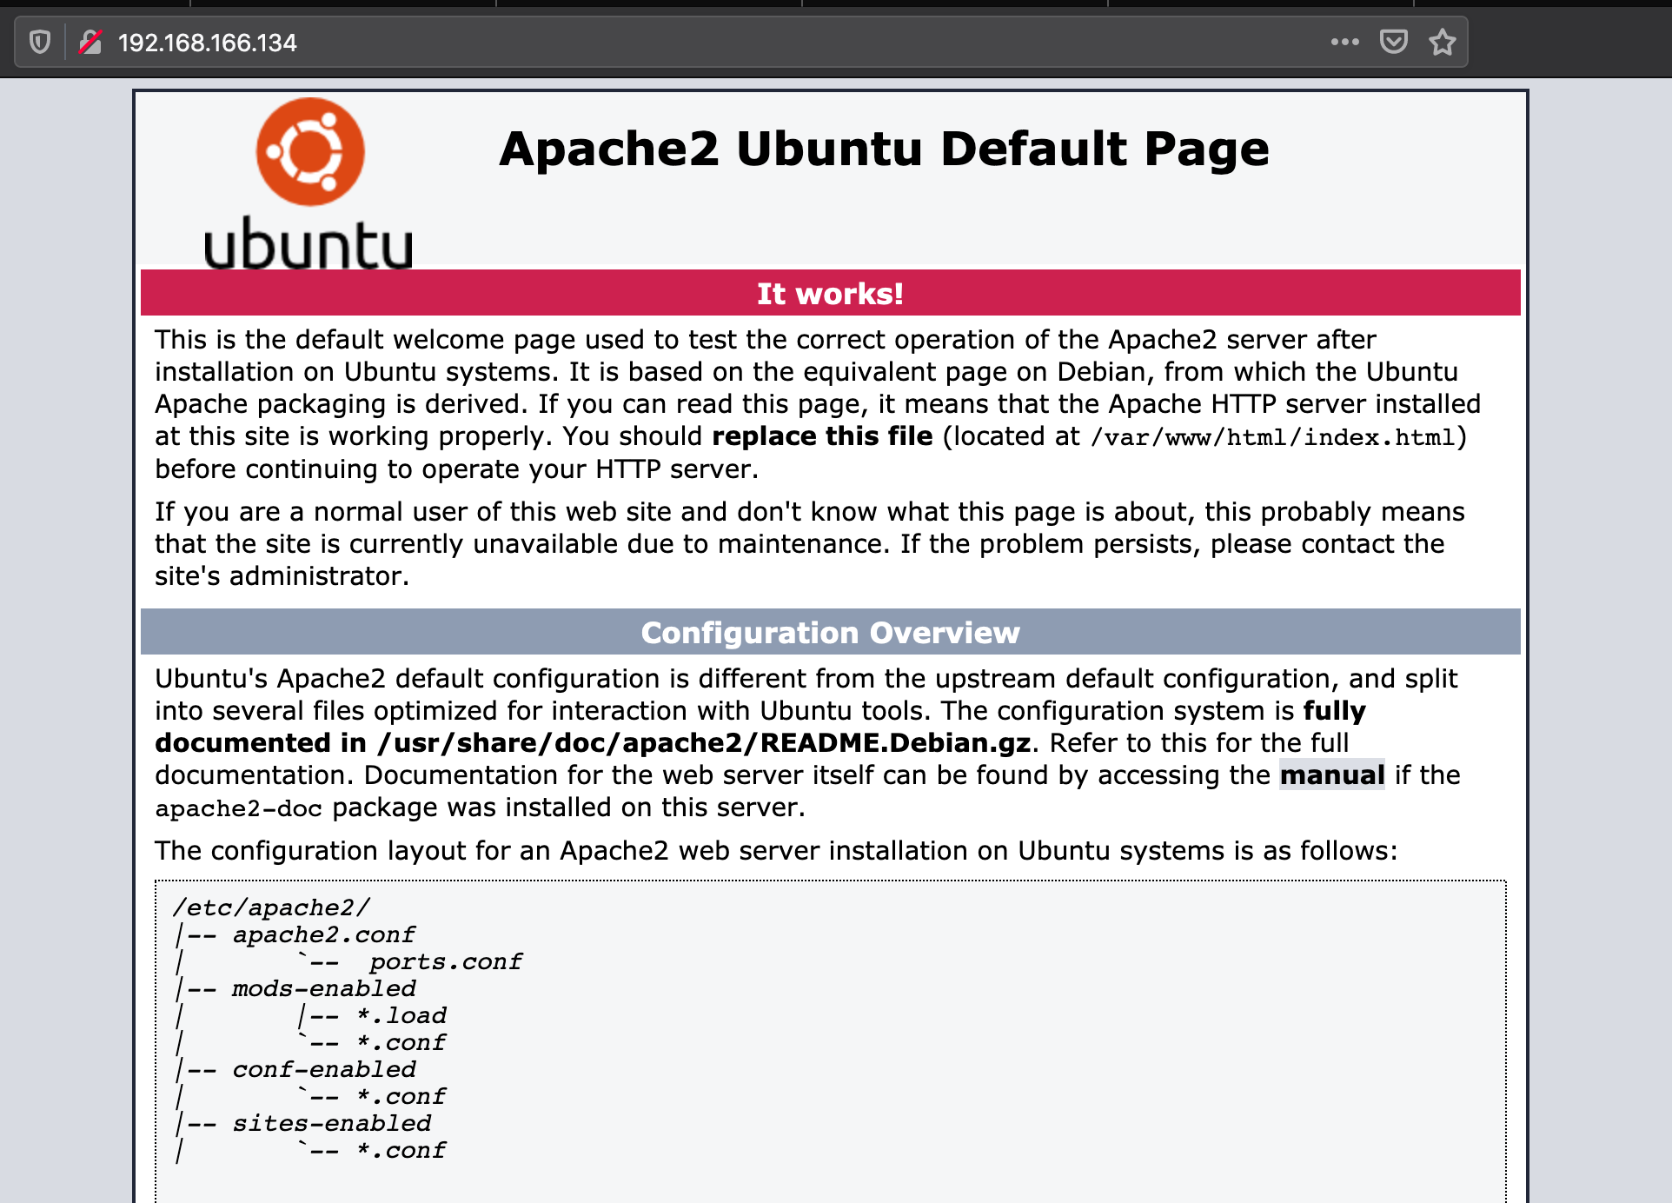

http://localhost/

http://localhost/info.php

<http://localhost/phpmyadmin/>

I had issues with this admin page resource loading properly, here is my solution:

https://askubuntu.com/questions/668734/the-requested-url-phpmyadmin-was-not-found-on-this-server

­

Part 2)

Install and configure apache2, mysql, php and phpmyadmin on Fedora 28-1.1 Server:

http://localhost/

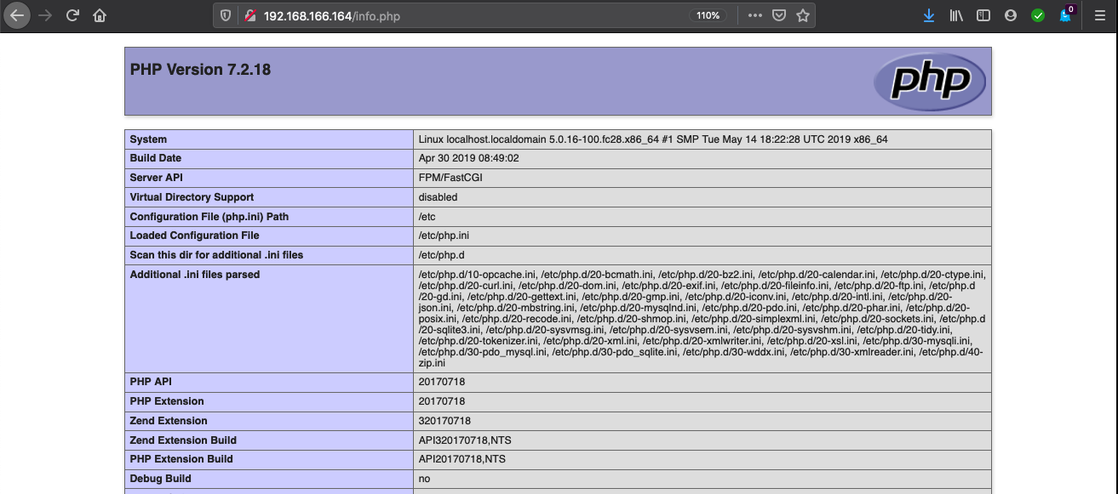  
http://localhost/info.php

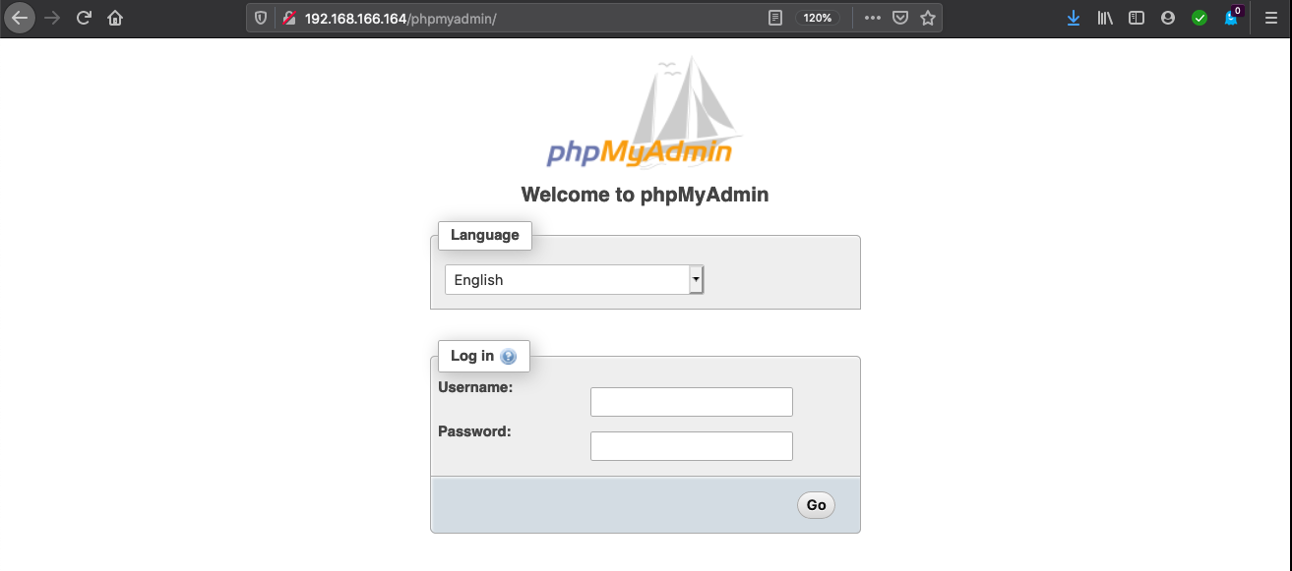

http://localhost/phpmyadmin/

­­­