# Lab 02B

Part 1) Ubuntu Server 18.04.1 Server

1. Working as the user named **mary**, create a directory in **/tmp** named **campaign**.
   1. mkdir /tmp/campaign

1. Display the standard access permissions for **campaign**.
   1. ls -la /tmp/campaign/

1. Display the ACL permissions for **campaign**using the **getfacl** command.
   1. getfacl /tmp/campaign

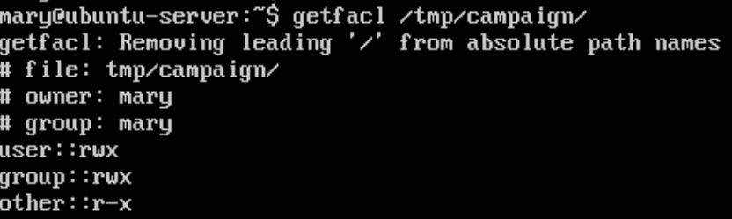

1. Adjust the permissions such that in addition to **mary**'s current access, members of the group **staff** (**jed**and **max)**have read write and execute access to the **campaign**directory.

1. Test your permissions by working as each of the 3 users above and 1) trying to view the contents of the directory and 2) create a file in the directory.

6. Look at the permissions of the new files that **mary**and **jed** created. Can **max** read the files and write files to the directory?

**Yes. Since he is a member of the group and has rwx permisions**

Part 2) Fedora Server 28-1.1

1. Working as the user named **mary**, create a directory in **/tmp** named **campaign**.
   1. mkdir /tmp/campaign

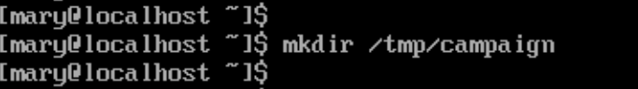

1. Display the standard access permissions for **campaign**.
   1. ls -la /tmp/campaign

1. Display the ACL permissions for **campaign**using the **getfacl** command.
   1. getfacl /tmp/campaign

1. Adjust the permissions such that in addition to  **mary**'s current access, members of the group **staff** (**jed**and **max)** have read write and execute access to the **campaign**directory.
   1. usermod --groups mary --append jed
   2. usermod --groups mary –append max

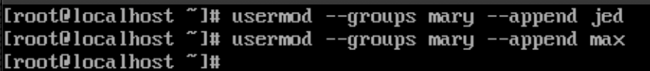

1. Test your permissions by working as each of the 3 users above and 1) trying to view the contents of the directory and 2) create a file in the directory.

6. Look at the permissions of the new files that **mary**and **jed** created. Can **max** read the files and write files to the directory

**Yes. Since max is a member of group mary, they have the same group permissions (rwx).**