# Lab 03A

Description: netstat is a command line utility that provides a list of all current network connections for a machine. This tool is extremely useful in identifying port numbers in use.

Perform the following activities on both of your virtual machines.  Record your commands and answer any questions in the lab activities.

Part 1) Ubuntu Server 18.04.1 Server

PROCEDURE: Use the book and the appropriate man pages to form with **root** privileges to perform these commands.)

Enter each of the following commands.  Briefly explain the command option. Show the output of each command.

**Viewing netstat output**

1. **netstat -a**

**netstat -a, --all displays all sockets**

1. **netstat -at**

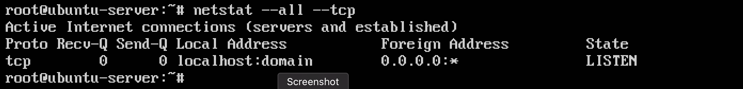

**netstat --all --tcp, displays all tcp sockets**

1. **netstat -au**

**netstat --all --udp, displays all udp sockets**

1. **netstat -l**

**netstat --listen, displays only listening sockets servers**

1. **netstat -s**

**netstat --statistics, displays networking statistics**

1. **netstat -r**

**netstat --route, displays the routing table**

**Viewing the Network Configuration**

1. **ifconfig –a** or **ip addr**

Results of running the command ***ip addr***

1. **hostname**

Results of running the command ***hostname***

1. Type **cat /etc/resolv.conf** - what information does this file contain?

This file contains all the nameservers and sets the order of domains for dns to use.

1. In Ubuntu, type **cat /etc/netplan/\***- what information does this file contain?

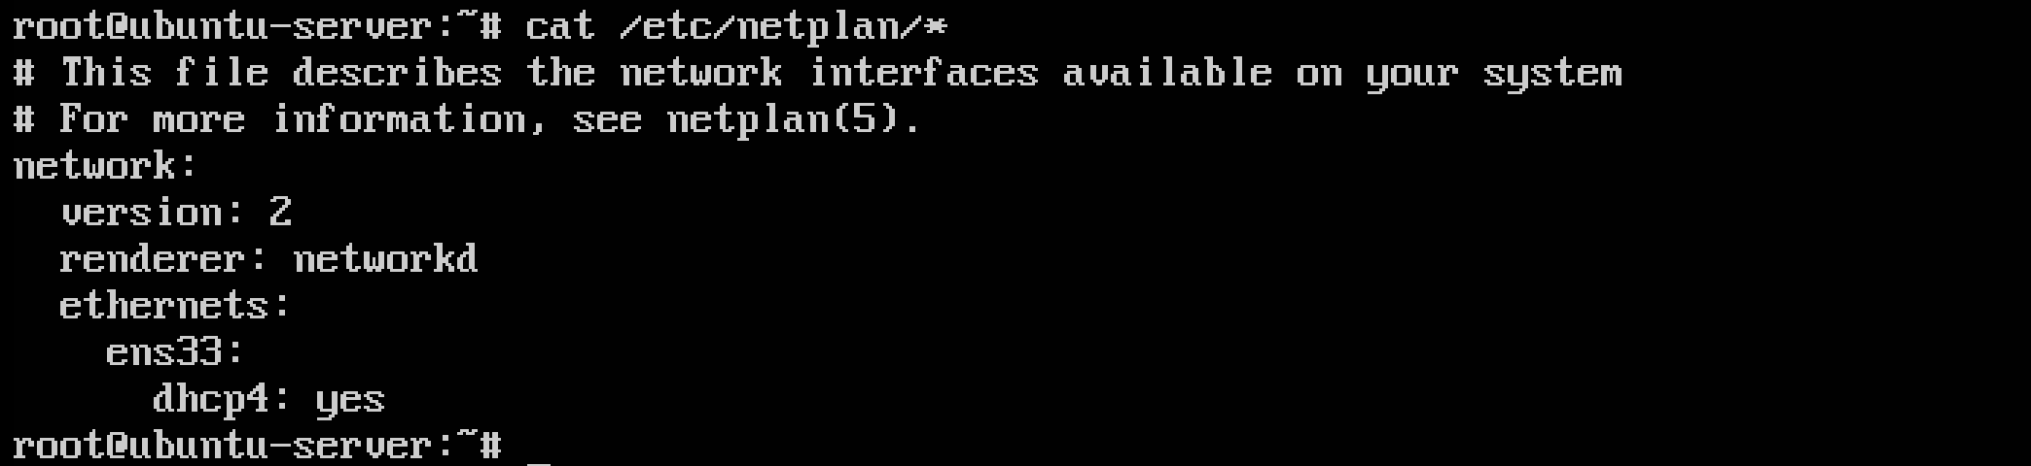

This file contains information about all the network interfaces on your system

Enter each of the following commands.  Briefly explain the command option. Show the output of each command.

Part 2) Fedora Server 28-1.1

**Viewing netstat output**

1. **netstat -a**

**netstat -a, --all displays all sockets**

1. **netstat -at**

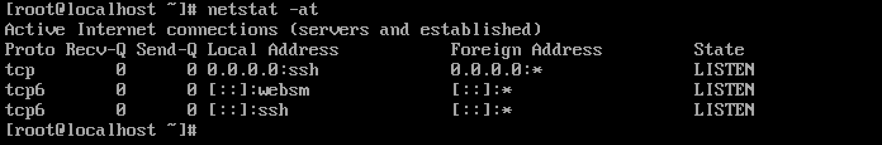

**netstat --all --tcp, displays all tcp sockets**

**netstat --all --udp, displays all udp sockets**

1. **netstat -l**

**netstat --listen, displays only listening sockets servers**

1. **netstat -s**

**netstat --statistics, displays networking statistics**

1. **netstat -r**

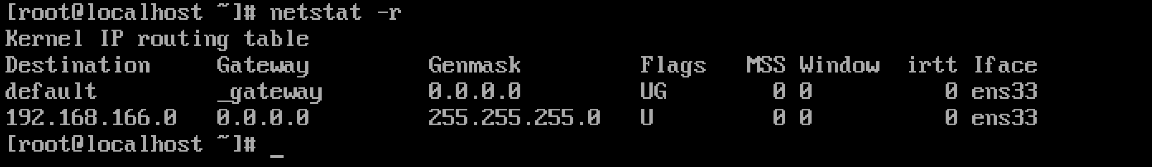

**netstat --route, displays the routing table**

**Viewing the Network Configuration**

1. **ifconfig –a** or **ip addr**

1. **hostname**

1. Type **cat /etc/resolv.conf** - what information does this file contain?

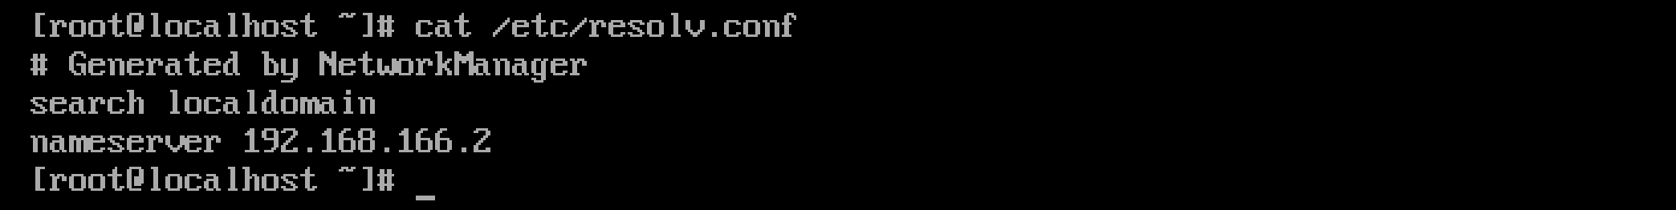

This file contains all the nameservers and sets the order of domains for dns to use.

1. 14. In Fedora, type **cat /etc/sysconfig/network-scripts/ifcfg-e\*** -

What information does this file contain?

This file contains the configuration for the ethernet interface, indicated by TYPE=Ethernet