Final Project - Databases

Nathaniel Carlson

CS-499

For Milestone 4, I’ve created all of the SQL Database tables I need for my final project, populated them with some sample data, and then imported and connected the tables in Qlik. In the current iteration of this dashboard in Excel, all of the data is housed within a single excel file and in many cases, this data was pulled from other reports that provided calculated values used, so the data in the dashboard was often one or two steps removed from the source raw data. By compiling the raw data into a SQL database and connecting it directly from there to a Qlik dashboard, the intent is to simplify the process of updating the data, improve the overall performance of the dashboard, and also make it easier to create other reports that share some of the same data points. This will also reduce the chance of transcription errors, and ensure that the data being used across all reports is consistent.

Creating the needed SQL tables started by identifying the different data I needed for the calculations used in the bonus scorecard and tracking all of the data points back to their original sources. From there I created SQL tables using the columns directly from the source to minimize time and effort in modifying or adjusting the data before importing it into the database. I then created tables in a SQL database to house the data from each of these sources, with careful attention paid to using the correct data types for the data being imported. Here is an example of the creation of one of the necessary tables.

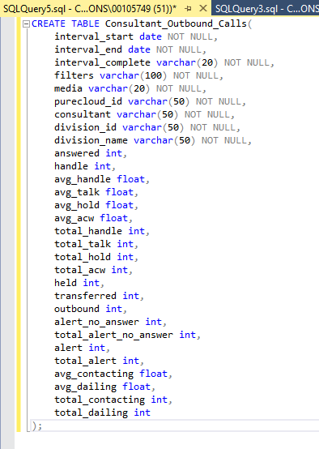

In total, I created 11 separate tables to house all of the data needed to populate the data points needed for the scorecard.

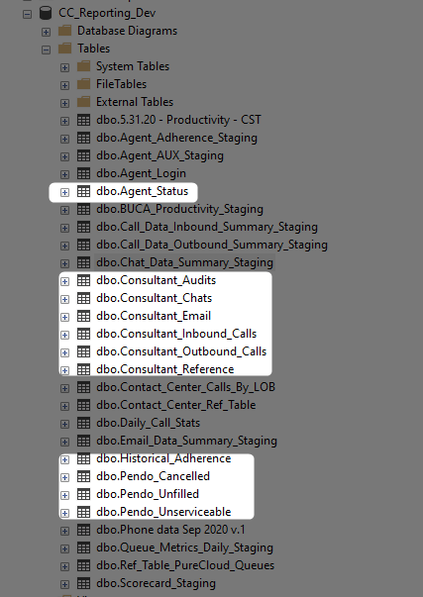

I then imported a months’ worth of data for each of the tables and inserted the data into the tables.

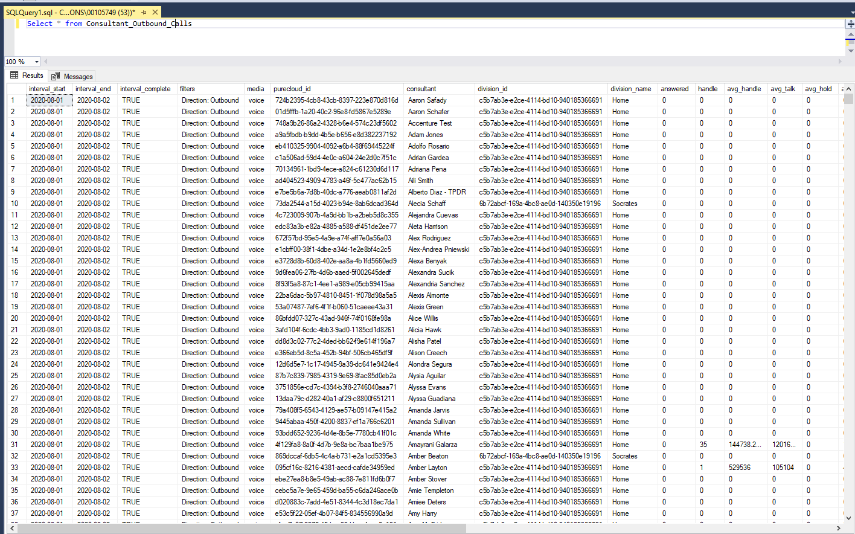

This took a bit of time and effort to ensure that formatting for the columns matched the data types for the database, that there were not any unexpected values in the data that would cause issues, and that the appropriate columns were identified as not null and as key values. Once the tables were all identified and mapped out, created, populated with data, and checked for accuracy, I was able to create a connection between Qlik and the database tables.

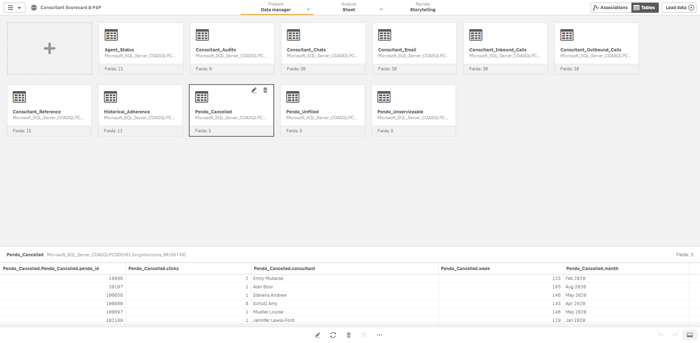

Within Qlik, I was able to edit the connections between tables, and also add a few additional calculated fields needed within the tables.

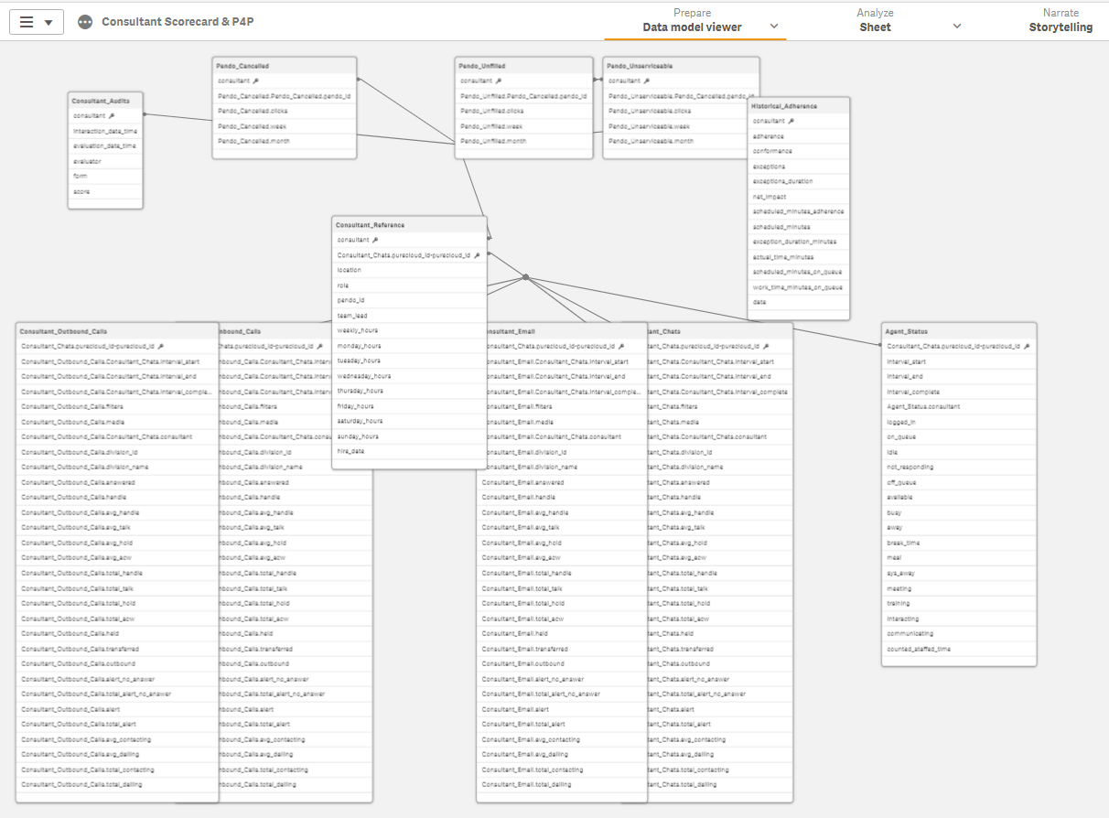

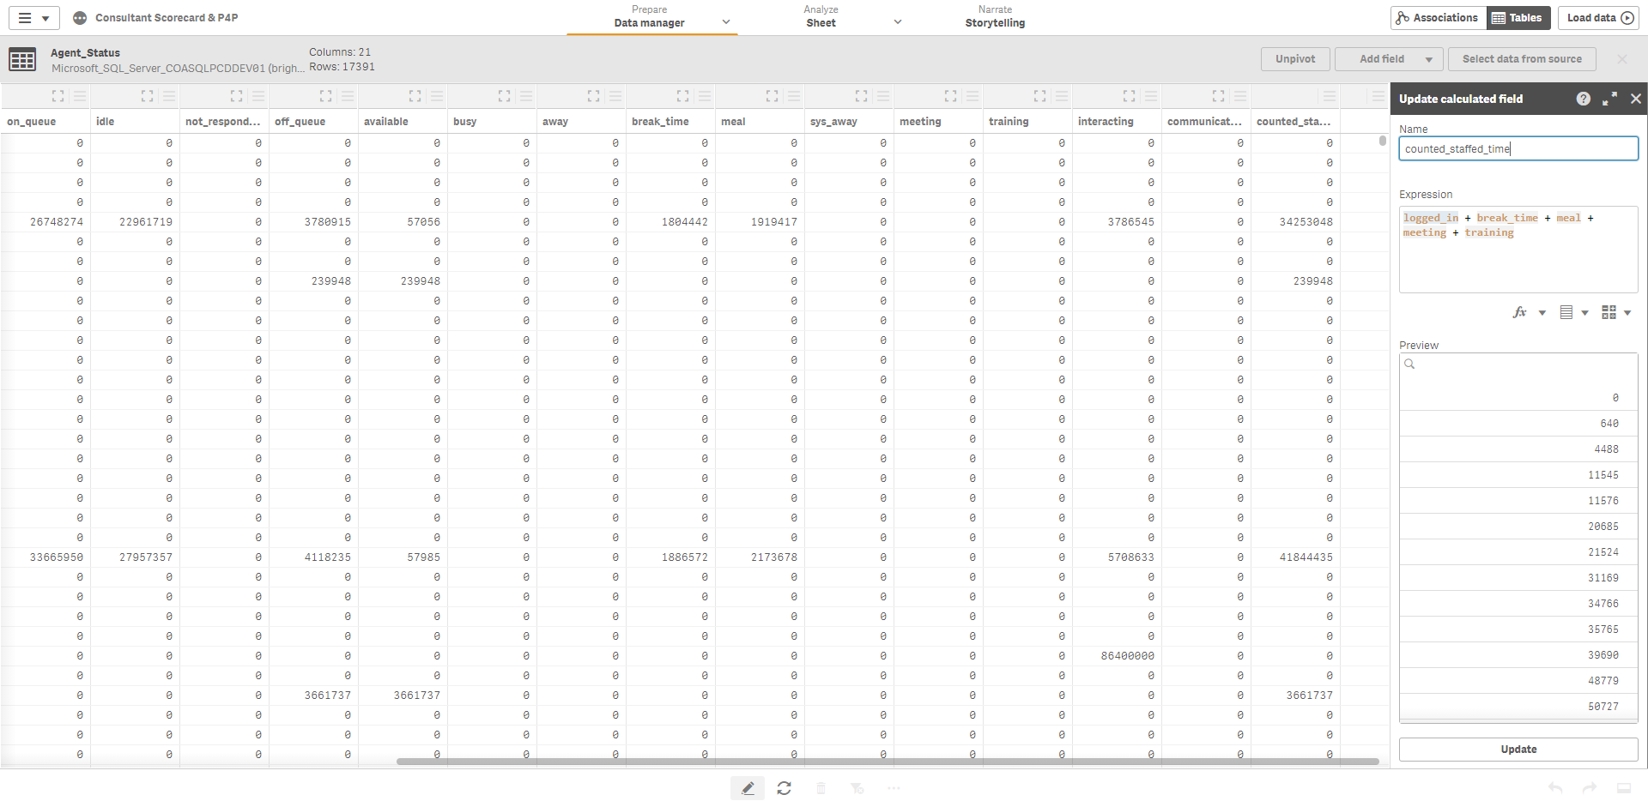

I now have the tables created and connected to Qlik to make updating the data within them straightforward, and to ensure that the dashboard is updated as soon as new data is populated into the database. The skills demonstrated in this milestone are the creation, management, and use of SQL database tables, and linking to them in a useful and practical manner in Qlik.