**Module 2 and 3**

**Logs**

------------------------------------------------------------------------------

01/06/2020 08:48:11 ** Saving... Repository EDW_DEV, Folder DATA_STRUCTURES

------------------------------------------------------------------------------

source SALES_TRANSACTIONS:EMPLOYEES inserted.

source SALES_TRANSACTIONS:SALES_CUSTOMERS inserted.

source SALES_TRANSACTIONS:TRANSACTIONS inserted.

source SALES_TRANSACTIONS:MARKETING_CUSTOMERS inserted.

source SALES_TRANSACTIONS:CUSTOMER_ORDERS inserted.

source SALES_TRANSACTIONS:CURRENT_EMPLOYEES inserted.

------------------------------------------------------------------------------

------------------------------------------------------------------------------

01/06/2020 08:52:32 ** Saving... Repository EDW_DEV, Folder DATA_STRUCTURES

------------------------------------------------------------------------------

source OPERATIONAL_DATA_STORE:ODS_TRANS_REVENUE inserted.

source OPERATIONAL_DATA_STORE:ODS_DEALER_SALES inserted.

source OPERATIONAL_DATA_STORE:ODS_DAILY_SALES_DATES inserted.

------------------------------------------------------------------------------

------------------------------------------------------------------------------

01/06/2020 08:53:59 ** Saving... Repository EDW_DEV, Folder DATA_STRUCTURES

------------------------------------------------------------------------------

source ENTERPRISE_DATA_WAREHOUSE:FACTS_ATOMIC inserted.

------------------------------------------------------------------------------

------------------------------------------------------------------------------

01/06/2020 08:57:20 ** Saving... Repository EDW_DEV, Folder DATA_STRUCTURES

------------------------------------------------------------------------------

source FlatFile:SALES_TRANSACTIONS inserted.

------------------------------------------------------------------------------

------------------------------------------------------------------------------

01/06/2020 09:04:00 ** Saving... Repository EDW_DEV, Folder DATA_STRUCTURES

------------------------------------------------------------------------------

source FlatFile:DAILY_TRANSACTIONS inserted.

------------------------------------------------------------------------------

------------------------------------------------------------------------------

01/06/2020 09:06:56 ** Saving... Repository EDW_DEV, Folder DATA_STRUCTURES

------------------------------------------------------------------------------

Target ODS_DAILY_SALES_DATES inserted.

Target ODS_HIGH_INCOME_FEMALE inserted.

Target ODS_HIGH_INCOME_SENIOR inserted.

Target ODS_TRANSACTIONS inserted.

Target ODS_TRANS_REVENUE inserted.

Target ODS_REV_DATE_NAME_PAYMENT inserted.

Target ODS_HIGH_INCOME_MALE inserted.

Target ODS_DEALER_SALES inserted.

Target ODS_CUST_TRANS_DETAIL inserted.

Target ODS_CUST_DEALER_DETAIL inserted.

------------------------------------------------------------------------------

------------------------------------------------------------------------------

01/06/2020 09:08:09 ** Saving... Repository EDW_DEV, Folder DATA_STRUCTURES

------------------------------------------------------------------------------

Target DIM_EMPLOYEES inserted.

Target DIM_TIME inserted.

Target SUM_PRODUCT_DATE inserted.

Target SUM_PRODUCT_MONTH inserted.

Target SUM_PRODUCT_DEALERSHIP inserted.

Target FACTS_ATOMIC inserted.

Target DIM_PRODUCTS inserted.

Target DIM_DEALERSHIP inserted.

Target DIM_CUSTOMERS inserted.

------------------------------------------------------------------------------

------------------------------------------------------------------------------

01/06/2020 09:12:26 ** Saving... Repository EDW_DEV, Folder LOAD_ODS

------------------------------------------------------------------------------

Shortcut to source SALES_TRANSACTIONS:Shortcut_to_TRANSACTIONS inserted.

Validating transformations of mapping mp_CURRENT_TRANS_REVENUE...

...transformation validation completed with no errors.

Validating data flow of mapping mp_CURRENT_TRANS_REVENUE...

...mapping has no Targets.

...Mapping must have at least one loadable target.

...there are data flow validation errors.

Parsing mapping mp_CURRENT_TRANS_REVENUE...

...parsing completed with no errors.

******** Mapping mp_CURRENT_TRANS_REVENUE is INVALID ********

mapping mp_CURRENT_TRANS_REVENUE inserted.

------------------------------------------------------------------------------

------------------------------------------------------------------------------

01/06/2020 09:37:16 ** Saving... Repository EDW_DEV, Folder LOAD_ODS

------------------------------------------------------------------------------

Shortcut to target Shortcut_to_ODS_TRANS_REVENUE inserted.

Validating transformations of mapping mp_CURRENT_TRANS_REVENUE...

...transformation validation completed with no errors.

Validating data flow of mapping mp_CURRENT_TRANS_REVENUE...

...data flow validation completed with no errors.

Parsing mapping mp_CURRENT_TRANS_REVENUE...

...parsing completed with no errors.

******** Mapping mp_CURRENT_TRANS_REVENUE is VALID ********

mapping mp_CURRENT_TRANS_REVENUE updated.

------------------------------------------------------------------------------

------------------------------------------------------------------------------

01/06/2020 09:38:29 ** Saving... Repository EDW_DEV, Folder LOAD_ODS

------------------------------------------------------------------------------

Validating transformations of mapping mp_CURRENT_TRANS_REVENUE...

...transformation validation completed with no errors.

Validating data flow of mapping mp_CURRENT_TRANS_REVENUE...

...data flow validation completed with no errors.

Parsing mapping mp_CURRENT_TRANS_REVENUE...

...parsing completed with no errors.

******** Mapping mp_CURRENT_TRANS_REVENUE is VALID ********

mapping mp_CURRENT_TRANS_REVENUE updated.

------------------------------------------------------------------------------

**Source: Flat File SALES_TRANSACTION inserted**

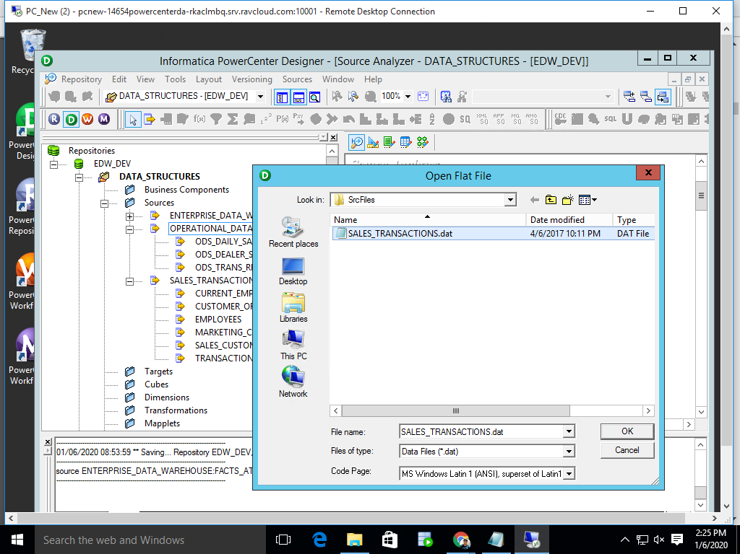

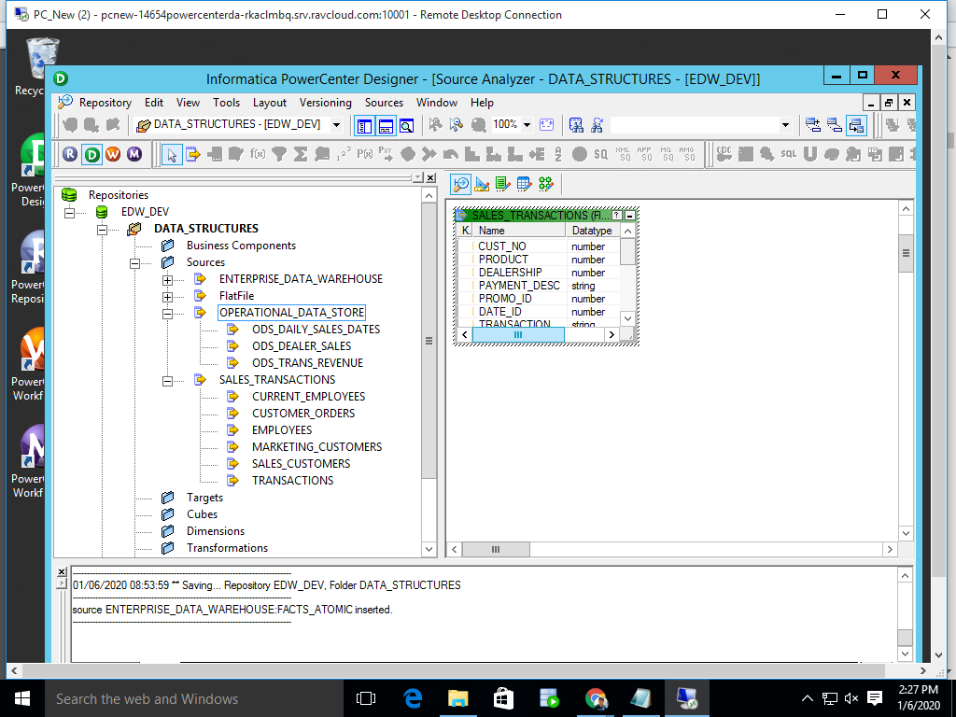

**EDW FACTS_ATOMIC inserted**



**Target ODS tables inserted**

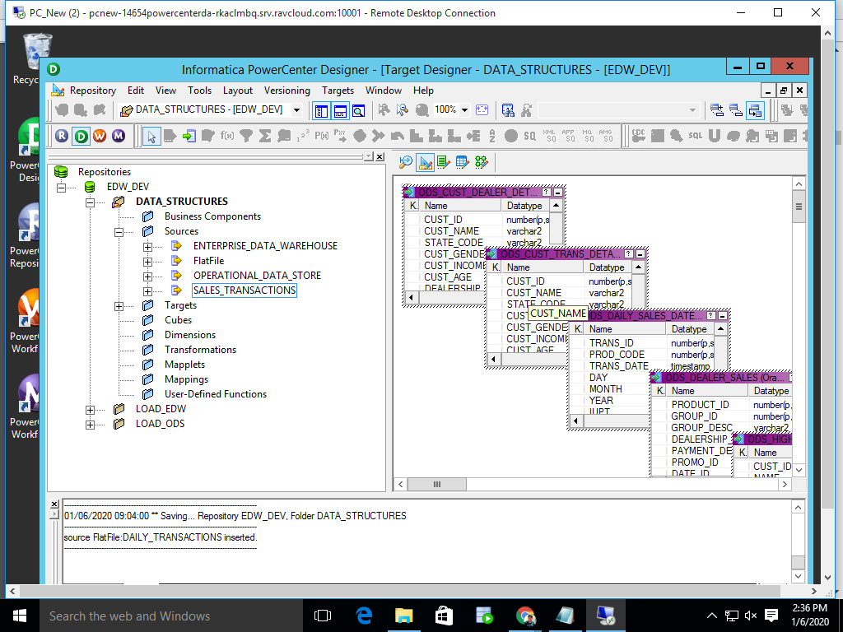

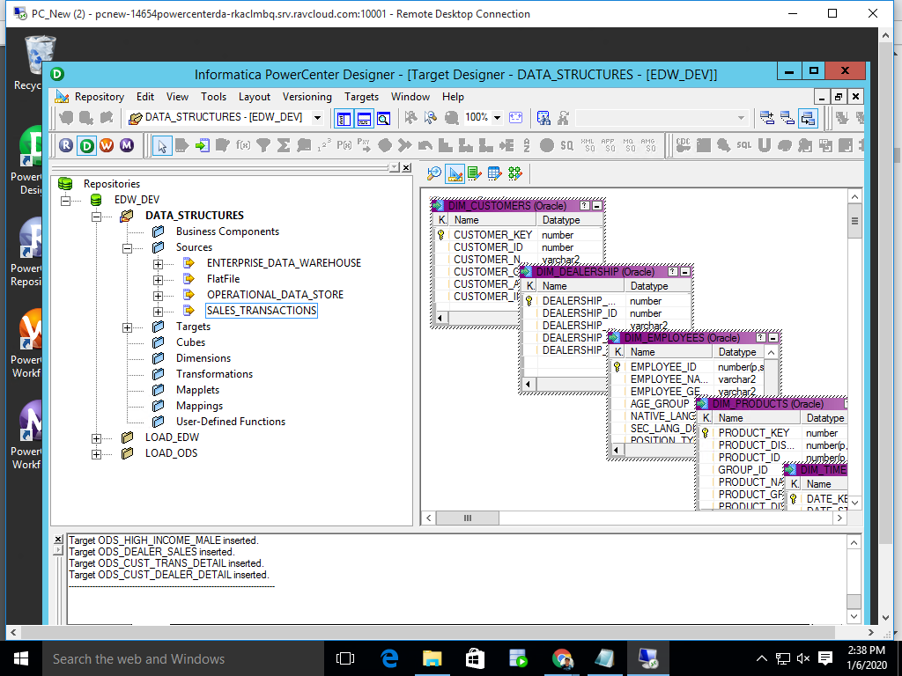

**Copied and Updated SALES_TRANSACTIONS to DAILY_TRANSACTIONS**

**>source FlatFile:SALES_TRANSACTIONS inserted.**

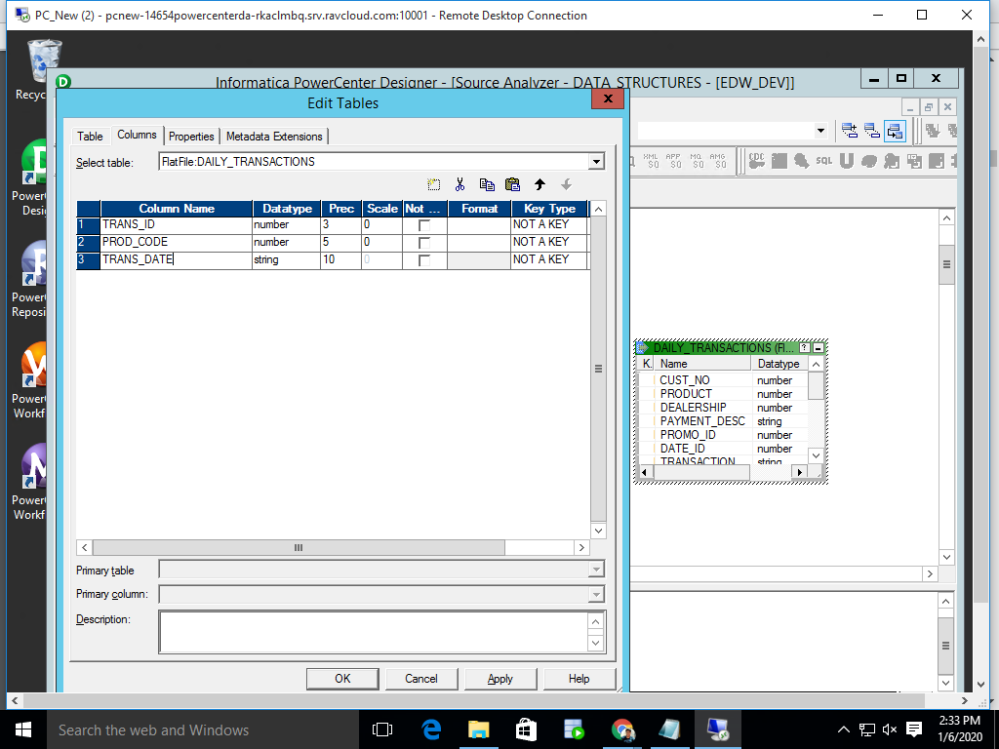

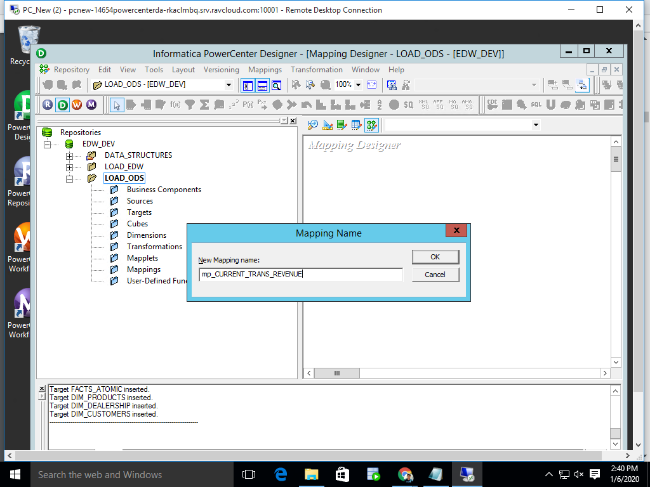**Mapping Created**

**Transformations done**

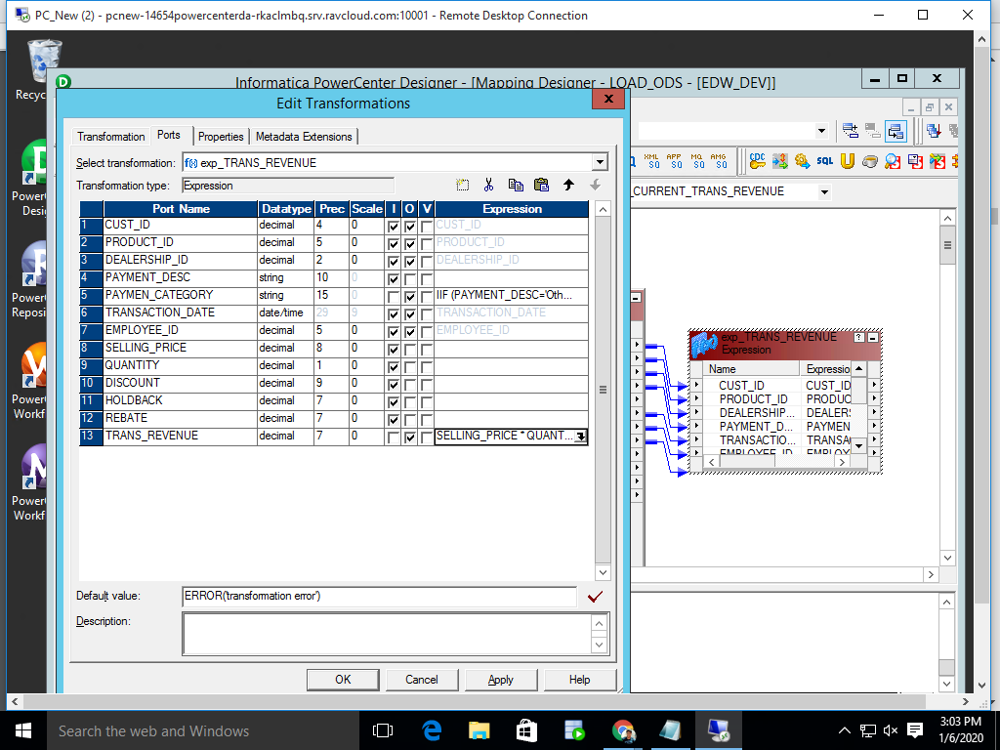

Mapping completed and validated

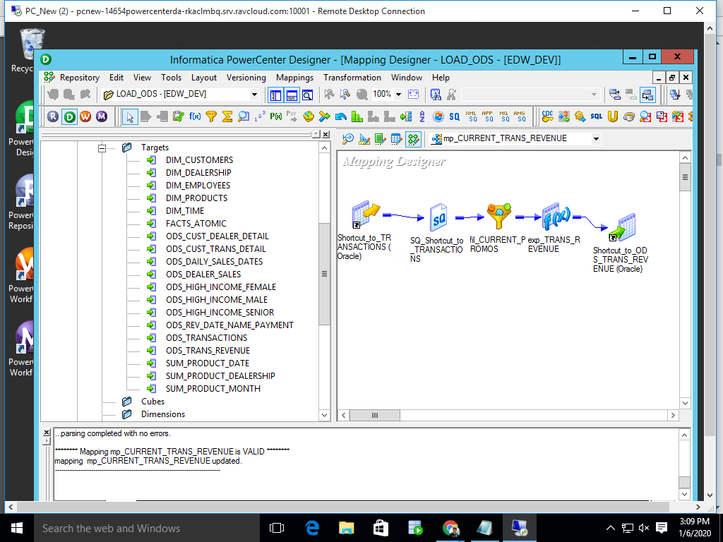

**Create task and workflow**

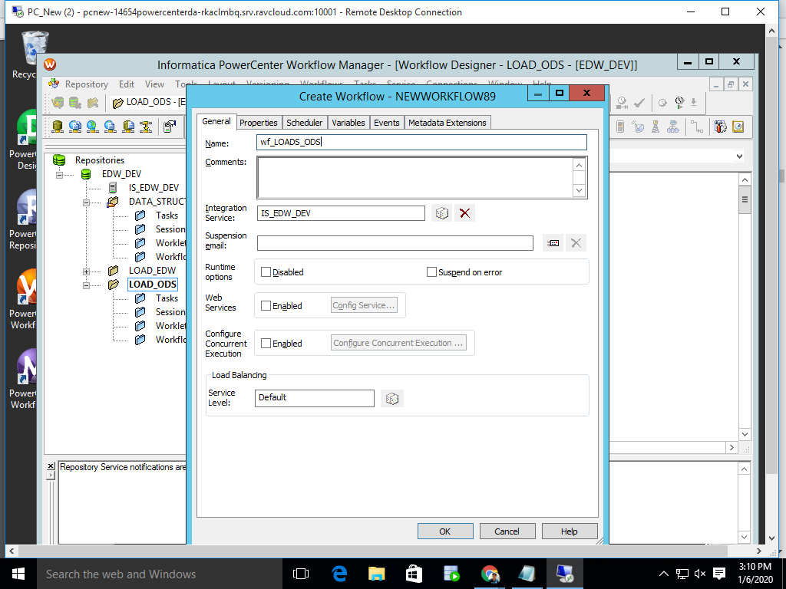

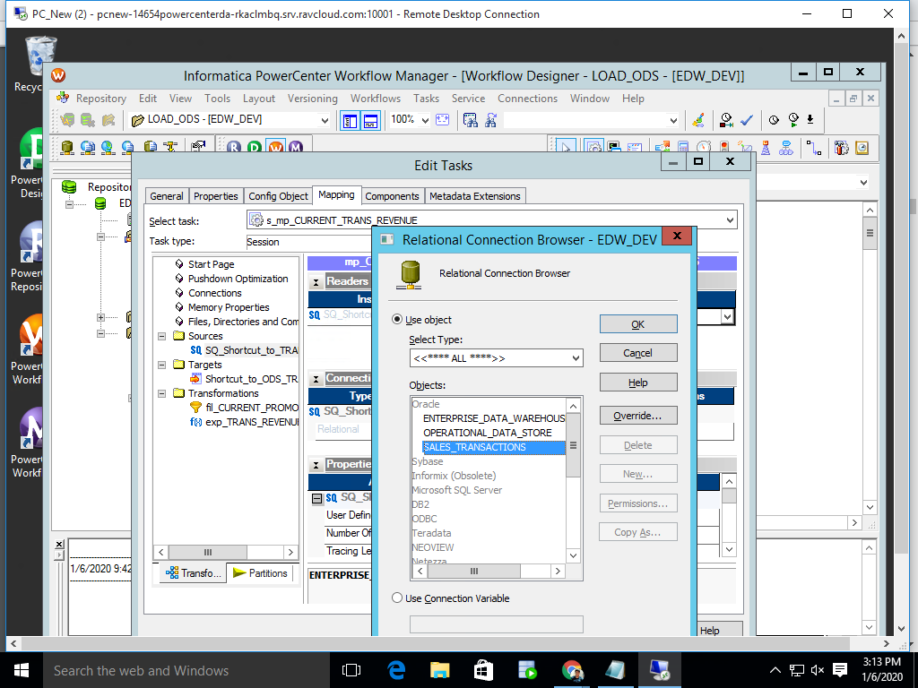

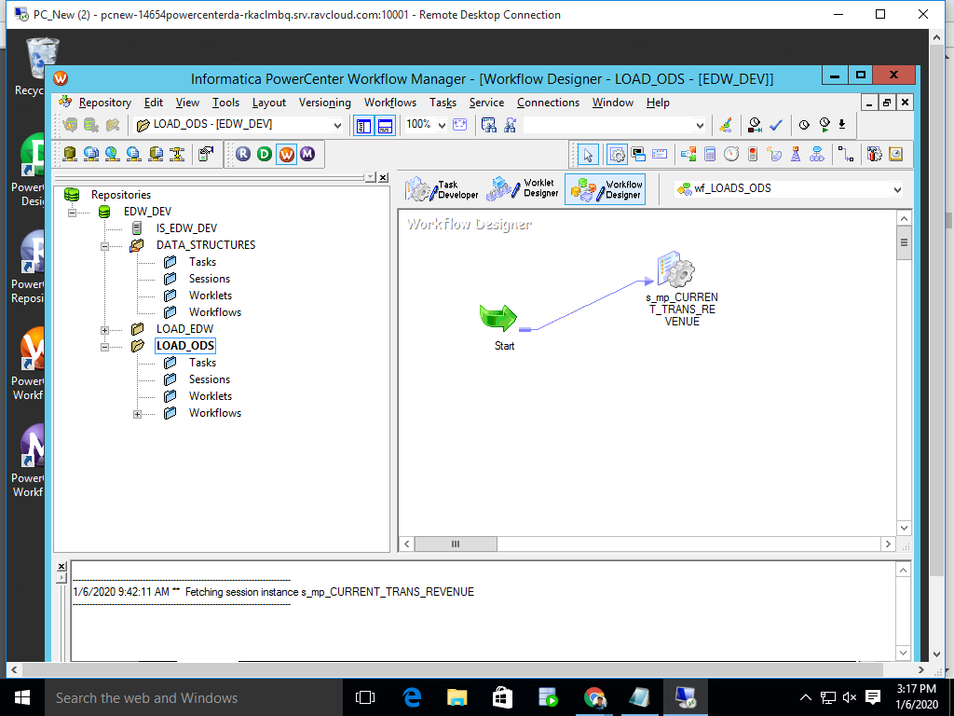

**Details**

