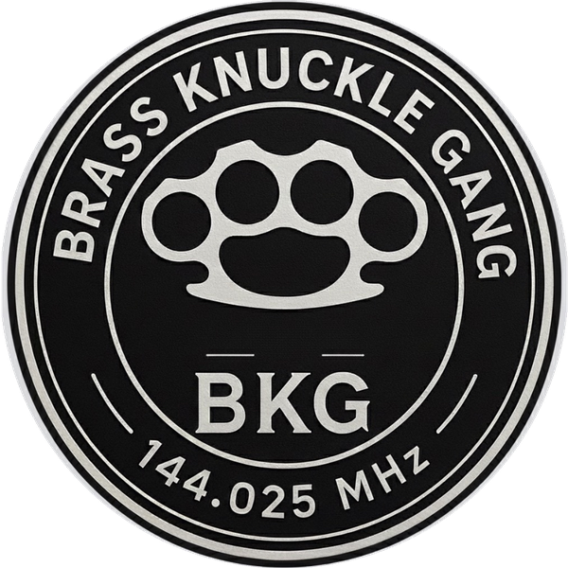 | BRASS KNUCKLE GANG  Pounding brass on 2 meters since 2024 | 144.025 MHz  2M CW OR BUST  WWW.BKG.CLUB

THE MANIFESTO
Why we roll, and what we roll for.
We are the Brass Knuckle Gang, and we came together around a simple conviction: amateur radio is best when it asks something of you. Not when it hands you a signal for free, but when you earn that signal with skill, build it with your own two hands, and share it with the people who live within range of your antenna. We pound brass on 2 meters because it is the purest and most demanding way to get on the air. The road we walk is the one most operators drove past years ago, and that is exactly why we walk it.
This document is our reason for being. It is what we fight for, and it is what we ask every member to carry forward.
First, we grow the code. Morse is not a relic gathering dust in the history of the hobby. It is the real thing, alive in the hands of anyone willing to learn it, and we intend to keep it that way. Our purpose is to swell the ranks of operators who can send and copy CW with confidence. We lower the barrier for the curious, we sit with the beginner who is still counting dits, and we prove night after night that a steady fist and a patient ear will outperform the most expensive rig on the market. Every operator we bring to the key is a victory for the entire hobby, not just for us.
Second, we claim the 2 meter band, and we do it in code. 144 MHz is our home, and far too much of it sits silent while the world talks past it on other bands. We exist to put activity back on those frequencies, and above everything else we champion CW on 2 meters, a mode so overlooked that most operators no longer believe it is there at all. When Morse on VHF becomes an ordinary thing to hear again, we reopen a door that has been closed for the better part of a generation. That door leads somewhere worth going, and we intend to hold it open for everyone who follows.
Third, we bring back the tinker. Amateur radio was built by experimenters, by people who wanted to know what would happen if they tried, and somewhere along the way the hobby traded that spirit for a catalog and a credit card. We want the spirit back. We encourage our members to build their own antennas, to roll their own gear, to chase strange propagation, and to try modes that nobody has touched in years. We treat the question of whether something will even work as an invitation rather than a warning. Experimentation is the beating heart of this hobby, and we refuse to let it become a footnote in the story of what radio used to be.
Fourth, we build the crew. The 2 meter band does not carry far, and we consider that a gift rather than a limitation. Because our signals stay close to home, the band forces us to know the operators in our own backyard. Our mission is genuine community: we plan our schedules together, we meet in person, we mentor the newcomers the way good elmers always have, and we weave tight local networks of operators who share our way of thinking. There is no room here for the lone wolf. On a band this small, we grow as one crew or we do not grow at all.
These four purposes are not separate goals sitting side by side. They feed one another. The code draws in new operators, the new operators fill the band, a full band rewards the experimenter, and the experimenter gives the community something to gather around. Turn any one of them and the others turn with it.
So this is our charge to every member who wears the name. Get on the key. Get on 2 meters. Build something with your hands, and bring somebody new along with you. Do those things, and the hobby we love does not merely survive. It comes roaring back.
BRASS KNUCKLE GANG
2M CW OR BUST

