Technical Portion of Proposal

1. Statement of Work

1.a. Objectives
The Insight Toolkit provides researchers with unprecedented access to state-of-the-art image segmentation and registration methods, with little programming required. This availability of methods speeds the development of new applications and invites rigorous validation of new methods via comparison with existing methods. Application development and comparative validations, however, are likely to require the evaluation of parameter spaces that encompass multiple methods and multiple parameters for each of those methods. These large parameter spaces necessitate the use of large validation datasets and/or thousands of Monte Carlo runs to maintain statistical significance. The Insight Toolkit does not directly support batch processing or reporting validation results.
We have developed a software application, BatchMake, and a reporting mechanism, Validation Dashboards, which automate the exploration and statistical analysis of parameter spaces, the comparison of methods, and the processing of large collections of data. BatchMake generates batch-processing scripts for a variety of PC and distributed processing environments and provides methods for the analysis of the results. BatchMake is easily extended to support new platforms and statistical analyses.
Traditionally, for method parameter selection, method comparison, and the processing of a large number of datasets requires the following: (a) researchers must become experts in the art of script writing for batch processing; (b) labs must purchase expensive computer servers or master Grid networking and software development to meet these computational costs, costs that increase exponentially as a function of the number of parameters being investigated; and (c) researchers must understand and correctly apply statistical hypothesis testing to analyze the results.
Regarding scripting and computing equipment, BatchMake can be directed to produce scripts that run on a single computer or that distribute processing across local area networks (LANs) and Grid networks (Open Grid Services Architecture standard draft document at http://www.globus.org). Currently supported operating systems for single-computer processing include Windows, Linux, and Unix machines. LAN and Grid distribution is provided via scripts for Condor-G (http://www.cs.wisc.edu/condor/condorg). Condor-G is an open-source, freely available package that provides cross-platform, distributed, batch processing on Grid networks and heterogeneous computer environments in a LAN. BatchMake build upon the software design of CMake; it is easily extended to support other operating systems and distributed computing environments.
BatchMake is not a single “tumor validation dashboard” or a validation dashboard dedicated to a single type of statistical analysis; it is an extensible statistical analysis and reporting infrastructure. BatchMake already contains multiple statistical analysis methods and can generate reports as Validation Dashboards. BatchMake supports three types of experiments: hypothesis testing, Taguchi processing, and summary reporting, e.g., mean error. Each experiment type produces a different style Validation Dashboard. Training and testing, input and idealOutput data can be provided or generated. Data can be presented in sequence, in random order, using v-fold cross-validation, or using a leave-one-out schedule. An arbitrary number of applications can be applied in one or more pipelines to process the data; possibly using multiple parameters settings. Error measures can be computed as the difference between gray-level images, binary image masks, or spatial object surfaces using ITK-based applications packaged with BatchMake. Hypothesis, Taguchi, and summary results are presented as Validation Dashboard web pages. These pages concisely and intuitively summarize the performance of and statistically significant differences between the methods and parameterizations of a validation experiment (Fig. 1).
Another major component of Batch make is its documentation. In particular, exemplar scripts, that demonstrate proper validation experiment design, are included with BatchMake. These case studies cover the operation of BatchMake and illustrate effective and ineffective experimental design to compare means, variances, and the extremes of performance, e.g., the 95th and 99th percentiles of accuracy via hypotheses and how to choose between methods and parameter settings using Taguchi methods. These exemplar scripts are complimentary to the formal documentation to be provided with BatchMake. That formal documentation consists of a Chapter for the ITK Software Guide and a journal article for the Journal of the Insight Software Consortium.
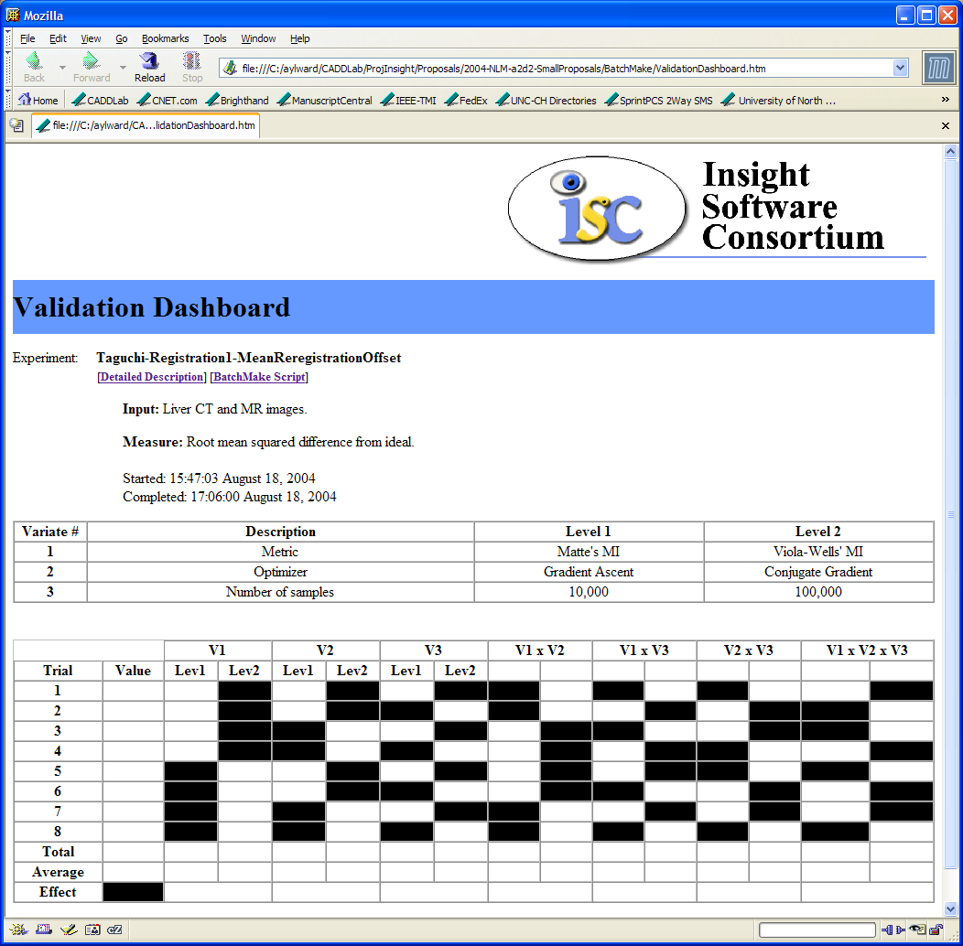
The components of BatchMake have been used to address daily needs in Dr. Stephen Aylward’s and Dr. Guido Gerig’s labs. For example, Dr. Aylward’s lab has submitted an article that reports on the comparison of four non-rigid registration methods for the stacking of images of consecutive histological sections. Those comparisons were conducted using Condor-G scripts. By distributing the processing across machines in the CADDLab, the evaluations required 3 hours instead of an estimated 15 hours if run on a single machine. When additional analyses were needed during the revision of the publication, new scripts were tested on a local machine and then distributed using Condor-G. Results were available later that day instead of delaying work for an entire day. In Dr. Gerig’s group, scripts generated using Matthieu Jomier’s Imaging system are used to specify the pipeline of image processing executables needed quantify volumetric differences in brain structures between hundreds subjects as controls and as patients having various mental disorders. The processing steps vary for each study, and the automated generation of scripts reduces batch-processing errors and has enabled Dr. Gerig’s to produce statistically significant results for a multitude of studies.
Figure 1. Validation Dashboards summarize results from experiments conducted using BatchMake. Shown is the page layout for results from Taguchi analysis of effects for three variates.
Next, we provide an overview of the existing technologies that comprise BatchMake. Then, we itemize what we will deliver to the ITK community to make BatchMake’s distributed processing and statistical analysis capabilities routinely available. The methods comprising each deliverable are then detailed. We conclude with a schedule for delivery.
1.b. Approach

1.b.1. Background
Central to this project is the software design of ITK’s CMake project, (optionally) the open-source and freely available Condor-G project, the Imagine image processing pipeline generator, ITK’s image and statistical analysis methods, Taguchi analysis methods, and DART Dashboards.
CMake (Cross-Platform Make) is an extensible, open-source system that manages the C++ build process for applications in an operating system and compiler independent manner. Unlike many cross-platform systems, CMake is designed to be used in conjunction with the native build environment of the target system. Simple configuration files placed in each source directory are used to generate standard build files (e.g., makefiles on Unix and projects/workspaces in Windows MSVC). Those files are then used in their usual way. Another nice feature of CMake is that it provides a graphical interface to edit those files – embedded rules verify the validity of the combination of options specified by the user.
BatchMake builds directly upon the CMake programming language, simple configuration files, support of native environments, extensibility using modules, and ability to be edited using a GUI.
Condor-G can distribute processes over LAN and Grid networks. It provides a job queuing mechanism, scheduling policy, priority scheme, resource monitoring, and resource management. Users submit their serial or parallel jobs to Condor-G, it places them into a queue, chooses when and where to run the jobs based upon a policy, carefully monitors their progress, and ultimately informs the user upon completion. It can be configured to only use desktop machines where the keyboard and mouse are idle. Should Condor-G detect that a machine is no longer available (such as a key press detected), in many circumstances Condor-G is able to transparently produce a checkpoint and migrate a job to a different machine that would otherwise be idle. Condor-G does not require a shared file system across machines - Condor-G can transfer the job's data files on behalf of the user, or it may be able to transparently redirect all the job's I/O requests back to the submit machine. For the Grid, Condor-G leverages advances in security and resource access in multi-domain environments, as supported by the Globus Toolkit.
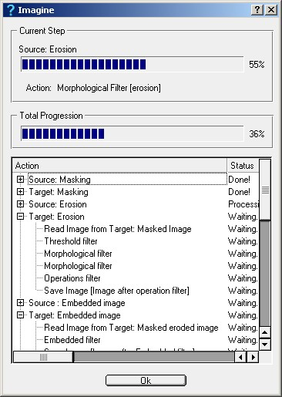
BatchMake does not require Condor-G but will generate scripts compatible with Condor-G as well as Windows (.bat) and Unix/Linux (bash and csh shells) environments.
Figure 2. Imagine’s GUI for image processing pipeline specification and tracking.
Imagine is a GUI for specifying scripts for batch processing images, Fig. 2. Imagine was developed by Matthieu Jomier, a former employee of Guido Gerig; Matthieu has agreed to serve as a paid consultant on this project. Imagine allows users to build batch-processing pipelines comprised of arbitrary numbers of processing steps, many built using ITK. Using Imaging, a user can easily specify that a directory of brain MR images be converted from DICOM, histogram-matched, registered, re-sampled to isotropic voxels, enhanced with variable conductance diffusion, and then saved to another image format.
BatchMake benefits from our experiences as developers and users of Imagine. BatchMake improves upon Imagine by offering script generation for multiple platforms, statistical analysis methods, and Validation Dashboards.
ITK provides the methods needed for image segmentation and registration accuracy quantification as well as statistical analysis for hypothesis testing, Taguchi analysis, and summary reporting. In particular, ITK contains methods for quantifying the distance between landmarks (distance measures), surfaces (Housdorf distance), and segmentation masks (overlap). It also provides methods for computing means, variances, percentiles, goodness-of-fit (chi-squared and log-likelihood), skewness, and kurtosis. These latter statistical analysis methods were added to ITK by Dr. Aylward’s lab.
BatchMake uses ITK statistical methods for error measurement as well as null and alternative hypothesis testing using f-tests and t-tests and effects analysis using the Taguchi method.
The Taguchi method, also called the Robust Design method, pioneered by Dr. Genichi Taguchi, is meant to improve productivity in methods research and application development. Taguchi methods belong to the class of approaches that attempt to ensure quality through design, specifically through the identification and control of critical variables that cause deviations to occur in process quality. For example, Dr. Aylward has applied Taguchi methods to optimize the design of neural networks [Peterson, 1995] by measuring the effects of network architecture, network size, sample size, input noise, and target noise. The Taguchi method can equally be used, for example, to determine the most significant parameter for registration of liver MR/CT images using gradient ascent or conjugate gradient ascent with Mattes’ or Viola-Wells’ mutual information metric.
Parameter selection remains a major challenge in application development and methods research. This challenge is exacerbated by ITK; via ITK, users may easily apply methods even without a complete understanding of their operation and parameters.
DART Dashboards post results from multi-platform compilation and regression testing of large toolkits such as ITK. Software that has a green/successful DART Dashboard compiles on multiple platforms and produces expected results when processing predefined images.
BatchMake posts results regarding the utility (statistical significance) of a method and its parameters. BatchMake, like CMake, generates Dashboards by producing XML data that is parsed to build HTML pages. That XML to HTML conversion can be performed locally, or the XML data can be automatically sent to a remote system for processing and centralized web hosting.

1.b.2. Deliverables
To make our batch processing, validation, and statistical analysis capabilities routinely available to the medical image analysis community, we will provide the following:
- BatchMake will integrate the batch processing and validation tools of Dr. Aylward’s lab (Condor-G, ITK statistical analysis methods, and the Taguchi method) and Dr. Gerig’s lab (the Imagine batch processing architecture). Coding, testing, and documentation standards of the Insight Software Consortium will be followed. BatchMake will be contributed to the Insight Software Consortium’s CVS repository and DART Dashboard.
- A Validation Dashboard will be established for the public submission of validation results. Example BatchMake scripts will be used to generate Validation Dashboard results for select registration tests using different optimizers, parameterizations, and BrainWeb data.
- The documentation for BatchMake will be delivered as a chapter in the Insight SoftwareGuide and as a set of slides to be used during ITK tutorials. Furthermore, an article on BatchMake will be written and submitted to the Insight Software Journal. We will also attend the required ITK developers’ meeting.

1.c. Methods / Tasks

1.c.1. Task I: BatchMake Integration
BatchMake is a modification of the CMake programming language. We assume that the reviewer is familiar with CMake; otherwise, please consult the website cmake.org. In the Appendix we provide a BatchMake.txt file that performs a paired-data test of the Null hypothesis that there is no difference between the mean accuracy of two different methods. That script demonstrates multiple facets of BatchMake:
- A user-specified programs can be combined to generate data. In this example, genData is used to produce testInput and idealOutput images for each of 100 runs. A command line variable, Alpha, is randomly chosen from a Gaussian distribution for each run. The inputImages are pre-processed, and if preprocessing produces an error, that run is not included in the experiment.
- Each method is implemented as a command line executable. In this example, each method produces an output image that is compared with the idealOutput image. The mean pixel intensity difference (computed using an ITK executable packaged with BatchMake) is written to standard output, and standard output is redirected to a file. The contents of that file are read and appended to a list variable in BatchMake. Standard output redirection is handled by BatchMake’s Run command to ensure cross-platform operation; input/output redirection is handled differently in distributed computing environments without shared file systems.
- A validation dashboard is generated based on variables set in the BatchMake.txt file and list variables computed when the script is executed. Using variables in BatchMake.txt files to control and record the experiments allows new types of experiments and analyses to be added as easily as new modules are added to CMake.
This program follows the constructs of CMake and demonstrates the three types of commands being added to the CMake to produce BatchMake
- Sequence / Randomize / CrossValidate / LeaveOneOut: These commands set BatchMake variables based different randomization principles parameterized by a list of arguments:
- “Sequence (iterator minValue maxValue [stepSize=1])” assigns the list of numbers from minValue to maxValue [stepping by stepSize] to the variable iterator. Such lists are typically passed to the CMake/BatchMake Foreach iteration command.
- “LeaveOneOut (trainVar testVar runNumber allCases)” will set trainVar and testVar based on runNumber so as to perform a leave-one-out presentation of the list of data in the variable allCases, as runNumber goes from 1 to the number of instances in allCases.
- “Run (returnValue “cmd” [stdOutput] [stdError] [stdIn])” executes the command “cmd” and stores the return values in returnValue and optionally redirects standard output to stdOutput and standard error to stdError, using stdIn as input.
- ValidationDashboard sets the parameters of the experiment to be run and therefore the format of the Dashboard to be produced. Each type of experiment has its own sets of options that must and that may be defined. New types of experiments are added as BatchMake modules. ValidationDashboards are discussed in the next subsection.
While a BatchMake.txt file cannot be processed by CMake, those familiar with CMake will be able to quickly learn BatchMake programming.
Furthermore, just as CMake has an FLTK-based GUI, so does BatchMake. The user specifies the type of experiment to be run, and the relevant parameters are then displayed for editing.
When a BatchMake.txt files is passed to BatchMake, the user can specify the target scripting language: csh, bash, Windows .bat, or Condor-G. This is cross-generation is particularly useful – a script can be debugged using on a local machine prior to distribution on the Grid via Condor-g. New scripting languages can be added as easily as new compilers can be supported by CMake.

1.c.2. Task 2: Validation Dashboard
Validation Dashboards are generated after the execution of a BatchMake script. Their format changes based on the type of experiment being conducted, see Fig 1. This process borrows heavily from the components of CMake used to generate DART Dashboard (the required changes are superficial). As with CMake/DART, the results are stored in XML format. They can be regenerated nightly and sent to a centralized dashboard web-host via ftp. When statistically significant values that support a hypothesis are reported, they are colored green. When they lead to the rejection of a hypothesis, they are colored red. By clicking on a value, the data that generated that value is displayed.

1.c.3. Task 3: Coding and Documentation
We were instrumental in setting the coding and documentation standards of ITK. We know the requirements (Dyoxgen, SoftwareGuide, and slides for ITK conference tutorial) and the benefits that come from following them in an open-source effort. We will exceed NLM requirements by also producing a journal article for the to-be-announced Insight Software Journal, Luis Ibanez editor.

1.d. Schedule
Task I: BatchMake Integration Months 1 – 8
Task 2: Validation Dashboard Months 8 – 11
Task 3: Documentation Months 11 – 12

2. Personnel
Stephen Aylward, PhD (3%) is an Associate Professor of Radiology, an Adjunct Associate Professor of Computer Science and Surgery, the Director of the CADDLab (http://caddlab.rad.unc.edu), and leader of the Image Processing Core Facility in the School of Medicine at the UNC.
Regarding ITK, Dr. Aylward is the PI of UNC’s component of the NLM’s contract to develop ITK. He is also the elected president of the Insight Software Consortium (ISC). The ISC is the non-profit agency that holds the copyright of ITK.
Regarding this project, Dr. Aylward’s work in the CADDLab and UNC’s Image Processing Core Facility provides challenging medical image analysis projects that motivated the development of BatchMake. For this project, in addition to his programming/ITK expertise, Stephen is providing expertise in statistics, particularly regarding Taguchi methods and hypothesis testing. He will also manage the business component of this project.
Julien Jomier, MS (10%) is a Faculty Research Lecturer of the Department of Radiology and the Technical Leader of the CADDLab. He is an outstanding programmer, researcher, image processor, and teacher. He has been a member of the CADDLab since 2000.
For ITK, Mr. Jomier is one of the most active supporters and developers of the toolkit. He makes daily updates to ITK to fix bugs and extend the toolkit’s functionality. Julien is the primary developer of the MetaIO file format, spatial objects, iterative closest point registration, generalized Hough transforms, model-to-image registration, and numerous other components of ITK.
For this project, Mr. Jomier is serving as the technical lead. He will address the overall design of the software, the implementation of the user interface, the training of the TBN programmer, and the daily progress of this project.
Guido Gerig, PhD (3%) is the Taylor Grundy Professor of Psychiatry and Computer Science and Director of the Brain Imaging Laboratory in the Department of Psychiatry at UNC.
For ITK, Dr. Gerig’s group has been an early adopter of ITK. His group developed SNAP which provides a GUI for the intuitive specification and control of active contour methods. Under the 2002 NLM A2D2 RFQ, Cognitica Inc., with Dr. Gerig and Dr. Aylward, ported SNAP to ITK.
For this project, Dr. Gerig will supervise the TBN programmer while he/she is working in his lab. The time in Dr. Gerig’s lab will focus on refining the usability and capabilities of BatchMake for the processing of large collections of data; particularly brain MR scans of patients with schizophrenia.
Matthieu Jomier (Consultant, 20 hours) is the developer of Imagine – the image processing pipeline scripting language being used in Dr. Gerig’s group and described in Section 1.b. That software will provide image and segmentation difference calculation applications used to quantify the performance of a method when an ideal output image is known, perhaps as hand segmentations. Those methods have been implemented in ITK.
To Be Named Programmer (100%) will work under the daily guidance of Mr. Jomier. Because the integration of existing methods in Dr. Aylward’s and Dr. Gerig’s lab is a major portion of this effort, this programmer will spend half-time in each of those labs. This split offers the unique opportunity to evaluate the software in two unique environments and for a wider variety of image analysis tasks.
To fill this position, Drs. Aylward and Gerig have access to outstanding programmers within their labs. Candidates for this position include Christelle Vivert and Vincent Le DiGarcher. Both have been working with Dr. Aylward on applications involving ITK. Dr. Aylward’s group has submitted multiple proposals in response to this RFQ, and personnel allocation will vary based on which projects are funded. Excellent candidates are also available through UNC’s Departments of Computer Science and Biomedical Engineering; the skills required for the proposed work are well aligned with the skills of many recent graduates from those departments, and Drs. Aylward and Gerig have become proficient at training ITK programmers for the past 5 years.

References
[Peterson 1995] G Peterson, D St. Clair, S Aylward, W Bond, “Using Taguchi’s Method of Experimental Design to Control Errors in Layered Perceptrons” IEEE Transactions on neural Networks 6(4):949-961

Appendix
1) Example BatchMake.txt file for generating a paired-data test of the Null hypothesis that there is no difference between the mean accuracy of two different methods, see Section 1.c. Methods.

ValidationDashboard ( Name “Example of Null Hypothesis Testing” )
ValidationDashboard ( Type NullHypothesis )
ValidationDashboard ( PairedData True )
ValidationDashboard ( Measure FTest )

Sequence ( NumberOfRuns 1 100 1 )
Foreach ( run NumberOfRuns )

# Set Alpha to a rnd number from a Gaussian distribution
# having a mean of 0 and a standard deviation of 1
Randomize ( Alpha Gaussian 0 1 )

# Set Beta to a rnd number from a Uniform distribution
# between –10 and 10, inclusive
Randomize ( Beta Uniform –10 10 )

# Set Option to a randomly chosen categorical label
Randomize ( Option Categorical a b c d e )

# Set DataDiffucltyRating to the value returned by the
# data generation command
Run ( DataDifficultyRating
“genData ${Alpha} inputImage.${run}.mhd idealOutputImage.${run}.mhd”)
Run ( PreProcessingValid
AnisotropicDiffusion inputImage.${run}.mhd tempImage.mhd )
If ( PreProcessingValid Equal 1 )

# Set MethodA to the value returned by fooA
Run ( MethodA
“fooA ${Beta} ${Option} tempImage.mhd resultA.${run}.mhd”)
Run ( ResultA
“meanDifference resultA.${run}.mhd idealOutputImage.${run}.mhd”
resultA.${run} )
Set ( FilesMethodA
${FilesMethodA} resultA.${run} )

# Set MethodB to the standard output of the fooB
Run ( MethodB
“fooB ${Beta} ${Option} tempImage.mhd resultB.${run}.mhd”)
Run ( ResultB
“meanDifference resultB.${run}.mhd idealOutputImage.${run}.mhd”
resultB.${run} )
Set ( FilesMethodB
${FilesMethodB} resultB.${run} )

endif ( PreProcessingValid Equal 1 )

EndForeach( run )

ValidationDashboard ( DataFiles1 ${FilesMethodA} )
ValidationDashboard ( DataFiles2 ${FilesMethodB} )
ValidationDashboard ( Generate )

