# PROBLEMS:

* The problem is that we have got a lot of people on the phone waiting to book an appointment for a medical problem for the doctor this makes the issue that you have to wait a long time for the doctor to answer your call and it is very inconvenient for the client and the doctor.
* There is also an e-Consult app currently used by a minimal amount of people which is deemed to be inconvenient, inefficient and a waste of money which we need to improve by the next update of the app.
* The problems with the app are there are no priority queues for the elderly, extremely vulnerable and young people who may need assistance more.
* There are no ways for the patient to see their medical history from their app.
* No wait times to see when your consult will be replied to which you can see as a patient.
* Sometimes people also call the doctor asking for an appointment for something that is not a medical problem serious enough for the doctor in they could’ve just submitted an eConsult and are wasting their time coming to book an appointment and coming into the doctor which costs the GP money and time which they could’ve used to treat another person.
* We need to find a way for people to ask the doctor for medical assistance without it being inconvenient for the doctor and for the client.
* The objective of the new system is that it will be convenient for the GP and for the client.

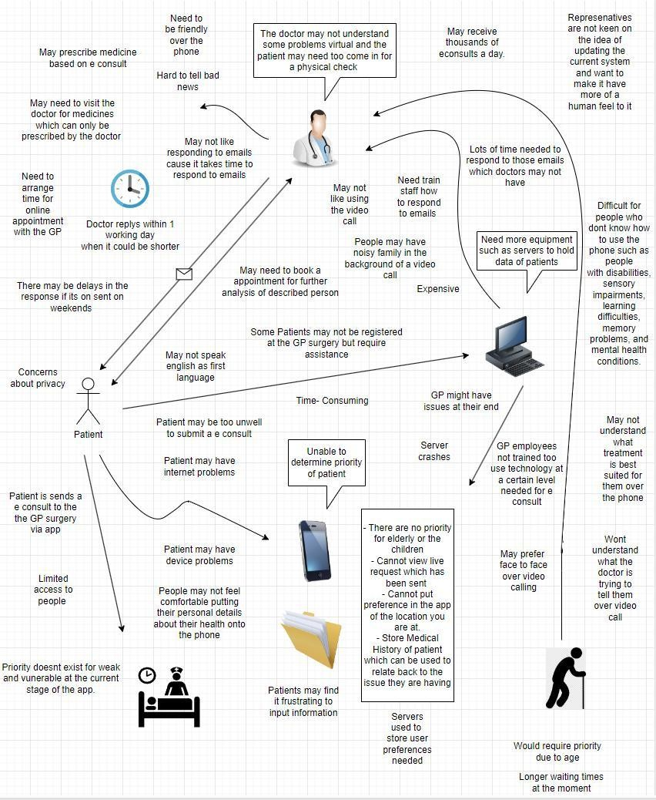

# PROCESS:

SCRUM and The Waterfall model are two software methodologies that fit most in the given case study. The Linear Sequential model, also known as the Waterfall model, is a traditional approach, while SCRUM, an Agile software development, is a contemporary approach. We will compare both by taking the advantages and disadvantages into consideration.

Advantages of The Waterfall model:**1. Simple and easy to use:** Since the app will be used by people of all ages and classes so simplicity in the app is really needed.

1. **Clear specifications:** When specifications are cleared at the beginning of the project, this methodology works better. In the case study, specifications are given already by the director.
2. **Association:** Each phase must be completed before the subsequent phase can commence. The given case study is also a sequential kind of work.

Disadvantages of the waterfall model:

1. **Rigid and inflexibility:** Changing requirements will be difficult once the project is started.
2. **Undefined cost:** Cost can only be calculated in the last phase whereas budget is already given in the case study.
3. **Unexpected deliverables:** A project with changing requirements delivers poor results.
4. **User involvement:** The user is not highly involved in this methodology which is the opposite compared to the case study.
5. **Smaller Project:** Works well for smaller projects but the project we are working on is complex and huge.

As for SCRUM, Advantages of SCRUM:

1. **Quick and efficient deliverables:** Works well for fast-moving development projects. Since it is a sensitive project, patients should get a response quickly from the application.
2. **Adopts feedback easily:** If the stakeholder is not satisfied with the work in the middle of the project, requirements can be changed easily.
3. **Most suitable:** Complex projects are broken into smaller pieces. The given case study is undoubtedly a complex one.
4. **Less chances of project failure:** No risk of failing the project if the team members are experienced which means effective use of time and money
5. **Daily meetings:** Meetings happen regularly where individual effort is shown. Therefore, no chance of getting any task unaccomplished
6. **Proof check:** The team repeats their work 2-5 times after being accomplished to meet the desired outcome of the project.

Disadvantages:

1. **Experienced team member needed:** Team members must be experienced otherwise the project will fail.
2. **Adoption**: In a large team, adopting a framework is tough.
3. **Frustration**: Daily meetings frustrate team members.
4. **Commitment:** Team members must not leave in the middle of the project.

## What and why?

If we choose one of the methodologies based on their merits and constraints, SCRUM will be the perfect one to choose. The waterfall model is not suitable for those whose requirements are likely to change frequently. Moreover, we are given a time limit and budget whereas in the waterfall model, the budget is not calculated until the last phase is completed and often crosses the deadline as well. However, these are not the case in SCRUM. It is a smaller group-friendly process. Requirements can be changed at any time of the project, and it does not waste time and money. Let us go on to further elaboration of this model.

## ROLES:

There are 3 major roles in a SCRUM lifecycle. They are the scrum product owner, the scrum master, and the scrum development team. The scrum development team is cross-functional, so it has a further 4-5 members in it. Let’s jump into a brief explanation of who is doing what role in our group-

**Product owner**: Nobel will perform the role of product owner. Being communicative and transparent with others is a mandatory attribute of a product owner. He must understand the requirements of the client and explain them to his team, which is considered the toughest part of the job. He has such attributes and so he will be performing that role.

**SRUM Master**: Tanim will perform the role of a scrum master. A scrum master is the champion in his team. He monitors whether the team is going on the right path or wrong. It does not matter how good the team members are if they are not supervised well. A scrum master has the power to lead the product owner so he must be a good leader. We found out Tanim has such qualities so he will be performing this important role.

**The development team**: Rest of the team members will be working in a group. Tahsith is good at planning and organizing things so he will be the developer. Pratthay is good at running code and detecting errors so he will be the tester. Rudra is good at designing graphics and products and so he is going to perform the role of a designer. And lastly, Sherrif will be the UX specialist.

## SCRUM Lifecycle:

Firstly, a product backlog is established by the product owner where features, requirements, enhancements, and fixes are listed. Secondly, sprint planning is conducted by the product owner and the development team. In sprint planning, the scope is determined in the first part and the plan for delivering the scope is determined in the second part. Thirdly, the development team starts performing the work necessary to deliver the product backlog items. Fourthly, the development team coordinates their work in daily meetings where their individual effort is

shown. The development team delivers the product backlog items in the fifth stage where the team holds a review to show the customer if they need any further changes. The team and the owner also reflect on how they proceeded so far. Lastly, when every step is completed, the team repeats them until the desired outcome of the product has been met.

# PROJECT:

* **Scope:** The goal of the project is to develop an eConsult mobile app.
* **Framework:** The scrum framework is divided into three parts. They are roles, ceremonies, and artefacts.
  1. **Roles**: There are three specific roles in a scrum team.
     1. **The Product owner**: Understands business, customers, their requirements and explain them to the team
     2. **The Scrum Master:** Coaches team, product owner and the business on the process
     3. **The Development team:** Since the scrum team is cross-functional, the development team is further divided into five more members

-**Developer**: Create clarity on the work, adjust plans, and engage in some quick problem solving

-**Tester:** Find out the defects, advocate the quality of the product, review code Up-to-date tools to solve problems etc.

-**Designer:** A designer designs the project before the development gets started.

-**UX specialists:** Work one sprint ahead of the developers to ensure the design is ready to be developed, facilitate design reviews etc.

-**OPS engineers:** They install, configure, and evolve common infrastructures such as the network, services, and external services.

* 1. **Ceremonies:** It is further divided into 6 stages.
     1. **Organize the backlog:** Drive the product towards its product vision and have a constant pulse on the market and the customer.
     2. **Sprint planning**: Led by scrum master and the team where they decide the goal of Sprint.
     3. **Sprint**: The scrum team works together to finish an increment in this ceremony.
     4. **Daily scrum or stand up:** Any concern with the sprint goal or any blockers is discussed here, which happens daily at the same time.
     5. **Sprint review:** The work that re are accomplished, selected in sprint, are shown to the stakeholders and teammates for feedback
     6. **Sprint retrospective:** Teams get together and discuss what has been done whatwas missed, what went well, what needs to be improved.
  2. **Artefacts:** There are three major stages.
     1. **Product backlog:** Features, requirements, enhancements and fixes that act as the Input is listed here.
     2. **Sprint backlog:** Determine the scope of the sprint and plan the work on delivering the scope.
     3. **Increment:** The usable end-product from a sprint is demonstrated here. The work done in the sprint backlog is shown in this phase.
* **Budget breakdown:** Firstly, let us distribute the salary. Everyone in the team must be experienced and thus they must be paid the highest range of salary.

|  |  |
| --- | --- |
| Role | Salary |
| 1. Product owner | £100000 |
| 2.Scrum master | £100000 |
| 3.The development team (4 members) | £300000 |
| Total | £500000 |

**Other costs:** Remaining £300000 were spent on purchasing required tools, hosting the app and other necessary things.

# Product:

* **App:** It is already an application we will extend in this case study. This is a cross-platform application that can be accessed from any gadget that is connected to the internet such as a mobile, computer, laptop etc. This application will be used by people of all ages, classes, and technological backgrounds. So, the product we are going to make should be user-friendly. Therefore, the application will have an easy-to-use design.
* **Features:** The product has new features like-

-**Patient preferences:** Patients are allowed to select which in surgery they want to go, which doctor they want to be assigned to and select schedule for appointment. meaning they will have the full power of selecting their amenities.

-**Real time status update**: Patients can see the live status of where their application is and how much time it will take to accomplish. It will help them to be relaxed and not being tensed for the application.

-**Medical history accessibility:** Every patient will have the access to the previous medical history. People often lose their previous medical history, however it will not the case here as every medical history will be stored here and can be accessed any time they want.

-P**riority queueing system:** This system will help recognizing the serious patient. Patients of serious health condition will get treatment first than the others.

* **Training and support:** Since Mr. Felix wants to train his staff before the system goes live, the product will provide comprehensive training to professionals who will be involved in using this app. There will be a support center available on the app user interface for those who will be visiting the app for the first time.

# People:

People who have little involvement in the software are part of this project. It starts with Mr. Felix who is the general director of eConsult to end user-like patients. Let us look at the prime movers in the software project

1. Mr. Felix, the General director of the company, is the client who wants to extend his software so that it will work better than the previously existing application.
2. The product owner is known as a stakeholder who is closely partners with both Mr. Felix and his team. He/she understands the requirements, budget, and time limit of the client and explains them to the team.
3. The scrum master is the leader of the development team who guides both the team and the product owner.
4. Every member of the development team is subject experts. They are champions of their own fields and work under the scrum master supervision.
5. Doctors, nurses, and other staff who are involved in this software lifecycle are actors. They perform their work after the software is completed.
6. Patients, for those the project was initialized, are the end users.

# REQUIREMENTS

This is considered as the toughest part for any software because clients often don’t know what the product should perform. There are two types of requirements.

**FUNCTIONAL REQUIREMENTS**: Actions that the system should do are functional requirements. For the given case study, the functional requirements will be

1. **Log in:** Every patient should log in to the system in order to have a particular account in their name. They will find the details on their account where no one can enter without the user’s authorization.
2. **Location:** Users should be able to allow their location to find the nearest surgery.
3. **Real-time status:** Users should be able to monitor the application so that they do not panic.
4. **Medical history:** Patient should have access to their previous medical history.
5. **Appointment:** Users should be able to select the appointment schedule and the appointment type based on the availability of doctors.
6. **Priority queueing:** Users should be given priority based on their age, gender and health condition.
7. **Asking for prescription:** User should be able to see the doctor's recommendation.
8. **Notification:** User should allow the notification to get updates instantly.
9. **Feedback:** Lastly the user should get the freedom to share and review their experience.

**NON-FUNCTIONAL REQUIREMENTS**

It describes the internal function of a system.

1. **Performance:** Millions of users may use the system at once. So, the system should allow all the users and response quickly.
2. **Security:** Guarantee the safety of costumer's medical history. Loging in should be required before entering the medical history
3. **Accessibilty:** the system should be accessed from any devices that is connected to the internet.
4. **Backups**: The system should backup information regularly so that it does not get erased.
5. **Usability:** The user interface must be designed simply so that no one with less technical background faces difficulties using the app.
6. **Organizational constraints:** The system should be teachable to new staff as soon as possible, meaning it must be easy to operate.

# ENTITY RELATIONSHIP DIAGRAM

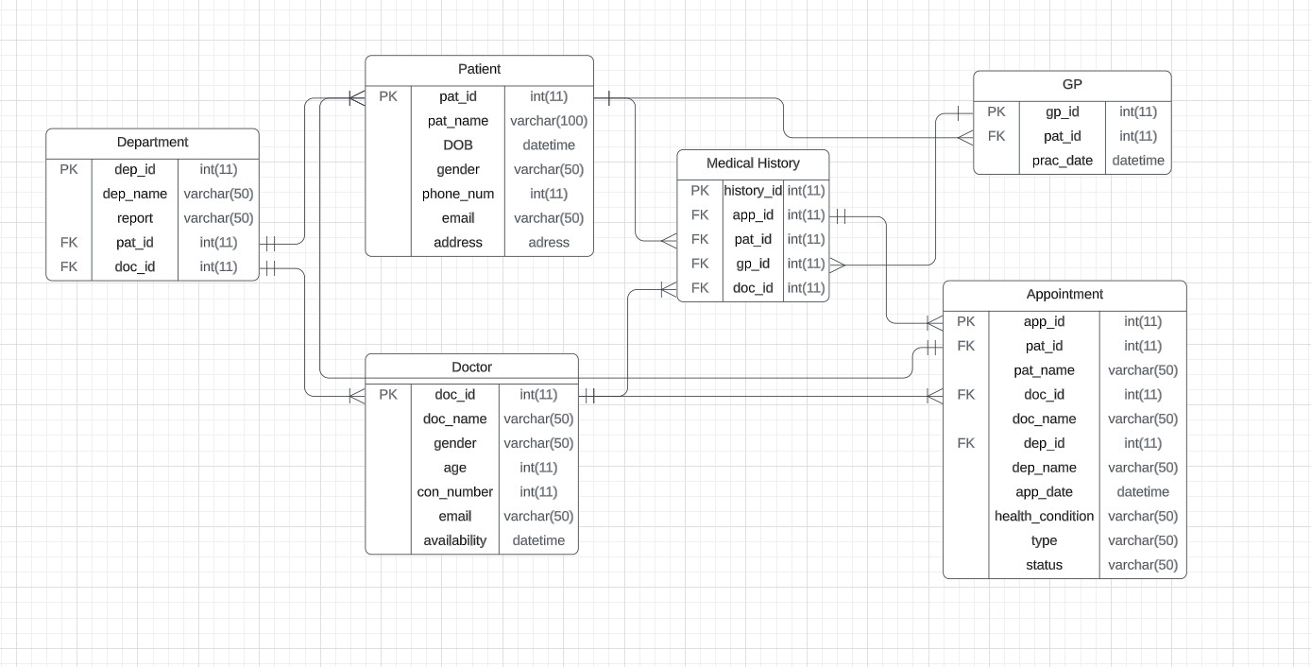

**CONTEXT DIAGRAM**

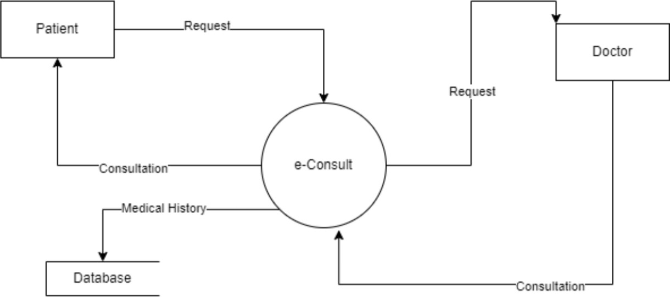

# 0 LEVEL DFD

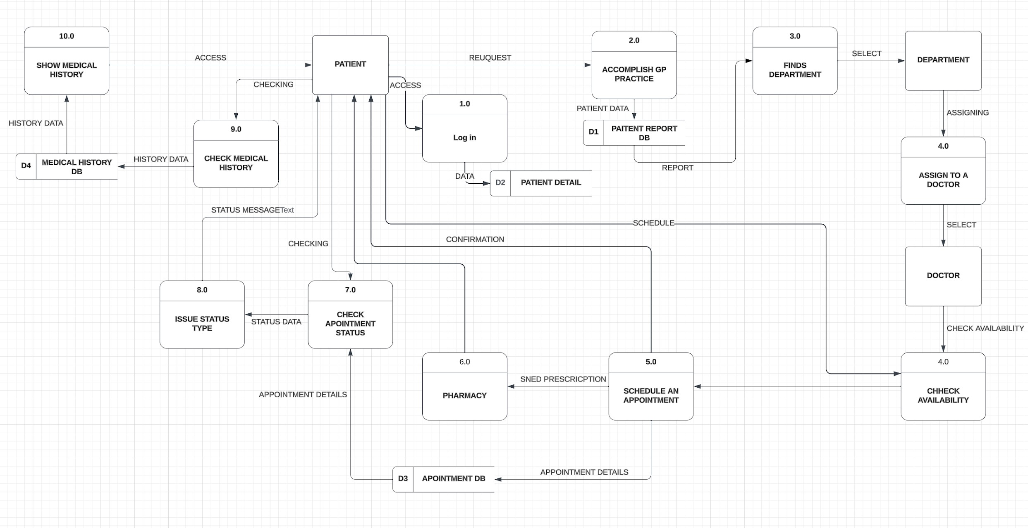**DATA BASE**

# SQL QUERIES AND RESULTS

1st Screenshot:

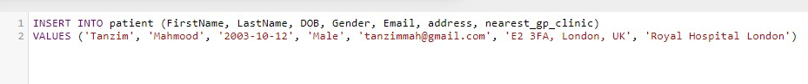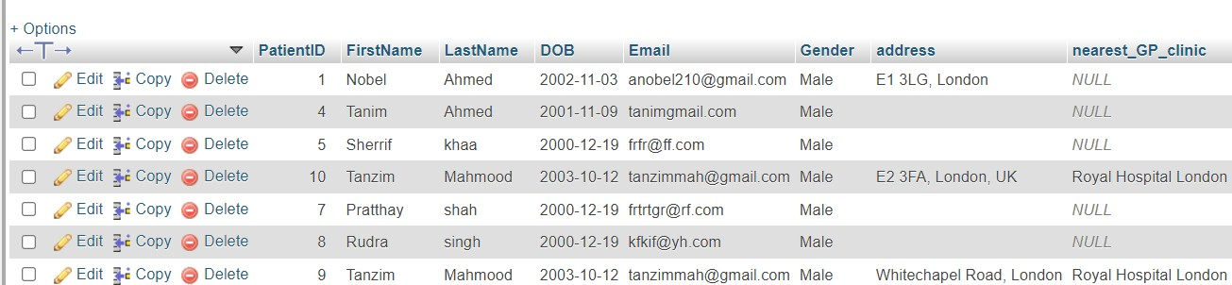

2nd Screenshot:

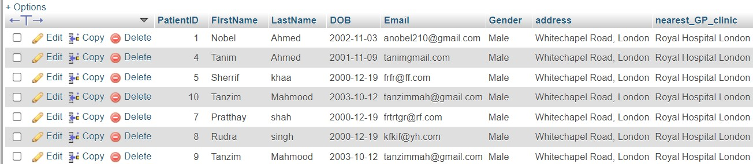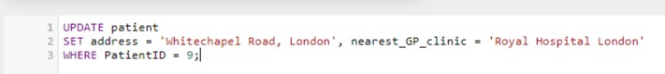

3rd Screenshot:



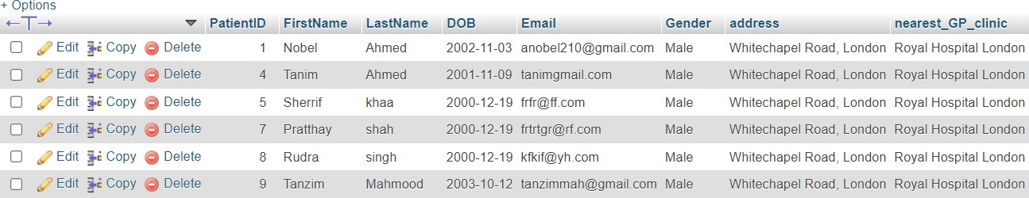

4th Screenshot:



5th Screenshot:



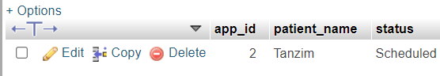

6th Screenshot:

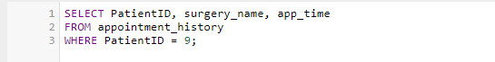

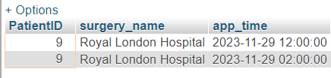

**USE CASE DIAGRAM**

**Actor**- There are three types of actors in use case diagram.

* 1. Patient 2.Doctor 3.eConsult App

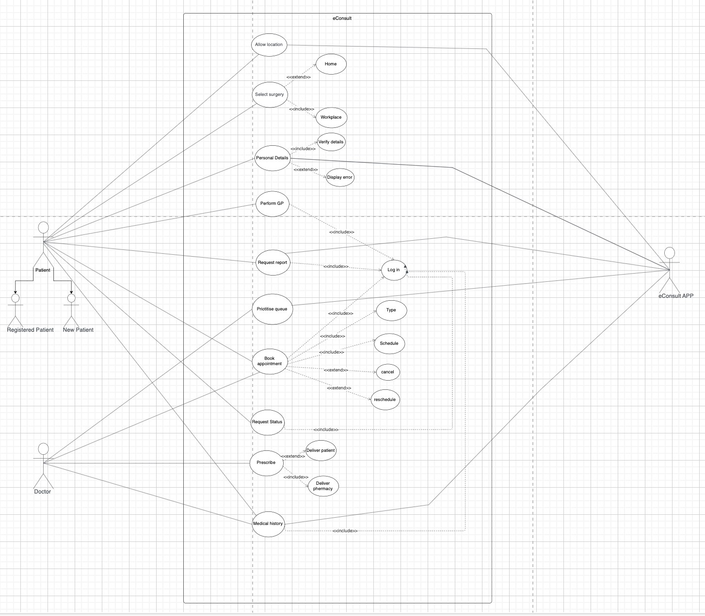**Use case**: There are 21 use cases. Some of the main use cases are GP practice, logging in, booking appointments, checking status, access to medical history and so on.

# SEQUENCE DIAGRAM

**FIRST SCENERIO:**

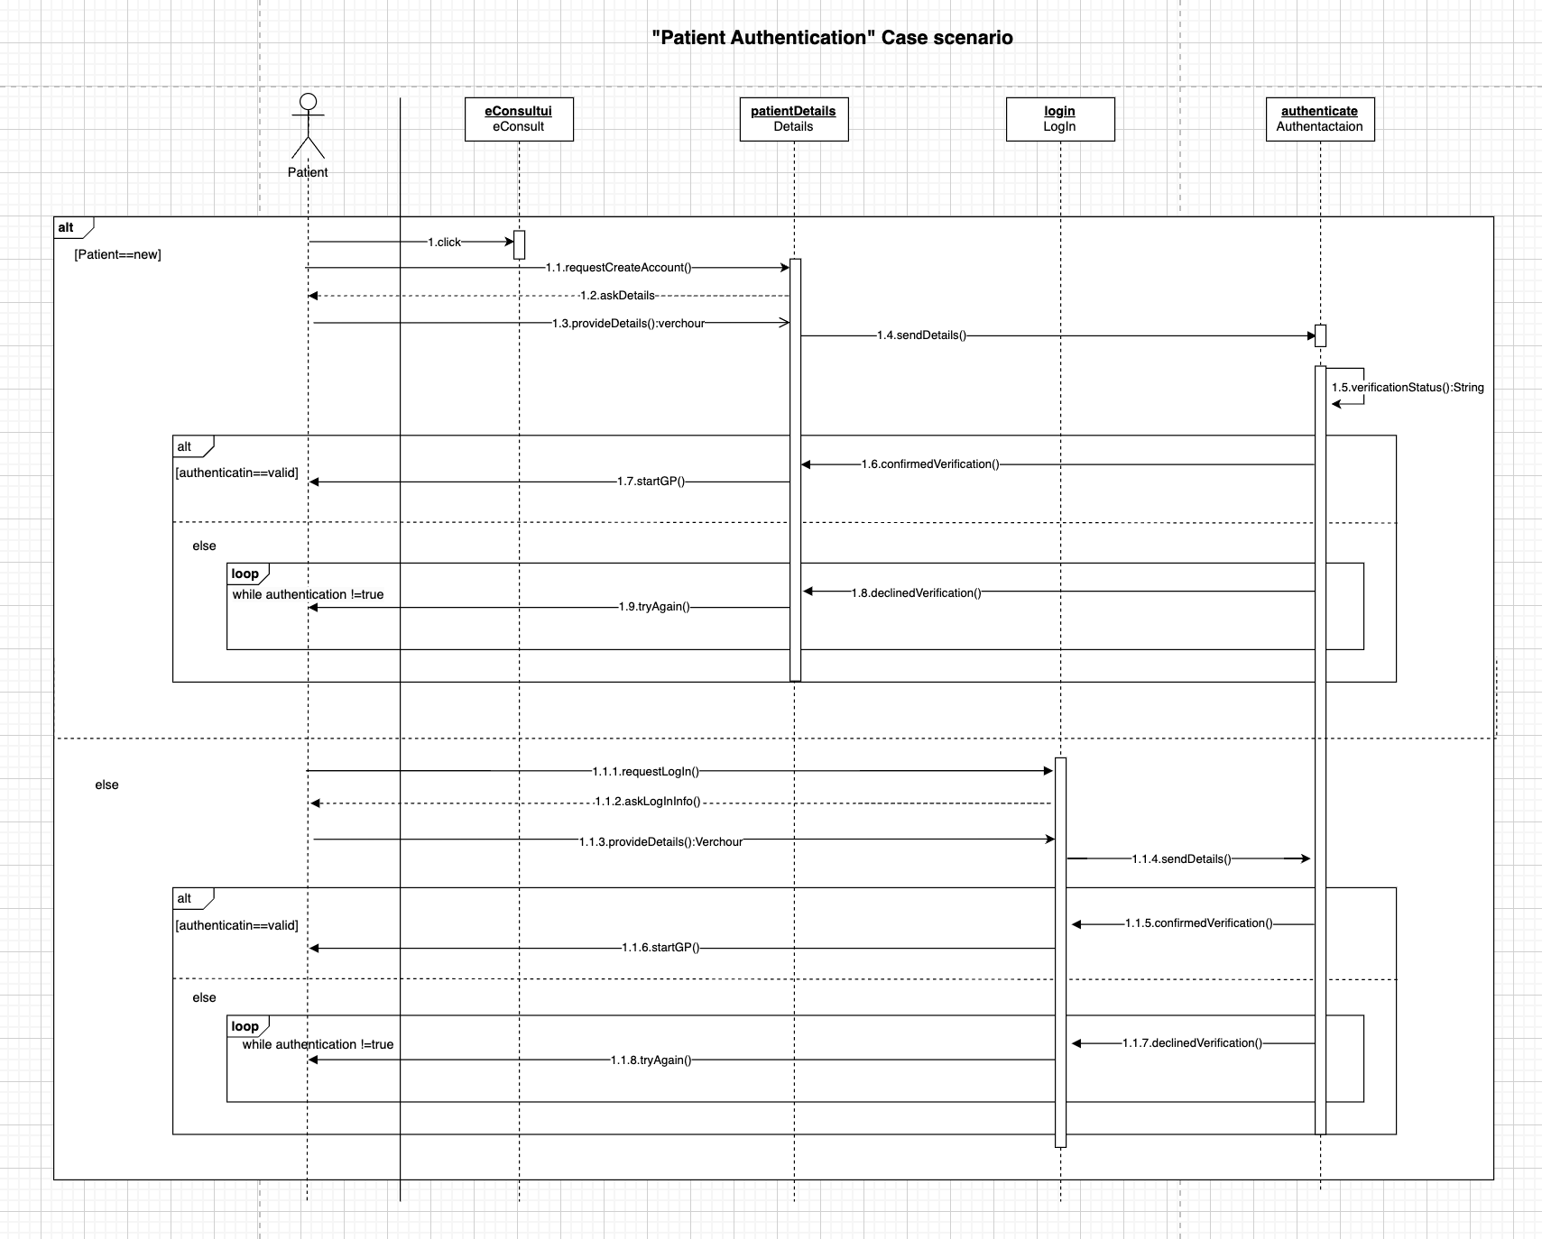

**SECOND SCENERIO:**

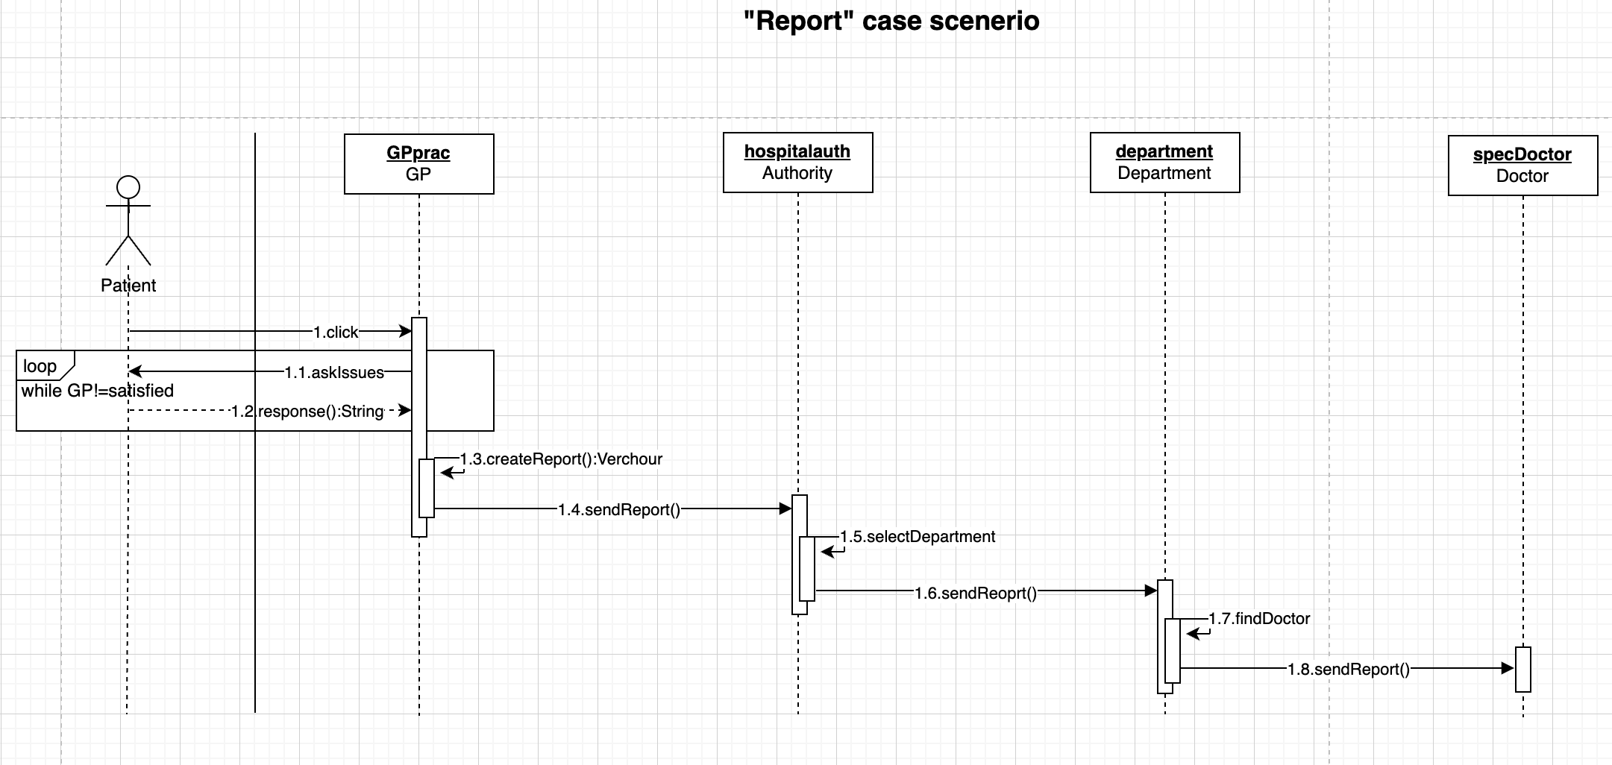

**THIRD SCENERIO: ￼**

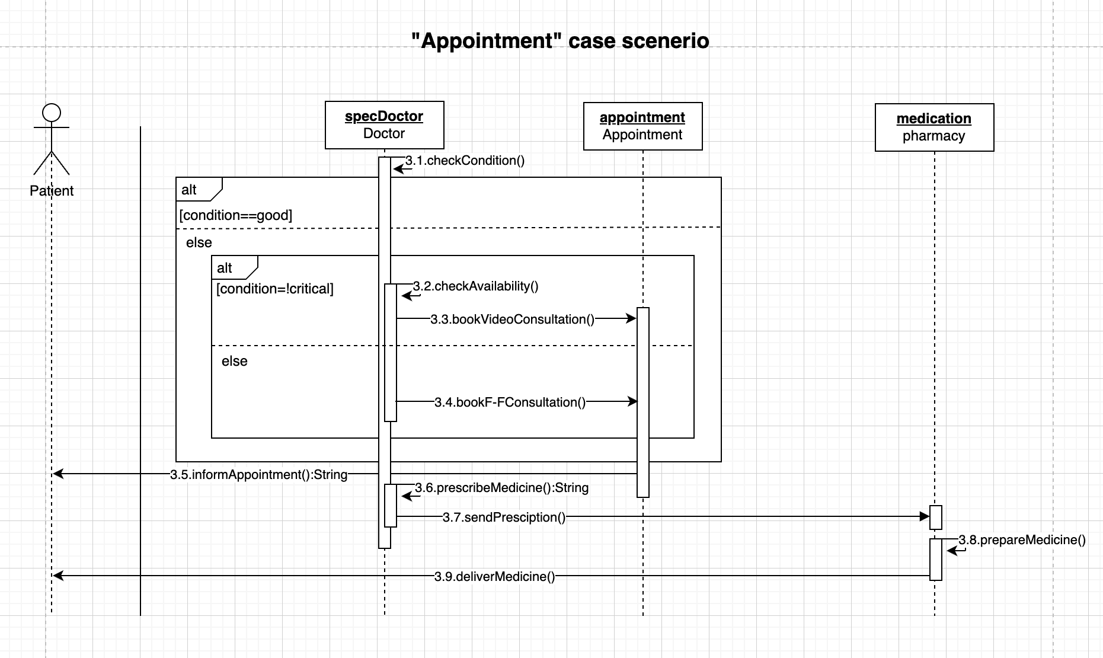

# DESIGN CLASS DIAGRAM

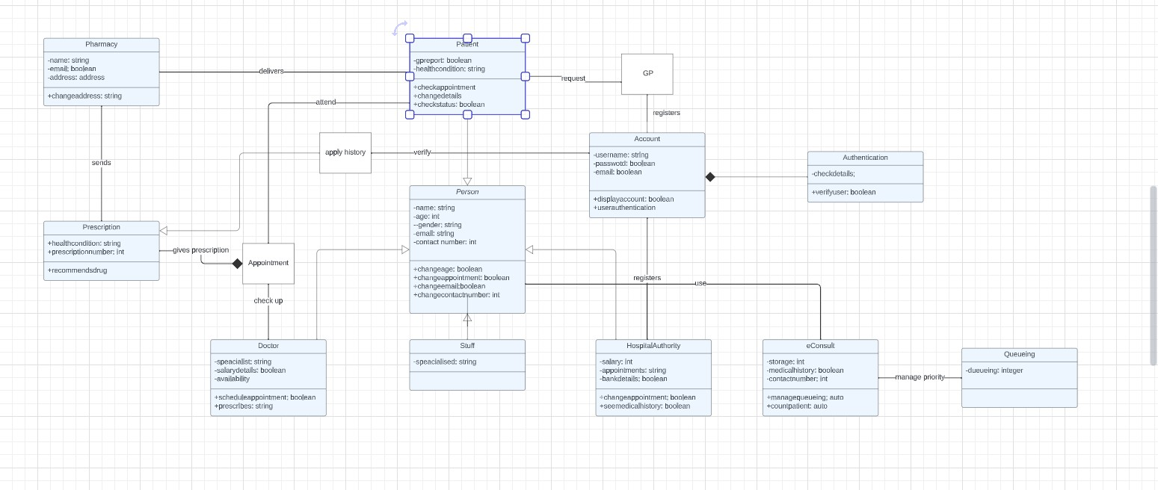

|  |  |  |  |  |  |  |  |
| --- | --- | --- | --- | --- | --- | --- | --- |
|  | **A** | **B** | **C** | **D** | **E** | **F** | **Comments** |
| **The 5Ps**   * **Problem** |  | ✔ |  |  |  |  | All the problems the eConsult system is facing are highlighted. There are many issues which is why the app is not gaining popularity as expected. All the major problems are detected and explained explicitly with a nice-looking rich picture. |
| * **Process** | ✔ |  | Two methodologies were selected and compared with the advantages and disadvantages. One was chosen and the reason was also written specifically. The requirements to perform a specific role were described in detail and the reasons who is doing what are also explained.  The lifecycle of the chosen model was described briefly with the main functionalities, but it was an organized summary. The associations of each activity were not detailed but have rough idea on the summary. |
| * **Project** |  | ✔ | The project was not very detailed. Although it describes the goal of the system, there is nothing mentioned about the resources. Budget breakdown was not shown appropriately. However, it has some good work as well, which is- the framework of the project. All the major things that make a frame are written there with a short description. |
| * **Product** | ✔ |  | It is explained thoroughly. It covers all the details that a product produces. Everything that the product will have in the final output is written here. However, it misses some information from the coursework deliverables which is artefacts, but this topic was covered in the project, so it is not going to be empty. |

|  |  |  |  |  |  |  |  |
| --- | --- | --- | --- | --- | --- | --- | --- |
| * **People** |  | ✔ |  |  |  |  | All the prime movers of the system were presented. They were described according to their roles and facilities |
| * **Functional and**   **Non-functional Requirements** | ✔ |  |  |  |  |  | All the requirements the client wants were inserted. They are explained thoroughly. It has a great number of new features and functions. The requirements were understood well. All the requirements have a statement with them mentioning the reason why they should be included in the new system. |
| * **ERD** |  | ✔ |  |  |  |  | A clear entity relationship diagram was made where all the primary key, foreign key, attributes, their types, and the relationship were shown on the table. The relations between tables are correct and make sense. Apart from this the tables contain as much information as the system needs. |
| * **DFD** | ✔ |  |  |  |  |  | Both the context diagram and the level 0 DFD diagram were created. Level 0 DFD, which is the detailed version of context diagram, is made based on the entity relationship diagram. The process of all the data we put in the ERD is shown here. All the externa entity, process, store and flow of the data is implemented on the diagram. |
| * **SQL queries** | ✔ |  |  |  |  |  | The database of the system was created. It has all the details starting from the patients to the pharmacist. This whole database was created by using queries. Since the database was created successfully that means the queries run on o tools were successful. Additionally, there are 6 screenshots added which proves that the database of the system works correctly. |

|  |  |  |  |  |  |  |  |
| --- | --- | --- | --- | --- | --- | --- | --- |
| **UML design**   * **Use Case**   **Diagram** |  | ✔ |  |  |  |  | The diagram has all the details in an organized way. It has all the three primary and secondary major actors, use cases, the link up of use cases and actors. The symbols for actors, use cases, and relationships are also correct. The include and extend relationships are also connected to the use cases appropriately. |
| * **Design class Diagram** |  |  | ✔ |  |  |  | Although the diagram has all the correct and valid classes for the system, it misses some information in attributes and method. Except this, the diagram is fine because it has all kinds of processes and relations, for example association and composition. Generalization and specialization were also implanted on the diagram as well. So, it has all the details that a perfect diagram owns except the attributes and methods. |
| * **Sequence Diagram** | ✔ |  |  |  |  |  | The Process of the whole system is described here. The three main case scenarios are created in three different diagrams as asked in the coursework. All of them have huge details. The correct usage of Objects, classes, actors, activation bars, messages were inserted into the diagram. Messages like synchronous message, asynchronous message, return message and reflexive messages were used. Lastly, alternative combination fragment and loop fragment were also used on the diagram. It has every detail in the diagram. |

## REPORT STRUCTURE

The first topic of the project is 5ps. This topic covers-

* **Problem**: The issues of the previous system were discussed.
* **Process**: Methodology that fits best to the system was discussed here.
* **Project**: It covers the goal, resources, budget and framework of the project.
* **Product**: The outcome of the product and its new features are covered here.
* **People**: people who are involved in the system are covered here. The second topic is requirements. It covers-
* **Functional** requirements: All the new features that the client wants to involve in the system are mentioned here
* **Non-functional requirements**: The internal requirements are highlighted here.

The third topic is the Entity Relationship Diagram. In this topic of the coursework all the entities, their attributes, their type, relationships, and cardinalities were highlighted in a diagram.

The fourth topic is Data Flow Diagram. The flow of the data that were inserted into the ERD is shown here.

And lastly the UML diagram covers-

* **Use Case diagram**
* **Sequence Diagram**
* **Design Class Diagram**

# REFERENCES

Reference list

1. Draw.io (2018). *Flowchart Maker & Online Diagram Software*. [online] app.diagrams.net. Available at: <https://app.diagrams.net/>.
2. Drumond, C. (2022). *Scrum - what it is, how it works, and why it’s awesome*. [online] Atlassian. Available at: <https://www.atlassian.com/agile/scrum>.
3. phpMyAdmin (2019). *phpMyAdmin*. [online] phpMyAdmin. Available at: <https://www.phpmyadmin.net/>