Unable to check out this product and system is not allowing to proceed further

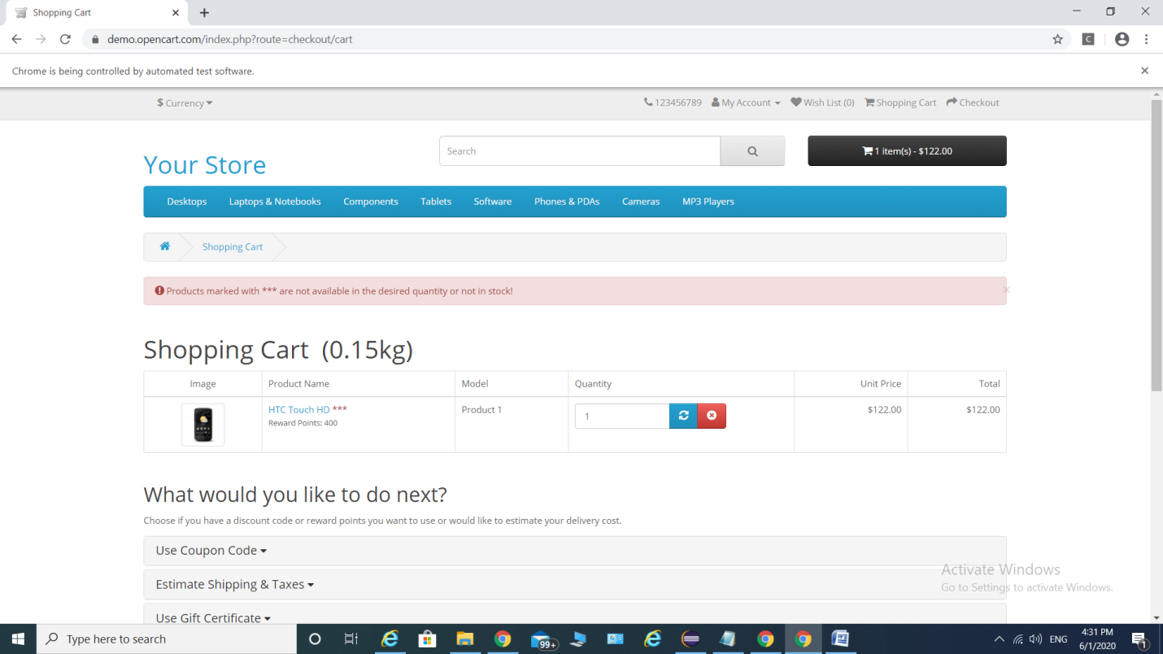

Unable to select the available options text box which is blocker to proceed further

