INYANI JEREMIAH ALPHONSE ARADAS, Reg no 23/BIT/BU/R/0020
- Installation and setup
Explain digital forensic and autopsy
Digital forensics is the process of identifying, preserving, analyzing, and presenting digital evidence from devices like computers and phones for legal or investigative purposes. Autopsy is a popular open-source, GUI-based forensic platform, often used by law enforcement, that automates data extraction, timeline analysis, file recovery, and keyword searching, enabling investigators to identify user activity and hidden files.
Autopsy features
- Ingest Modules: Automatically extract artifacts, including web browser history, recently accessed documents, installed programs, and USB device history.
- Timeline Analysis: Provides a graphical timeline of system events, making it easy to identify user behavior and system activity at specific times.
- Keyword Search: Extracts text from files to create indexes for searching, including support for regular expressions (regex).
- File System Analysis: Supports forensic analysis of varied file systems, including NTFS, FAT, Ext3, Ext4, and HFS+.
- Deleted File Recovery: Finds and recovers deleted files from unallocated space.
- Hash Lookup: Uses databases of known bad files (e.g., from NSRL) to flag suspicious files and known good files to filter them out.
- File Type Identification: Detects file types based on signatures rather than extensions.
- EXIF Analysis: Extracts geolocation data and camera information from images.
- Mobile Data Analysis: Extracts call logs, messages, and app data.
- Report Generation: Generates reports in multiple formats, including HTML, PDF, or text.
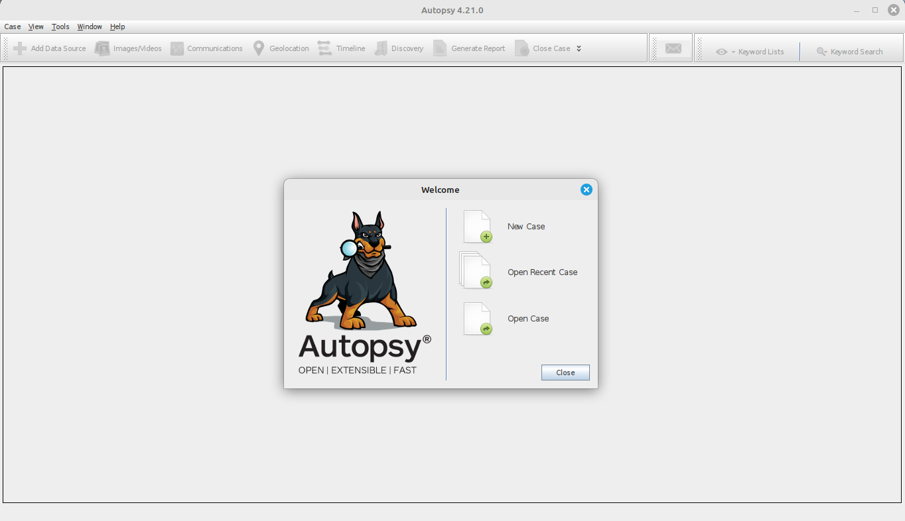

- Case creation and evidence loading
Explanation: What is a forensic image?
A forensic image is a bit-for-bit copy of storage media (disk, partition, memory) created to preserve original data and metadata. It captures allocated and unallocated space, file slack, and file system structures, enabling analysis without altering the original evidence. Common formats: raw/dd, E01 (EnCase), AFF.
Analysis approach in Autopsy
Allow ingest modules to complete (monitor progress).
Use left-hand navigation: File Types, Recent Activity, Views (Data Sources → Results).
Use Keyword Search, Hash Lookup (known bad/good), and Timeline to correlate events.
Examine file system tree in “File Analysis” to identify anomalies, recently accessed files, and deleted files (look under “Deleted” or check Unallocated space).
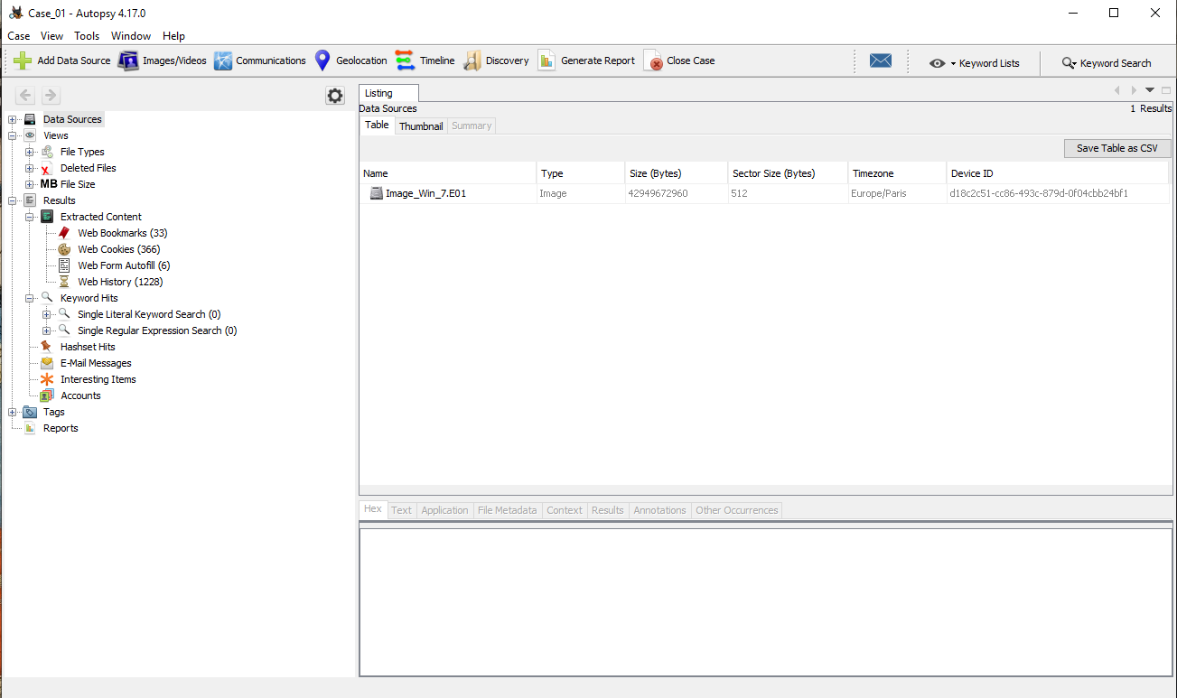
- Files system anaysis
PE Header Parsing: For Windows executables (.exe, .dll), analysts parse Portable Executable headers to examine import/export tables, sections, and metadata.
Strings Extraction: Extracting ASCII and Unicode strings can reveal embedded URLs, IP addresses, or suspicious commands.
Hash Identification: Generating cryptographic hashes (MD5, SHA256) serves as a unique digital fingerprint to check against databases like VirusTotal.
Document Analysis (PDF/Office): Examining PDFs or Office documents (e.g., using pdfid or pdf-parser) for embedded JavaScript, OpenAction tags, or macros, which are common infection vectors
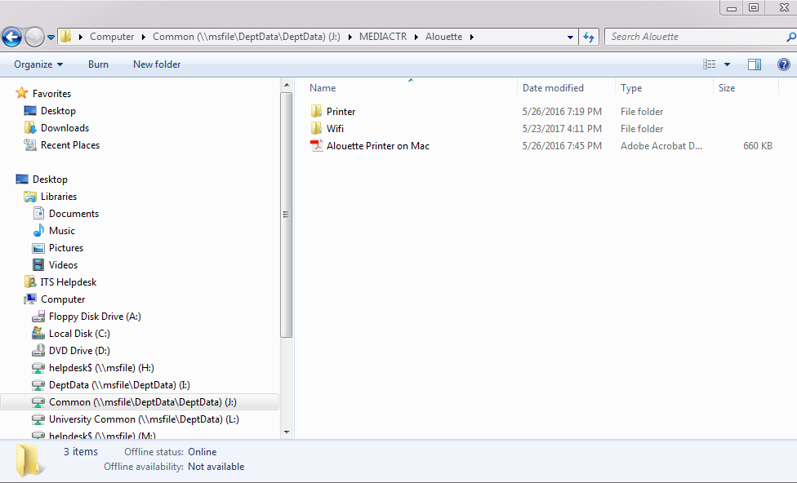
- Recovery of deleted files
- Initialize Case: Start Autopsy, click "New Case," and provide necessary details.
- Add Data Source: Select "Local Disk" or "Disk Image" to analyze. Choose the drive containing the deleted files.
- Configure Ingest Modules: Run ingest modules (e.g., File Type Identification) to analyze the disk. Deleted files will often appear.
- Locate Deleted Files: In the left-hand pane, navigate to Views > File Types > Deleted Files.
- Filter/Search: Use the results viewer to browse files. You can identify them by checking the "Metadata" tab.
- Export/Recover: Right-click the desired file, select Extract File, and save it to your computer.
Key Considerations:
- Unallocated Space: Deleted files often reside in unallocated space before they are overwritten.
- File Carver: If the files are not listed, use the PhotoRec Carver module within Autopsy to search for file signatures.
- Check Integrity: Ensure the recovered file is not corrupted by opening it.
- Timeframe: The success of recovery depends on whether the data has been overwritten by new data.
How to recover files in Autopsy (step-by-step)
In the file tree or results pane, filter by “Deleted” or search by filename.
Right-click target file → “Extract File(s)” → choose output directory (document where you saved recovered files).
Verify recovered file integrity by calculating hashes (MD5/SHA1) via Autopsy’s Hash Lookup module or external tool.
Preserve chain-of-custody: note case, examiner, extraction time, and storage location.
Analysis

Correlate recently accessed/suspicious files with timeline and system logs (Windows prefetch, registry RecentDocs, browser histories).
Check recovered files’ timestamps and metadata (EXIF for images, document metadata for Office files).
Perform hash lookups against known malware databases (VirusTotal, NSRL) for payload.exe and any suspicious binaries.
If plaintext credentials found, search for related access events (remote login logs, suspicious processes, new user accounts).
Evidence prioritization: prioritize executables with unknown hashes, credential material, and documents with financial or legal relevance.

Introduction
Objective: Analyze web activity, perform keyword searching and filtering, create timeline correlations, and generate/export a formal forensic report from an Autopsy case containing a disk image.
Scope: Step-by-step procedures, evidence collection/export guidance, and suggested findings sections to populate with your case-specific data and screenshots.
Methodology
Prerequisites
Autopsy installed and a case created with the target disk image ingested and ingest modules run (Timeline, Recent Activity, File Type Identification, Keyword Search, Hash Lookup).
Ensure ingest completed or paused at a point where modules of interest have processed the image.
Maintain a working directory for exported evidence and report artifacts; document chain-of-custody details (case name, examiner, date/time, storage path).
Web activity analysis (Autopsy modules and artifacts to check)

Modules: Recent Activity, Browser History, Network Analysis (if available), Timeline, File Type Identification.
Artifacts to inspect:
Browser histories and caches (Chrome, Edge, Firefox, Internet Explorer): urls, visit timestamps, downloads.
Cookies and session storage.
Downloaded files (Downloads folder, browser cache).
DNS cache, hosts file modifications.
Prefetch, AppCompat, and prefetch- related evidence of browser execution.
Proxy and VPN config files, network captures (if present).
Steps:
In Autopsy, open left pane → Recent Activity and expand browser-specific sections (Chrome, Firefox, Edge, IE).
Review entries sorted by timestamp; export relevant entries (Select → Export → choose CSV/TSV).
In File Analysis, filter by common browser cache/file extensions (.sqlite, .db, .log, .json, .html) and inspect.
For downloads, open Downloads artifact and note filename, path, and hashes. Right-click → Extract.
Capture screenshots: browser history view with highlighted suspicious URLs and download entries.
Keyword search and filtering

Preparation:
Build a keyword list: suspect names, email addresses, domain names, keyword families (password, credential, secret, invoice, bank, transfer), file names, IPs, and regular expressions if needed.
Optionally include known bad hashes or YARA rules (if Autopsy supports).
Steps in Autopsy:
Tools → Keyword Search → New Keyword List (or use existing).
Import list (plaintext) or add keywords manually. Set search options: case sensitivity, whole-word, regex.
Run search against the data source (select modules/ingest results to include).
Review Keyword Hits view; filter by artifact type, data source, or time range.
Use right-click → Open in Viewer or Extract to evidence directory for further analysis.
Filtering:
Use the Results pane filters (Deleted/Allocated, File Type, MIME type, timeframe).
Combine filters: e.g., keyword hits + “Deleted” + filetype=txt to find removed credential files.
Exporting hits: Select all hits → Export → as CSV/TSV or create an exported artifact package.
Timeline analysis

Purpose: Correlate system and user events to build a sequence of actions (file creation, modification, execution, network access).
Steps:
Ensure Timeline ingest module ran (Mactime-style timeline). If not, run Timeline ingest and wait for completion.
Open Timeline view. Set time range and granularity (hours/days).
Filter events by source/type: File System events, Registry, Browser, Prefetch, LNK, MFT, $USN, event logs (if parsed).
Identify clusters of activity: suspicious executable creation → execution → network connections → data transfer/downloads.
Use keyword hits and web activity results to annotate timeline events (e.g., link URL visit to corresponding downloaded file and execution timestamp).
Export timeline: Timeline → Export → CSV/JSON for inclusion in reports or further analysis in timeline tools (Timesketch, Plaso).
Tips:
Normalize timestamps to a single timezone and note OS timezone.
Correlate MFT timestamps (Created, Modified, MFT changed, Accessed) with event log times for verification.
Findings (placeholders — replace with case-specific data and screenshots)

Web activity examples:
Suspicious URL: http://malicious.example.com/downloads/payload.exe
Visit timestamp: 04/02/2026 03:05 UTC
Evidence: Browser history entry (Chrome), cached download in Downloads\payload.exe, hash: SHA256:
Screenshot: browser history entry + download entry
Keyword search examples:
Keyword: “secret_credentials”
Hits: C:\Users\victim\AppData\Local\Temp\secret_credentials.txt (deleted)
Extracted content: username: alice@example.com, password: P@ssw0rd!
Screenshot: Keyword hits pane showing file path and preview
Timeline examples:
Sequence:
04/02/2026 03:04:56 — Browser navigates to malicious URL (browser history)
04/02/2026 03:05:10 — payload.exe downloaded to Downloads
04/02/2026 03:06:05 — payload.exe executed (Prefetch, MFT entry, Process artifacts)
04/02/2026 03:06:20 — Network connections to 203.0.113.45:443 (if network logs available)
04/02/2026 03:07:00 — secret_credentials.txt deleted (MFT/unallocated)
Screenshot: timeline filtered to 03:04–03:08 with events highlighted
Recovery and Exporting Evidence

Recovering files:
In Results/File Analysis/Deleted Files view, select files to recover.
Right-click → Extract File(s) → choose secure output directory (document path).
Generate hashes: Use Autopsy Hash Lookup or export files and run external tool (md5sum, sha256sum).
Log extraction metadata: examiner, case, extraction time, original path, output path, file hashes.
Exporting Autopsy report:
Autopsy built-in report:
Case -> Generate Report.
Choose report type(s): HTML, Excel, CSV, or XML (Autopsy version dependent).
Select content to include: Extracted Files, Keyword Hits, Timeline Summary, Recent Activity, Hash Sets, Notes, Screenshots.
Configure report options (include embedded files or links to exported files).
Generate → save report to case exports folder. Note the generated file(s) and compute hashes.
Supplemental exports:
Export Timeline CSV for external timeline tools.
Export Keyword hits CSV.
Export browser history CSV.
Include recovered files in a zip (store hashes and manifest).
Report contents to include:
Executive summary (concise findings and impact).
Case metadata and chain-of-custody.
Methods and tools used (Autopsy version, modules, ingest options).
Detailed findings: web activity logs, keyword hits, timeline with annotated events.
Recovered files list with hashes and relevance statements.
Screenshots of key evidence views (browser history, keyword hits, timeline, file previews).
Conclusions and recommended actions.
Appendix: exported CSVs, hashes, recovered file manifest.
Analysis (how to interpret and correlate)

Correlation strategy:
Link browser visit → downloaded file → execution → network connections → data deletion/exfiltration events.
Validate timestamps across multiple artifacts (browser history, MFT, event logs).
Check hashes of executables against malware databases (VirusTotal, NSRL, internal hash sets).
Examine recovered documents for sensitive content and determine scope of compromise (accounts, PII, financial).
Prioritization:
High: Unknown executable with matching execution evidence + outbound network connections.
Medium: Plaintext credentials or tokens found in recovered files.
Low: Old/benign browsing entries or system updates.
Recommendations for next steps:
Quarantine and analyze suspicious binaries in sandbox.
Reset compromised credentials and notify affected parties.
Expand network log review and endpoint telemetry for lateral activity.
Preserve exported artifacts and include hashes in any legal packages.
Conclusion
Use Autopsy to produce a defensible, reproducible report by exporting relevant artifacts (timeline, keyword hits, recovered files, browser histories) and embedding screenshots and a clear chain-of-custody.
Key deliverables to produce and attach:
Autopsy HTML/PDF report
Timeline CSV
Keyword hits CSV
Recovered files archive + manifest + hashes
Screenshots (browser history, keyword pane, timeline)
If you provide the case files, screenshots, or exported CSVs (or paste the key artifacts: keyword hits, timeline CSV, recovered file list), I can:
Draft a fully populated report using your real findings.
Format the report into Word/PDF and embed screenshots and hashes.

