NUMERICAL METHODS ASSIGNMENT
Runge-Kutta, Newton-Raphson and Secant Methods
Solutions using FOR and WHILE loops, pseudocode and flowcharts

GROUP TEN
Name | Registration Number
NABUKALU ANGEL | BU/UP/2025/2127
NABUKENYA LATIFAH MATOVU | BU/UP/2025/3271
ODONG HARON | BU/UP/2025/3885
MUSASIZI DAN | BU/UP/2025/1549
OLWENY EMMANUEL | BU/UP/2025/4656

Contents of this document
- Question 1: Fourth-order Runge-Kutta method
- Question 2: Newton-Raphson method (three equations)
- Question 3: Secant method
- Summary of answers

Question 1: Runge-Kutta (order 4)
Use the fourth-order Runge-Kutta algorithm with step size h = 0.1 to find a numerical solution of the initial value problem y'' - 2xy' + 8y = 0, y(0) = 12, y'(0) = 0 on the interval 0 <= x <= 1.

Method
Let z = y'. The second-order equation becomes a system of two first-order equations:
y' = z and z' = 2xz - 8y, with y(0) = 12 and z(0) = 0.
k1 = f(x, y, z); k2 = f(x + h/2, y + h k1/2); k3 = f(x + h/2, y + h k2/2); k4 = f(x + h, y + h k3)
y(n+1) = y(n) + (h/6)(k1 + 2k2 + 2k3 + k4), applied to both y and z.

Pseudocode

FOR loop version
START
INPUT f(x,y,z), x0, y0, z0 (z = y'), h, n
x <- x0 ; y <- y0 ; z <- z0
FOR i = 1 TO n DO
k1 <- f(x, y, z)
k2 <- f(x+h/2, y+h/2*k1y, z+h/2*k1z)
k3 <- f(x+h/2, y+h/2*k2y, z+h/2*k2z)
k4 <- f(x+h, y+h*k3y, z+h*k3z)
y <- y + h/6*(k1y + 2k2y + 2k3y + k4y)
z <- z + h/6*(k1z + 2k2z + 2k3z + k4z)
x <- x0 + i*h
PRINT i, x, y, z
END FOR
OUTPUT y(1)
STOP

WHILE loop version
START
INPUT f(x,y,z), x0, y0, z0, h, x_end
x <- x0 ; y <- y0 ; z <- z0
WHILE x < x_end DO
k1 <- f(x, y, z)
k2, k3, k4 as in the FOR version
y <- y + h/6*(k1y + 2k2y + 2k3y + k4y)
z <- z + h/6*(k1z + 2k2z + 2k3z + k4z)
x <- x + h
PRINT x, y, z
END WHILE
OUTPUT y(1)
STOP

Flowcharts
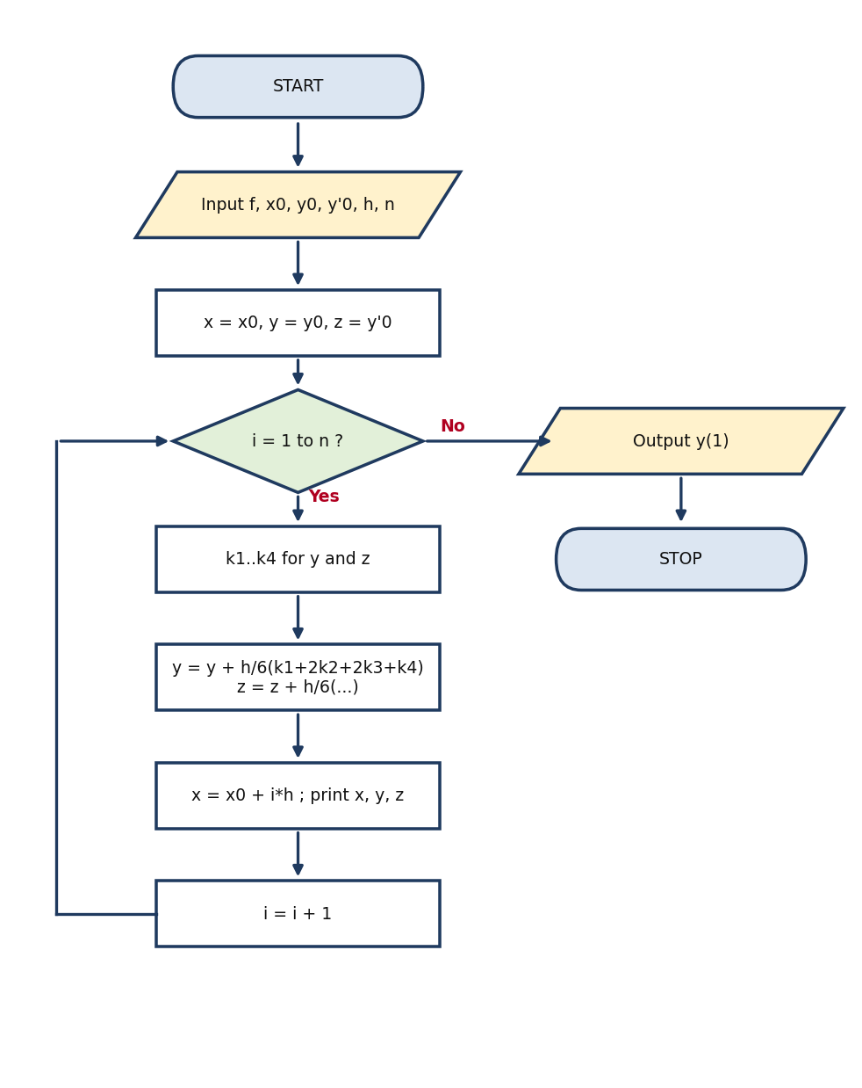  FOR loop flowchart | 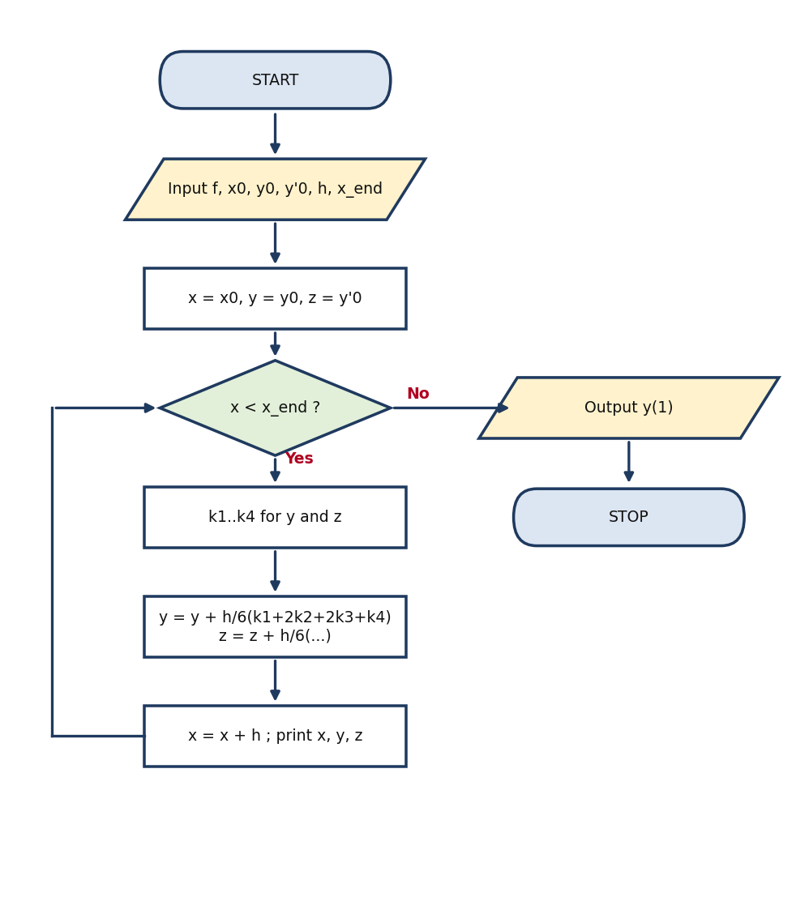  WHILE loop flowchart

Program code (Python)

FOR loop version
# RK4 for y'' - 2xy' + 8y = 0, y(0)=12, y'(0)=0, h=0.1, 0<=x<=1 (FOR loop)
def f(x, y, z):
# y' = z , z' = y'' = 2*x*z - 8*y
return z, 2*x*z - 8*y

def rk4_for(x0, y0, z0, h, n):
x, y, z = x0, y0, z0
rows = [(0, x, y, z)]
for i in range(1, n + 1):
k1y, k1z = f(x, y, z)
k2y, k2z = f(x + h/2, y + h/2*k1y, z + h/2*k1z)
k3y, k3z = f(x + h/2, y + h/2*k2y, z + h/2*k2z)
k4y, k4z = f(x + h, y + h*k3y, z + h*k3z)
y = y + h/6*(k1y + 2*k2y + 2*k3y + k4y)
z = z + h/6*(k1z + 2*k2z + 2*k3z + k4z)
x = x0 + i*h
rows.append((i, x, y, z))
return rows

rows = rk4_for(0, 12, 0, 0.1, 10)
for r in rows:
print("%2d x=%.1f y=%.6f y'=%.6f" % r)

WHILE loop version
# RK4 for y'' - 2xy' + 8y = 0, y(0)=12, y'(0)=0, h=0.1, 0<=x<=1 (WHILE loop)
def f(x, y, z):
return z, 2*x*z - 8*y

def rk4_while(x0, y0, z0, h, xend):
x, y, z = x0, y0, z0
i = 0
rows = [(i, x, y, z)]
while x < xend - 1e-9:
k1y, k1z = f(x, y, z)
k2y, k2z = f(x + h/2, y + h/2*k1y, z + h/2*k1z)
k3y, k3z = f(x + h/2, y + h/2*k2y, z + h/2*k2z)
k4y, k4z = f(x + h, y + h*k3y, z + h*k3z)
y = y + h/6*(k1y + 2*k2y + 2*k3y + k4y)
z = z + h/6*(k1z + 2*k2z + 2*k3z + k4z)
i = i + 1
x = x0 + i*h
rows.append((i, x, y, z))
return rows

rows = rk4_while(0, 12, 0, 0.1, 1.0)
for r in rows:
print("%2d x=%.1f y=%.6f y'=%.6f" % r)

Solution (FOR and WHILE loops give identical results)
i | x | y (RK4) | y' (RK4) | y exact | |error|
0 | 0.0 | 12.000000 | 0.000000 | 12.000000 | 0.00e+0
1 | 0.1 | 11.521596 | -9.535281 | 11.521600 | 4.00e-6
2 | 0.2 | 10.105672 | -18.686571 | 10.105600 | 7.23e-5
3 | 0.3 | 7.809827 | -27.069919 | 7.809600 | 2.27e-4
4 | 0.4 | 4.730055 | -34.301373 | 4.729600 | 4.55e-4
5 | 0.5 | 1.000747 | -39.996982 | 1.000000 | 7.47e-4
6 | 0.6 | -3.205311 | -43.772795 | -3.206400 | 1.09e-3
7 | 0.7 | -7.676938 | -45.244862 | -7.678400 | 1.46e-3
8 | 0.8 | -12.164555 | -44.029234 | -12.166400 | 1.85e-3
9 | 0.9 | -16.380188 | -39.741962 | -16.382400 | 2.21e-3
10 | 1.0 | -19.997470 | -31.999099 | -20.000000 | 2.53e-3

Check: this equation is Hermite's equation with n = 4, whose solution with these initial values is y = 16x^4 - 48x^2 + 12, so the exact value is y(1) = -20. RK4 gives y(1) = -19.997470, an error of only about 2.5 x 10^-3.
Answer: y(1) = -19.99747 and y'(1) = -31.99910.

Question 2: Newton-Raphson Method
Use Newton's method to determine the required root:
(i) Find the root of 3x - e^(-x) = 0.
(ii) Find the smallest root of tan x + 2 tanh x = 0.
(iii) Find the largest root of x^4 - 4x^3 + x^2 + 1.2 = 0.

Method
x(n+1) = x(n) - f(x(n)) / f'(x(n))
Stopping rule (WHILE version): |x(n+1) - x(n)| <= 10^-6. FOR version: fixed number of iterations N = 6.
The same code is used for all three equations; only f(x), f'(x) and the starting value x0 change.

Pseudocode

FOR loop version
START
INPUT f(x), f'(x), x0, N
x <- x0
FOR i = 1 TO N DO
x_new <- x - f(x)/f'(x)
PRINT i, x_new
x <- x_new
END FOR
OUTPUT root x
STOP

WHILE loop version
START
INPUT f(x), f'(x), x0, tol, max_iter
x <- x0 ; error <- 1 ; i <- 0
WHILE error > tol AND i < max_iter DO
x_new <- x - f(x)/f'(x)
error <- |x_new - x|
i <- i + 1
PRINT i, x_new
x <- x_new
END WHILE
OUTPUT root x, i
STOP

Flowcharts
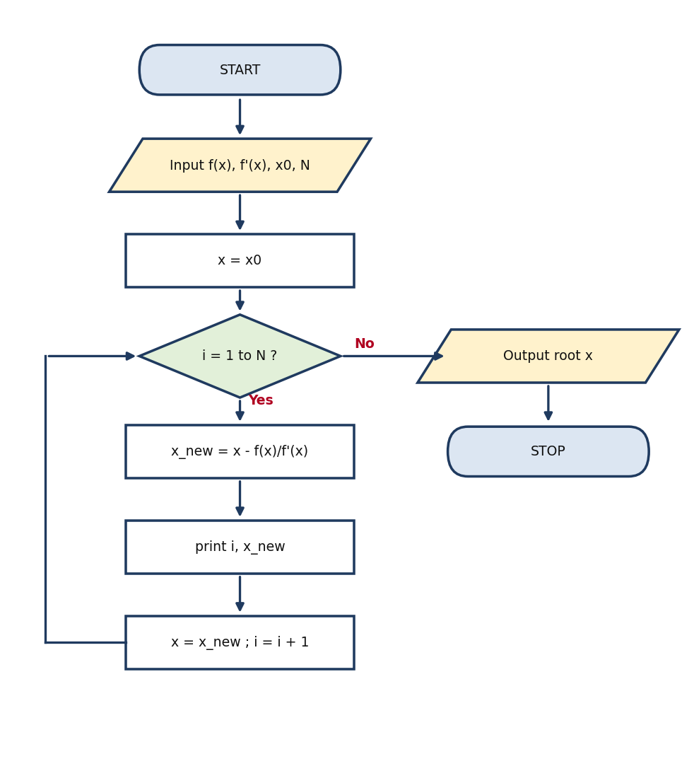  FOR loop flowchart | 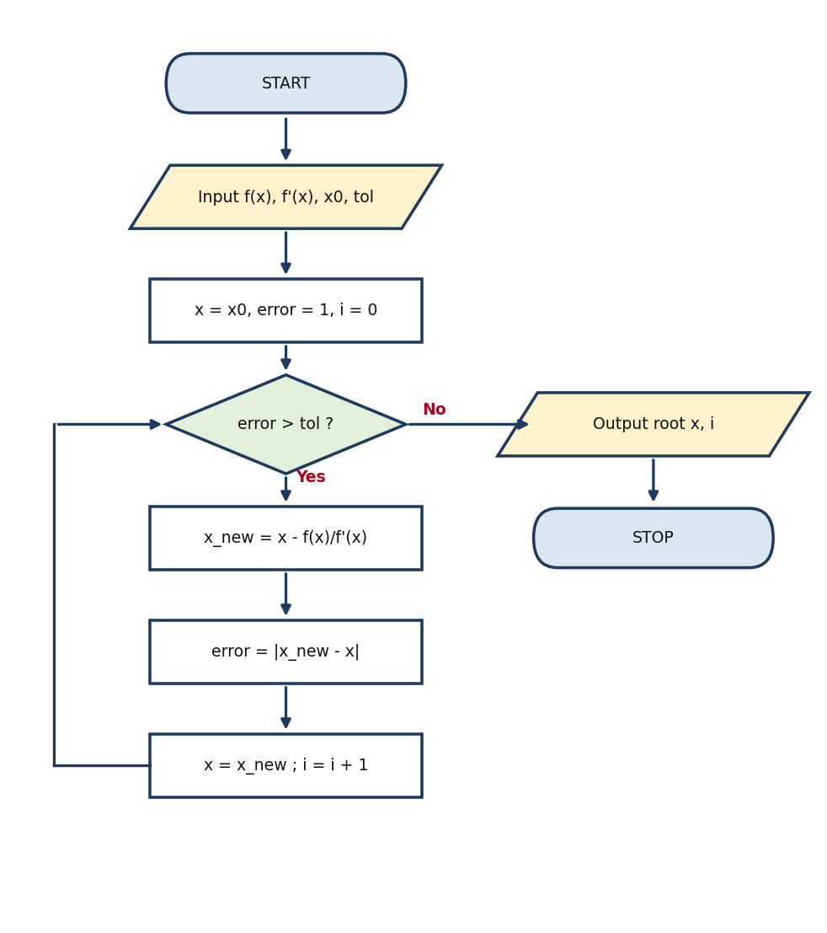  WHILE loop flowchart

Program code (Python)

FOR loop version
# Newton-Raphson x_{n+1} = x_n - f(x_n)/f'(x_n) (FOR loop)
from math import exp, tan, tanh, cosh, cos

def newton_for(f, df, x0, N=6):
x = x0
rows = []
for i in range(1, N + 1):
x_new = x - f(x) / df(x)
rows.append((i, x, f(x), x_new))
x = x_new
return x, rows

# (i) 3x - e^-x = 0
r1, t1 = newton_for(lambda x: 3*x - exp(-x), lambda x: 3 + exp(-x), 0.0)
# (ii) tan x + 2 tanh x = 0
r2, t2 = newton_for(lambda x: tan(x) + 2*tanh(x),
lambda x: 1/cos(x)**2 + 2/cosh(x)**2, 2.0)
# (iii) x^4 - 4x^3 + x^2 + 1.2 = 0
r3, t3 = newton_for(lambda x: x**4 - 4*x**3 + x**2 + 1.2,
lambda x: 4*x**3 - 12*x**2 + 2*x, 4.0)
print(r1, r2, r3)

WHILE loop version
# Newton-Raphson x_{n+1} = x_n - f(x_n)/f'(x_n) (WHILE loop)
from math import exp, tan, tanh, cosh, cos

def newton_while(f, df, x0, tol=1e-6, max_iter=50):
x = x0
i = 0
error = 1.0
rows = []
while error > tol and i < max_iter:
x_new = x - f(x) / df(x)
error = abs(x_new - x)
i = i + 1
rows.append((i, x, f(x), x_new))
x = x_new
return x, rows

r1, t1 = newton_while(lambda x: 3*x - exp(-x), lambda x: 3 + exp(-x), 0.0)
r2, t2 = newton_while(lambda x: tan(x) + 2*tanh(x),
lambda x: 1/cos(x)**2 + 2/cosh(x)**2, 2.0)
r3, t3 = newton_while(lambda x: x**4 - 4*x**3 + x**2 + 1.2,
lambda x: 4*x**3 - 12*x**2 + 2*x, 4.0)
print(r1, r2, r3)

Solutions

(i) 3x - e^(-x) = 0
f(x) = 3x - e^(-x); f'(x) = 3 + e^(-x); starting value x0 = 0
Iteration | x(n) | f(x(n)) | x(n+1)
1 | 0.000000 | -1.000000 | 0.250000
2 | 0.250000 | -0.028801 | 0.257622
3 | 0.257622 | -0.000023 | 0.257628
4 | 0.257628 | -0.000000 | 0.257628
Root = 0.257628

(ii) tan x + 2 tanh x = 0
f(x) = tan x + 2 tanh x; f'(x) = sec^2 x + 2 sech^2 x; starting value x0 = 2
Iteration | x(n) | f(x(n)) | x(n+1)
1 | 2.000000 | -0.256985 | 2.043441
2 | 2.043441 | -0.021865 | 2.047854
3 | 2.047854 | -0.000184 | 2.047892
4 | 2.047892 | -0.000000 | 2.047892
Root = 2.047892

(iii) x^4 - 4x^3 + x^2 + 1.2 = 0
f(x) = x^4 - 4x^3 + x^2 + 1.2; f'(x) = 4x^3 - 12x^2 + 2x; starting value x0 = 4
Iteration | x(n) | f(x(n)) | x(n+1)
1 | 4.000000 | 17.200000 | 3.761111
2 | 3.761111 | 2.635989 | 3.709005
3 | 3.709005 | 0.109063 | 3.706656
4 | 3.706656 | 0.000215 | 3.706651
5 | 3.706651 | 0.000000 | 3.706651
Root = 3.706651
Notes: x = 0 is also a root of tan x + 2 tanh x = 0, so in (ii) we take the smallest non-zero positive root, which lies between pi/2 and pi (2.0479). For (iii) the polynomial has f(3) < 0 and f(4) > 0, so the largest root lies between 3 and 4 and starting at x0 = 4 converges to 3.7067.

Question 3: Secant Method
Find the positive solution of f(x) = x - 2 sin x = 0 by the secant method, starting with x0 = 2 and x1 = 1.9.

Method
x(n+1) = x(n) - f(x(n)) (x(n) - x(n-1)) / (f(x(n)) - f(x(n-1)))
Worked first step: f(2) = 2 - 2 sin 2 = 0.181406, f(1.9) = 1.9 - 2 sin 1.9 = 0.007400
x2 = 1.9 - 0.007400 (1.9 - 2)/(0.007400 - 0.181406) = 1.895747

Pseudocode

FOR loop version
START
INPUT f(x), x0, x1, N
FOR i = 1 TO N DO
x2 <- x1 - f(x1)*(x1 - x0)/(f(x1) - f(x0))
PRINT i, x2
x0 <- x1 ; x1 <- x2
END FOR
OUTPUT root x1
STOP

WHILE loop version
START
INPUT f(x), x0, x1, tol, max_iter
error <- 1 ; i <- 0
WHILE error > tol AND i < max_iter DO
x2 <- x1 - f(x1)*(x1 - x0)/(f(x1) - f(x0))
error <- |x2 - x1|
i <- i + 1
PRINT i, x2
x0 <- x1 ; x1 <- x2
END WHILE
OUTPUT root x1, i
STOP

Flowcharts
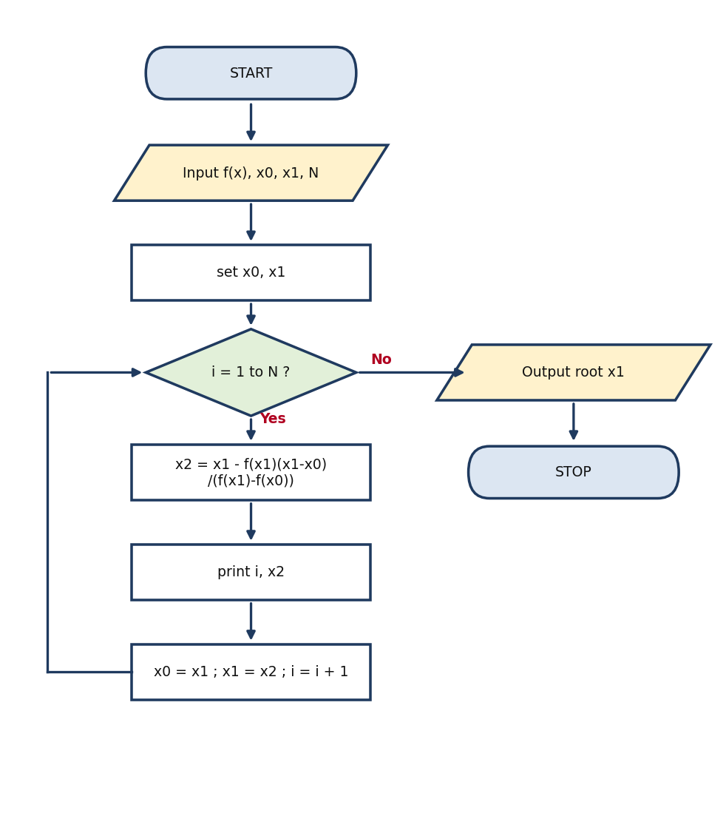  FOR loop flowchart | 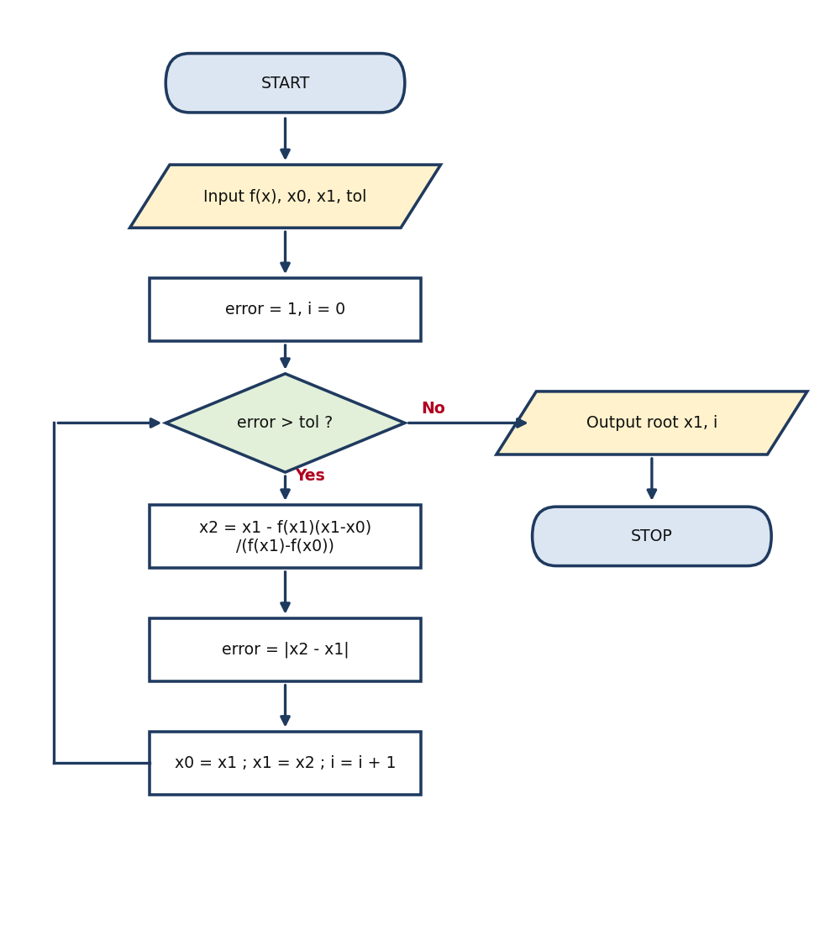  WHILE loop flowchart

Program code (Python)

FOR loop version
# Secant method x_{n+1} = x_n - f(x_n)(x_n - x_{n-1})/(f(x_n) - f(x_{n-1})) (FOR loop)
from math import sin

def f(x):
return x - 2*sin(x)

def secant_for(x0, x1, N=5):
rows = []
for i in range(1, N + 1):
x2 = x1 - f(x1)*(x1 - x0)/(f(x1) - f(x0))
rows.append((i, x0, x1, f(x1), x2))
x0, x1 = x1, x2
return x1, rows

root, rows = secant_for(2.0, 1.9)
print(root)

WHILE loop version
# Secant method x_{n+1} = x_n - f(x_n)(x_n - x_{n-1})/(f(x_n) - f(x_{n-1})) (WHILE loop)
from math import sin

def f(x):
return x - 2*sin(x)

def secant_while(x0, x1, tol=1e-6, max_iter=50):
i = 0
error = 1.0
rows = []
while error > tol and i < max_iter:
x2 = x1 - f(x1)*(x1 - x0)/(f(x1) - f(x0))
error = abs(x2 - x1)
i = i + 1
rows.append((i, x0, x1, f(x1), x2))
x0, x1 = x1, x2
return x1, rows

root, rows = secant_while(2.0, 1.9)
print(root)

Solution
Iteration | x(n-1) | x(n) | x(n+1)
1 | 2.000000 | 1.900000 | 1.895747
2 | 1.900000 | 1.895747 | 1.895495
3 | 1.895747 | 1.895495 | 1.895494
Answer: the positive root is x = 1.895494.

Summary of answers
Question | Method | Answer
1 | Runge-Kutta 4 (h = 0.1) | y(1) = -19.99747 (exact -20)
2(i) | Newton-Raphson | x = 0.257628
2(ii) | Newton-Raphson | x = 2.047892
2(iii) | Newton-Raphson | x = 3.706651
3 | Secant | x = 1.895494

