DID THIS

Get the driver from here:

<https://docs.microsoft.com/en-us/sql/connect/jdbc/release-notes-for-the-jdbc-driver?view=sql-server-ver15>

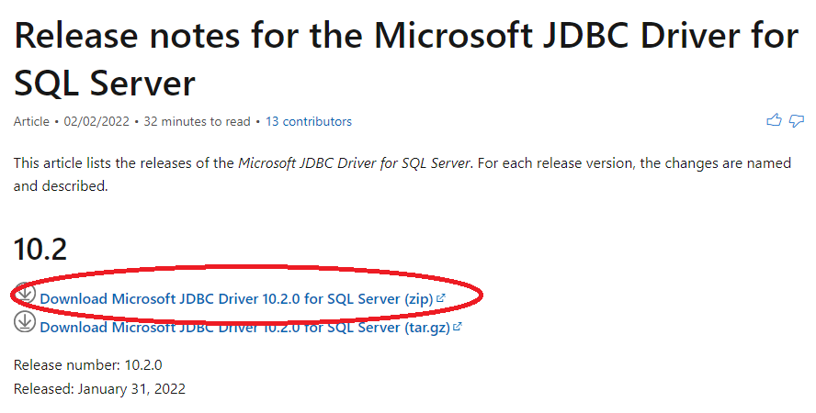

Find the dll:

C:\Users\gresh\Downloads\sqljdbc_10.2.0.0_enu.zip\sqljdbc_10.2\enu\auth\x64

Copy the dll to C:\Program Files\Java\jre1.8.0_261

RESTART THE IDE