**INT102 Lab 11: Box Model, Floating and Positioning (CSS) (1/2021)**

1. Download Lab11.zip and unzip the file.
2. Open the jenware.html in the browser. It should look like the picture below:

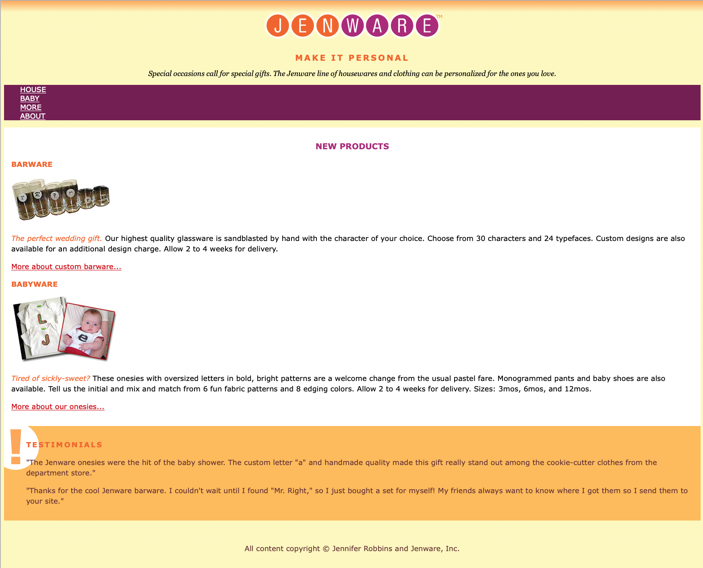 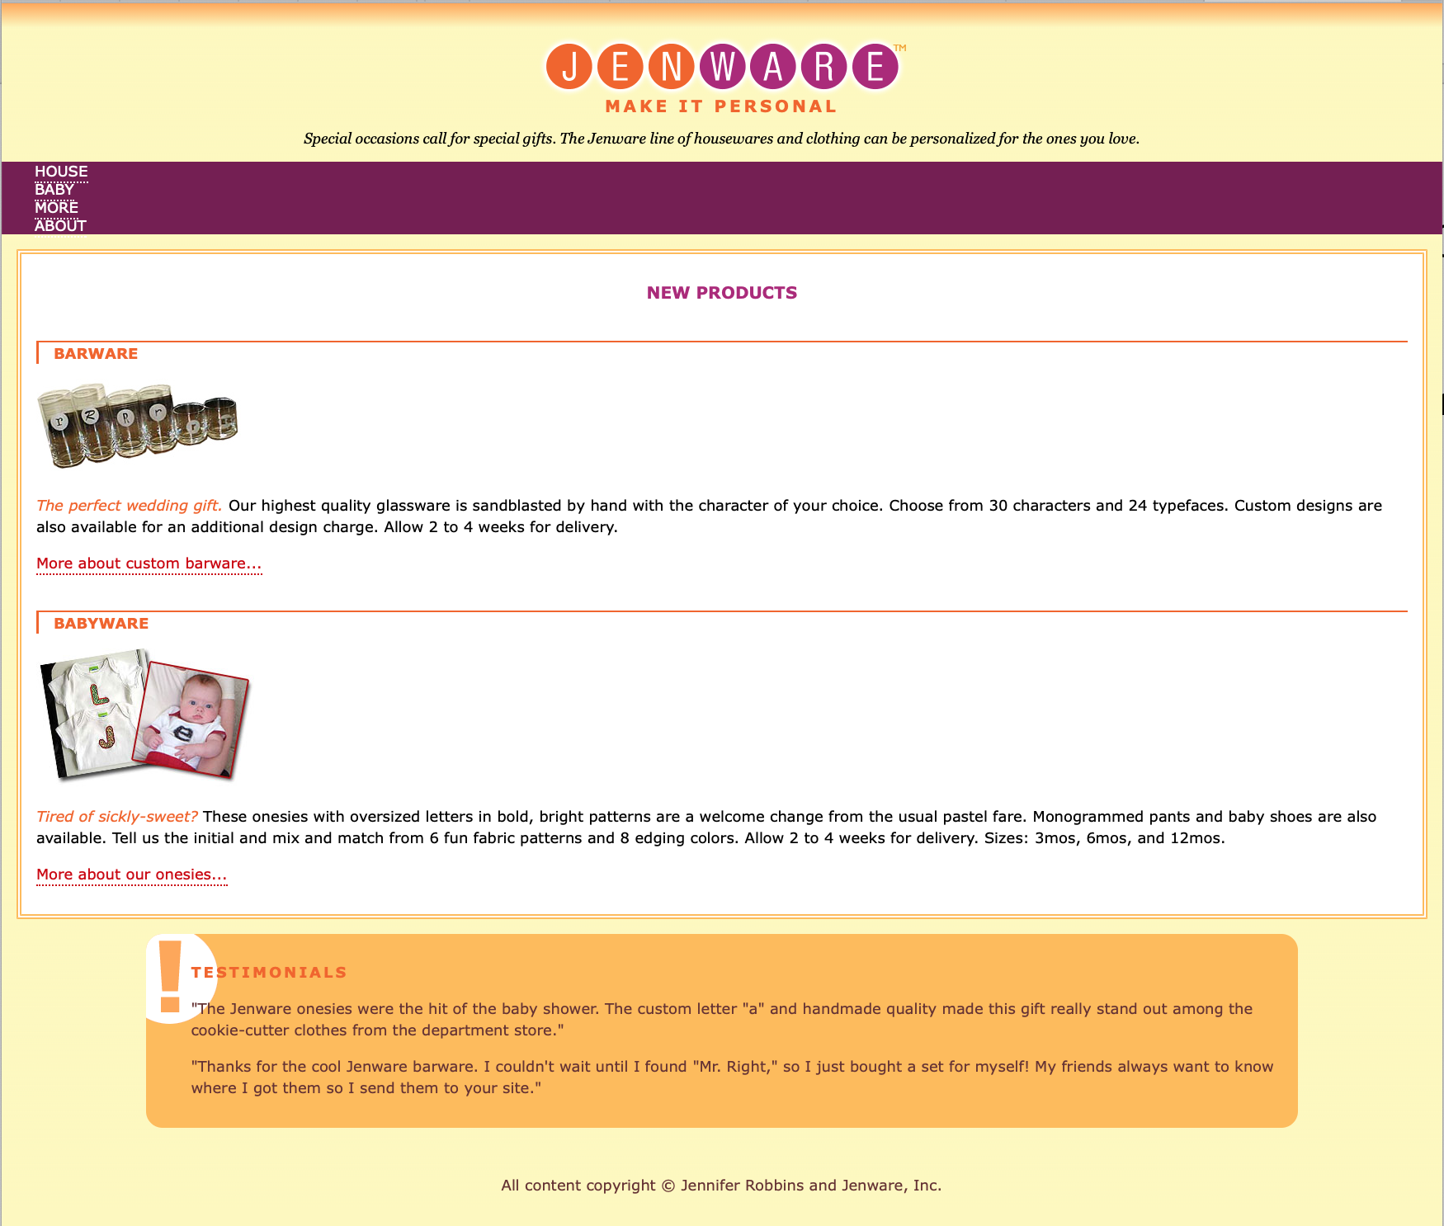

Before After

1. Open VS Code editor > Open the jenware.html.

**Adding a little padding**

1. Add padding to the “product” div by finding the #products selector and add the padding declaration. Set the padding value to 1em.
2. In the “testimonials” section, Add some space in the left side of “testimonials” div so that the exclamation (!) background image is visible clearly.
   1. Use the padding shorthand property to add 1em of padding on all sides of the “testimonials” div.
   2. Then write a second declaration that adds 55px of padding to the left side only. Because the padding-left declaration comes second, it will override the 1em setting applied with the padding shorthand property.
3. Save the file and try it out in the browser. The product and testimonials descriptions should look a little more comfortable in their boxes.

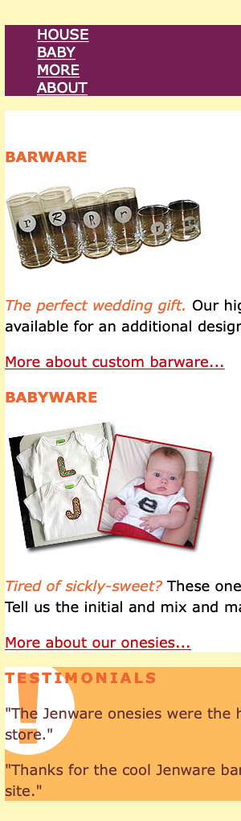 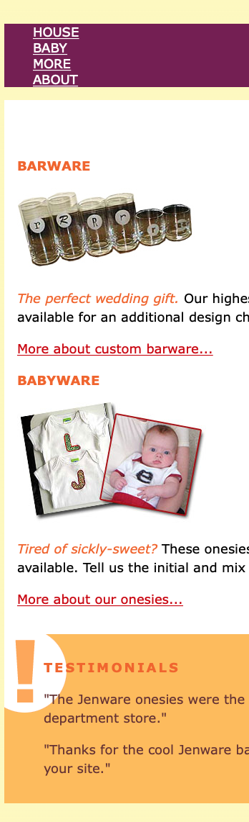

**Setting Border**

1. Add a light-orange (#FFDC53) double rule around the “products” area by using the shorthand border property. Find “product” div and add the new declaration as follows:

#products {

…..

border: double #FFBC53 ;

}

1. 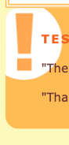Make the “testimonials” section rounded corners. Find #testimonials and add the new declaration as follows:

#testimonials {

….

border-radius: 20px ;

}

1. Add a decorative border on two sides of the product category headings (h3). Make the borders to be the same colors as the text (so don’t need to specify the border-color).
   1. Find the existing rule for h3 elements in the “products” div
   2. Add a declaration that adds a thicker, 3px solid rule on the left side.
   3. To prevent the text from bumping into that left border (ตัวหนังสือชน/ชิดกับขอบด้านซ้าย), add a little bit of padding (1em) to the left of the heading content.

#products h3 {

font-size: 1em;

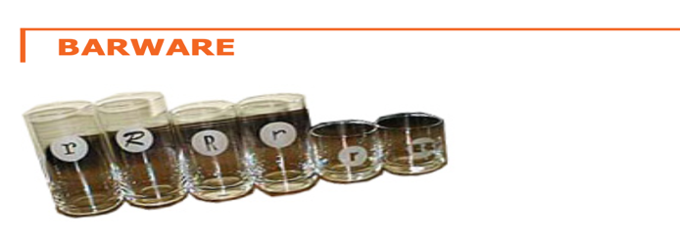 text-transform: uppercase;

color: #F26521;

border-top: 1px solid;

border-left: 3px solid;

padding-left: 1em;

}

1. Replace the standard text underline under links with a decorative bottom border.
   1. To turn the underline off for all links by setting the text-decoration to none for the a element. Add this rule in the “link style” section of the style sheet.
   2. Add a 1px dotted border to the bottom edge of links.
   3. Usually, when add a border to an element, it is a good idea to also add a little padding to keep things from bumping together.
   4. Add .1em for padding to the bottom edges.

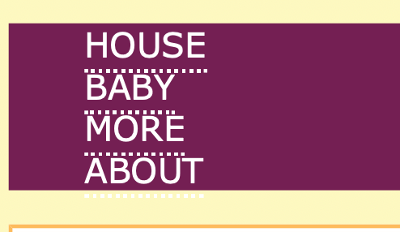a {

text-decoration: none;

border-bottom: 1px dotted;

padding-bottom: .1em;

}

**Adding margin space around elements**

1. Adjust the margins on the whole document, and make tweaks (ปรับหรือบิด) to each section from top to bottom.
   1. It is common practice to set the margin for the body element to zero, thus clearing out the browser’s default margin setting and creating a starting point for setting our own margins on elements throughout the page.

body {

….

margin: 0 ;

}

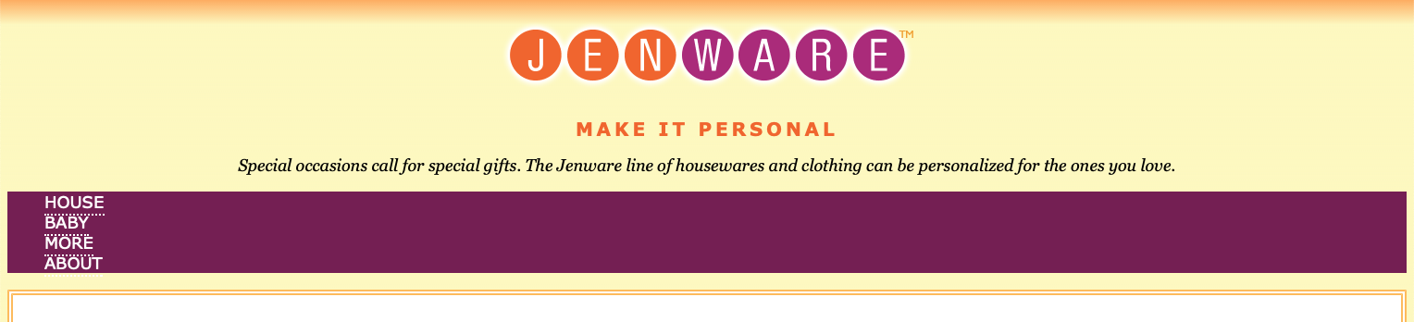

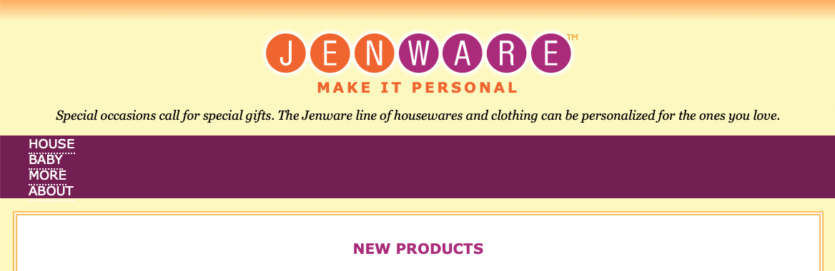

1. To tweak other content area.
   1. Start with the #intro div, and add a 2em margin on the top and 1em below.
   2. To close up the space between the logo and tagline, so set the bottom margin on the h1 to zero and the top margin on the h2 to -10px to move the tagline up nice and close to the logo.
   3. Finally put 1em margin all around the introductory paragraph (p).

#intro {

text-align: center;

margin: 2em 0 1em;

}

#intro h1 {

margin-bottom: 0;

}

#intro h2 {

font-size: 1.2em;

text-transform: uppercase;

letter-spacing: .2em;

color: #f26521;

margin-top: -10px;

}

#intro p {

font-family: Georgia, "Times New Roman", Times, serif;

font-style: italic;

margin: 1em;

}

1. Set the #products section a 1em margin all around.

#products {

background-color: #FFF;

line-height: 1.5em;

padding: 1em;

border: double #FFBC53;

margin: 1em;

}

1. Add a 2.5em space above the products subsection headings (h3). Try different amount of space and see what you like best.

#products h3 {

font-size: 1em;

text-transform: uppercase;

color: #F26521;

border-top: 1px solid;

border-left: 3px solid;

padding-left: 1em;

margin-top: 2.5em; /* try different amount of space and see what you like */

}

1. Save the file and try it out in the browser. It should look something like picture below.

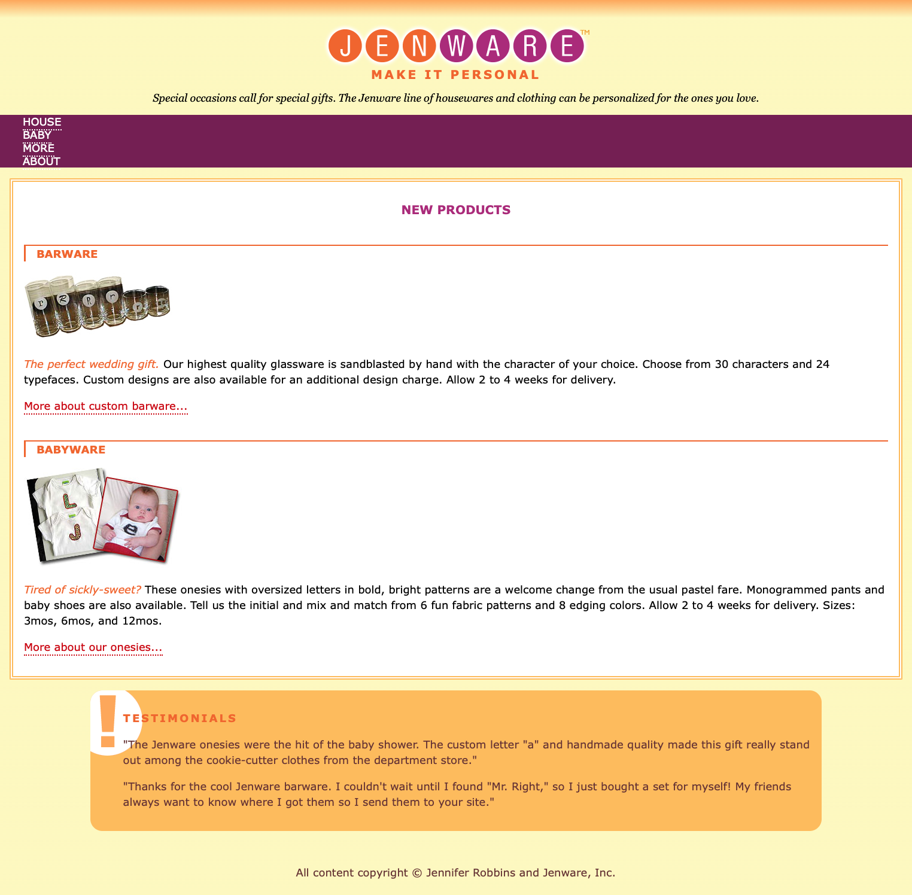

**Floating images**

1. Remove wasted vertical space next to the product images by floating the image to the left.
   1. Make sure that only those images are floated to the left in the “products” section of the page.
   2. Add a little margin on the right and bottom sides using the margin shorthand property

#products img {

float: left;

margin: 0 6px 6px 0;

}

Set apart the “Testimonials” box by adding 1em of space above and 10% on the left and right edges.

#testimonials {

background: #FFBC53 url(images/ex-circle-corner.gif) no-repeat left top;

color: #633;

font-size: .875em;

line-height: 1.5;

padding: 1em;

padding-left: 55px;

border-radius: 20px;

margin: 1em 10%;

}

1. Save the file and try it out in the browser. It should look something like picture below.

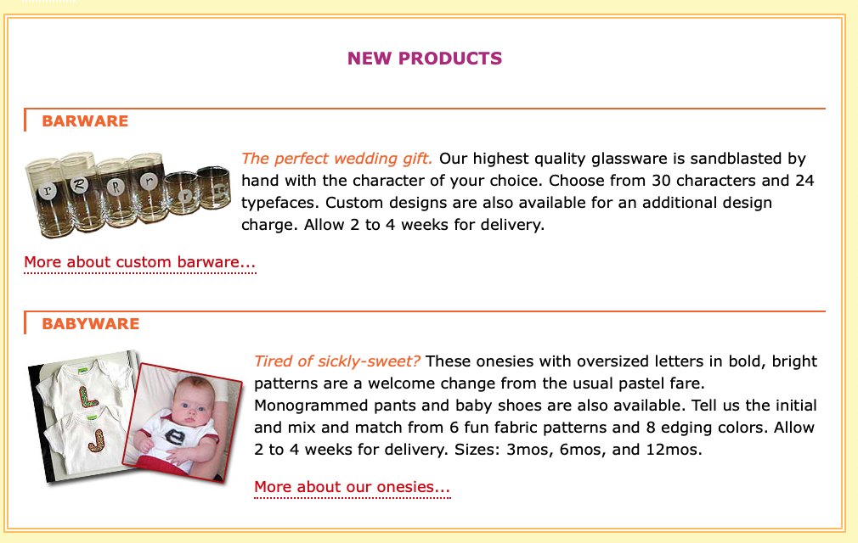

1. Adjust “More about….” Links to always appear below images so they are clearly visible and consistently on the left side of the product section. This change is going to require a little extra markup because we need a way to target just the paragraphs that contain “More about…” links.
   1. Add the class name “more” to each of the paragraphs that contain links. Here is the one:

<p class="more"><a href="#">More about custom barware...</a> </p>

1. Use class sector to make those paragraphs clear the floated images.

#products .more {

clear: left;

}

1. Save the file and try it out in the browser. It should look something like picture below.

before

after

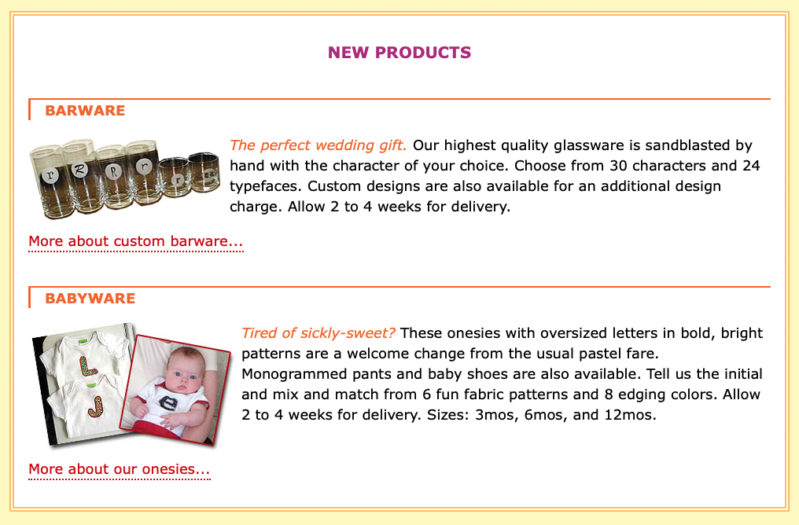

1. When you finish, rename the jenware.html to xxxxxxxxxxx.html (xxxxxxxxxxx is your student id) and upload the xxxxxxxxxxx.html to LEB2.