**INT102 Lab 3: Working with HTML Elements (1/2021)**

1. Open the HTML Live Code from URL in Classroom On Demand (COD)
2. Download recipe.txt from COD and copy the contents in the file and paste under the <body> element.
3. Se the title page to Tapenade.
4. Use the proper HTML elements to format the content as follows:

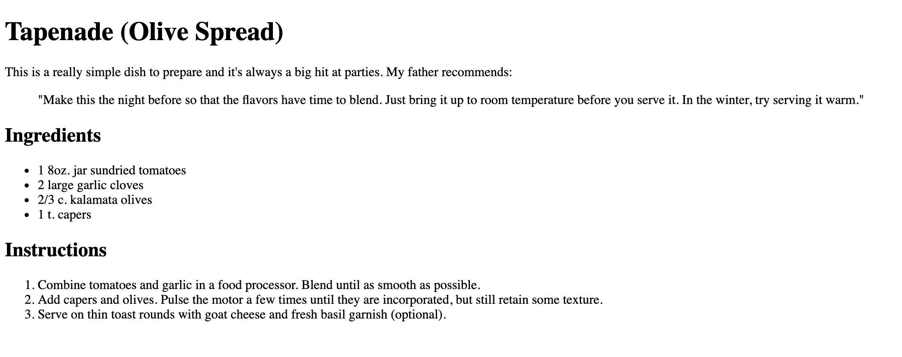

1. Group the HTML elements into three parts and provide the unique id to each part as
   1. description
   2. ingredients
   3. instructions



**description**

**instructions**

**ingredients**

1. Add a few fine details. Classify each ingredient as "ingredient" using span elements for the following texts:
   1. sundried tomatoes
   2. garlic cloves
   3. kalamata olives
   4. capers
2. Add the style element between </title> and </head> as follows

</title>

<style>

.ingredient {

font-weight: bold;

color: purple

}

</style>

</head>

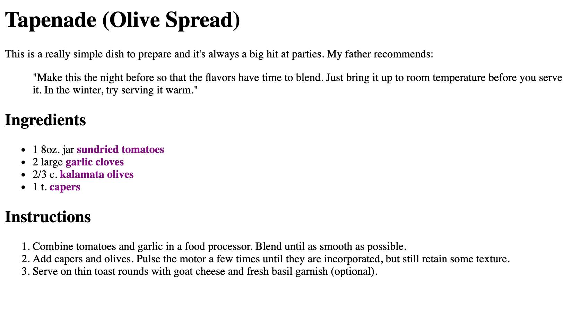

1. Click the menu and press the button Save and give the file name as xxxx_lab3.html (xxxx is your student id) and upload to LEB2