**INT102 Lab 6: HTML Form (1/2021)**

1. Download lab6.zip and extract it to “lab6\”

1. Open VS Code editor > Open the contest_entry.html

1. Change the contest_entry.html to a functional online form shown below:

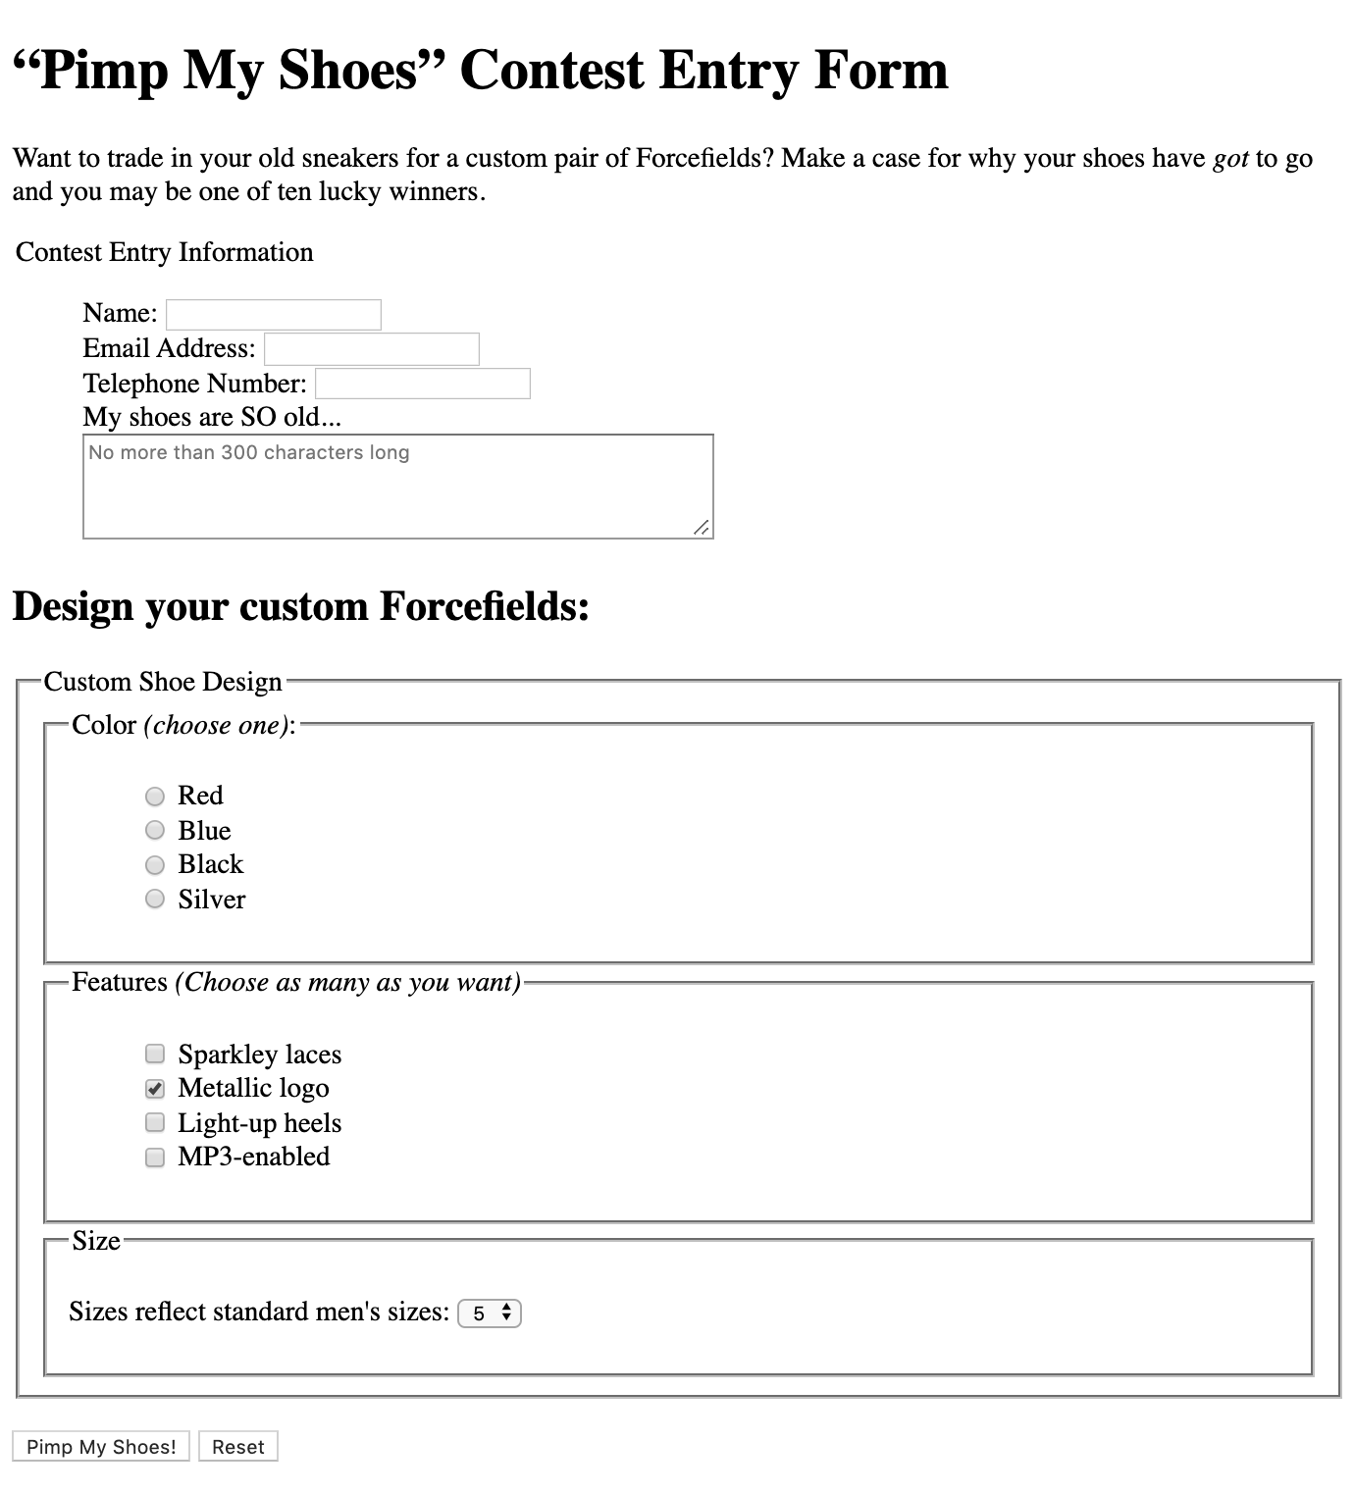

1. Put everything after the intro paragraph into a form element. The action and method attributes in the form element should look like this:

<form action="contest.php" method="post">

…

</form>

1. In the “Contest Entry Information” section of the form, add three short text entry form controls and name the text fields “name”, “email”, and “phone”, respectively.
2. Add a multiple text area for the shoe description on a new line. Use attributes to make it four rows long and 60 characters wide and name the text area “story”.
3. In the “Custom Shoe Design” section, there are lists of color and feature options. The Color option should be radio buttons because shoes can be only one color. Name the variable name for each to “color”. Set the value for each to lower case such as “blue”, “black” and “silver”.
4. The feature option should checkbox buttons and name the variable name for each to “feature[]” and set the “ Metallic logo” option as preselected option. Here are the list of values : “laces”, “logo”, “heels” and “mp3”.
5. Insert a menu element with the shoe sizes (5 to 13). Name the variable for the shoe sizes to “size”.
6. Add the submit and reset buttons at the end, just before the </form> tag. Change the text on the submit button to “Pimp my shoes!”.
7. Rename the contest_entry.html to xxxxxxxxxxx.html (xxxxxxxxxxx is your student id ) and upload to LEB2.

