**INT102 Lab 10 : Colors and Backgrounds (CSS) (1/2021)**

1. Download Lab10.zip and unzip the file.
2. Open the bistro.html in the browser. It should look like the picture below:

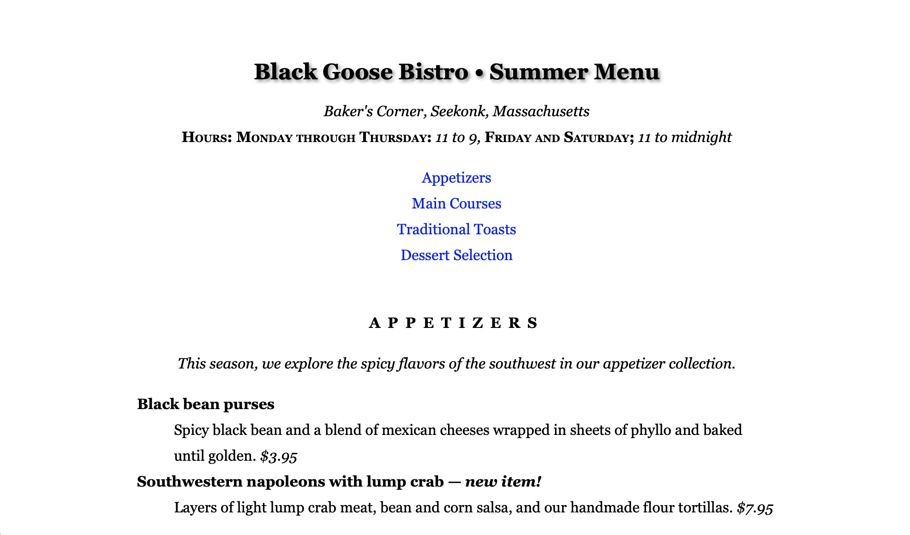

1. Open VS Code > Open the bistro.html.

**Adding color to a document**

1. Make the h1 heading purple (R:153, G: 51, B: 153,or #993399 or #939) by adding a new declaration to the existing h1 rule.
2. Make the h2 headings light orange-brown (R:204, G:102, B:0, or #cc6600).
3. Make the background of the “header” div white with 50% transparency (R:255,G:255,B:255, .5) so a hint of the background color shows through.
4. Make the background of the entire page a light green (R:210,G220, B:157, or #d2dc9d).
5. Save the file and try it out in the browser.

**Adding styles to a elements with pseudo-classes**

1. Making visited links a muted purple (#993399).
2. When the mouse is place over links, make the text a brighter purple (#c700f2) and add a white background color (#fff). This will look like the links are lighting up when the mouse is pointing at it. Use the same style rules for when the links are in focus.
3. At the mouse is being clicked (or tapped on a touch device), add a white background color and make the text turn a vibrant purple (#ff00ff). Make sure that all the link pseudo-classes are in the correct order.
4. When you are done, your page should look like the picture below.

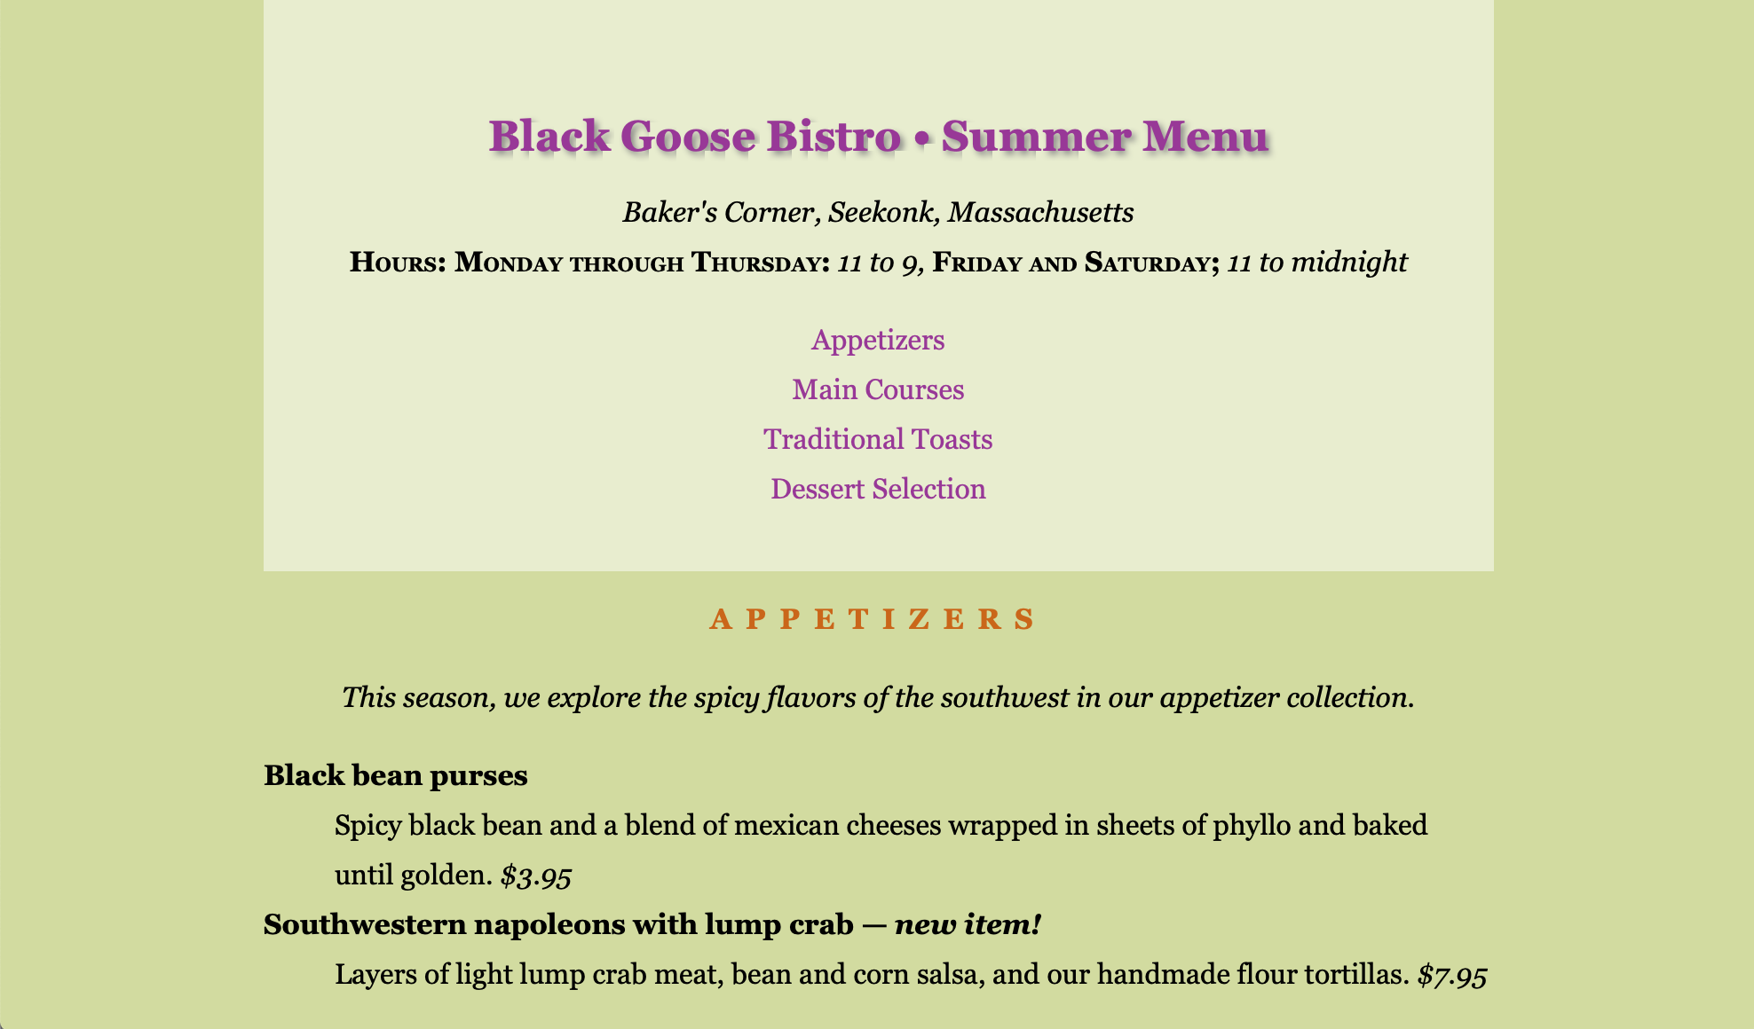

**Adding a tiling background image**

1. Add a declaration to the body style rule that makes the image bullseye.png title in the background of the page. Be sure to include the pathname relative to the style sheet.
2. When you are done, your page should look like the picture below.

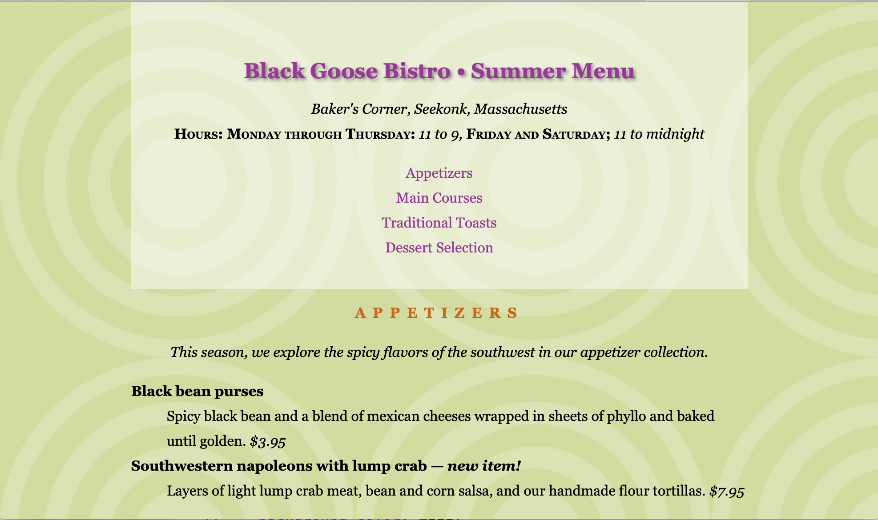

**Controlling a tile direction**

1. In the #header rule, add the image purpledot.png and set it to repeat horizontally only.
2. Save the file and try it out in the browser.

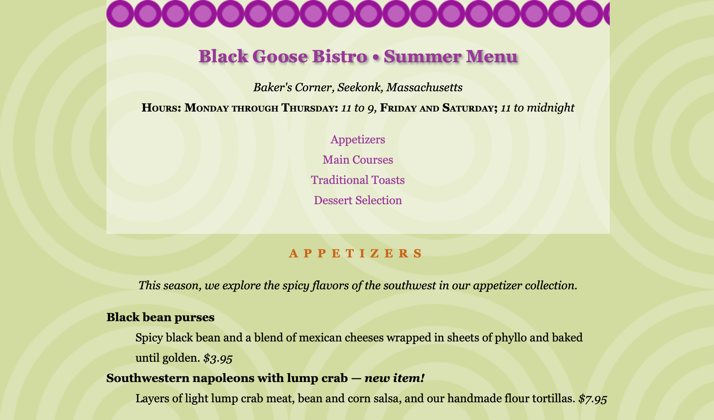

**Positioning background images**

1. Make the background patterns styed centered. Add this declaration to both the body and #header rules, then save and look at it in the browser.

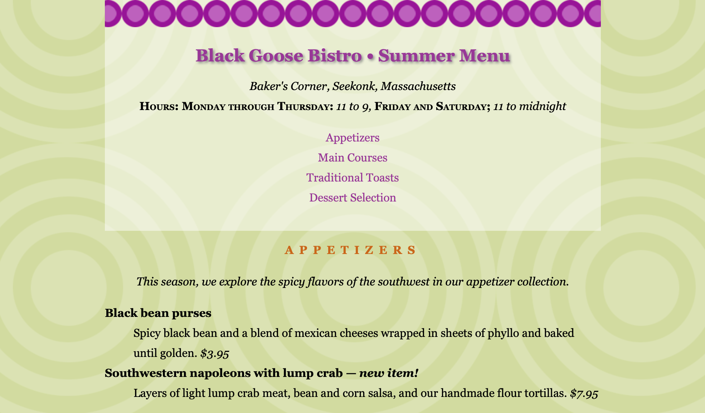

1. Comment the settings in 13 and add the blackgoose.png images to the background of the pages. Set it to not repeat, the position to “center 100px” in the page.
2. Save the file and try it out in the browser.

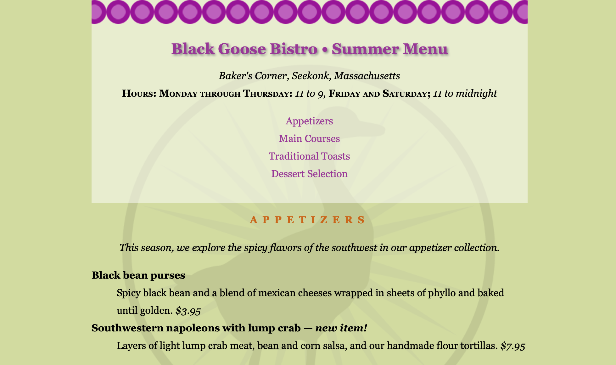

1. Use the property to keep the background image in the same place when the page scrolls.
2. Save the file and try it out in the browser.

**Making an external style sheet**

1. Open the latest version of bistro.html. Select and cut all of the rules within the style element, but leave the <style>…..</style> tags because we’ll be using them in a moment.
2. Create a new plain ASCII text document and paste all the style rules. Make sure that no markup got in there by accident.
3. Save this document as xxxxxxxxxxx.css [xxxxxxxxxxx is your student id] in the same directory as the bistro.html document.
4. In the bistro.htm, add and @import rule to attach the external style sheet xxxxxxxxxxx.css.
5. Save the file and reload it in the browser. It should look exactly the same as it did when the style sheet was embedded.
6. Delete the whole style element, and add the style sheet with a link element in the head of the document.
7. Save the file and reload it in the browser. It should look exactly the same as it did when the style sheet is loaded by @import.
8. When you finish, rename the bistro.html to xxxxxxxxxxx.html
9. Zip the xxxxxxxxxxx.html and xxxxxxxxxxx.css and rename the file to xxxxxxxxxxx.zip and upload the xxxxxxxxxxx.zip to LEB2.