PROJECT DOCUMENTATION
Student Performance Analytics System
Student Name: Nadir Khan
Course: Diploma in Computer Engineering / CSE
Institute: Ch. Bansi Lal Government Polytechnic, Bhiwani, Haryana
Technologies: Python, NumPy, Pandas
Dataset: 300 student records
Project Deadline: 15 October 2026

1. Project Title and Student Details
Project Title: Student Performance Analytics System
Student Name: Nadir Khan
Course: Diploma in Computer Engineering / CSE
Institute: Ch. Bansi Lal Government Polytechnic, Bhiwani, Haryana

2. Objective
The main objective of this project is to build a simple Student Performance Analytics System using Python. The project takes student marks and attendance data and converts it into useful academic information. It calculates total and average marks, assigns grades, identifies Pass/Fail status, compares subject performance, finds top-performing students, and checks the relationship between attendance and performance.

3. Technologies Used
• Python
• NumPy
• Pandas
• Google Colab / Jupyter Notebook

4. Dataset Description
The project uses a CSV dataset containing 300 student records. Each record represents one student and contains basic student information, marks in four subjects, and attendance.
Dataset columns:
• Student_ID
• Name
• Department
• Python
• SQL
• Mathematics
• Data_Analysis
• Attendance
Subject marks are on a 0–100 scale and attendance is stored as a percentage.

7. Outputs / Screenshots
The Google Colab notebook screenshots are included in Appendix A. They show the executed analysis questions and their outputs.

8. Final Outcome
The completed Student Performance Analytics System provides a structured analysis of the 300 student records. It converts raw marks and attendance data into useful academic information such as total marks, average marks, grades, results, subject-wise performance, top performers, and the attendance-performance relationship.
Actual calculated values can be added here after the final notebook run.

9. Challenges and Learning
While working on this project, I practiced loading CSV data into Pandas, inspecting a dataset, selecting specific columns, performing row-wise calculations, and using functions for repeated logic. I also learned how Pandas operations such as sum(), mean(), value_counts(), sort_values(), idxmax(), and idxmin() can be used for practical data analysis.
The project helped me understand how raw data can be converted into useful results using Python, NumPy, and Pandas without using complicated machine-learning techniques.

5. Implementation
I implemented the project step by step in a Google Colab notebook. First, the CSV file is loaded into a Pandas DataFrame. After checking the dataset, the required calculations are performed one by one. Reusable functions are used for grade and Pass/Fail classification.
- Load and understand the dataset.
- Calculate Total_Marks for each student.
- Calculate Average_Marks for each student.
- Assign grades from A+ to F.
- Determine Pass/Fail status using the 40-mark minimum in every subject.
- Calculate the overall class average.
- Identify the highest and lowest performing students.
- Calculate subject-wise average marks.
- Calculate Pass/Fail counts and percentages.
- Identify the top 5 performing students.
- Identify the best-performing subject.
- Calculate correlation between Attendance and Average_Marks.
- Generate the final performance summary.

6. Key Features
- Student dataset loading and inspection
- Total and average marks calculation
- Grade assignment
- Pass/Fail classification
- Overall class performance analysis
- Highest and lowest performer identification
- Subject-wise performance analysis
- Pass/Fail statistics
- Top 5 student identification
- Best-performing subject identification
- Attendance versus performance analysis
- Final performance summary

10. GitHub Repository
GitHub Repository Link: [Add GitHub link after uploading the project]
Final project files:
- Student_Performance_Analytics.ipynb
- students.csv
- README.md
- Project_Documentation.docx

Appendix: Grade and Pass/Fail Criteria
Average Marks | Grade
90–100 | A+
80–89 | A
70–79 | B
60–69 | C
50–59 | D
Below 50 | F
Pass/Fail Rule: A student is considered Pass only if they score at least 40 marks in every subject. If the student scores below 40 in any one subject, the result is Fail.

Appendix A: Google Colab Notebook Screenshots
The following screenshots were provided from the project notebook and are included as evidence of the analysis steps and outputs.
Q2 – Calculate Total Marks
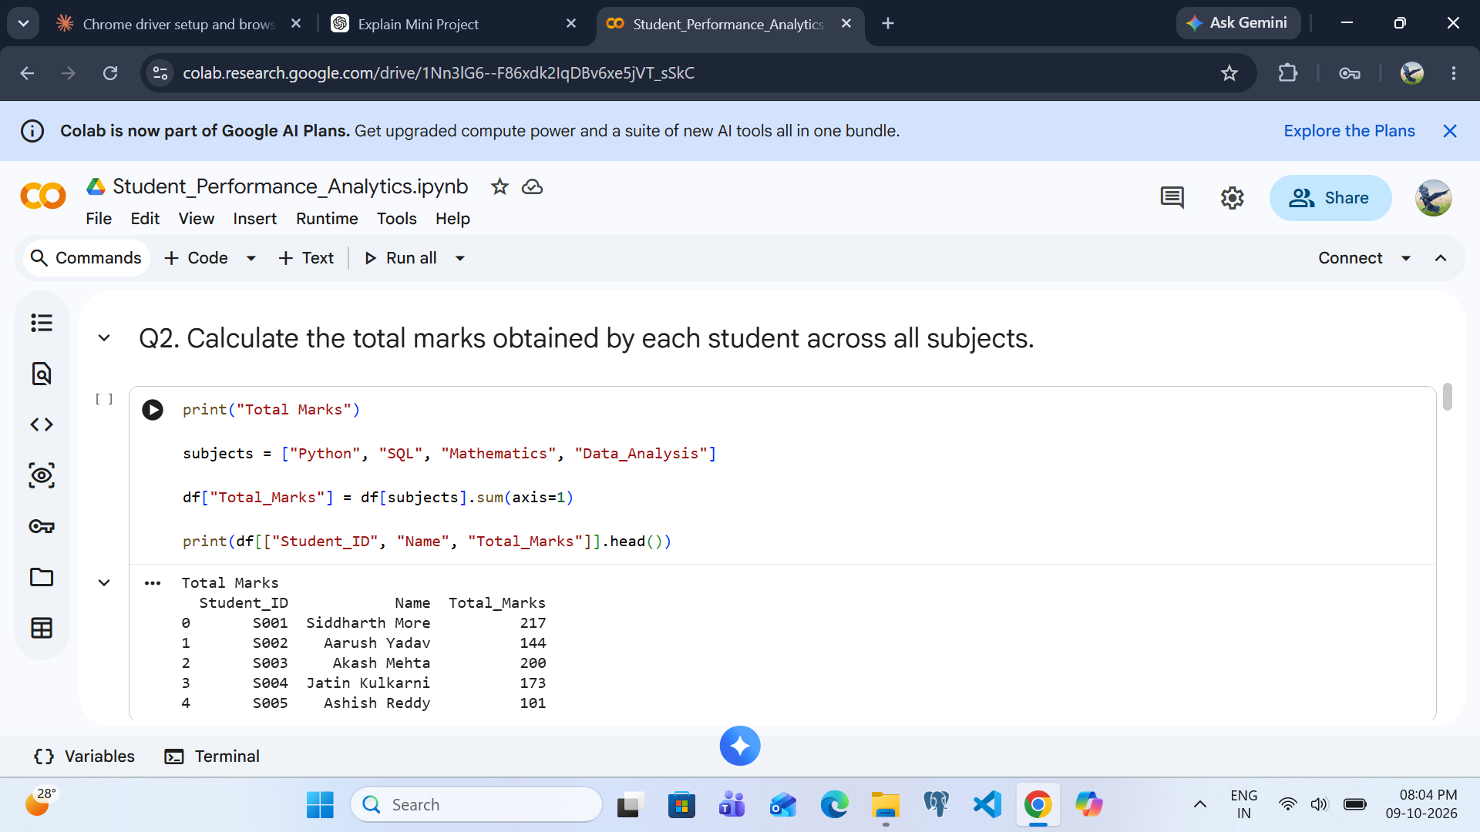

Q3 – Calculate Average Marks
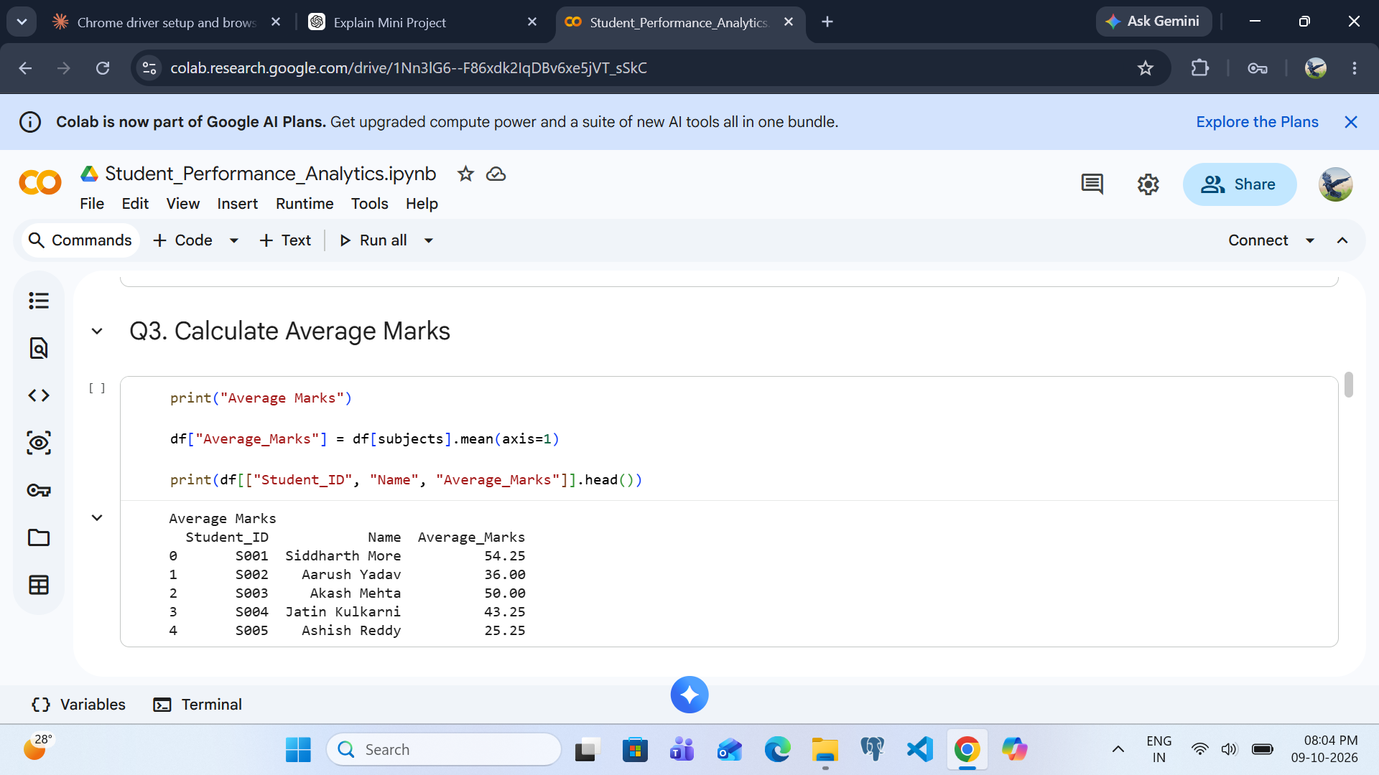

Q4 – Assign Grades
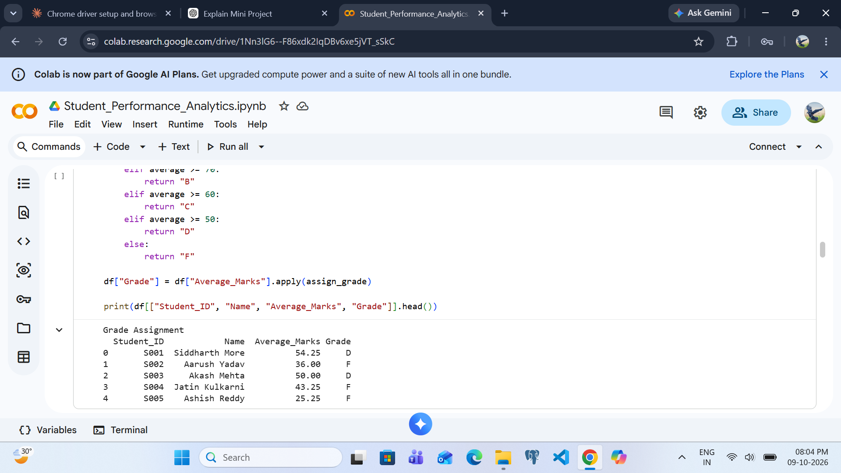

Q5 – Identify Pass/Fail Status
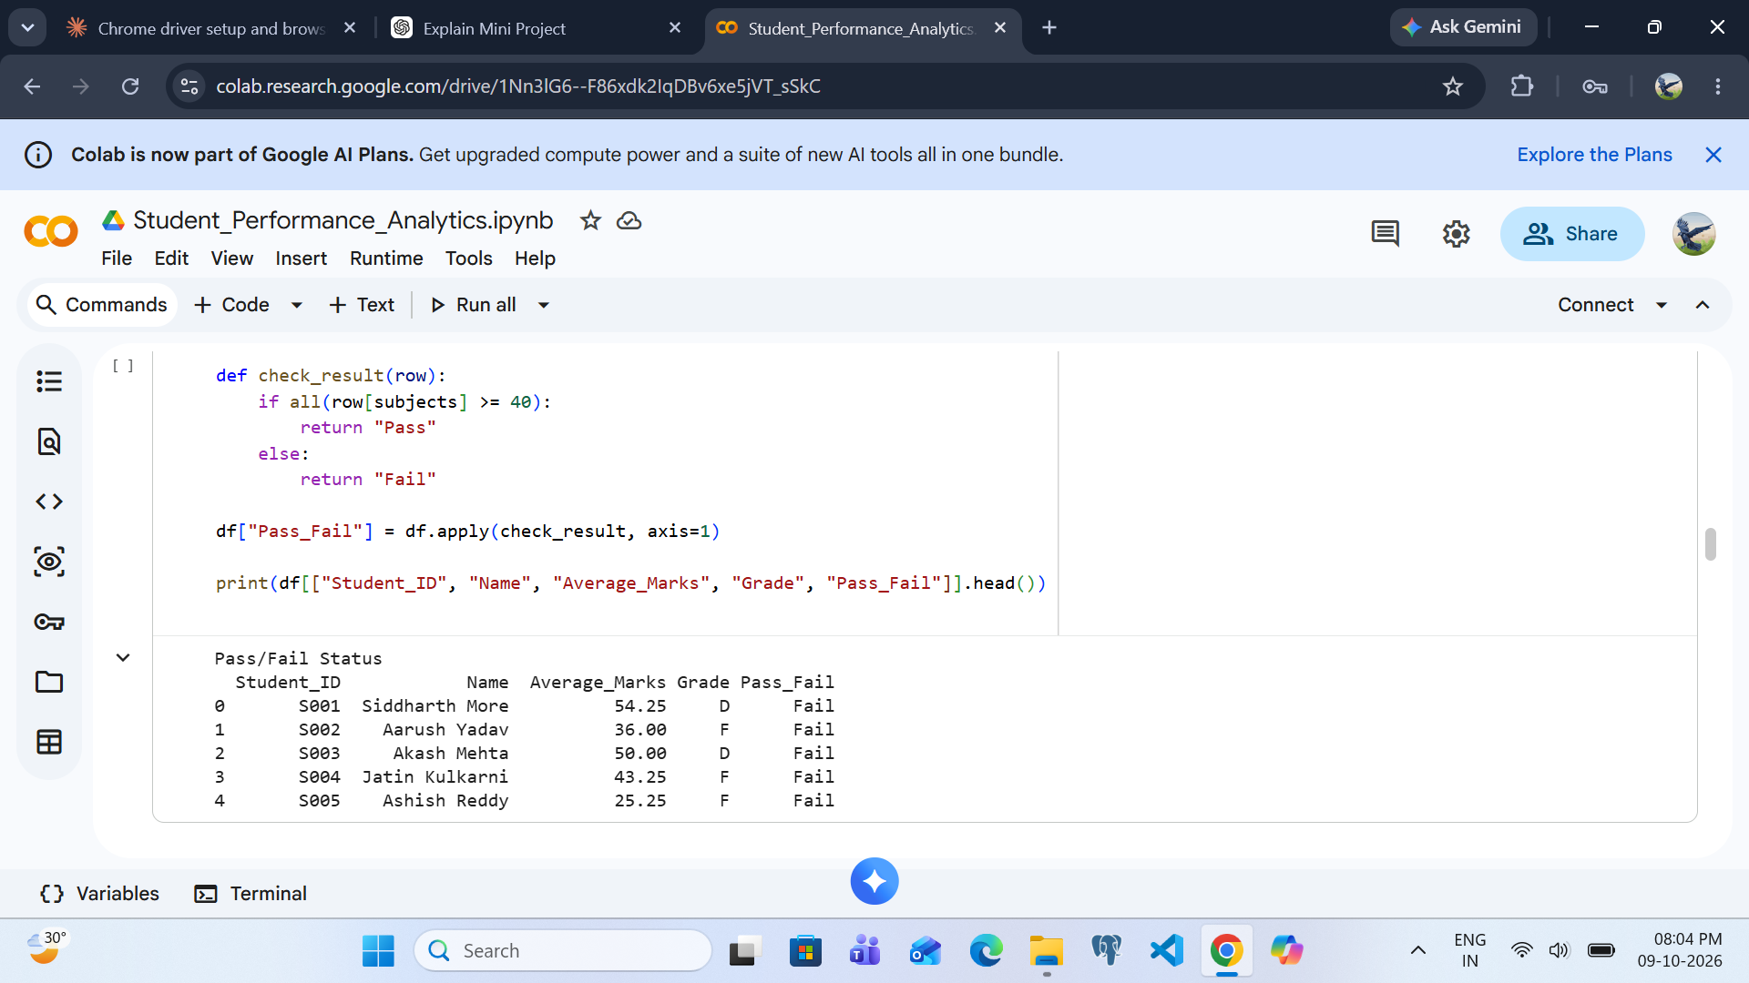

Q6 – Calculate Overall Class Average
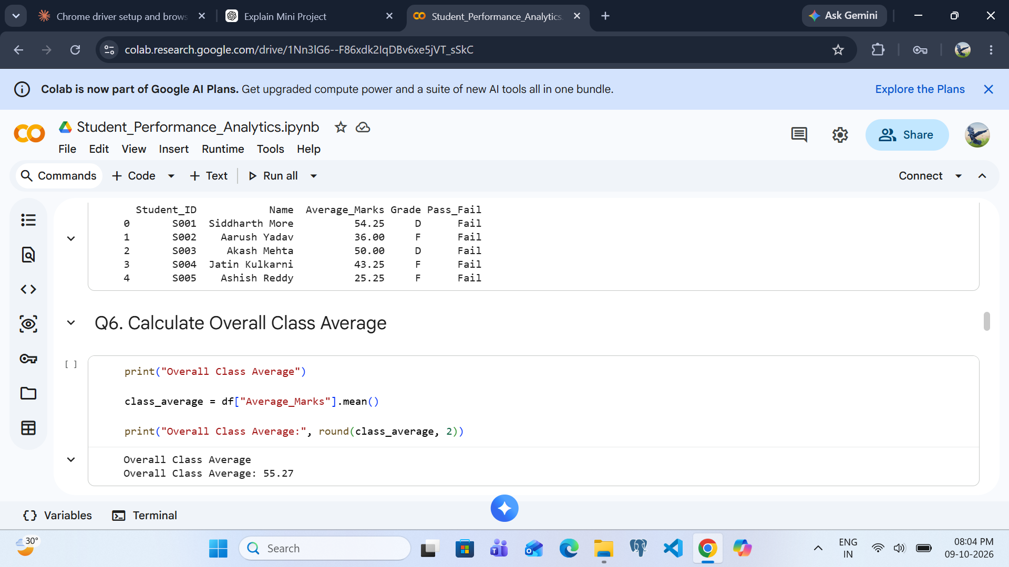

Q7 – Identify Highest and Lowest Performers
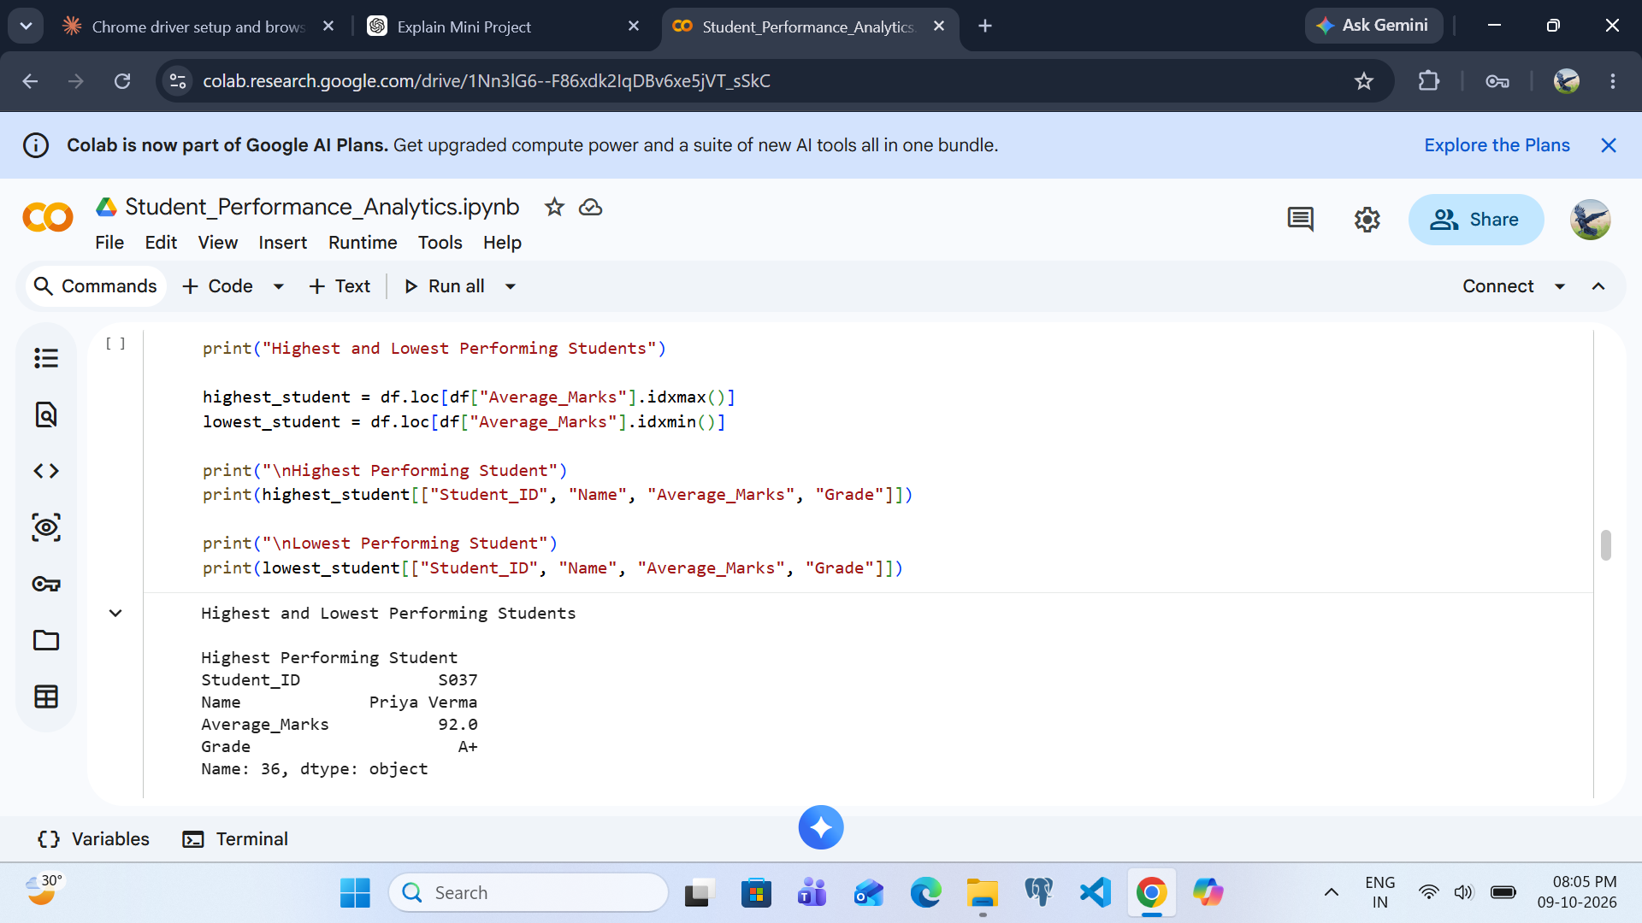

Q8 – Analyze Subject-wise Performance
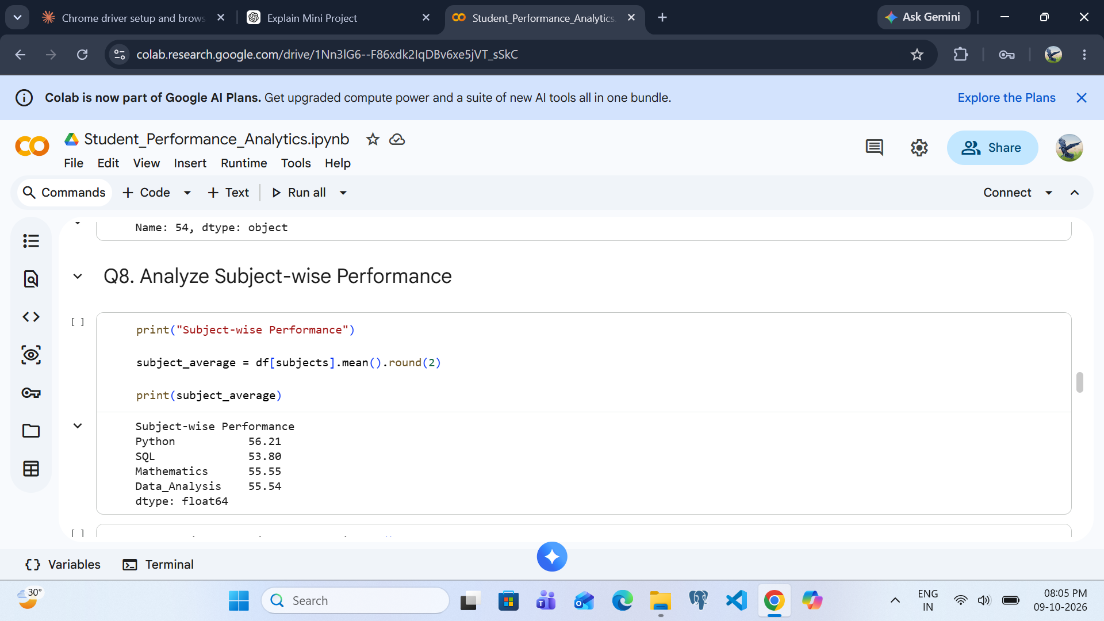

Q8 – Subject-wise Average Output
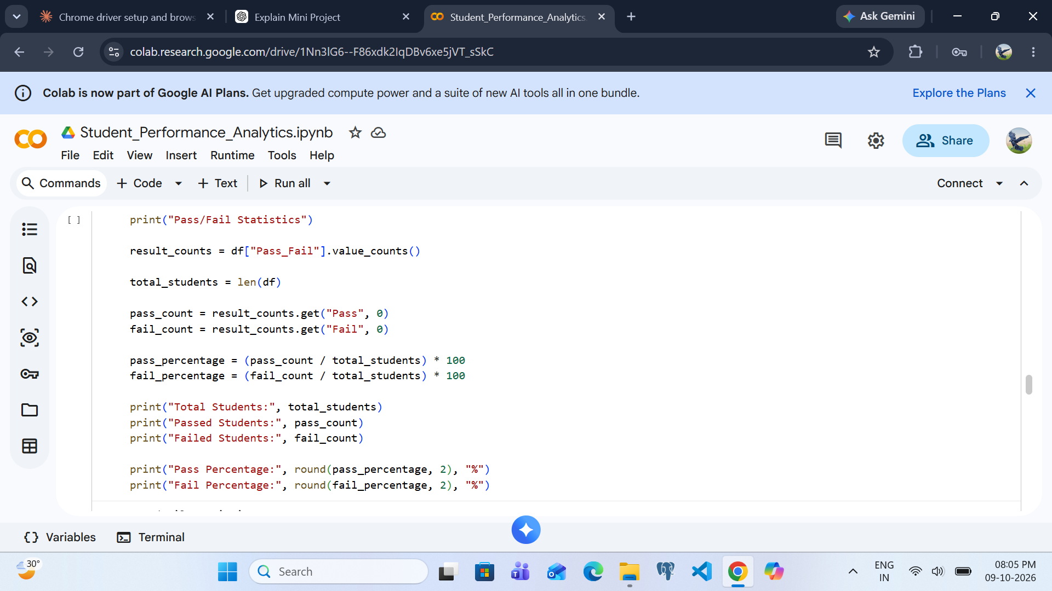

Q9 – Pass/Fail Statistics
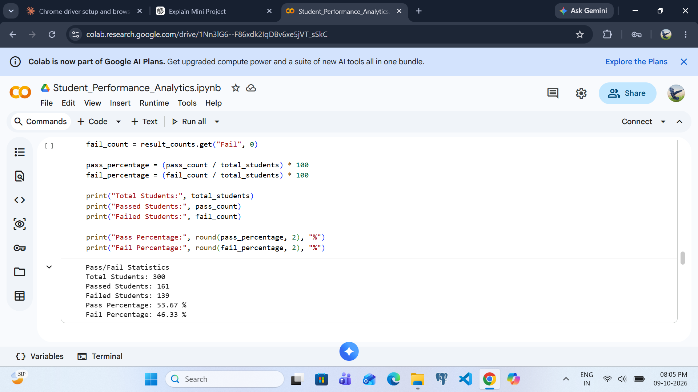

Q9 – Pass/Fail Summary Output
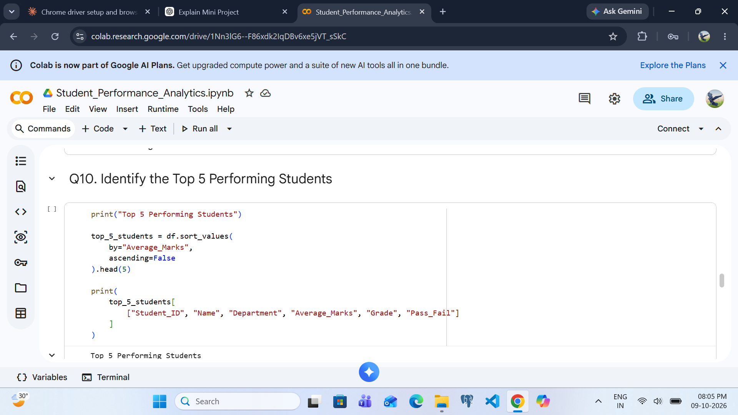

Q10 – Identify the Top 5 Performing Students
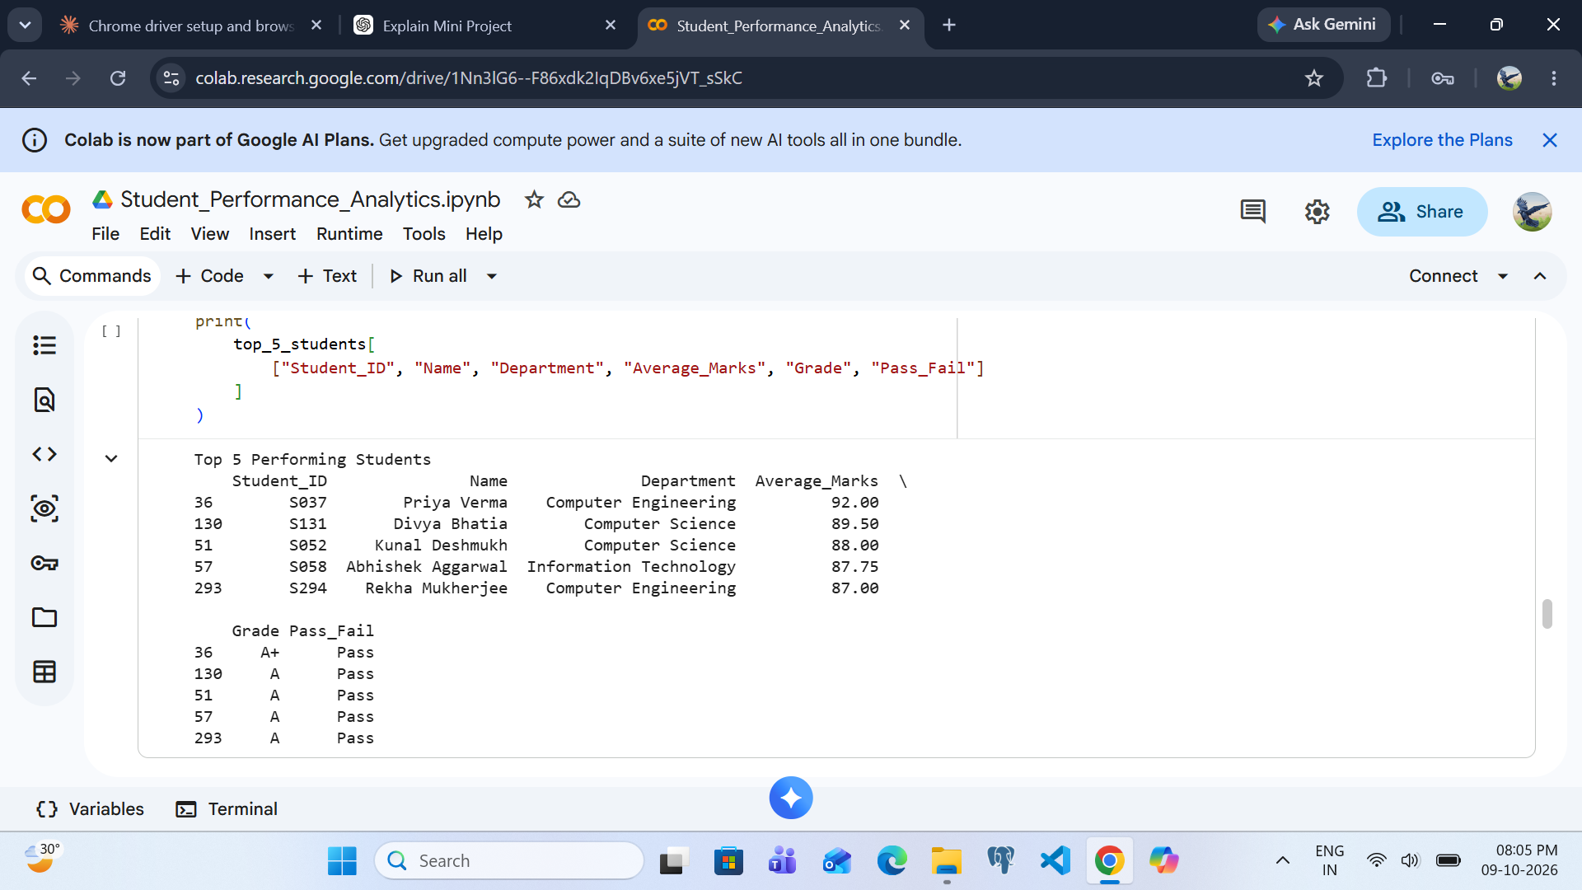

Q10 – Top 5 Students Output
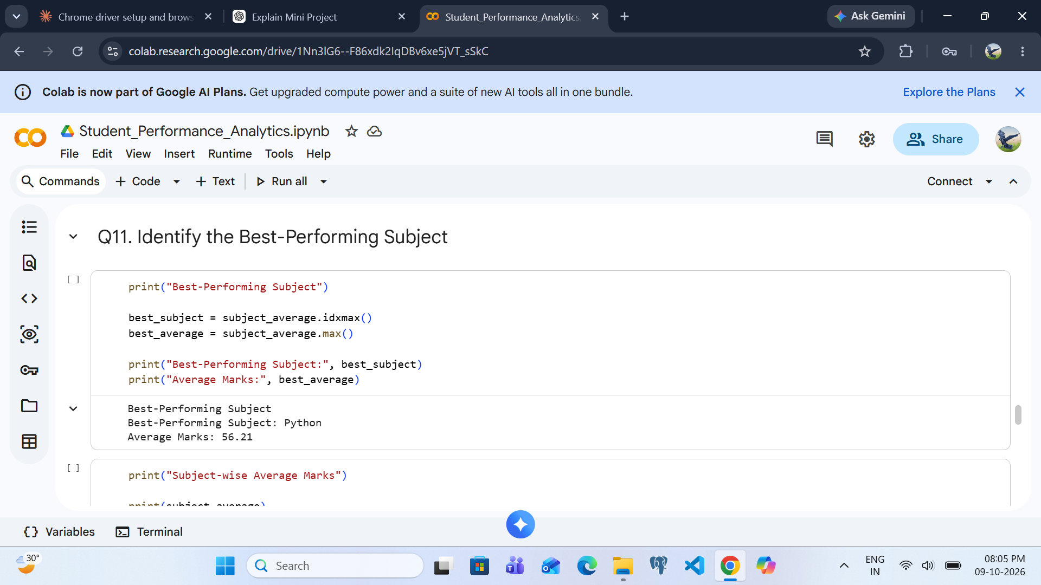

Q11 – Identify the Best-performing Subject
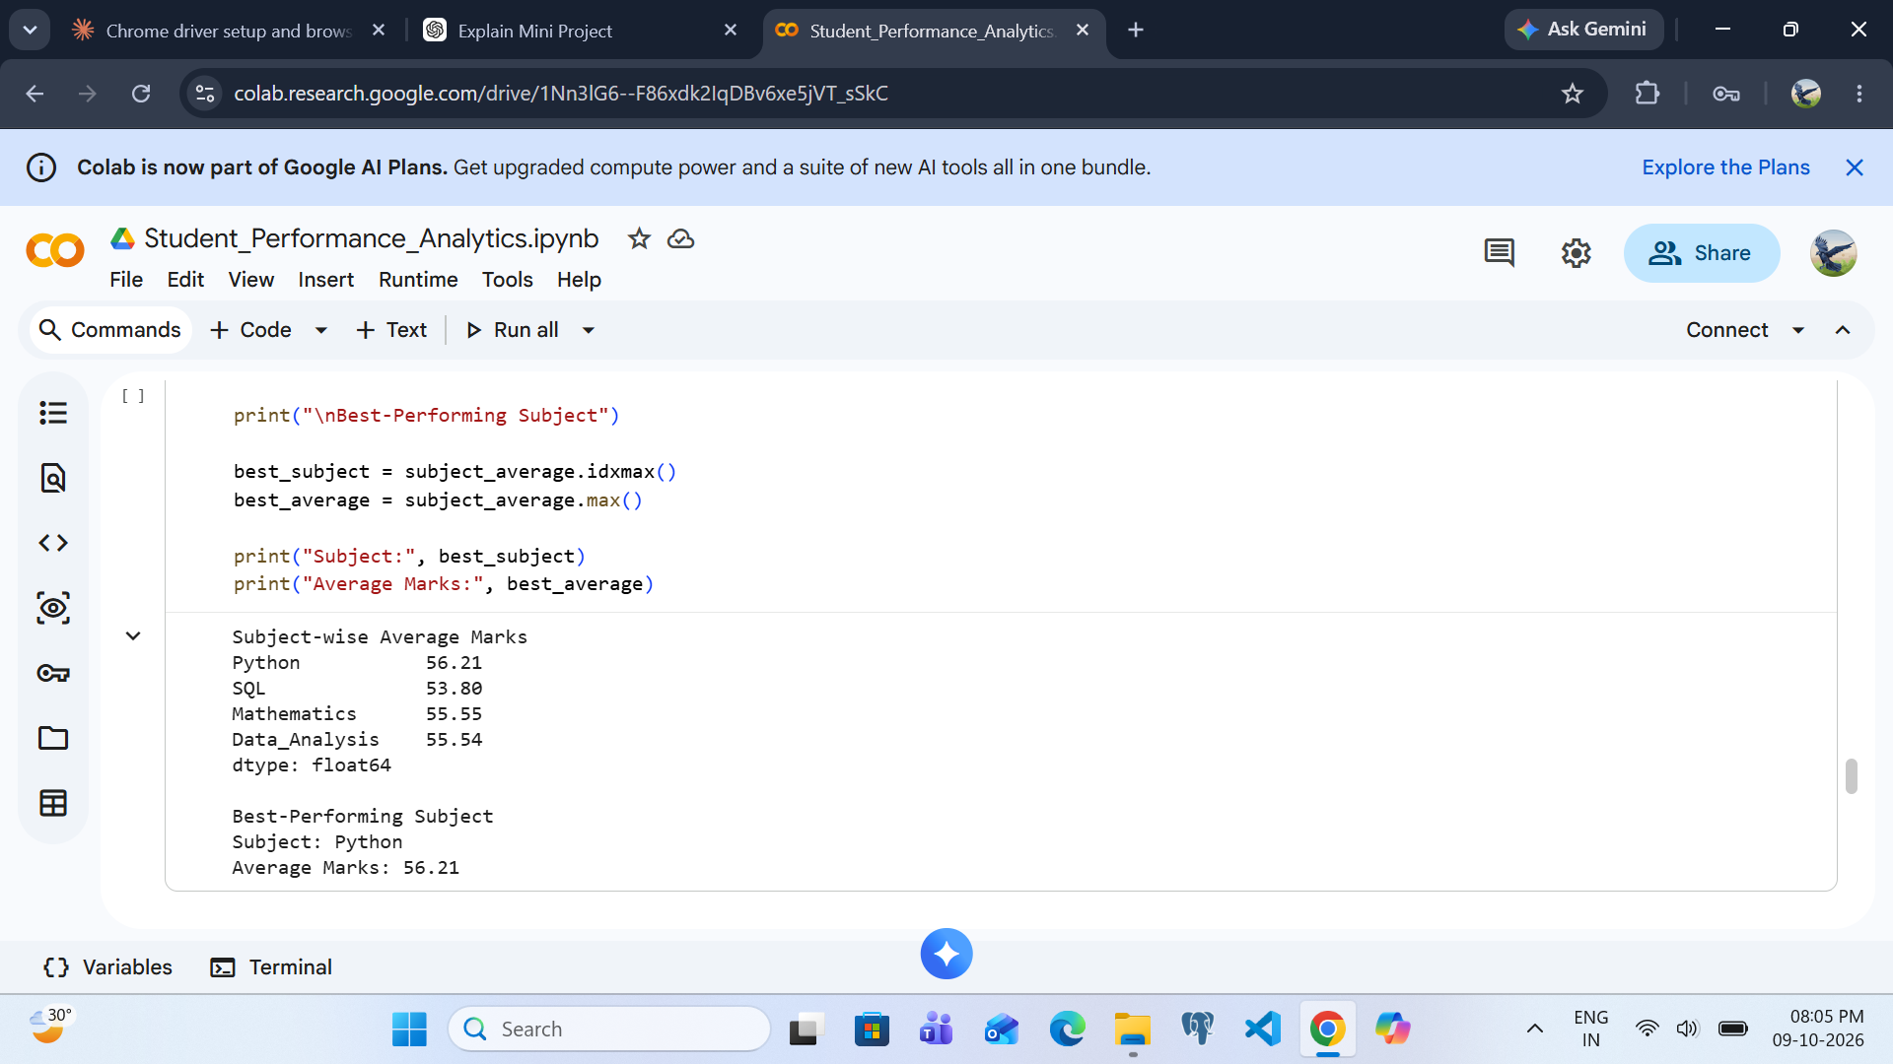

Q11 – Best Subject Output
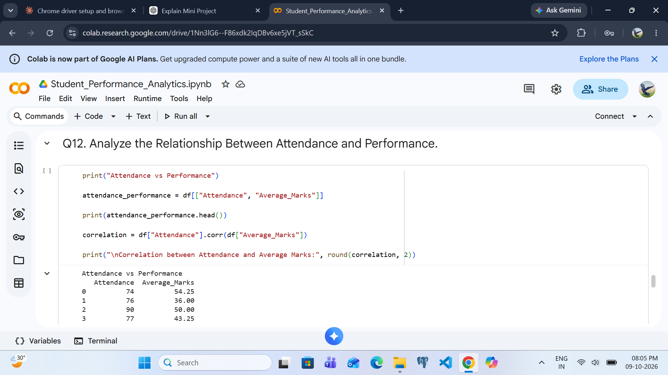

Q12 – Analyze Attendance and Performance
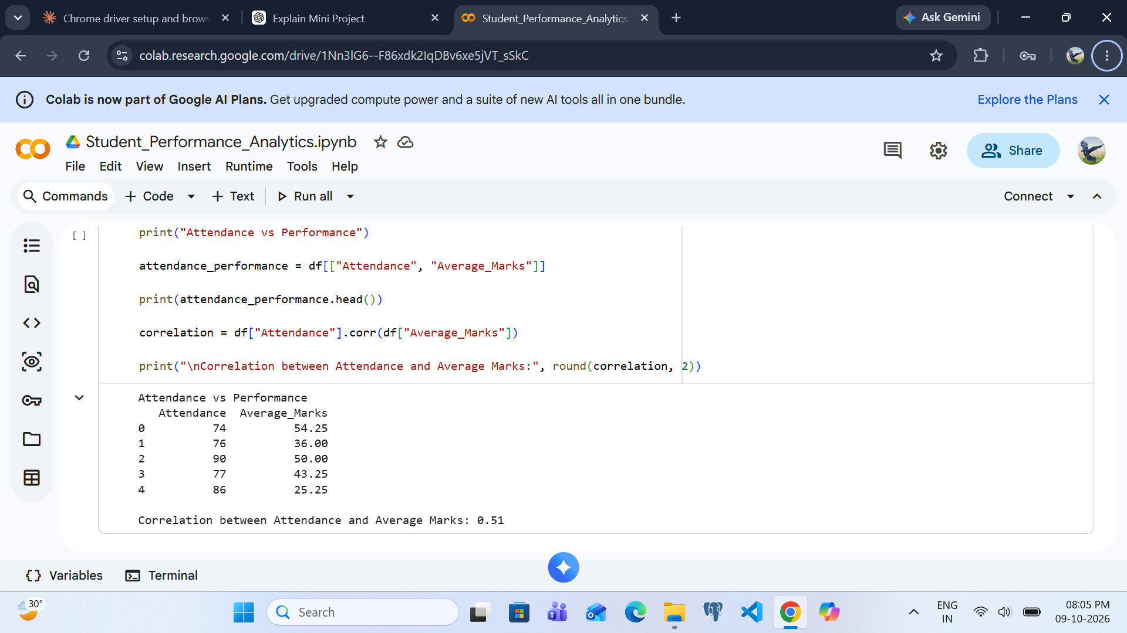

Q12 – Attendance/Performance Output
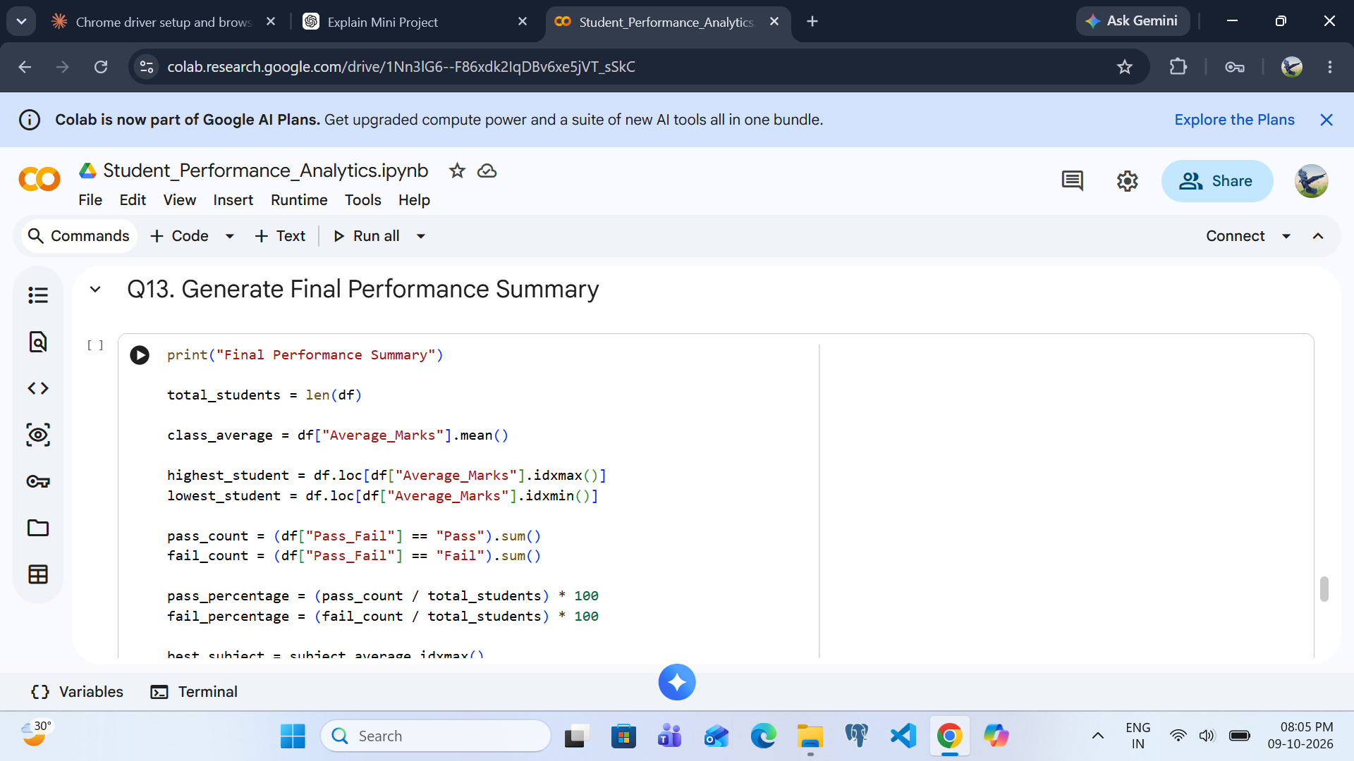

Q13 – Generate Final Performance Summary
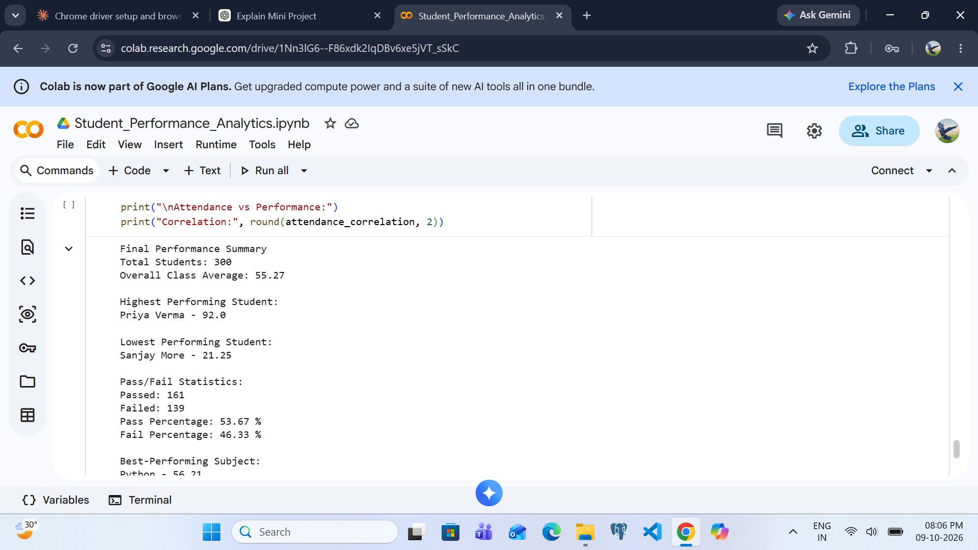

Q13 – Final Summary Output
