**SW2 – Project Evaluation Form**

In brief, this desktop application is for parking. the parking has several spots, customers have to print a ticket which contains the details of the car spot, the customer ID and the time that the car joined the system at, from this ticket the application calculates the total parking hours and how much should the customer pay.

Customer only can login, print the ticket and logout, but Admins can access all the details, review the car spots, the total payments and can also change and update the system.

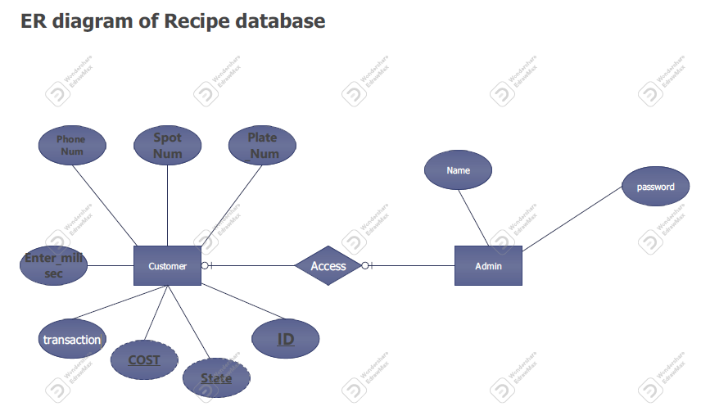

|  |
| --- |
| AdminController |
| checkAccount():boolean  parkedCars_Report(Customers[] ticket):string  Payment_Report(ResultSet Resultset_for_customer):string |

|  |
| --- |
| Admins |
| - adminName:string  - adminPassword:string |
| Admins()  Admins(String adminName, Strin adminPassword)  + getAdminName():string  + setAdminName(String adminName):void  + getAdminPassword():string  + setAdminPassword(String adminPassword):void |

|  |
| --- |
| CustomerController |
| + entry(ResultSet Resultset_for_customer, Customers[] ticket,int user_input, String plateNumber, int phoneNumber): boolean  + pay_theBill(ResultSet Resultset_for_customer, Customers[] ticket, int customer_spot):string |

|  |
| --- |
| Customers |
| - Plate_Number_of_car: String  - phone_of_ticketOwner: long |
| Customers()  Customers(int id_of_ticket, String Plate_Number_of_car, int spot_number_in_parking, long phone_of_ticketOwner, Date date_of__entry)  + getPlate_Number_of_car():string  + setPlate_Number_of_car(String Plate_Number_of_car): void  + getPhone_of_ticketOwner():long  + void setPhone_of_ticketOwner(int phone_of_ticketOwner):void |

|  |
| --- |
| + void setPhone_of_ticketOwner(int phone_of_ticketOwner):void |
|  |
|  |