**Special-Purpose Legwork for INtegration of Ticketing Systems.**

**SPLINTS**

Concordia University

COMP 487

Winter 2018

Prepared by

*Team 08*

Vincent Fugnitto  
Kenneth-Gerard Serrano  
Ziad Yarbouh  
Daniil Karpov

**Directory Layout**

*splints/lib/*

Contains all the jar dependencies of the project

*splints/nbproject/*

Contains all the splints project properties and xml files

*splints/rest-client/*

Contains Splints as a RESTful service itself. The application was generated with Angular CLI version 1.7.3

*splints/src/java/*

Contains the complete directory of the Splints project developed in java.

*splints/src/java/bitbucket/*

Contains all the issue functionalities specific for BitBucket with constants and config classes.

*splints/src/java/github/*

Contains all the issue functionalities specific for GitHub with constants and config classes.

*splints/src/java/rt/*

Contains all the issue functionalities for RT with constants and config classes.

*splints/src/java/fp/v11/splints/*

Contains all the splints functionalities. ISplints interface class, FootPrints as well as FP issue transfers and edit classes, and constants and config classes.

*splints/src/java/bpel/*

Contains the BPEL applications.

*splints/src/java/bpel/BitbucketToGithubBpel/*

Contains the Bitbucket to Github issue transfer BPEL.

*splints/src/java/bpel/FP11ToAllBpel/*

Constains BPEL of FP11 parallel issue transfer to all other issue trackers.

*splints/src/java/bpel/GithubToBitbucketBpel/*

Contains Github to Bitbucket ticket transfer bpel.

*splints/src/java/bpel/JointRtToFp11AndFp11ToRTBpel/*

Contains Joint RT to FP11 and FP11 to RT ticket transfer BPEL.

*splints/src/java/bpel/JointRtToFp11AndFp11ToRtComposite/*

Contains Joint RT to FP11 and FP11 to RT ticket transfer composite application.

*splints/src/java/bpel/RtToFp11Bpel/*

Contains BPEL process that transfers existing ticket from RT to FP11.

*splints/src/java/bpel/RtToFp11Composite/*

Contains RT To FP11 ticket transfer Composite Application.

*splints/src/java/bpel/TransferClient/*

Contains the RT to FP11 transfer client.

*splints/src/java/ws/RESTfulSplintsWebService/*

Contains refactored refactored RESTful web services for splints

*splints/src/java/ws/rest-client/*

Contains Splints as a RESTful client itself. The application was generated with Angular CLI version 1.7.3

**Libraries**

Included all the different JSON, HTTP, commons, and fluent jars, and the jna platform jar.

**Petri Nets**

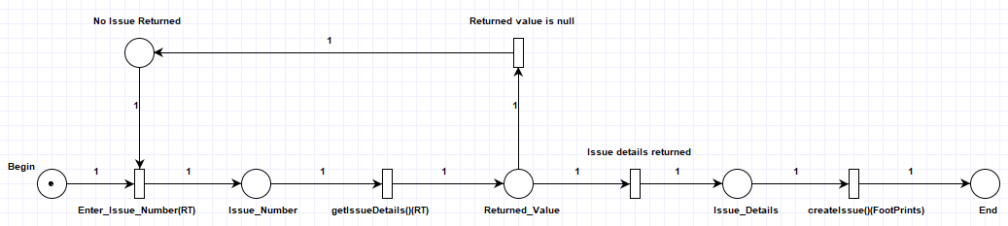

**BPEL**

Our BPEL folder contains all of the files for PM3, which includes most of the bonuses. The folder also contains the synchronized activities of the Team 3.

**Hadoop**

We manage to successfully complete the simple Hadoop/HDFS/MapReduce exercise for PM4.1. The sample text that we used to test our MapReduce application was the novel called “A Tale of Two Cities” by Charles Dickens.

Our Hadoop folder consists of the WordCount.java file and the part-r-00000 file, which contains the full list of N words and their number of occurrences with the tag and all of the accessory files.