**TEAM MEMBERS:-**

**NAGAPPAN**

**AKASH**

**SIVAKARTHICK**

**SANDEEP**

**BARATH KUMAR**

**Development part-1:**

o In this phase, We’re going to do three important steps in big data analysis &cloud.

o They are,

• Loading the data to cloud,

• Reading a data from Cloud,

• Data preprocessing

**Selection of dataset:**

**As per the project, We’ve to select social trends or climate dataset.**

**So, We took weather data in india from 1901 to 2017 which is in the CSV format for our big data analysis.**

**Loading the data to the cloud object storage:**

**Step-1: Go to the upload asset to project, Then browse the dataset & upload.**

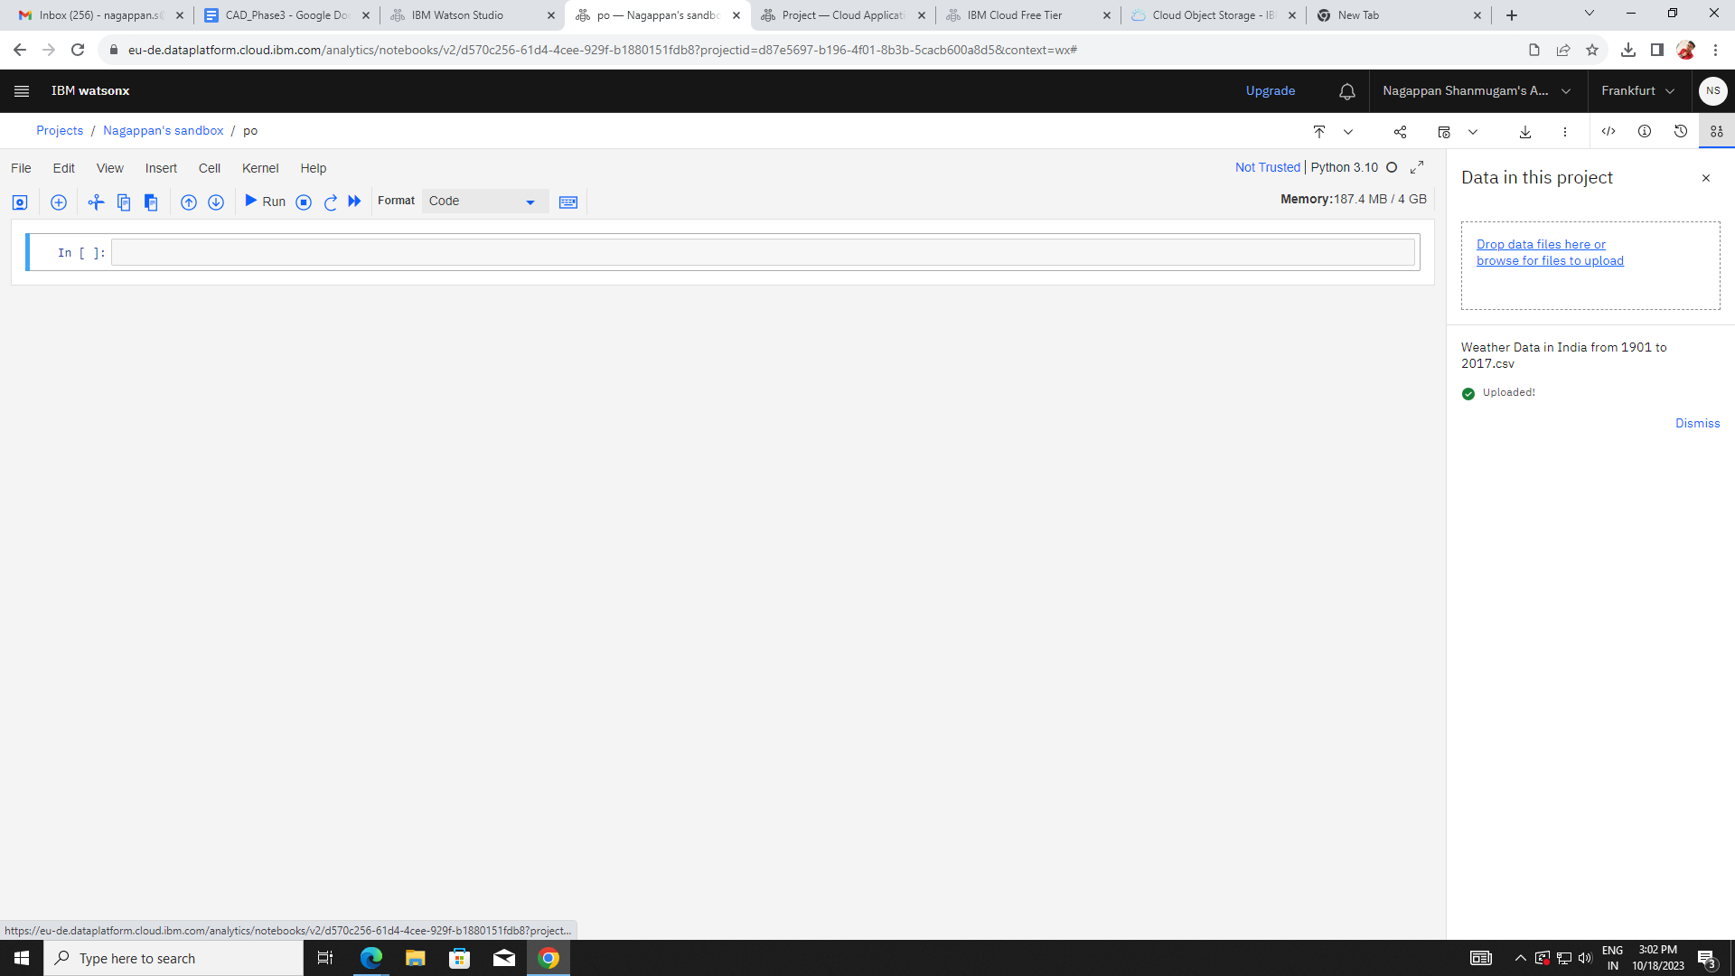

Step-2: After step-1, go to code snippets, then click read data & select the data from project.

Then click load as panda frame, the above codes will be display.

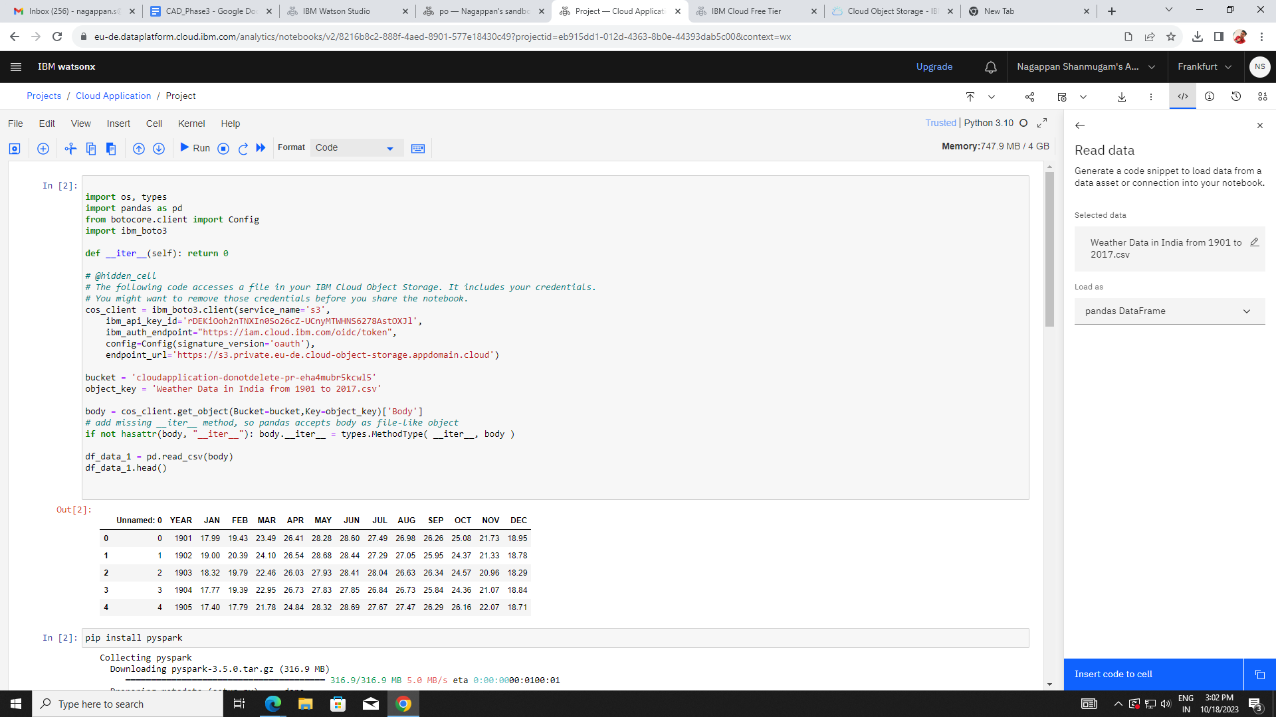

Step-3: Buckets are created in IBM cloud object storage

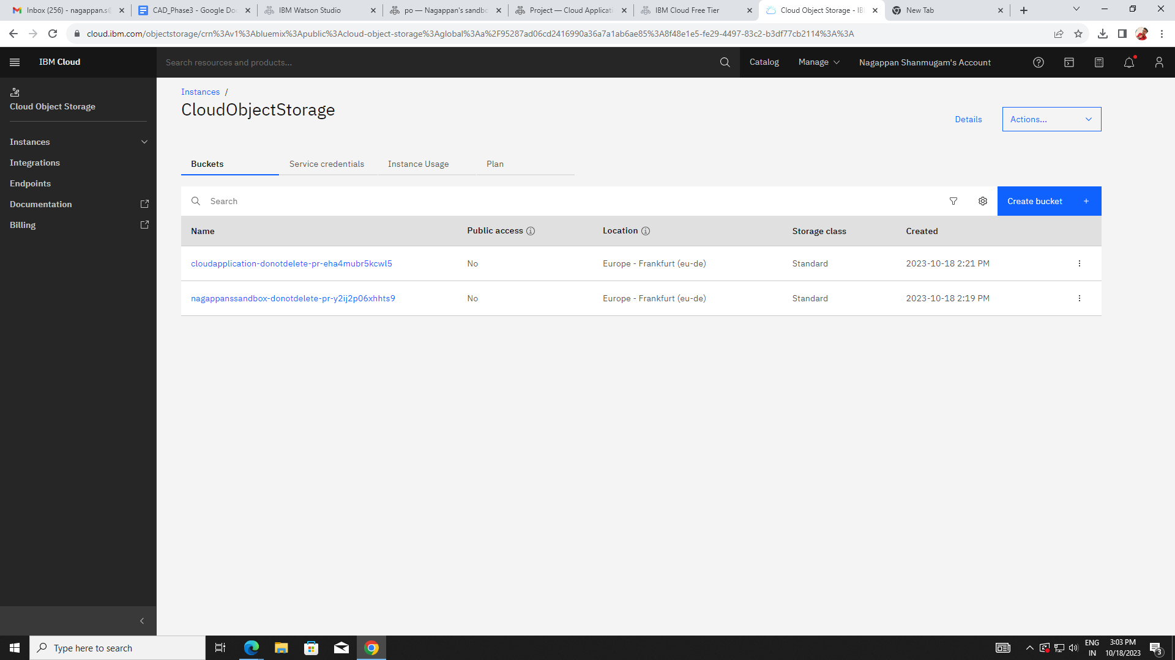

Reading the data from cloud object storage

Step-1: As we already known, Data are loaded in cloud object storage as pandas data frame.

Code [1]

import os, types

import pandas as pd

from botocore.client import Config

import ibm_boto3

def __iter__(self): return 0

# @hidden_cell

# The following code accesses a file in your IBM Cloud Object Storage. It includes your credentials.

# You might want to remove those credentials before you share the notebook.

cos_client = ibm_boto3.client(service_name='s3',

ibm_api_key_id='rDEKiOoh2nTNXIn0So26cZ-UCnyMTWHNS6278AstOXJl',

ibm_auth_endpoint="https://iam.cloud.ibm.com/oidc/token",

config=Config(signature_version='oauth'),

endpoint_url='https://s3.private.eu-de.cloud-object-storage.appdomain.cloud')

bucket = 'cloudapplication-donotdelete-pr-eha4mubr5kcwl5'

object_key = 'Weather Data in India from 1901 to 2017.csv'

body = cos_client.get_object(Bucket=bucket,Key=object_key)['Body']

# add missing __iter__ method, so pandas accepts body as file-like object

if not hasattr(body, "__iter__"): body.__iter__ = types.MethodType( __iter__, body )

df_data_1 = pd.read_csv(body)

df_data_1.head()

Output[1]

Unnamed: 0 YEAR JAN FEB MAR APR MAY JUN JUL AUG SEP OCT NOV DEC

0 0 1901 17.99 19.43 23.49 26.41 28.28 28.60 27.49 26.98 26.26 25.08 21.73 18.95

1 1 1902 19.00 20.39 24.10 26.54 28.68 28.44 27.29 27.05 25.95 24.37 21.33 18.78

2 2 1903 18.32 19.79 22.46 26.03 27.93 28.41 28.04 26.63 26.34 24.57 20.96 18.29

3 3 1904 17.77 19.39 22.95 26.73 27.83 27.85 26.84 26.73 25.84 24.36 21.07 18.84

4 4 1905 17.40 17.79 21.78 24.84 28.32 28.69 27.67 27.47 26.29 26.16 22.07 18.71

Step-2: Convert pandas data frame into pyspark dataframe.

Code[2]

from pyspark.sql.types import *

from pyspark.sql.functions import *

from pyspark.ml.classification import LogisticRegression

from pyspark.ml.feature import HashingTF, Tokenizer, StopWordsRemover

import pyspark

from pyspark.sql import SparkSession

#create Spark session

appName = "Weather Report"

spark = SparkSession \

.builder \

.appName(appName) \

.config("spark.some.config.option", "some-value") \

.getOrCreate()

data_frame=spark.createDataFrame(df_data_1)

display(data_frame)

Output[2]

DataFrame[Unnamed: 0: bigint, YEAR: bigint, JAN: double, FEB: double, MAR: double, APR: double, MAY: double, JUN: double, JUL: double, AUG: double, SEP: double, OCT: double, NOV: double, DEC: double]

Data Preprocessing:

o Data preprocessing is a crucial step in the big data analysis on IBM cloud object storage.

o It involves:

▪ Data cleaning,

▪ Data transformation,

▪ Organizing the raw data,

▪ Handling duplicates,

▪ Handling missing data

o Handling Duplicates:

Code[3]

#preprocessing

#handling duplicates

a = df.count()

b = df.dropDuplicates().count()

c = a - b

print("No.of original data: ", a)

print("No of data rows after deleting duplicated data: ", b)

print("number of duplicated data: ", c)

Output[3]

No.of original data: 117

No of data rows after deleting duplicated data: 117

number of duplicated data: 0

o Handling missing data:

Code[4]

#Handling missing data:

no_miss_val = df.dropDuplicates().dropna(how="any", subset=["JAN","FEB","MAR","APR","MAY","JUN","JUL","AUG","SEP","OCT","NOV","DEC"])

miss_val= a - no_miss_val.count()

print("number of missing value rows: ", miss_val)

Output[4]

number of missing value rows: 0

Drop duplicated data and fill missing data with mean value

Code [5]

#Drop duplicated data and fill missing data with mean value

m1 = df.groupBy().avg("JAN").take(1)[0][0]

print("Mean of JAN: ", m1)

m2 = df.groupBy().avg("DEC").take(1)[0][0]

print("Mean of DEC ", m2)

TweetCleanData=df.fillna( {'JAN': m1, 'DEC': m2})

df.groupBy().avg("JAN").show()

df.describe('JAN','DEC').show()

Output[5]

Mean of JAN: 18.42324786324786

Mean of DEC 19.173333333333332

+-----------------+

| avg(JAN)|

+-----------------+

|18.42324786324786|

+-----------------+

+-------+------------------+------------------+

|summary| JAN| DEC|

+-------+------------------+------------------+

| count| 117| 117|

| mean| 18.42324786324786|19.173333333333332|

| stddev|0.6129631662723346|0.6359123231693377|

| min| 17.25| 17.98|

| max| 20.92| 21.89|

+-------+------------------+------------------+

o Correlation

Code [6]

#correlation

cor = df.corr('JAN', 'DEC')

print("correlation between JAN & DEC", cor)

Output[6]

correlation between JAN & DEC 0.5021710390764857

**Technologies used:**

• Watson Studio

• Cloud object Storage

• Pyspark

• Pandas