**Installations and creation of project**

**Installation of eclipse and setup:**

1. Eclipse java Enterprise Model : (JEE model)

[Eclipse downloads - Select a mirror | The Eclipse Foundation](https://www.eclipse.org/downloads/download.php?file=/technology/epp/downloads/release/2024-09/R/eclipse-jee-2024-09-R-win32-x86_64.zip)

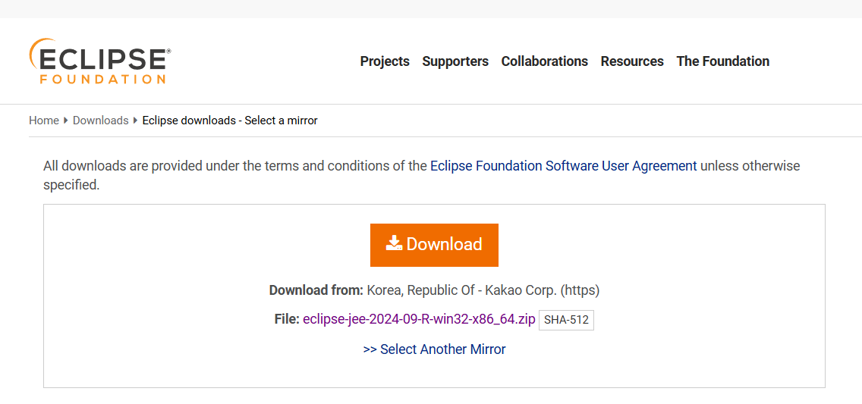

2. Tomcat installation :

<https://tomcat.apache.org/download-90.cgi>

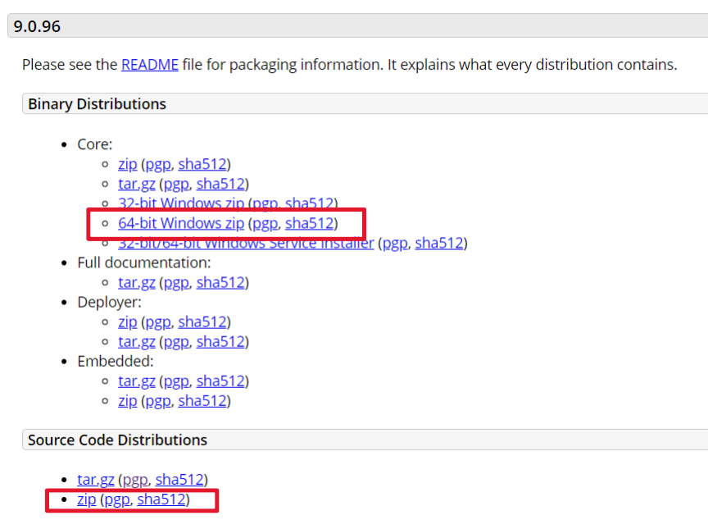

Download highlighted two zip files

3. Adding tomcat into eclipse :

Eclipse - Servers - Touch Blue link(in sever window) - Select tomcat version - Next - Browse the folder where you extracted the tomcat zip file - finish

**Creation of Project :**

1. Create a new eclipse project.
2. Use **apache-tomcat-8.5.99 at localhost** as server
3. Put the files in the following order:
4. **Views** => project - src - main - webapp
5. **Controllers and Models** => project - java resources - src/main/java