**COVID-19 CASES ANALYSIS USING PYTHON**

**PROJECT MEMBERS**

812121104032: MOHAMED YUSUF M

812121104033: MOHAMED TAUFIK M

812121104035: NAGARJUN B N

812121104036: NAMBUMUGESH R

812121104037: NANTHAMANISH M

**PROJECT TITLE: COVID-19 CASES ANALYASIS**

**PHASE 5: PROJECT DOCUMENTATION & SUBMISSION**

**INTRODUCTION:**

**Analyzing COVID-19 Cases**: Navigating a Global Health Crisis

The COVID-19 pandemic, stemming from the novel coronavirus SARS-CoV-2, has had an unprecedented impact on our world. It has tested the resilience of nations, strained healthcare systems, and altered the way we live, work, and interact. In the face of this global health crisis, understanding the patterns and implications of COVID-19 cases is paramount for shaping effective responses and strategies.

Recently, the world gained rapid progression in technology

And it shows an important role in the developed countries. Nowadays all

Daily life sectors such as education, business, marketing, militaries, and

Communications, engineering, and health sectors are dependent on the

New technology applications. The health care center is a crucial field that

Strongly needs to apply the new technologies from defining the symptoms

To the accurate diagnosis and digital patient's triage. Coronavirus-2

(SARSCoV-2) causes severe respiratory infections, and respiratory

Disorders, which results in the novel coronavirus disease 2019 (COVID-19)

In humans who had been reported as the first case in Wuhan city of China

In December 2019.

In this comprehensive analysis of COVID-19 cases, we will explore a range of critical topics to provide a holistic understanding of the pandemic's evolution and impact. These topics include:

**1**. **Epidemiological Trends:** We will delve into the global and regional dynamics of COVID-19 cases, examining infection rates, trends in transmission, and the factors influencing the spread of the virus.

**2**. **Public Health Responses:** This section will explore the measures taken to control the pandemic, such as lockdowns, testing and contact tracing, social distancing, and mask mandates. We will also assess the effectiveness of these interventions.

**3**. **Vaccination Efforts:** The development and distribution of vaccines have been pivotal in the fight against COVID-19. We will analyze the progress of vaccination campaigns, including vaccine efficacy and distribution challenges.

**4**. **Healthcare Impact:** The pandemic has placed enormous strain on healthcare systems. We will examine the capacity and resilience of healthcare infrastructure, the challenges faced by medical professionals, and the impact on non-COVID medical services.

**5. Socio-Economic Consequences:** Beyond the health impact, COVID-19 has had far-reaching economic and societal consequences. We will assess the economic downturn, job losses, and disparities in how different communities have been affected.

**6**. **Lessons Learned and Future Preparedness:** As the pandemic has evolved, important lessons have emerged. We will discuss these insights and consider the prepared measures needed for future health crises.

This analysis aims to provide a comprehensive view of the COVID-19 pandemic, based on information available up to my last knowledge update in January 2022. While the situation has likely evolved since that time, the principles and methodologies for analyzing COVID-19 cases remain crucial for ongoing efforts to combat the virus and for understanding the broader implications of this global health crisis**.**

The novel Coronavirus disease (COVID-19) in Wuhan, China, became a pandemic after its outbreak in January 2020. Countries one after the other are witnessing peak effects of the disease, and they need to learn from the experience of others already affected or peaked countries. Thus, this paper aims to analysis the effect of the COVID-19 pandemic on different countries through COVID-19 cases, resulting in deaths and recoveries**.**

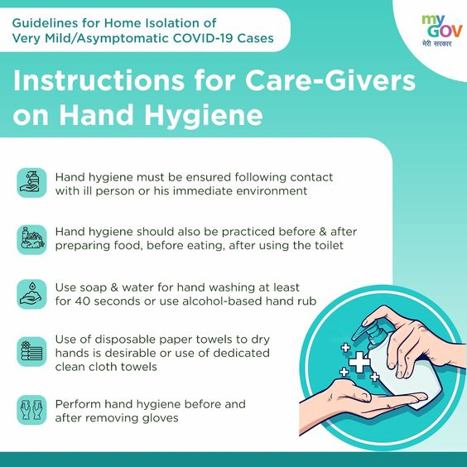

**PROJECT OBJECTIVE:**

1. Project Objectives: The COVID-19 pandemic demonstrates that every country remains vulnerable to public health emergencies.

2. Analysis Approach: Each group selected one problem related to one of their specific challenges and formulated it as a question.

3. Visualization Selection: visual-deep learning diagnosis, COVID-19, chest CT, volume rendering, MIP, classification model, explainable DL.

**DESIGN THINKING:**

**SYSTEM DESIGN**

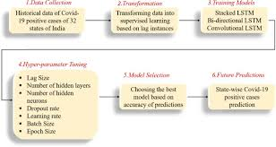

**DATA COLLECTION:**

The Covid-19 pandemic is the most important health disaster that

has surrounded the world for the past eight months. There is no

clear date yet on when it will end. As of 18 September 2020, more

than 31 million people (about the population of California) have been infected worldwide. Predicting

The Covid-19 trend has become a challenging issue. In this study,

data of COVID-19 between 20/01/2020 and 18/09/2020 for USA,

Germany and the global was obtained from World Health

Organization. Datasets consist of weekly confirmed cases and

weekly cumulative confirmed cases for 35 weeks (about 8 months).

**TRANSFORMATION**:

Current evidence suggests that the virus spreads mainly between

people who are in close contact with each other, for example at a

conversational distance. The virus can spread from an infected

person’s mouth or nose in small liquid particles when they cough,

sneeze, speak, sing or breathe. Another person can then contract

the virus when infectious particles that pass through the air are

inhaled at short range (this is often called short-range aerosol or

short-range airborne transmission) or if infectious particles come

into direct contact with the eyes, nose, or mouth (droplet transmission).

**TRAINING** **MODELS:**

Creating a COVID-19 cases analysis training model involves using data related to the COVID-19 pandemic and machine learning techniques to gain insights or make predictions. outline the steps involved in creating such a model:

1. Data Collection:

Gather relevant data, such as COVID-19 case counts, testing data,

vaccination data, demographic information, and other related datasets. You can obtain this data from sources like government health agencies, research organizations, or public data repositories.

2. Data Preprocessing:

Clean and prepare the data for analysis. This may include handling

missing values, normalizing data, and aggregating data at appropriate levels (daily, weekly, by location, etc.).

3. Feature Engineering:

Create meaningful features from the data that can help in the analysis. For example, calculate growth rates, test positivity rates, or other relevant indicators.

4. Exploratory Data Analysis (EDA):

Perform EDA to understand the data patterns, trends, and correlations. Visualizations and summary statistics can be helpful for this stage

5. Model Selection:

Choose a suitable machine learning or statistical model. For COVID-19 analysis, time series forecasting models, regression models, or deep learning models can be used depending on the task.

6. Model Training:

Train the chosen model using a portion of the data. For time series data, you might use historical data to predict future cases, while regression models can be trained to understand relationships between variables.

HYPER-PARAMETER TUNING FOR COVID-19 CASES ANALYSIS:

Select the Model:

Start with a choice of the machine learning model or algorithm. For time

Series data, models like ARIMA, SARIMA, or Prophet is common. For regression or classification tasks, you might use linear regression, decision trees, random forests, or deep learning models.

MODEL SELECTION:

Selecting an appropriate model for COVID-19 cases analysis involves understanding the nature of the data, the research questions you want to answer, and the specific goals of your analysis. Here are some model selection guidelines for analyzing COVID-19 cases:

Time Series Analysis:

ARIMA (Auto Regressive Integrated Moving Average):

ARIMA models are commonly used for time series data. They can be effective for forecasting and analyzing trends in daily or weekly COVID-19 case data.

Machine Learning Models:

Regression Models: You can use linear or nonlinear regression models to understand the relationship between COVID-19 cases and various factors like population density, policy measures, or vaccination rates.

FUTURE PREDICTIONS:

Predicting future COVID-19 cases is a complex task and requires data, modeling, and expertise in epidemiology. I can provide some information on the general principles and methods used for such predictions, but please note that any specific predictions or analysis I provide are purl speculative and not based on real-time data beyond my knowledge cutoff date in September 2021.

Here are some steps and factors considered in COVID-19 case analysis and future predictions:

1. Data Collection: To make predictions, you need access to accurate and up-to-date data on COVID-19 cases, including the number of cases, recoveries, and deaths. Data quality is crucial for accurate predictions.

2. Epidemiological Models: Epidemiologists use various mathematical models to predict future cases, such as the SIR (Susceptible-Infectious-Recovered) model, SEIR (Susceptible-Exposed-Infectious-Recovered) model, and more. These models consider factors like transmission rates, incubation periods, and the impact of interventions (e.g., lockdowns or vaccination campaigns).

3. Historical Trends: Analyzing historical data and trends can help in understanding how the virus has spread in the past and making short-term predictions based on current conditions.

4. Interventions and Vaccination: The success and coverage of vaccination campaigns, as well as the effectiveness of public health measures (such as mask mandates and lockdowns), play a significant role in determining future case numbers.

5. Variants: Monitoring and understanding the impact of new COVID-19 variants is essential, as some variants may be more transmissible or resistant to immunity from previous infections or vaccinations.

6. Public Behavior: How people behave in response to the virus, such as mask-wearing, social distancing, and travel restrictions, also influences future case numbers.

7. Seasonality: Some diseases, including respiratory viruses like COVID-19, can exhibit seasonal patterns, which need to be considered in predictions.

8. Uncertainty: Predictions typically come with a level of uncertainty. This uncertainty can be due to changing variables, human behavior, data quality, and other factors.

INPUT:

import pandas as pd # data manipulation , analysis,

cleaning

import numpy as np # mathematical calculations

# Plotly - interactive, open-source, and browser-

based graphing library for Python

import plotly.express as px

import plotly.graph_objects as go

from plotly.subplots import make_subplots

country_wise = pd.read_csv(&#39;/kaggle/input/corona-

virus-report/country_wise_latest.csv&#39;)

day_wise = pd.read_csv(&#39;/kaggle/input/corona-virus-

report/day_wise.csv&#39;)

worldometer_data = pd.read_csv(&#39;/kaggle/input/corona-

virus-report/worldometer_data.csv&#39;)

DD_CW1 = pd.read_csv(&#39;/kaggle/input/corona-virus-

report/full_grouped.csv&#39;)

DD_CW2 = pd.read_csv(&#39;/kaggle/input/corona-virus-

report/covid_19_clean_complete.csv&#39;)

usa = pd.read_csv(&#39;/kaggle/input/corona-virus-

report/usa_county_wise.csv&#39;)

country_wise.head()

**OUTPUT:**

|  |  |  |  |  |  |  |  |  |  |  |  |  |  |  |  |
| --- | --- | --- | --- | --- | --- | --- | --- | --- | --- | --- | --- | --- | --- | --- | --- |
| s  n  o | Countr  y/Region | Cof  irme  d | De  ath  s | Rec  over  ed | Ac  tiv  e | N  e  w  ca  se  s | Ne  w  de  ath  s | New  reco  vere  d | De  ath  s /  10  0  Ca  se  s | Rec  over  ed /  100  Cas  es | Deat  hs /  100  Rec  over  ed | Conf  irme  d  last  wee  k | 1  we  ek  ch  an  ge | 1  we  ek  %  incr  eas  e | WHO  Region |
| 0 | Afghan  istan | 362  63 | 12  69 | 2519  8 | 97  96 | 106 | 10 | 18 | 3.5  0 | 69.4  9 | 5.04 | 355  26 | 737 | 2.0  7 | Easter  n  Medite  rranea  n |
| 1 | Albani  a | 488  0 | 144 | 2745 | 1991 | 117 | 6 | 63 | 2.95 | 56.25 | 5.25 | 4171 | 709 | 17.00 | Europ  E |
| 2 | Algeria | 279  73 | 1163 | 1883  7 | 7973 | 616 | 8 | 749 | 4.16 | 64.37 | 6.17 | 236  91 | 4282 | 18.07 | Africa |
| 3 | Andorr  a | 907 | 52 | 803 | 52 | 10 | 0 | 0 | 5.7  3 | 88.53 | 6.48 | 838 | 23 | 2.60 | Europ  E |
| 4 | Angola | 950 | 41 | 242 | 667 | 18 | 1 | 0 | 4.32 | 25.4  7 | 16.94 | 749 | 201 | 26.84 | Africa |

**DEVELOPMENT PHASES**

Developing a comprehensive COVID-19 cases analysis involves several phases, each building upon the previous one. These phases help ensure that the analysis is rigorous, accurate, and actionable. Here are the key development phases for COVID-19 cases analysis:

**1. Data Collection and Acquisition:**

- Gather COVID-19 data from reliable sources, which may include public health agencies, hospitals, testing centers, and research institutions.

- Collect data on cases, hospitalizations, deaths, testing rates, demographics, and geographic information.

- Ensure data quality, consistency, and timeliness.

**2. Data Cleaning and Preprocessing:**

- Clean and preprocess the data to handle missing values, outliers, and inconsistencies.

- Standardize data formats and create a structured database for analysis.

**3. Exploratory Data Analysis (EDA):**

- Conduct EDA to gain a preliminary understanding of the data. This may involve generating summary statistics, visualizations, and identifying trends.

- Explore the distribution of cases over time, geographical regions, and demographics.

**4. Hypothesis Formulation:**

- Develop hypotheses or research questions to guide your analysis. For example, you might investigate factors influencing the spread of the virus or the impact of interventions.

**5. Feature Engineering:**

- Create new variables or features that can enhance your analysis. For COVID-19 cases analysis, this may include calculating infection rates, mortality rates, or other derived metrics.

**6. Statistical and Machine Learning Modeling:**

- Apply statistical and machine learning models to answer your research questions or test hypotheses.

- Use regression analysis, time-series modeling, or other relevant techniques to explore relationships and make predictions.

**7. Geospatial Analysis:**

- Incorporate geospatial analysis to understand the geographic distribution of COVID-19 cases. Utilize geographic information systems (GIS) to create maps and identify hotspots.

**8. Temporal Analysis:**

- Analyze temporal trends in COVID-19 cases, including seasonality and changes over time.

- Use time-series analysis to model and forecast case counts.

**9. Demographic and Socioeconomic Analysis:**

- Explore how COVID-19 cases are distributed among different demographics and socioeconomic groups.

- Assess disparities in infection rates and health outcomes.

**10. Impact Assessment:**

- Evaluate the impact of public health interventions and policies on COVID-19 cases.

- Determine the effectiveness of measures such as lockdowns, mask mandates, and vaccination campaigns.

**11. Visualization and Reporting** - Create informative data visualizations and reports to communicate your findings. Dashboards, charts, and maps can make the analysis more accessible to a wider audience.

**12. Model Validation and Sensitivity Analysis:** - Validate your models and analysis methods to ensure accuracy and reliability.

- Perform sensitivity analysis to assess how changes in parameters or assumptions affect results.

**13. Peer Review and Collaboration:**

- Seek peer review from experts in epidemiology, data analysis, and related fields to enhance the rigor and credibility of your analysis.

- Collaborate with relevant stakeholders and researchers to benefit from their expertise.

**14. Policy Recommendations and Decision Support:**

- Translate your analysis into actionable recommendations for policymakers, public health officials, and the public.

- Provide insights that can inform public health strategies and response efforts.

**15. Ongoing Monitoring and Updates:**

- Continuously monitor and update your analysis as new data becomes available and the COVID-19 situation evolves.

- Stay current with the latest research and findings in the field.

These development phases ensure a systematic and rigorous approach to COVID-19 cases analysis, helping to provide insights that inform decision-making and public health responses. It's essential to use the most up-to-date and reliable data sources and methodologies while maintaining transparency in your analysis and reporting.

**ANALYSIS OBJECTIVES**

The objectives for COVID-19 cases analysis may vary depending on the specific context, goals, and stakeholders involved. However, here are some common objectives for COVID-19 cases analysis:

The objective of this course is to spread awareness about the COVID-19 Pandemic and how to prevent oneself and the community from being affected.

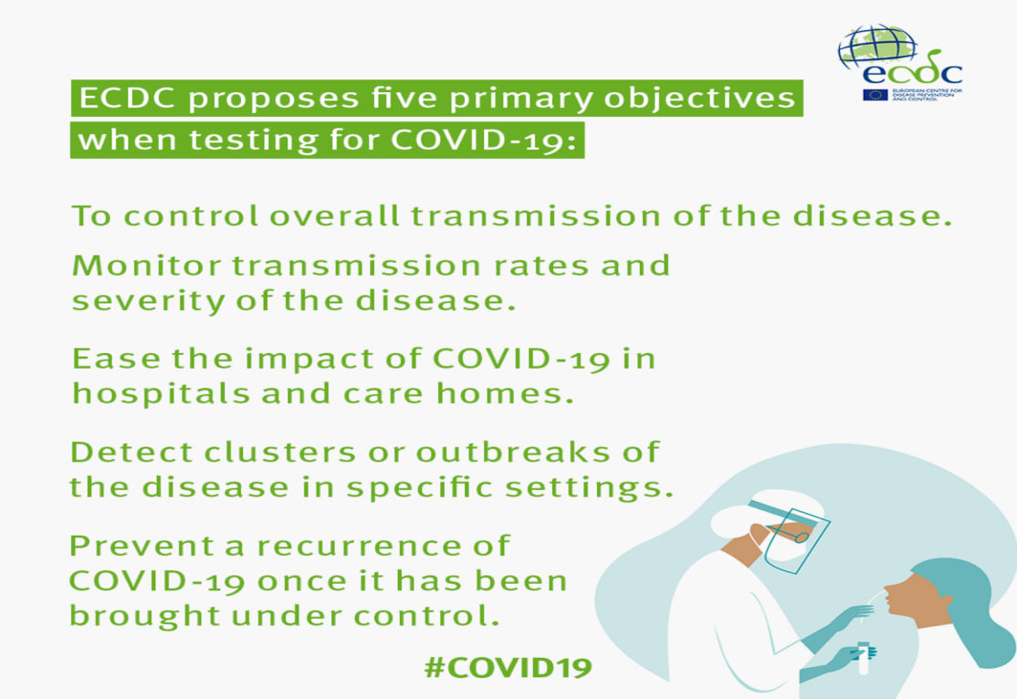

**1. Epidemiological Understanding:**

- To gain a comprehensive understanding of the spread and dynamics of the COVID-19 virus, including the rate of infection, transmission patterns, and the identification of potential hotspots.

**2. Public Health Response Assessment:** - To assess the effectiveness of public health measures such as social distancing, mask mandates, lockdowns, and vaccination campaigns in reducing the spread of the virus.

**3. Healthcare System Impact:**

- To evaluate the impact of COVID-19 on healthcare systems, including hospitalization rates, resource utilization, and the capacity to respond to the crisis.

**4. Vaccination Efficacy and Coverage:**

- To determine the effectiveness of COVID-19 vaccines in preventing infection, reducing severe cases, and achieving herd immunity.

- To assess the coverage and equity of vaccination campaigns.

**5. Socioeconomic Consequences:**

- To understand the economic, social, and psychological consequences of the pandemic, including job losses, mental health impacts, and educational disruptions.

**6. Vulnerability and Health Disparities: -** To identify and address health disparities, including disparities related to race, ethnicity, socioeconomic status, and access to healthcare.

**7. Predictive Modeling: -** To develop predictive models that forecast the future course of the pandemic, helping authorities plan and allocate resources effectively.

**8. Policy and Intervention Evaluation:**

- To evaluate the impact of various policies and interventions, such as travel restrictions, testing strategies, and contact tracing, on controlling the spread of the virus.

**9. Virus Variant Analysis:**- To monitor the emergence and spread of COVID-19 variants and assess their potential impact on transmission, severity, and vaccine efficacy.

**10. International and Regional Comparisons:** - To compare the COVID-19 situation in different countries and regions, helping to identify best practices and areas for improvement.

**11. Communication and Education:**

- To provide clear and accessible information to the public, policymakers, and healthcare professionals, enabling informed decision-making and behavior changes.

**12. Research and Scientific Advancements:**

- To contribute to the scientific understanding of COVID-19 by conducting research on various aspects of the virus, its transmission, and its effects on health and society.

**13. Emergency Response Preparedness:**

- To inform preparedness for future public health emergencies by assessing the strengths and weaknesses of the response to COVID-19.

**14. Vaccine Safety Monitoring:** - To monitor and analyze adverse events related to COVID-19 vaccines to ensure their safety and effectiveness.

**15. Community Outreach and Support:**

- To identify vulnerable populations and provide targeted support and resources to mitigate the impact of COVID-19 on these groups.

These objectives are not mutually exclusive, and an effective COVID-19 cases analysis may involve addressing multiple objectives simultaneously. The specific objectives should be tailored to the needs and priorities of the stakeholders involved in the analysis.

DATA COLLECTION PROCESS

The data collection process for COVID-19 cases analysis is a critical and meticulous step in understanding the pandemic's impact. To ensure the accuracy and reliability of your analysis, consider the following steps and best practices:

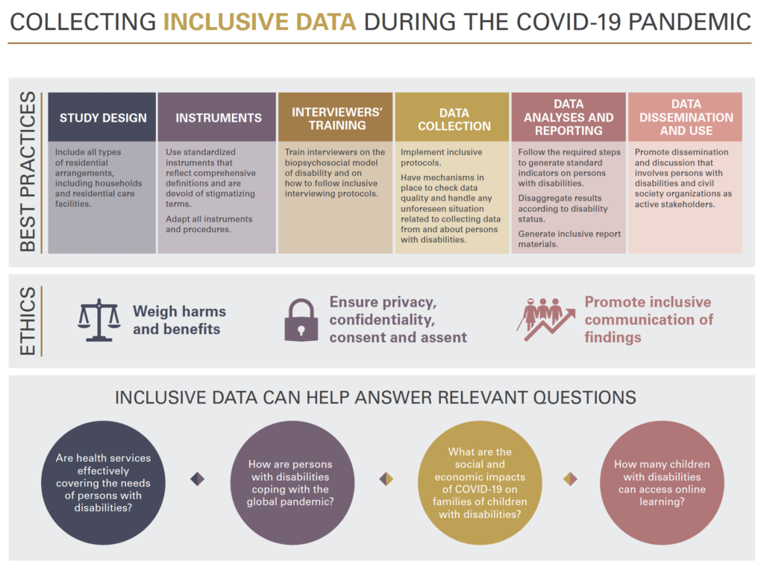

**1. Identify Reliable Data Sources:** - Utilize authoritative sources such as government health agencies (e.g., CDC, WHO, national health ministries), research institutions, and reputable public health databases.

- Access data from local health authorities, hospitals, and testing centers for granular information.

**2. Access Open Data Repositories:**

- Many governments and organizations have made COVID-19 data available through open data repositories, making it accessible for analysis. Examples include the COVID-19 Data Repository by the Center for Systems Science and Engineering (CSSE) at Johns Hopkins University and the COVID-19 Data Hub by the European Centre for Disease Prevention and Control (ECDC).

**3. Define Data Requirements:**

- Clearly specify what types of data you need, including the format (e.g., daily case counts, testing data, demographic information, and geographic data).

- Ensure you have access to historical data to examine trends over time.

**4. Data Scraping and Automation:**

- Use web scraping and automation tools to collect data from websites and online dashboards that provide COVID-19 information.

- Be respectful of websites' terms of use and rate limits when scraping data.

5. **Data Aggregation:**

- Aggregate data at appropriate geographical levels (e.g., national, state/province, county, city) and demographic breakdowns (e.g., age, gender, ethnicity) to facilitate analysis.

**6. Data Validation and Quality Control:**

- Scrutinize the data for completeness, accuracy, and consistency. This may involve checking for duplicate entries, missing values, and data outliers.

- Cross-reference data from multiple sources to ensure its accuracy.

**7. Data Privacy and Ethics:**

- Respect data privacy and ethical guidelines when collecting and using COVID-19 data, particularly when dealing with sensitive patient information.

- Anonymize or aggregate data to protect individuals' privacy.

**8. Data Formatting and Standardization:**

- Standardize data formats, units of measurement, and date/time stamps to ensure consistency.

- Consider using international standards for disease coding (e.g., ICD-10 for diagnoses).

**9. API Integration:**

- Some organizations provide Application Programming Interfaces (APIs) for accessing COVID-19 data programmatically. These APIs often offer real-time data updates.

**10. Data Documentation:**

- Keep detailed records of the data sources, collection methods, and any transformations or cleaning performed.

- Maintain a data dictionary to define the meaning of each data field.

**11. Automated Data Updates:**

- Set up automated processes to regularly fetch updated data to ensure your analysis remains current.

**12. Data Security:** - Protect the collected data from unauthorized access and ensure that it is stored securely.

**13. Compliance with Legal and Regulatory Requirements:**

- Adhere to local and international data protection laws, such as GDPR in Europe or HIPAA in the United States.

**14. Collaboration with Health Authorities:**

- Collaborate with local and national health authorities to access and validate COVID-19 data. They can provide valuable insights and context.

**15. Data Sharing and Transparency:**

- Make the collected data and your analysis transparent and accessible to the public. Open data practices foster trust and encourage collaboration.

**16. Keep Abreast of Data Changes:**

- COVID-19 data reporting standards and practices can change over time. Stay informed about updates to ensure your analysis remains accurate and relevant.

By following these best practices and being diligent in your data collection process, you can lay a strong foundation for your COVID-19 cases analysis and contribute to a better understanding of the pandemic.

**DATA VISUALIZATION USING IBM COGNOS**

Using IBM Cognos for data visualization and generating insights from the comparison of COVID-19 cases data can provide valuable information for decision-makers and the public. Here's a step-by-step guide on how to create data visualizations in IBM Cognos and some insights that can be gained from the comparisons:

**Step 1: Data Preparation**

Before creating visualizations in IBM Cognos, you should have collected and cleaned your COVID-19 cases data as mentioned earlier. Ensure that your data is in a format that IBM Cognos can handle, such as a structured database or spreadsheet.

**Step 2: Data Import**

1. Open IBM Cognos and create a new project or workspace for your analysis.

2. Import your prepared COVID-19 data to IBM Cognos. You can use the Data module or other relevant tools within the platform to do this.

**Step 3: Data Modeling**

1. Define the data relationships, dimensions, and measures you want to work with. In the context of COVID-19 cases analysis, dimensions could include geographic location, time, demographics, and interventions. Measures might encompass the number of cases, deaths, hospitalizations, and vaccination rates.

**Step 4: Create Visualizations**

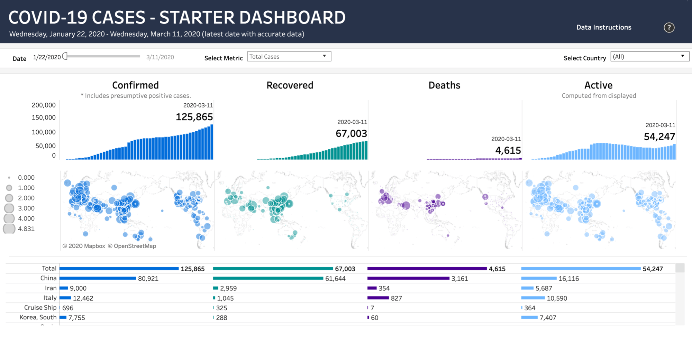

Using the data model, you've established; you can create a variety of data visualizations in IBM Cognos. Here are some common types:

1. Line Charts and Time Series Graphs: Compare the evolution of COVID-19 cases over time, revealing trends and seasonality. Insights could include identifying spikes, declines, or the impact of interventions.

2. Heat maps: Visualize the geographic distribution of cases. Insights may include identifying hot spots or areas with increasing transmission rates.

3. Bar Charts: Compare the number of cases, hospitalizations, or deaths across different regions, age groups, or demographic categories. Insights can include disparities in the impact of COVID-19.

4. Stacked Area Charts: Show the composition of cases, differentiating between mild, severe, and critical cases. Insights could include the strain on healthcare systems.

5. Dashboard: Create interactive dashboards that combine multiple visualizations and allow users to explore the data. This can help decision-makers gain a holistic view of the pandemic's impact.

**Step 5: Generate Insights**

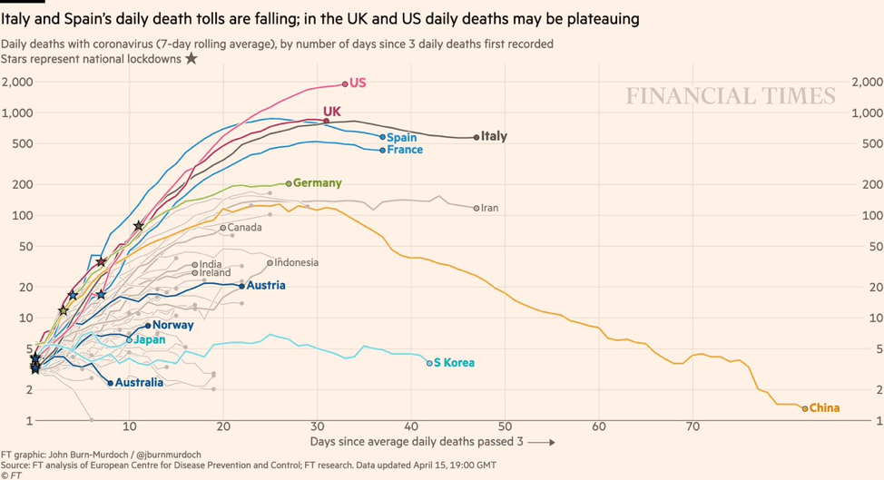

Once you have created your data visualizations, you can generate insights from the comparisons. Here are some examples:

1. Trend Analysis: Compare the rate of change in cases before and after the implementation of public health measures, helping to assess the effectiveness of interventions.

2. Geographic Patterns: Identify areas with increasing or decreasing case counts, enabling targeted responses and resource allocation.

3. Vaccination Impact: Visualize the impact of vaccination campaigns on case numbers, hospitalizations, and deaths, providing insights into the effectiveness of vaccination efforts.

4. Demographic Disparities: Explore how different age groups, genders, or ethnicities are affected by COVID-19, which can inform strategies to address health disparities.

5. Healthcare System Strain: Assess the correlation between case numbers and hospitalizations, providing insights into the strain on healthcare facilities.

6. Comparative Analysis: Compare the COVID-19 situation in different regions, states, or countries, helping to identify best practices and areas that require additional support.

**Step 6: Share Insights**

Use IBM Cognos to share your findings with relevant stakeholders, including public health officials, policymakers, and the public. You can create reports, dashboards, or presentations that convey the insights clearly and effectively.

IBM Cognos provides a powerful platform for data visualization and analysis, and by following these steps, you can derive meaningful insights from COVID-19 cases data and contribute to informed decision-making during the pandemic.

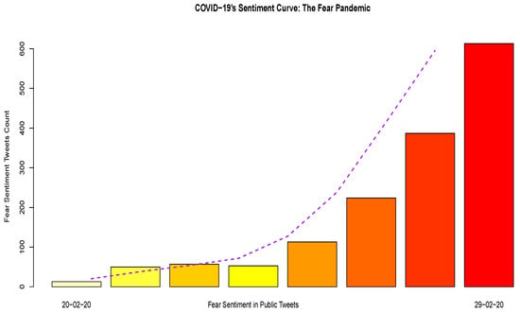

**ADVANTAGES:**

Analyzing COVID-19 cases has several advantages that contribute to a better understanding of the pandemic and the development of effective response strategies. Some of these advantages include:

1. Disease Surveillance and Monitoring: An Analyzing COVID-19 case provides valuable data for disease surveillance and monitoring. This data helps public health officials and researchers track the spread of the virus, identify hotspots, and make informed decisions about resource allocation.

2. Epidemiological Insights: Analysis of COVID-19 cases helps epidemiologists understand how the virus spreads, its incubation period, and its impact on different demographic groups. This information is crucial for developing targeted interventions and public health recommendations.

3. Forecasting and Prediction: By examining the patterns and trends in COVID-19 cases, experts can create models to predict future outbreaks and assess the potential impact of interventions. This aids in planning and resource allocation.

4. Resource Allocation: Analyzing COVID-19 cases can inform the allocation of resources, such as hospital beds, ventilators, and personal protective equipment, to areas with the greatest need.

5. Vaccine Distribution: Data analysis is essential for efficient distribution of COVID-19 vaccines. It helps identify priority groups, distribution centers, and strategies to reach the most vulnerable populations.

6. Contact Tracing: Understanding the patterns of transmission through case analysis is crucial for effective contact tracing. It helps identify individuals who may have been exposed to the virus and need to be tested or isolated.

7. Public Awareness: Analysis of COVID-19 cases can be used to create public awareness campaigns and provide evidence-based information to the public about the severity of the pandemic and the importance of preventive measures.

**CONCLUSION**:

The coronavirus disease is not any ordinary viral infection; it has become a pandemic as it has an impact on health, mortality, economy and social wellbeing of the entire world. Qualitative and Quantitative analysis of the statistics related to COVID-19 in different countries is done based on their official’s data. The primary objective of this analysis is to learn about the relationships of various countries in containing the spread of COVID-19 and the various factors such as government policies, the cooperation of people, economy, and tourism.