Microprocessor and Computer Architecture UE21CS251B

4th Semester, Academic Year 2022-23

Date:

|  |  |  |
| --- | --- | --- |
| Name: NAGAVENI L G | SRN:  PES2UG21CS315 | Section:  F |

Week# 2 Program Number: 1

Title of the Program

Write a program in ARM7TDMI-ISA to copy a block of N data items from Location A to Location B.

1. **Use Full word (.word directive)**
2. **Use Half word(.hword directive)**
3. **Use Byte wise (.Byte directive)**
   1. ARM Assembly Code
   2. Output Screen Shots (Three)

The output should be verified for word, half word, byte

I.

a)

.data

a: .word 10,20,30,40,50

b: .word 0,0,0,0,0

.text

ldr r0,=a ldr r1,=b mov r2,#5 loop:

ldr r4,[r0] add r0,r0,#4 str r4,[r1] subs r2,r2,#1 add r1,r1,#4 bne loop

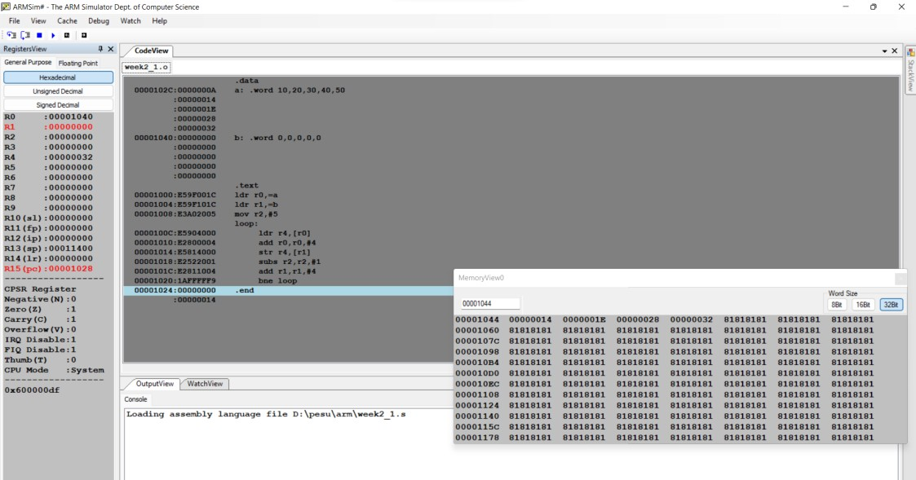.end

b) .data

a: .hword 10,20,30,40,50

b: .hword 0,0,0,0,0

.text

ldrh r0,=a ldrh r1,=b mov r2,#5 loop:

ldrh r4,[r0] add r0,r0,#2 strh r4,[r1] subs r2,r2,#1 add r1,r1,#2 bne loop

.end

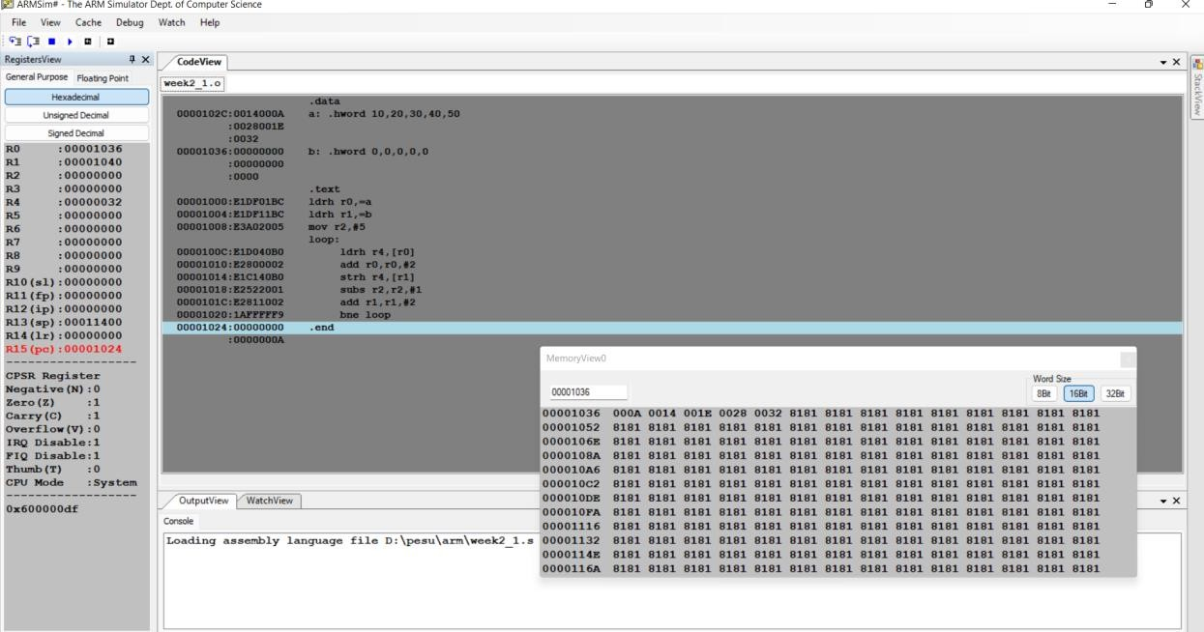

c)

.data

a: .byte 10,20,30,40

b: .byte 0,0,0,0,0

.text

ldr r0,=a ldr r1,=b mov r3,#5

loop: ldrb r4,[r0] add r0,r0,#1 strb r4,[r1]

add r1,r1,#1 subs r3,r3,#1 bne loop

.end

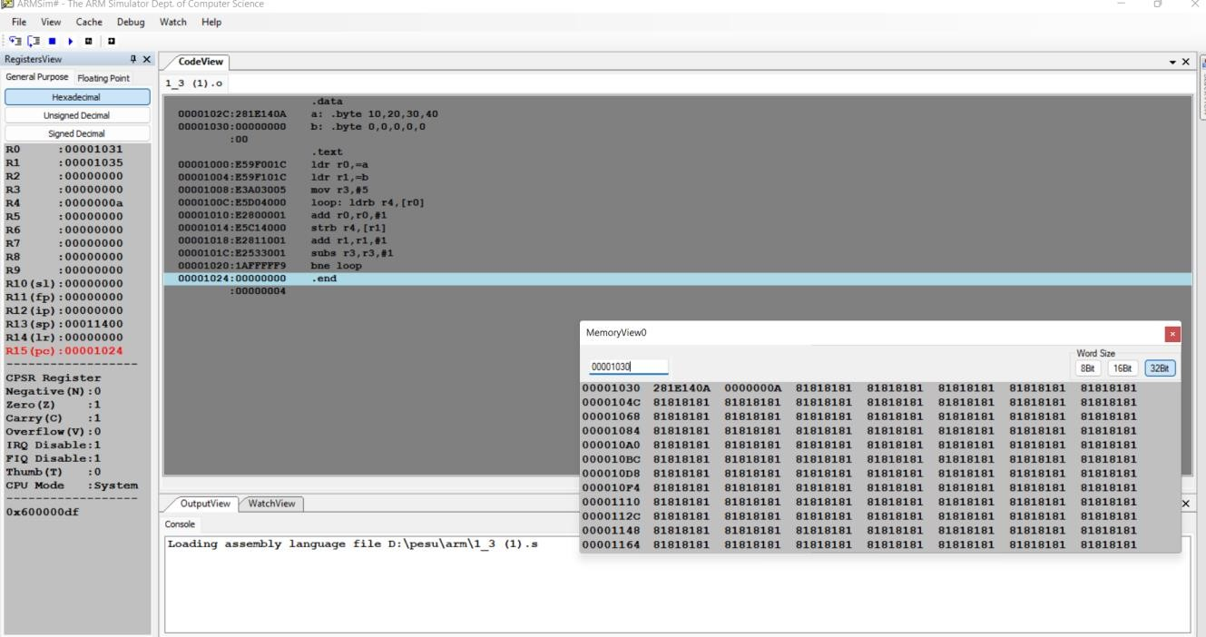

Microprocessor and Computer Architecture

UE21CS251B

4th Semester, Academic Year 2022-23

Date:

|  |  |  |
| --- | --- | --- |
| Name: NAGAVENI L G | SRN: PES2UG21CS315 | Section F |

Week# 2 Program Number: 2

Title of the Program

Write a program in ARM7TDMI-ISA to find the sum of N data items in the memory. Store the result in the memory location.

1. **Use Full word (.word directive)**
2. **Use Half word(.hword directive)**
3. **Use Byte wise (.Byte directive)**
   1. ARM Assembly Code
   2. Output Screen Shots (Three)

The output should be verified for word, half word, byte

**a)**

**.data**

**a: .word 10,20,30,40,50**

**b: .word**

**.text**

**ldr r0,=a mov r1, #5 ldr r4,=b loop:**

**ldr r2,[r0],#4 add r3,r3,r2 str r3,[r4] subs r1,r1,#1 cmp r1,#0 bne loop**

**.end**

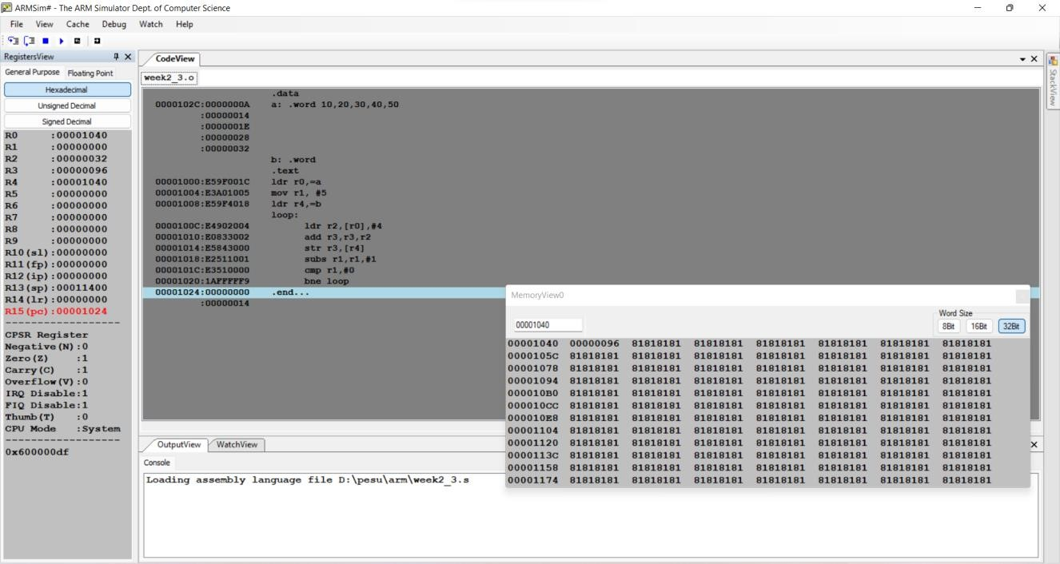

b)

.data

a: .hword 10,20,30,40,50

b: .hword 0,0,0,0,0

.text

ldr r0,=a ldr r1,=b mov r2,#5 loop:

ldr r4,[r0] add r0,r0,#4 str r4,[r1] subs r2,r2,#1 add r1,r1,#4 bne loop

.end

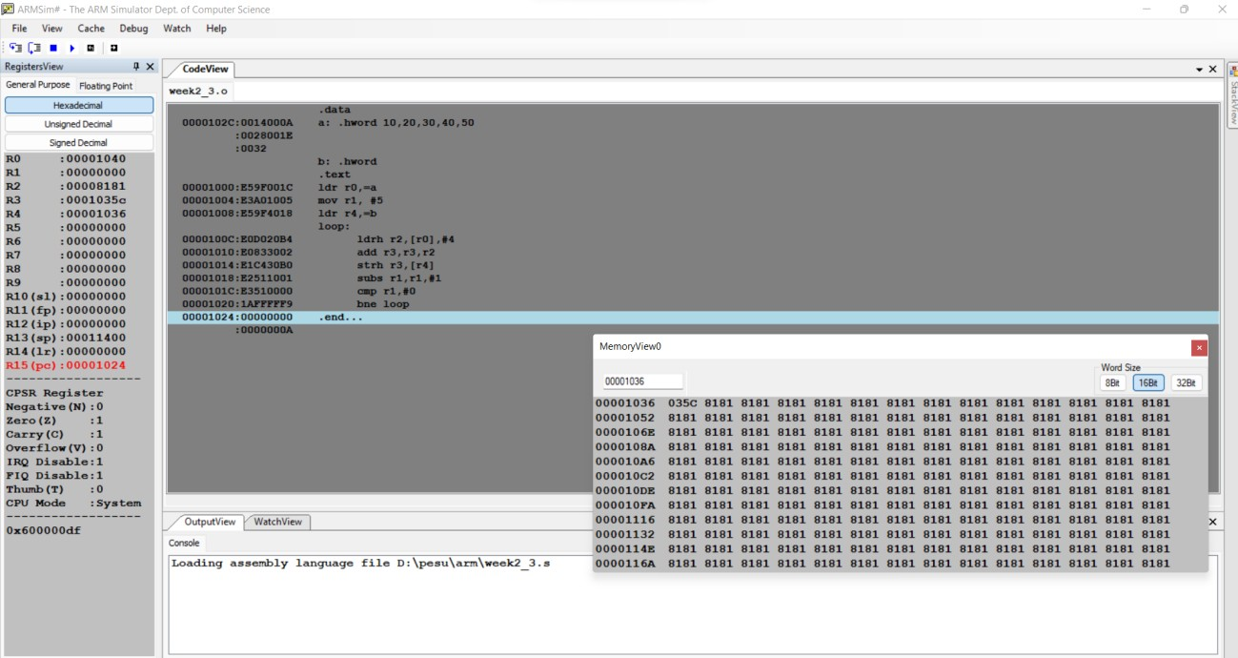

c)

.data

a: .byte 10,20,30,40,50

b: .byte 0,0,0,0,0

.text

ldr r0,=a ldr r1,=b mov r2,#5 loop:

ldrb r4,[r0]

add r0,r0,#4 strb r4,[r1] subs r2,r2,#1 add r1,r1,#4 bne loop

.end

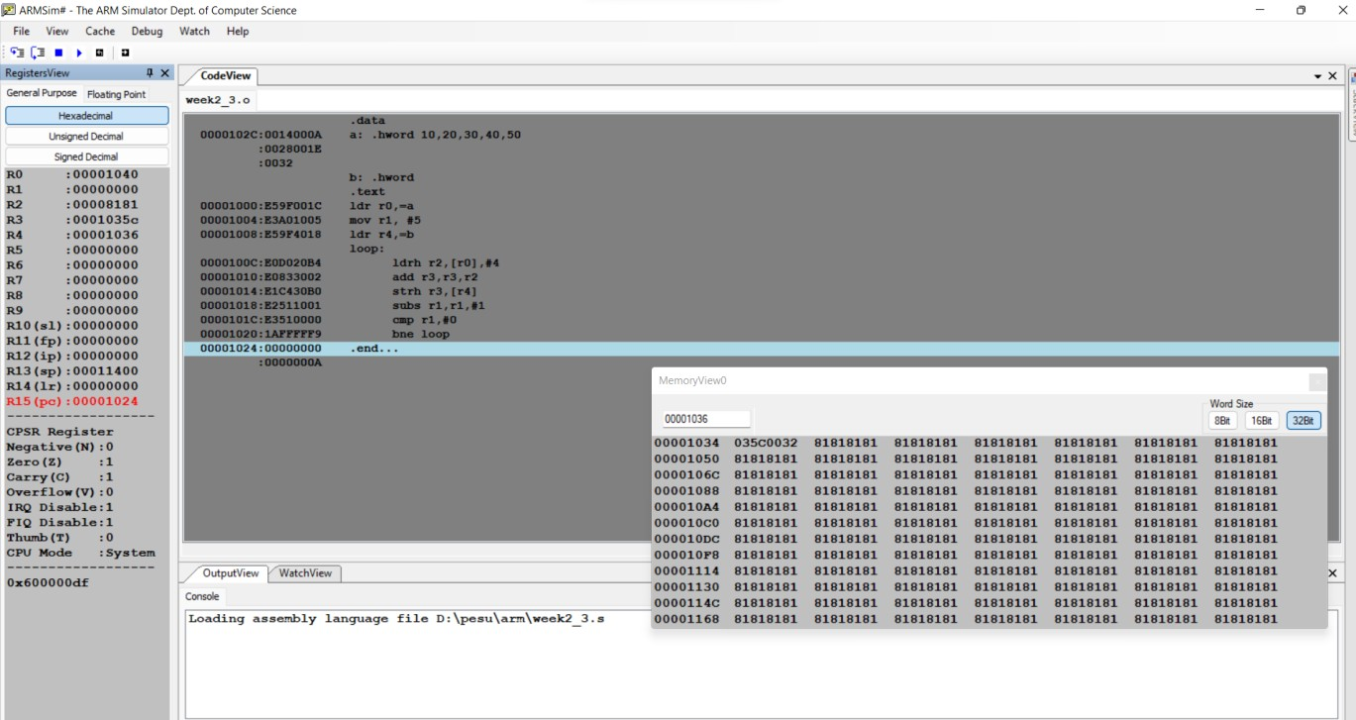

Microprocessor and Computer Architecture UE21CS251B

4th Semester, Academic Year 2022-23

Date:

|  |  |  |
| --- | --- | --- |
| Name:  NAGAVENI L G | SRN: PES2UG21CS315 | Section F |

Week# 2 Program Number: 3

Title of the Program

Write a program in ARM7TDMI-ISA to find the sum of N natural numbers. Store the result in the memory location.

1. ARM Assembly Code
2. Output Screen Shots (One)

Microprocessor and Computer Architecture UE21CS251B

4th Semester, Academic Year 2022-23

Date:

|  |  |  |
| --- | --- | --- |
| Name:  NAGAVENI L G | SRN: PES2UG21CS315 | Section: F |

Week# 2 Title of the Program

Program Number: 4

Write a program in ARM7TDMI-ISA to find the product of two 32bit numbers using barrel shifter.

1. ARM Assembly Code
2. Output Screen Shot (One) mov r0,#50

mov r1,r0,lsl#5 rsb r0,r0,r0,lsl#3 sub r0,r1,r0 mov r0,#50

mov r1,r0,lsl#5 rsb r0,r0,r0,lsl#3

sub r0,r1,r0

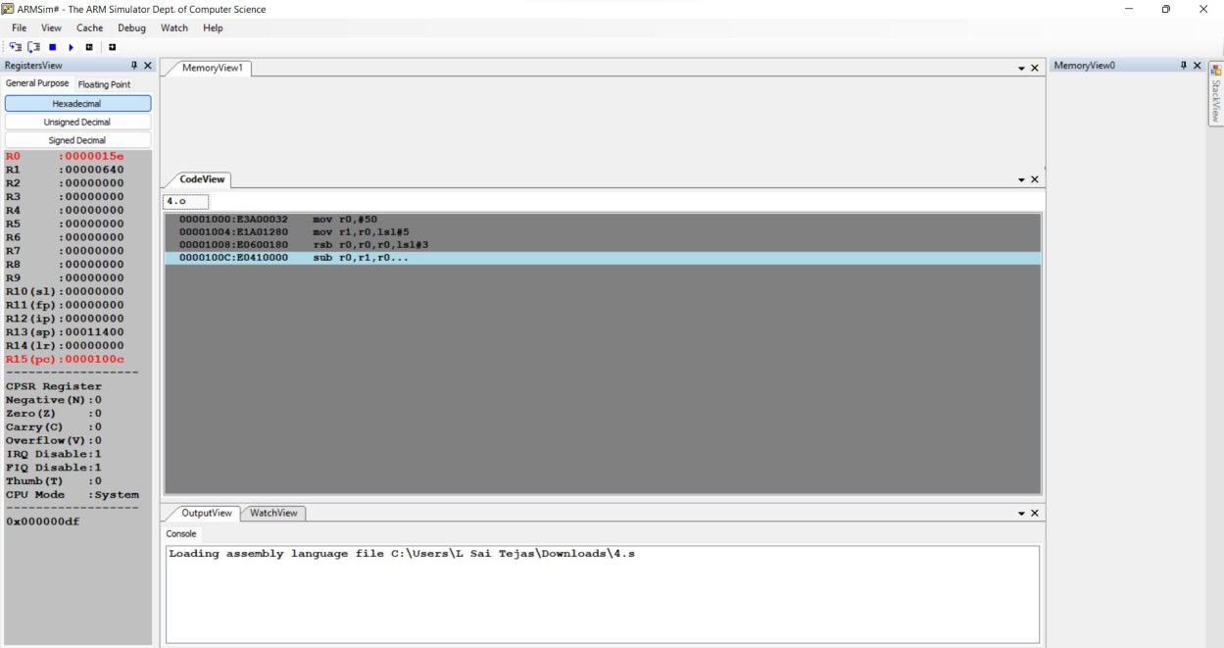

Microprocessor and Computer Architecture UE21CS251B

4th Semester, Academic Year 2022-23

Date:

|  |  |  |
| --- | --- | --- |
| Name:  NAGAVENI L G | SRN: PES2UG21CS315 | Section: F |

Week# 2 Title of the Program

Program Number: 5

Convert the following statement in C language into an ALP using ARM7TDMI – ISA.

IF([A]==[B]) then C=[A]+[B];

ELSE IF ([B]==[C]) D=[A]-[B]; ELSE E=[A]*[B]

Where A,B C, D & E are memory locations.

1. ARM Assembly Code
2. Output Screen Shot (One)

.data

a: .word 10

b: .word 30

c: .word 30 d: .word

e: .word

.text

ldr r0,=a ldr r1,=b ldr r2,=c ldr r3,=d ldr r4,=e ldr r5,[r0] ldr r6,[r1] ldr r7,[r2] cmp r5,r6 beq ad cmp r6,r7 beq sb

mul r10,r0,r1

str r10,[r4] swi 0x11

ad:

add r8,r0,r1 str r8,[r2] swi 0x11

sb:

subs r9,r0,r1 str r9,[r4] swi 0x11

.end

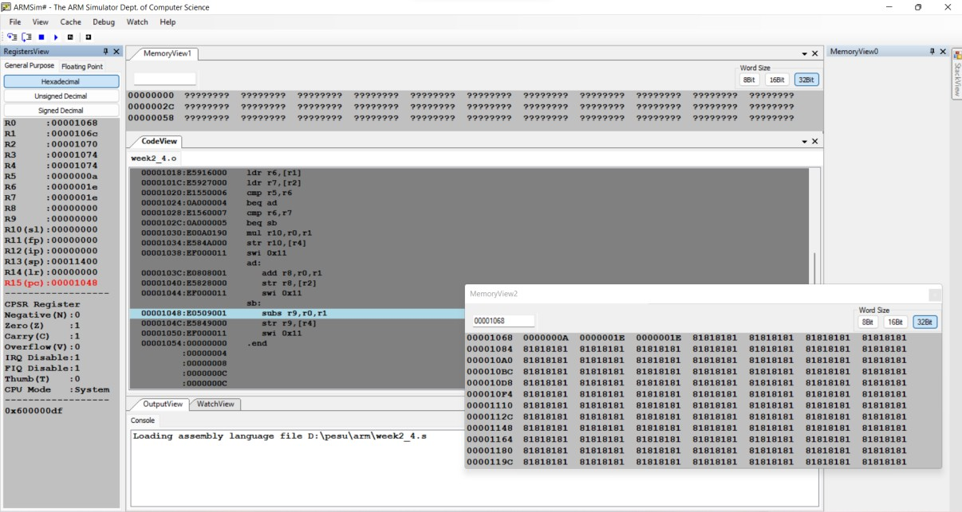

Microprocessor and Computer Architecture UE21CS251B

4th Semester, Academic Year 2022-23

Date:

|  |  |  |
| --- | --- | --- |
| Name:  NAGAVENI L G | SRN: PES2UG21CS315 | Section: F |

Week# 2 Title of the Program

Program Number: 6

Write a program in ARM7TDMI-ISA to find the factorial of a number.

1. ARM Assembly Code
2. Output Screen Shot (One)

.text mov r0,#5 mov r1,r0 loop:

sub r0,r0,#1 mul r2,r0,r1 mov r1,r2 cmp r0,#1 bne loop swi 0x11

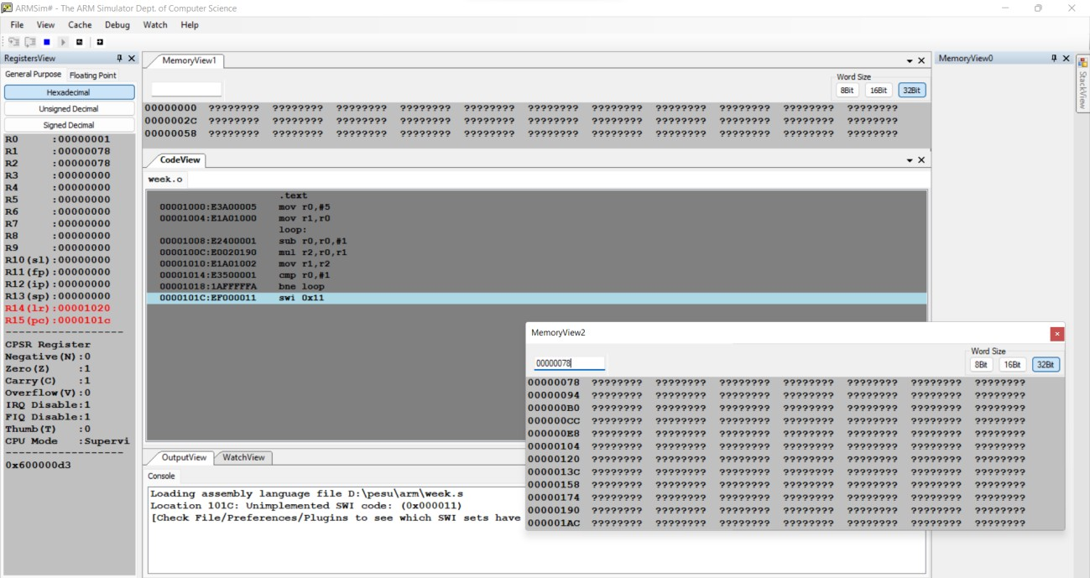

Disclaimer:

* The programs and output submitted is duly written, verified and executed by me.
* I have not copied from any of my peers nor from the external resource such as internet.
* If found plagiarized, I will abide with the disciplinary action of the University.

Signature:

Name: NAGAVENI L G

SRN:PES2UG21CS315

Section:F Date:20-01-2023