**Microprocessor and Computer Architecture UE21CS251B**

**4th Semester, Academic Year 2022-23**

Date:06-02-2023

|  |  |  |
| --- | --- | --- |
| Name: NAGAVENI L G | SRN:PES2UG21CS315 | Section  :F |

Assignment 1

Program 1

**Write a program in ARM7TDMI-ISA to search for an element in an array. Display appropriate messages on the standard output device. For Successful search display as “Successful Search” and if the search is unsuccessful, display as “Unsuccessful Search”. Use Binary search Technique.**

1. ARM Assembly Code

.data

array: .word 5,8,12,17,23,29,36,42,55,78

search_ele: .word 23

array_size: .word 10

success: .asciz "successful search"

failure: .asciz "unsuccessful search"

.text

    mov r4,#0

    ldr r0, =array

    ldr r7, =search_ele

    ldr r1,[r7]

    ldr r8,=array_size

    ldr r2,[r8]

    sub r3,r2,#1

    binary_search:

    ldr r6,[r0]

    cmp r6,r1

    beq successful_search

    add r0,r0,#4

    cmp r3,r4

    beq unsuccessful_search

    add r4,r4,#1

    bl binary_search

    bx lr

    swi 0x11

successful_search:

    ldr r5,=success

    b loop

unsuccessful_search:

    ldr r5,=failure

    b loop

loop:

    ldrb r0,[r5],#1

    cmp r0,#0

    swine 0x00

    bne loop

1. Output Screen Shots (Two)

The output should be verified for search Successful and Search Unsuccessful

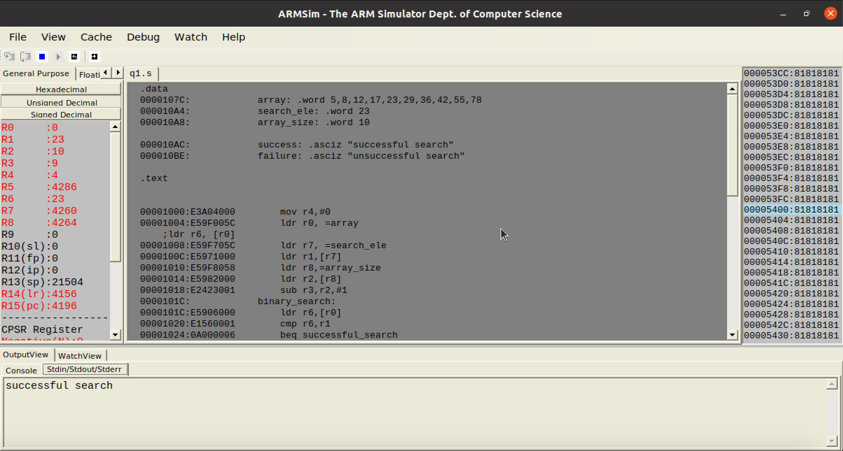

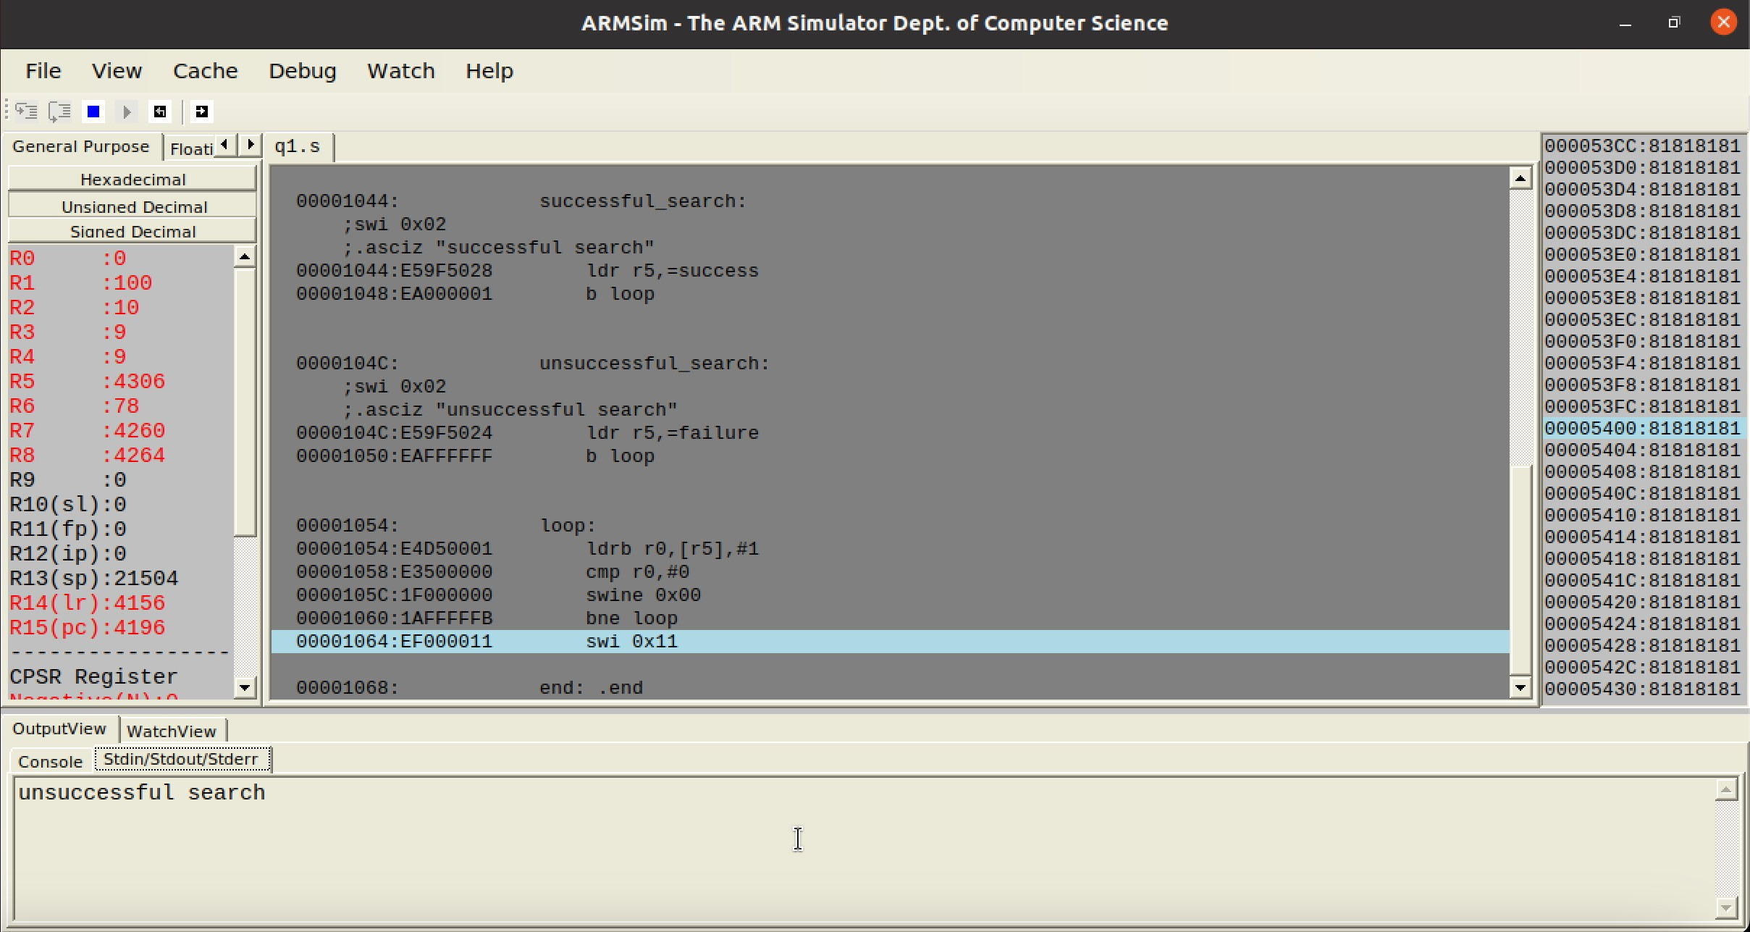

**Microprocessor and Computer Architecture UE21CS251B**

**4th Semester, Academic Year 2022-23**

Date:

|  |  |  |
| --- | --- | --- |
| Name: NAGAVENI L G | SRN:PES2UG21CS315 | Section  :F |

Assignment 1 Program 2

**Write a program in ARM7TDMI-ISA to ﬁnd a sub string in a given main string.**

**Example1: Main string : My name is Bond.**

**Character : ‘name’.**

**Expected Output : “String Present” Example2: Main string : My name is Bond.**

**Character : ‘James’.**

**Expected Output : “String Absent”**

.ARM Assembly Code

.data

    STRING: .ASCIZ "My name is Bond"

    SUBSTR: .ASCIZ "name"

    OUTPUT1: .ASCIZ "String Present"

    OUTPUT2: .ASCIZ "String Absent"

.text

LDR r0,=STRING

LDR r1,=SUBSTR

initmatch:

    LDRB r2,[r0],#1

    LDRB r3,[r1]

    CMP r2,#0

    BEQ notfound

submatch:

    LDRB r2,[r4],#1

    LDRB r3,[r5],#1

    CMP r2,r3

    BEQ submatch

    B initmatch

found:

    LDR r1,=OUTPUT1

    B LOOP

notfound:

    LDR r1,=OUTPUT2

    B LOOP

LOOP:

    LDRB R0,[R1],#1

    CMP R0,#0

    SWINE 0x00

    BNE LOOP

    SWI 0x11

I. Output Screen Shots (Two)

The output should be verified for Substring Present and Substring Absent

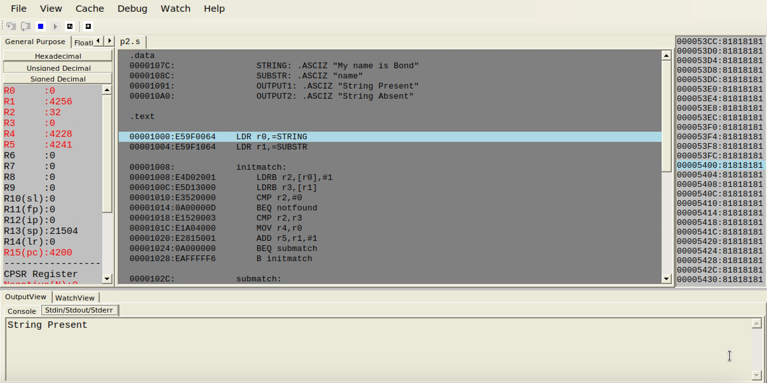

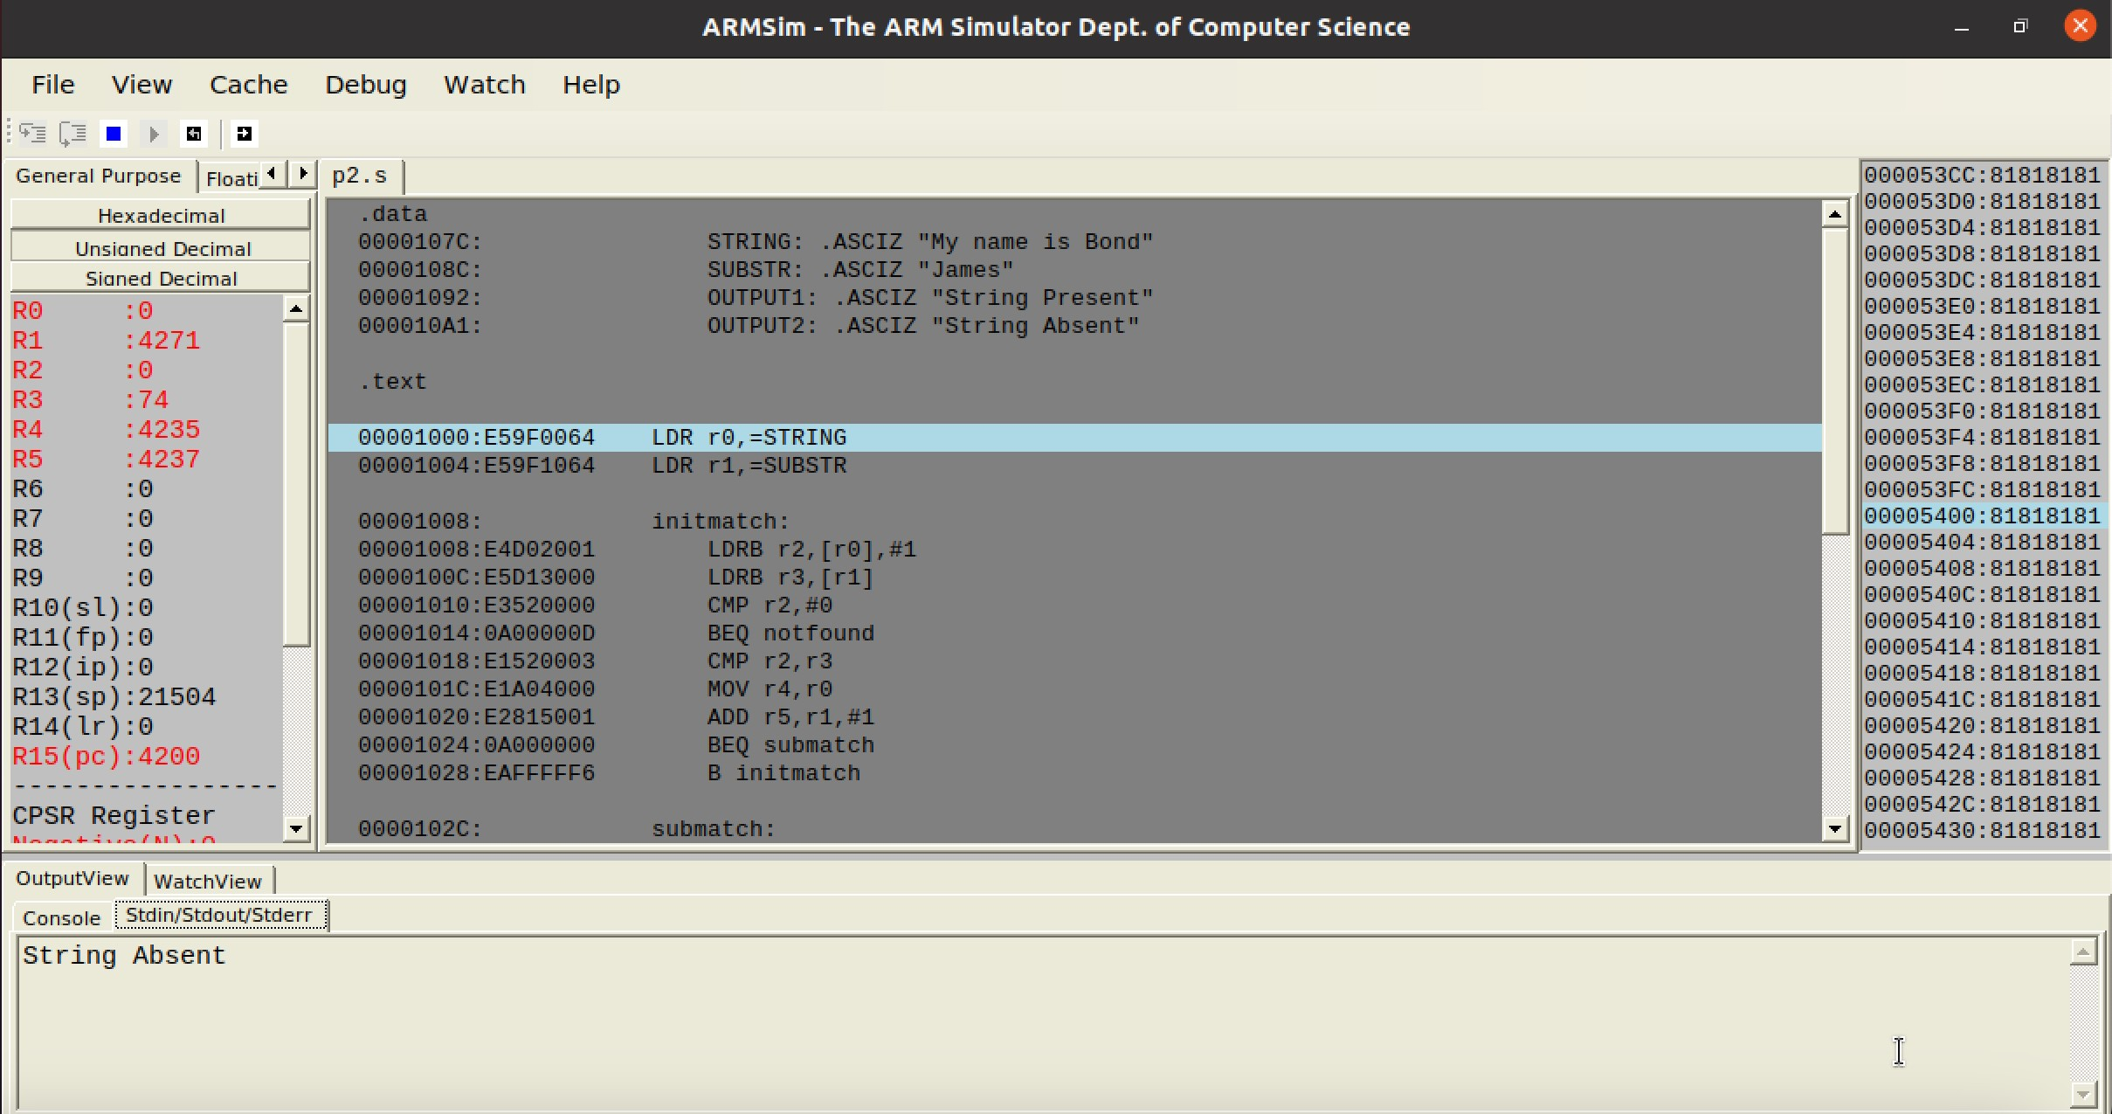

**Disclaimer:**

* The programs and output submitted is duly written, verified and executed by me.
* I have not copied from any of my peers nor from the external resource such as internet.
* If found plagiarized, I will abide with the disciplinary action of the University.

SIGNATURE:

NAME:NAGAVENI LG

SRN: PES2UG21CS315

Section: F

Date: 06-02-2023