MICROPROCESSOR AND COMPUTER ARCHITECTURE –WEEK 1

NAGAVENI L G

PES2UG21CS315

4TH SEM- F SEC

**Sample programs**

* 1. Write an ALP using ARM instruction set to add and subtract two 32 bit numbers .Both numbers are in registers.

Hexadecimal

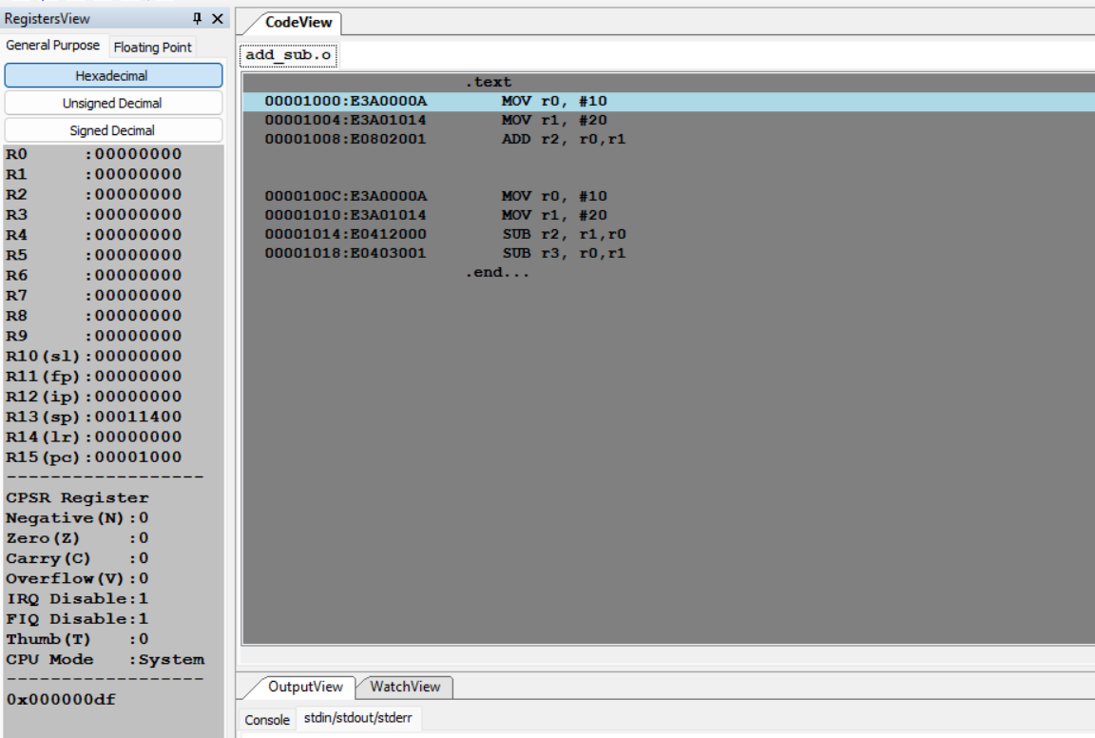

Unsigned Decimal

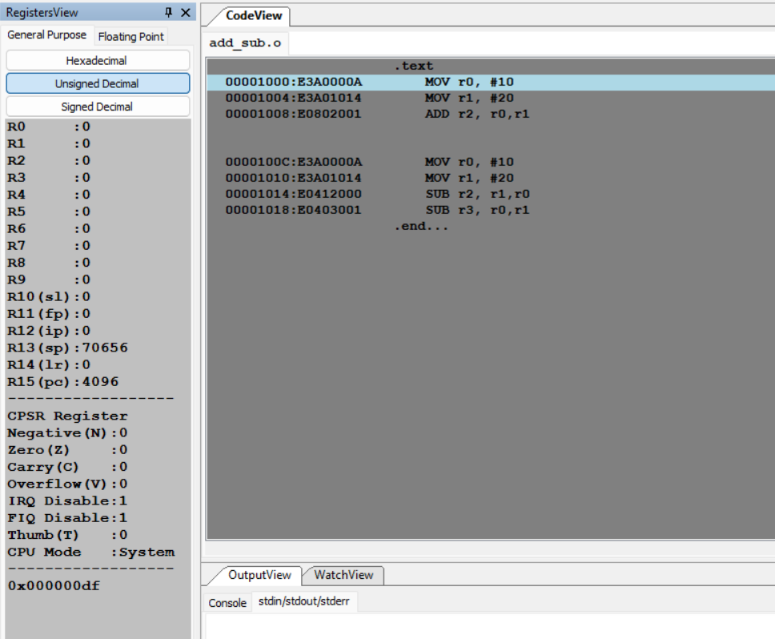

signed Decimal

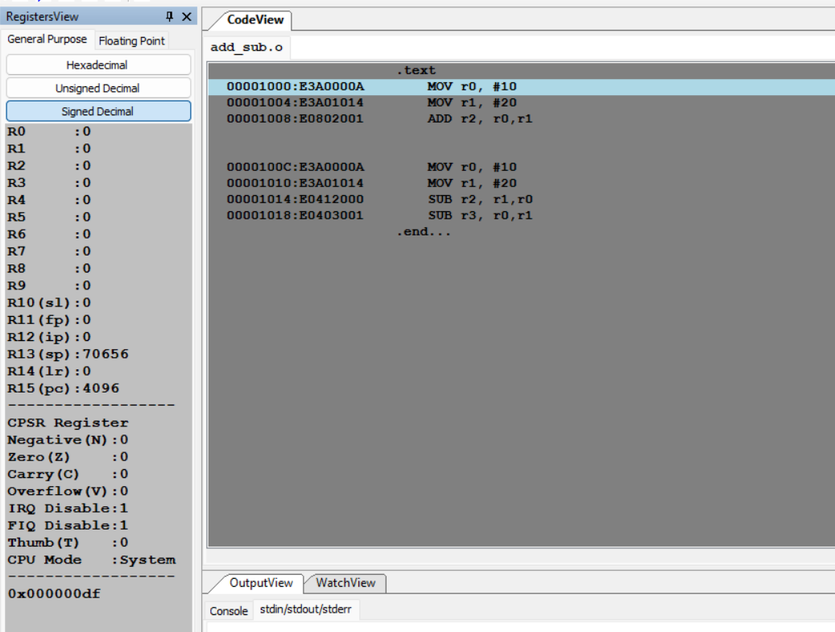

* 1. Write an ALP to demonstrate logical operations. All operands are in registers.

Hexadecimal

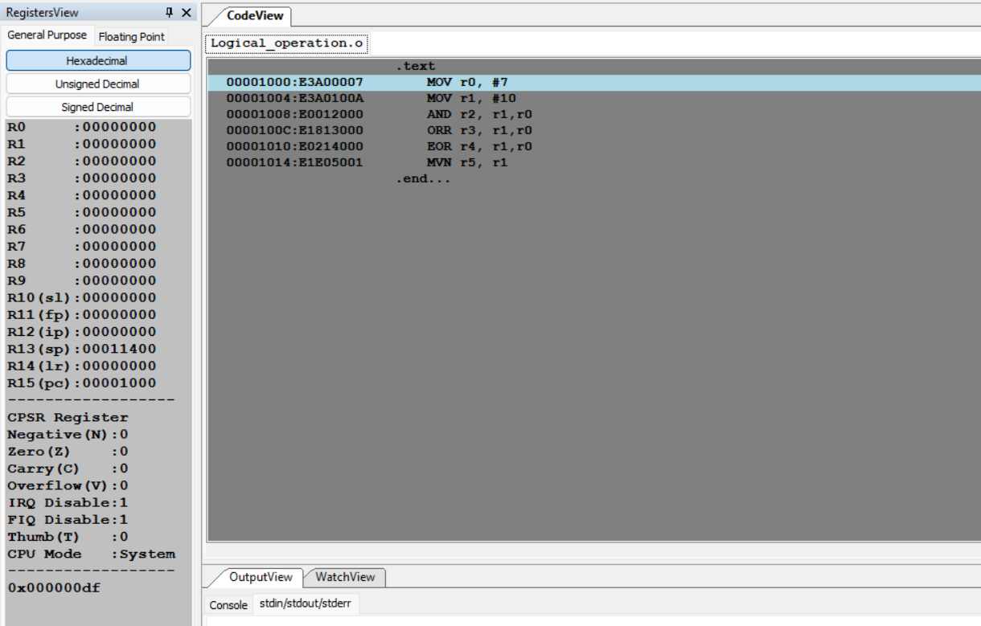

Unsigned Decimal

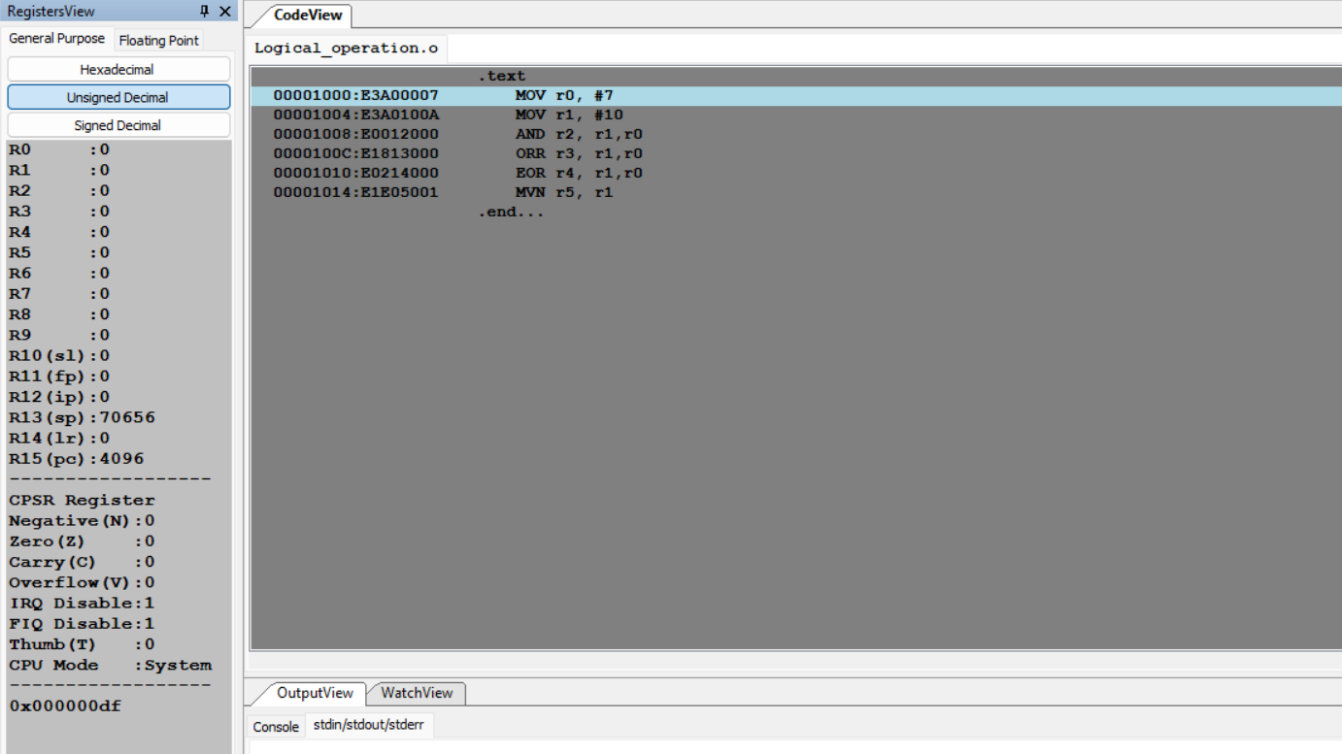

signed Decimal

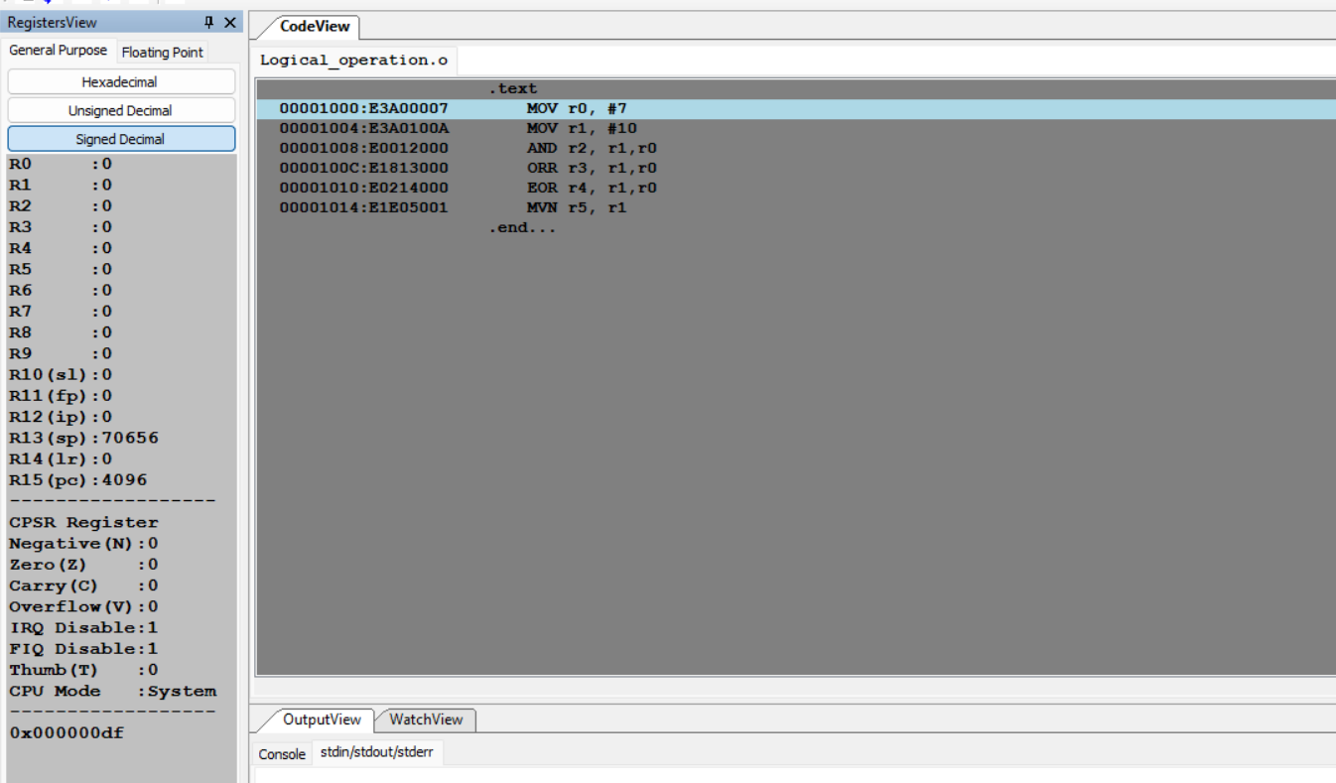

* 1. Write an ALP to add 5 numbers where values are present in registers.

Hexadecimal

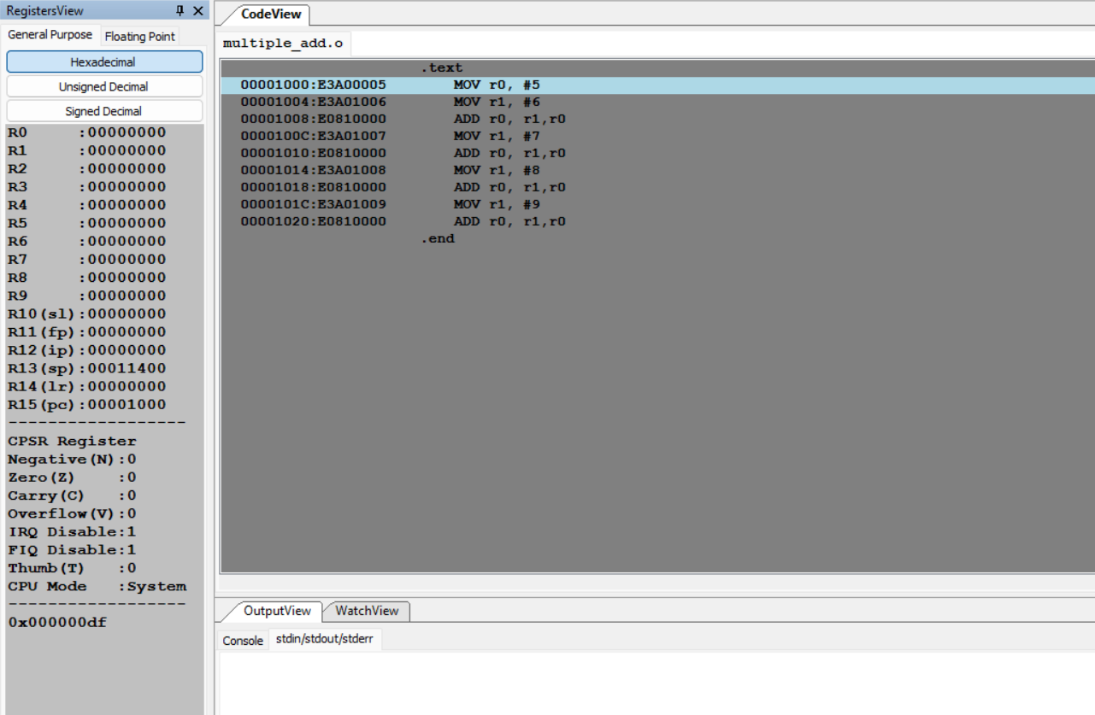

Unsigned Decimal

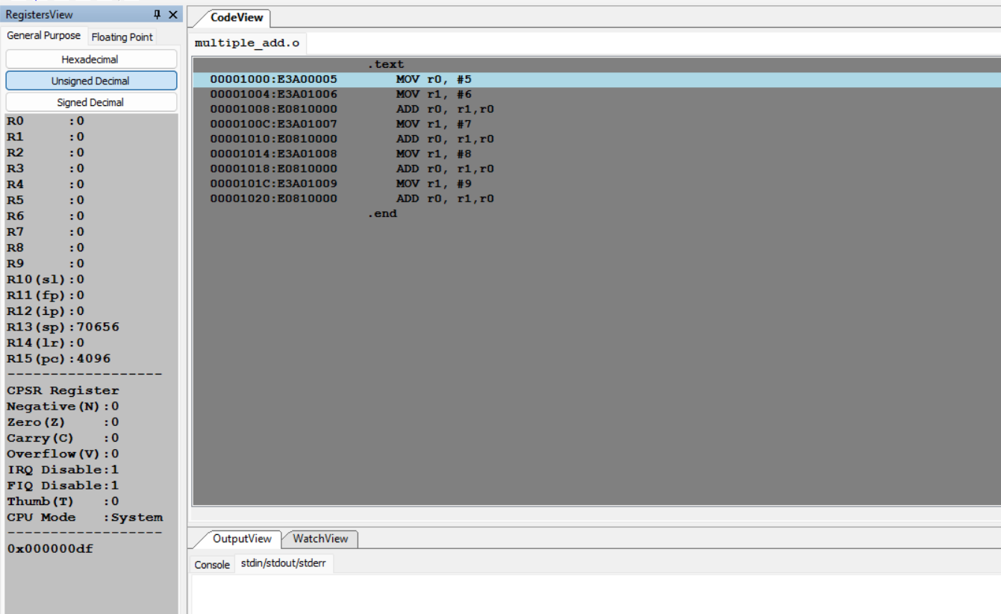

signed Decimal

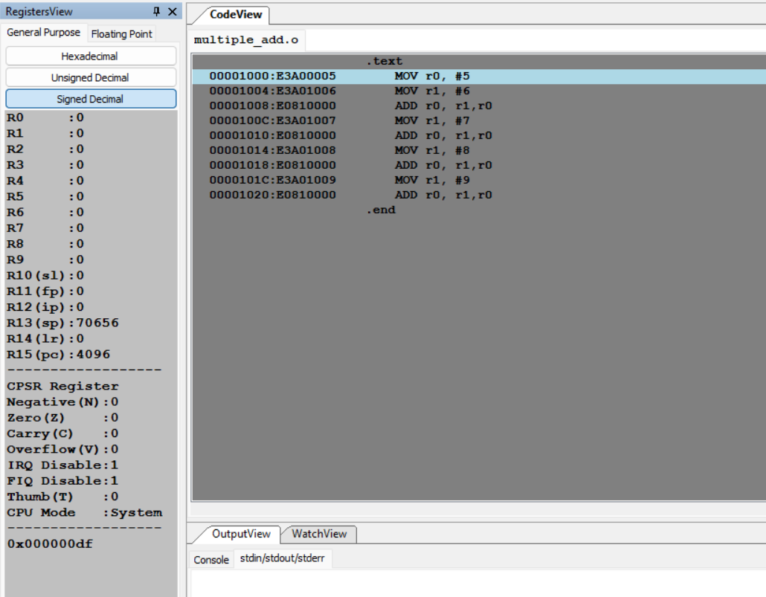

**2. Assignment:**

* 1. Write an ALP using ARM instruction set to check if a number stored in a register is even or odd.

Hexadecimal

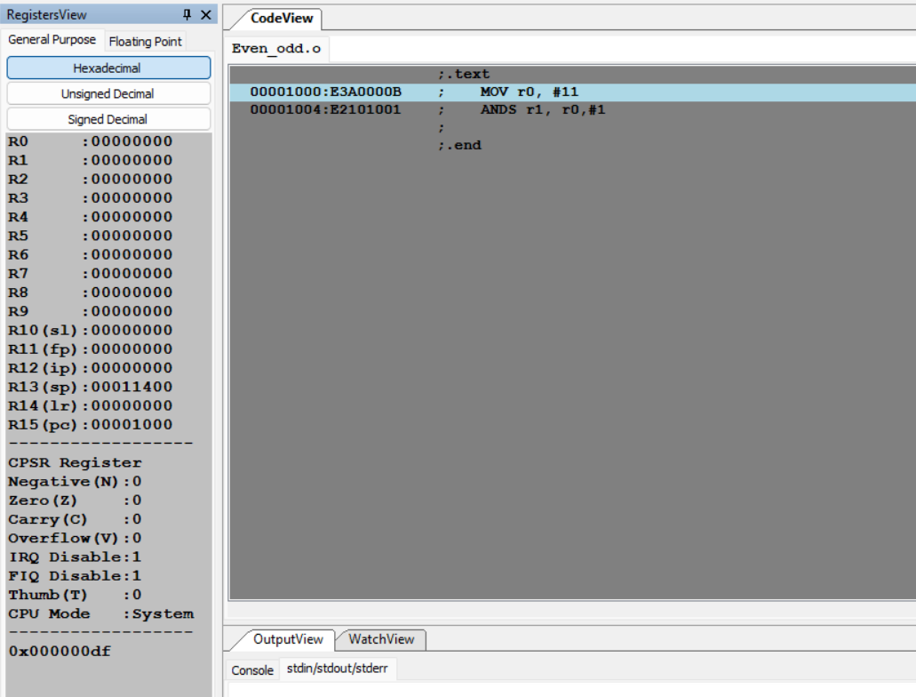

Unsigned Decimal

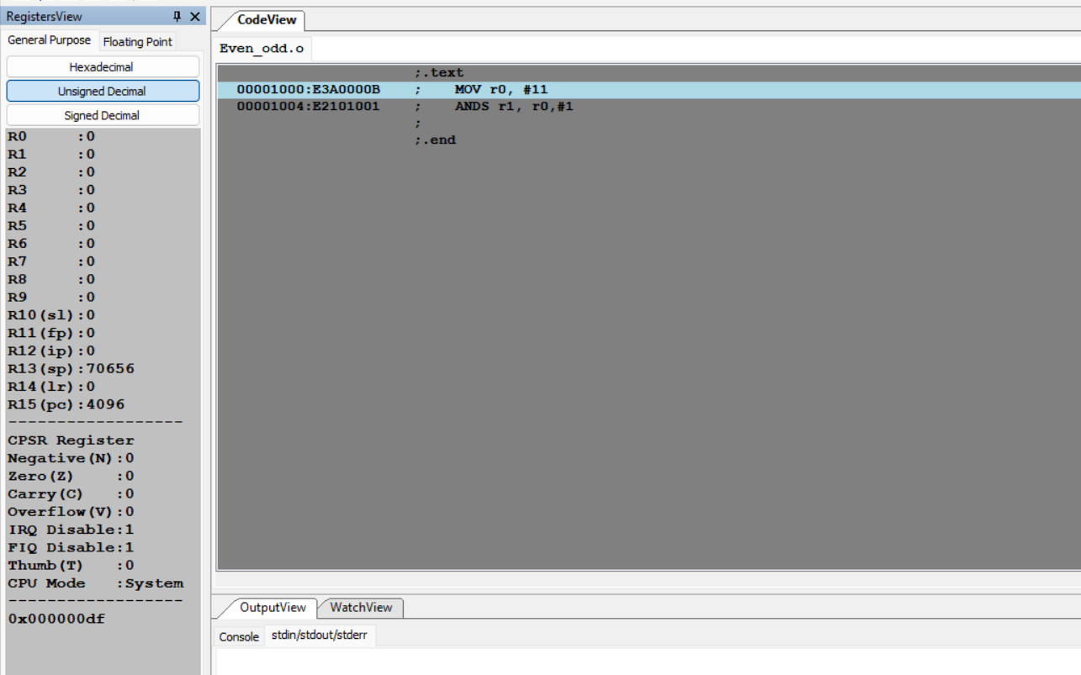

signed Decimal

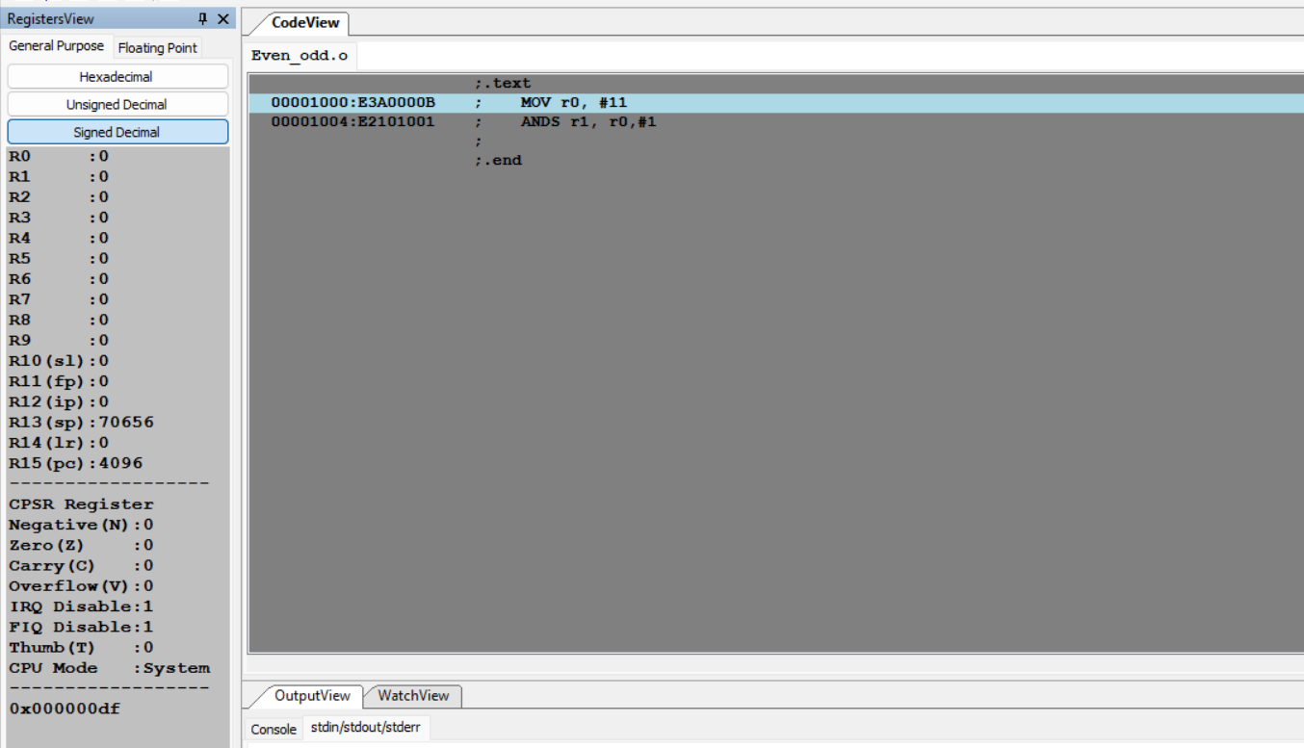

* 1. Write an ALP to compare the value of R0 and R1, add if R0 = R1, else subtract

Hexadecimal

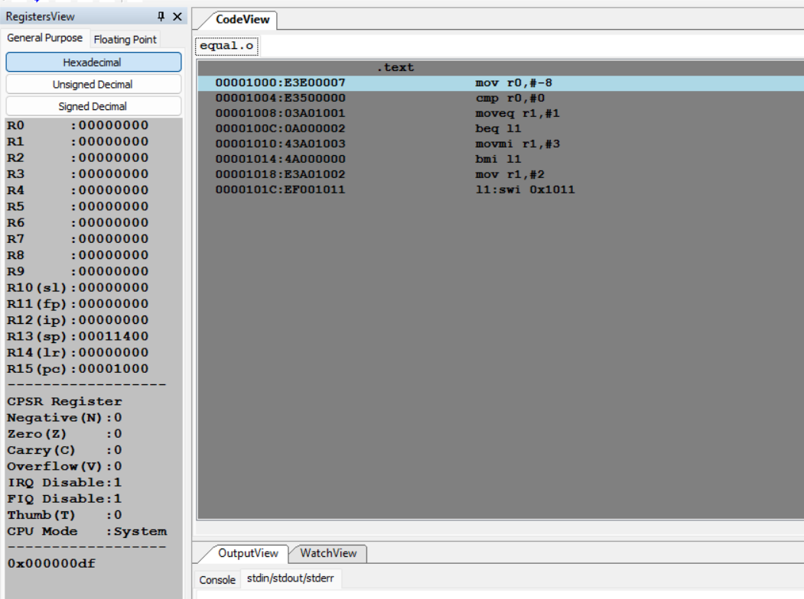

Unsigned Decimal

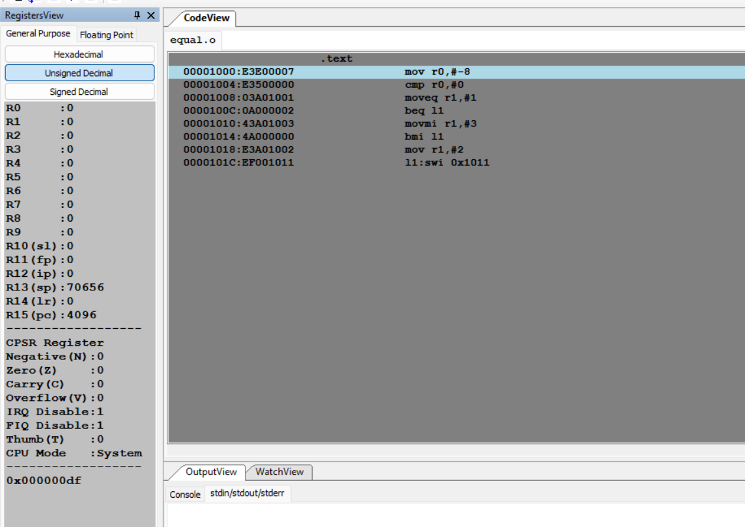

signed Decimal

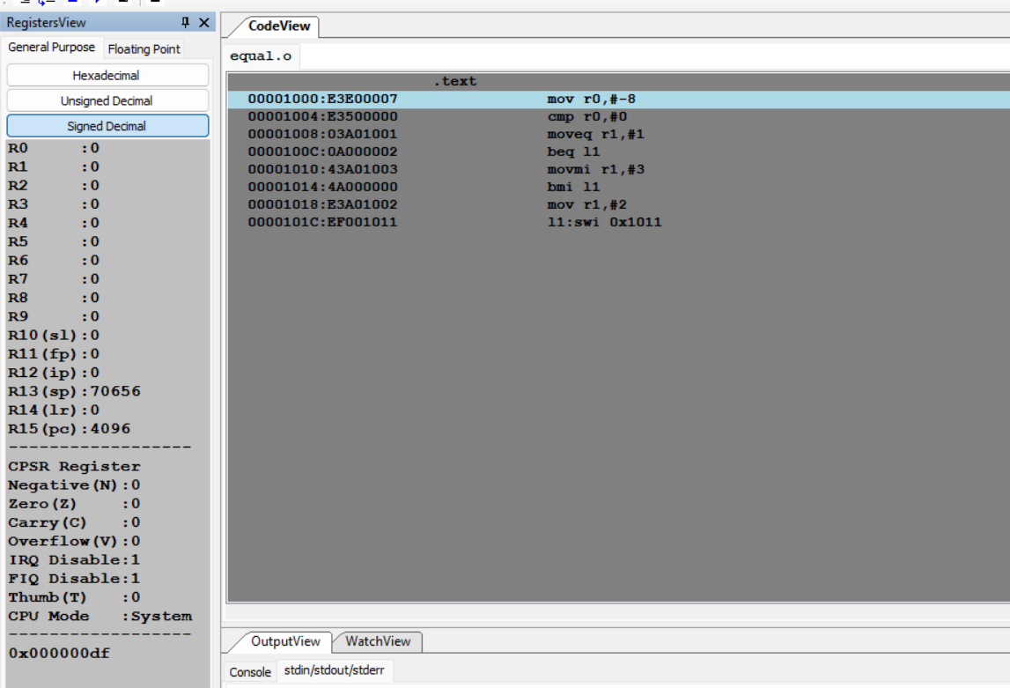

* 1. Based on the value of the number in R0, Write an ALP to store 1 in R1 if R0 is zero, Store 2 in R1 if R0 is positive, Store 3 in R1 if R0 is negative.

Hexadecimal

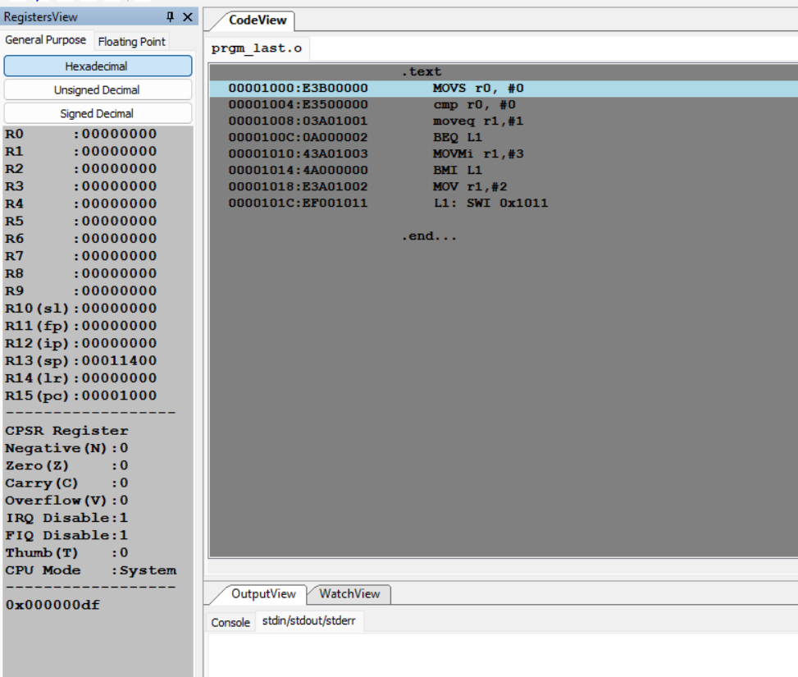

Unsigned Decimal

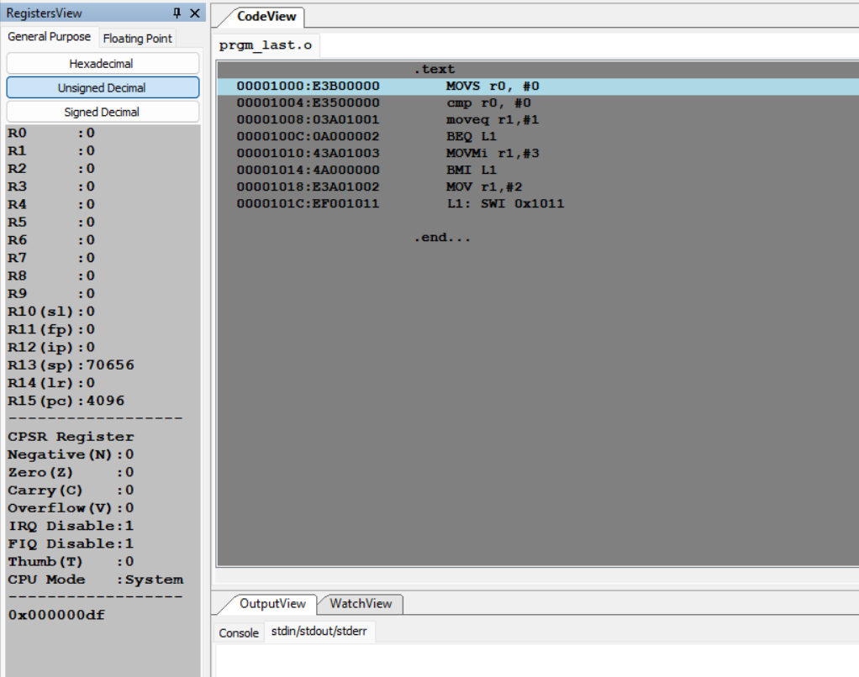

signed Decimal

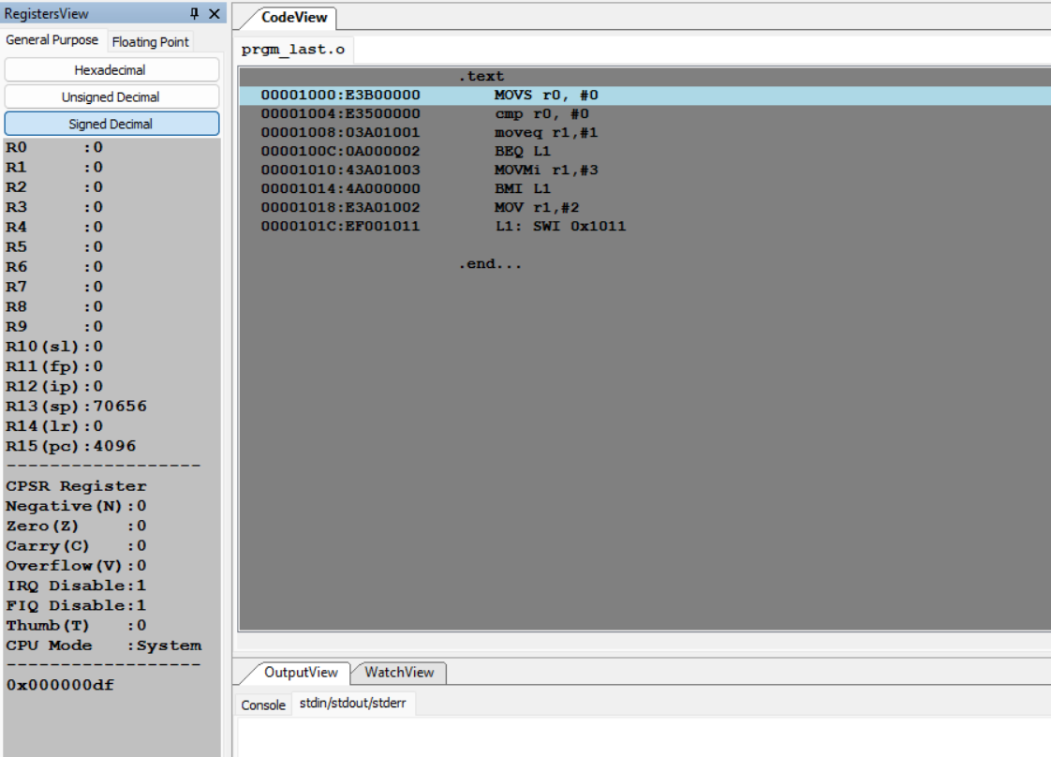

THANK YOU 😊